

GCSE GEOGRAPHY Name:
Coasts
Complete the questions by typing in the answer boxes, which will expand as necessary.
Then fill in the self-assessment form as fully as you can to help you reflect on your work.

1 The following statements are about the different types of weathering.
Write the correct type of weathering (mechanical, chemical or biological) in the box next to each statement. Each answer may be used once, more than once or not at all.
A change in both the appearance and the
mineral composition of rock.
The effects of plant roots or burrowing
animals on rock.
The breaking of rock into smaller pieces
without changing its composition.
(Total 3 marks)
2 The following statements are about processes that affect the coast.
Write the correct process (weathering, mass movement, erosion or transportation) in the box next to each statement. Each answer may be used once, more than once or not at all.
Material slides down a slope
Particles of sand are bounced along
the beach
Temperatures rise above and fall below 0 °C causing ice to thaw and water to freeze
(Total 3 marks)
3 The sea erodes the coast in a variety of ways.
Match each process to the correct definition.
Process | Definition
1 Erosion is | A sand and pebbles being thrown against the coast.
2 Hydraulic power is | B the dissolving of some rocks by sea water.
3 Abrasion is | C the wearing away of the land.
4 Attrition is | D the force of the water against the coast.
5 Solution is | E the colliding of rock fragments into each other.

1 |  |  | 2 |  |  | 3 |  |  | 4 |  |  | 5
(Total 4 marks)
4 The following paragraph describes how coastal processes are linked.
Complete the paragraph. Choose the correct words from the list below.
deposition transported weathering
Erosion and break down rocks in coastal areas.

Sediment is by the action of waves and tides.

Once the waves and tides have lost energy takes place.

(Total 2 marks)

5 Study the photograph of part of a coastline
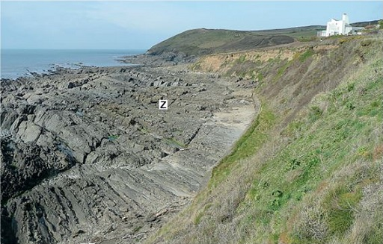
Using the photograph, identify the landform marked Z.

(Total 1 mark)
6 Explain how a coastline of headlands and bays forms and changes over time.

(Total 4 marks)
7
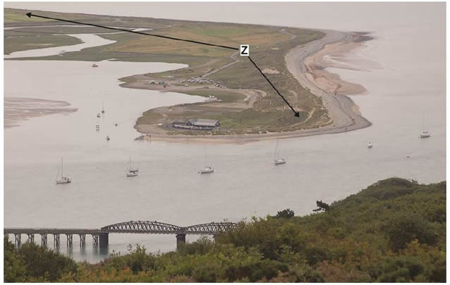
Feature Z labelled on the photograph above is a spit.
Explain the formation of a spit.

(Total 4 marks)
8 Study the photograph showing sea defences at Beesands in Devon.
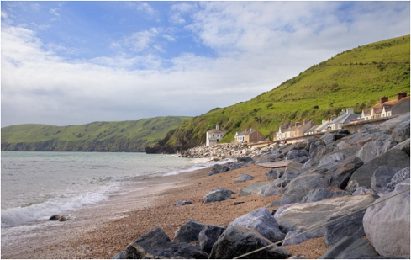
Suggest how the sea defences help to protect the coastline.

(Total 4 marks)
9 Explain how soft engineering might be used to manage the coastal zone.

(Total 4 marks)
10 Suggest one environmental advantage of managed retreat.

(Total 1 mark)

Feedback Form Instructions
When you have answered as many questions as you can, complete the form on the last page to help you reflect on your work.
How to fill in the form
1 Put your confidence score in Column C. This is not about the number of marks you achieved but how sure you felt while you were answering the question.
Confidence | Definition
0 | I didn’t answer this one
1 | I guessed the answer
2 | I needed help with the answer
3 | I understood the question but wasn’t sure about my answer
4 | I was fairly confident I would get most of the marks
5 | I was sure my answer was correct and I would get full marks
2 Use the mark scheme to check your answers.
Put the mark you think you achieved in Column Mark.
3 Write an overall comment about how you felt each question went.
- If you got help, make a note in the comment box specifying the source: internet,
friend, book, parent or tutor.
4 Complete ‘I can…’ and ‘I need to…’ sentences.
- ‘I can…’ sentences might include the questions you found easiest to answer, got the most marks for or felt the most confident about.
- ‘I need to…’ sentences might include areas you need to revise, questions you want to ask your teacher or the next topic or skill you want to work on.
5 Return the form to your teacher.

Coasts
Feedback form Name

Qu | Total marks | Self-assessment
 |  | C | Mark | Comment
1 | 3
2 | 3
3 | 4
4 | 2
5 | 1
6 | 4
7 | 4
8 | 4
9 | 4
10 | 1
Overall
I can ……

I need to …….

Qu | Total marks | Teacher review
 |  | Mark | Comment
1 | 3
2 | 3
3 | 4
4 | 2
5 | 1
6 | 4
7 | 4
8 | 4
9 | 4
10 | 1
Overall
You can ……

You need to …….

