

GCSE GEOGRAPHY Name:
The Living World
Complete the questions by typing in the answer boxes, which will expand as necessary.
Then fill in the self-assessment form as fully as you can to help you reflect on your work.

1 Study the diagram below showing energy flows in an ecosystem in the UK.
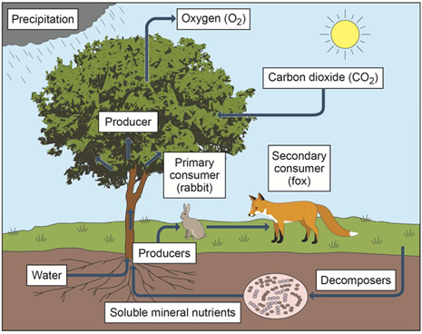
(a) Describe the role of producers in an ecosystem.

(1)
(b) Give one reason why energy is lost at each level in a food chain.

(1)
(c) Using the diagram and your own understanding, complete the following sentences.
If a disease reduced the number of primary consumers, one effect on the food chain would be that

Decomposers help to return nutrients to the soil by

(2)
(Total 4 marks)
2 Study the world map below showing some global ecosystems.
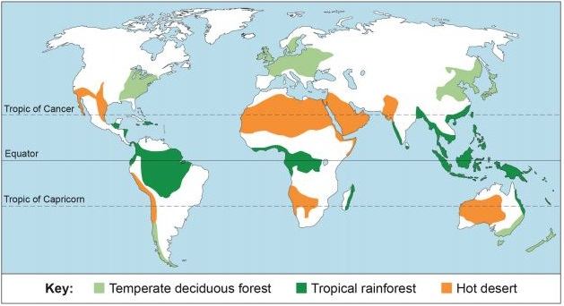
(a) Using the world map above which one of the following statements is true?
Put an X in one box only.
A | There is a greater area of hot desert in the  Southern Hemisphere than the Northern Hemisphere.
B | The largest single area of tropical rainforest is  in South America.
C | Temperate deciduous forests are all found on  the western side of continents
D | Hot desert areas are all found between the  two tropics.
(1)
(b) Outline one reason for the distribution of tropical rainforest.

(2)
(Total 3 marks)
3 Which one of the following statements describes the climate of a tropical rainforest?
Put an X in one box only.
A | Mild temperatures (10–18°C), rainfall all year (approximately 1000 mm)
B | High temperatures all year (over 30°C),  very dry (250 mm of rainfall per year)
C | High temperatures all year (25–27°C), rainfall  in every month (1800–2000 mm per year)
D | Wide range of temperatures (15–30°C),  seasonal rainfall (approximately 750 mm)
(Total 1 mark)
4 Outline one reason for the high levels of biodiversity in tropical rainforests.

(Total 2 marks)
5 Study the graph below which is a typical climate graph for one global ecosystem.
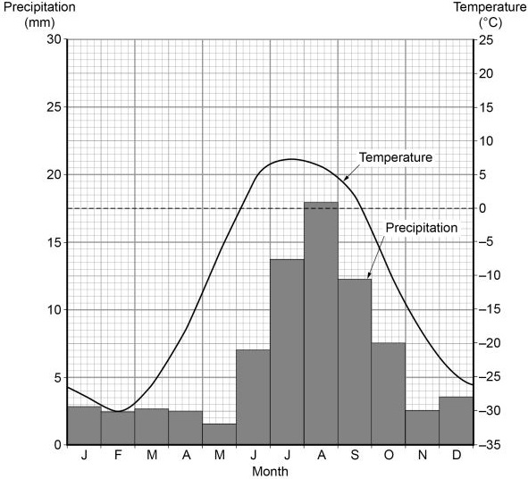
(a) Which global ecosystem is most likely to have the temperature and precipitation pattern shown in the graph above.
Put an X in one box only.
A | temperate deciduous forest
B | tundra
C | hot desert
D | savanna
(1)
(b) State the minimum temperature shown in the graph above.
Put an X in one box only.
A | –26°C
B | –28°C
C | –30°C
D | –30°C
(1)
(Total 2 marks)
6 Study the photograph of part of an ecotourism scheme in the Amazon rainforest, Brazil.
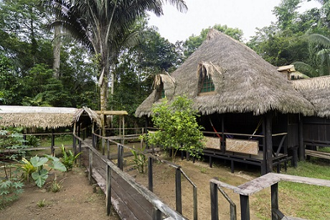
Using the photo above suggest how ecotourism can help in managing tropical rainforests sustainably.

(Total 2 marks)
7 Explain how either international hardwood agreements or selective logging can encourage the sustainable management of tropical rainforests.

(Total 2 marks)
8 Choose one of the following environments:
Environments on the fringe of hot deserts
Cold environments
Put an X in the box indicating the environment chosen.
To what extent is your chosen environment at risk from human activity?

(Total 9 mark)

Feedback Form Instructions
When you have answered as many questions as you can, complete the form on the last page to help you reflect on your work.
How to fill in the form
1 Put your confidence score in Column C. This is not about the number of marks you achieved but how sure you felt while you were answering the question.
Confidence | Definition
0 | I didn’t answer this one
1 | I guessed the answer
2 | I needed help with the answer
3 | I understood the question but wasn’t sure about my answer
4 | I was fairly confident I would get most of the marks
5 | I was sure my answer was correct and I would get full marks
2 Use the mark scheme to check your answers.
Put the mark you think you achieved in Column Mark.
3 Write an overall comment about how you felt each question went.
- If you got help, make a note in the comment box specifying the source: internet,
friend, book, parent or tutor.
4 Complete ‘I can…’ and ‘I need to…’ sentences.
- ‘I can…’ sentences might include the questions you found easiest to answer, got the most marks for or felt the most confident about.
- ‘I need to…’ sentences might include areas you need to revise, questions you want to ask your teacher or the next topic or skill you want to work on.
5 Return the form to your teacher.

The Living World
Feedback form Name

Qu | Total marks | Self-assessment
 |  | C | Mark | Comment
1 | 4
2 | 3
3 | 1
4 | 2
5 | 2
6 | 2
7 | 2
8 | 9
Overall
I can ……

I need to …….

Qu | Total marks | Teacher review
 |  | Mark | Comment
1 | 4
2 | 3
3 | 1
4 | 2
5 | 2
6 | 2
7 | 2
8 | 9
Overall
You can ……

You need to …….

