  - You have five minutes. Children should be working towards scoring 100%.
  - Watch out for the changes to + /÷ / - / x
  - This test will be repeated five times, where mistakes are made it will be an indication that further times tables work and attention to detail is necessary.

17 – 9 = | 9 + 6 = | 6 x 8 = | 19 – 7 = | 12 + 5 =
8 x 3 = | 7 x 8 = | 63 ÷ 7 = | 6 + 9 = | 11 – 7 =
11 – 6 = | 32 ÷ 8 = | 12 – 9 = | 7 x 4 = | 13 + 6 =
8 x 6 = | 14 – 5 = | 7 + 5 = | 63 ÷ 9 = | 9 x 9 =
5 x 7 = | 2 + 9 = | 45 ÷ 9 = | 4 + 3 = | 13 – 7 =
7 – 2 = | 56 ÷ 8 = | 8 x 12 = | 13 – 8 = | 32 ÷ 4 =
3 + 7 = | 16 – 7 = | 7 + 8 = | 4 x 6 = | 14 – 6 =
12 – 9 = | 9 x 3 = | 11 – 8 = | 49 ÷ 7 = | 5 + 8 =
8 x 9 = | 6 + 7 = | 27 ÷ 9 = | 15 – 4 = | 9 x 7 =
72 ÷ 8 = | 13 – 9 = | 5 x 12 = | 4 + 8 = | 18 - 7 =

Score /50

  - Karl has completed his Mental Maths task but unfortunately he’s made a number of mistakes. His answers are underlined.
  - Circle the mistakes. See if you can work out what he might have done wrong.

① 45 ÷ 5 = 9

② (0 x 6) + (6 - 0) = 0

③ 800m x 5 = 4 km

④ Write the afternoon time in figures using am or pm.
Quarter to five = 4.45 pm
⑤ Take 30mm from ¾ metre = 720cm

⑥ £4.96 = 9 Tens and 6p

Marks /
⑦ How much greater is 8 x 4 than 3 x 8 8
⑧ 860mm = 86 cm
⑨ £0.07 x 20 = £0.14
⑩
½ + ³/8
4
= /16
⑪ What fraction of 40p is 5p = 1/8
⑫ In how many months of the year are
there 31 days = 7

  - Use the notes below each question to help you develop a range of skills. These skills can help you to work more accurately and quickly.

①
19 x 12 =
* Multiply 20 x 12 then subtract 12
②
£1.40 x 8 =
* Double, double again and then double
again
③
70 ÷ 5 =
* Divide by 10 then multiply by 2
④
123 + 89 =
* Add 90 then subtract 1
⑤
240 ÷ 15 =
* Divide by 3, then 5
⑥
0.3 x 9 =
* You know that 3 x 9 = 27

Marks /10
⑦
4/5 of 65 =
* Find ¹/5 then multiply by 4
⑧ 42 + 17 + 38 + 23 =
* 42 + 38 and 17 + 23 first
⑨ 2.9 x 3 =
* The result must be about 9
⑩ 25 x 6 =
* The units digit of answer is 0
TIP:
Try to use these skills when you do other Mental Maths work

MMS4

Try the following questions. Do as many in your head as possible.
①
£1 – (7px8) = p
②
0.67m = cm
③
19 + 35 = x 6
④
6.4cm – 27mm = mm
⑤
7cm ÷ 10 = mm
⑥
0.2 + 12 + 0.07 =
⑦
78 + 27 =
⑧
1.7kg - 950g = g
⑨
(7x6) - (8x3) =
⑩
£2.50 x 6 = £
⑪ Increase £6.78 by 23p = £

⑫ 42/6 = 28 ÷ y. Find the value of y.

⑬ 7.8kg x 3. Write the answer to the nearest kg. kg

⑭ Write 78p as a decimal fraction of £1.

⑮ What sum of money is equal to 6 x 45p?
£

⑯ Multiply 6.88m by 100. km

⑰ By how many is the sum of 12 and 11 less than the product of 12 and 11?

⑱ How many times can 0.25 be taken from 2?

⑲ Find the difference between £0.60 and one fifth of £1. p

⑳ Find the radius in cm of a circle which has a diameter of 74mm. cm

Marks /20

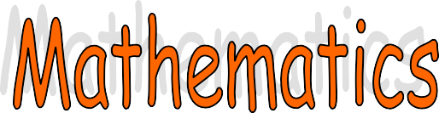

- This is a V line
2. This is a R angle
3. This is a H line

4. 3
8
of 48 =

You will need to find one-eighth first, then times your answer by 3

  - To 2
3
of 15 add 4
of 50 =

  - 12 x 8 =

Take your time to complete this slowly and carefully. Answers are provided. Then go over any mistakes so that you would achieve full marks if you had to repeat this exercise.
5

  - 72 =
6
    - This means divide

  - 3 x 9 =

  - 300 – 197 =

  - 6 x 6 = 9 x

    - The two sides must balance here

  - 2936 What is the value of the 9?

  - 1
4
of a metre = cm

  - How many times larger is 900 than 9?

  - 6 x 12 =

  - 12 x 10 =

  - Find the PRODUCT of 12 and 9.
    - Check your Mathematics Vocabulary sheet if you can’t remember what
Product means!

  - How many faces (sides) has a cube?

  - 11 x 11 =

  - 11 x 12 =

  - 11 x 10 =

Marks this week:



- The 8 sided shape is called an octagon. An octopus has 8 legs. You can cut out the octagon if you wish, stick it in your book and draw 8 legs! This may help you to remember its name.

- A hexagon has 6 sides. Here’s a little crossword to help you
remember.

S I
he X agon

- The oval has a posh name. It is an ellipse. An ellipse is a stretched out circle. You can colour it in as lips if this will help you.

- A pentagon has 5 sides and looks a bit like a tent. Look at this: Pentagon
Tentagon

- This triangle has 3 equal sides.
It is called an equilateral triangle.
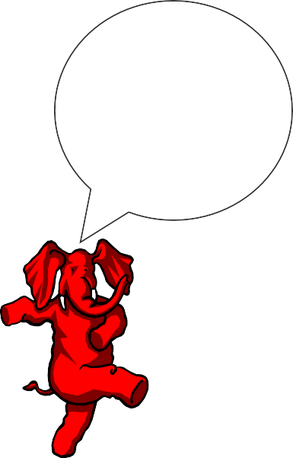
equi means equal
lateral means sides

- This is an isosceles triangle. It has 2 equal sides. Can you see them?

I know all the shapes and I can spell them too. Can you?

YES/NO


Fractions Exercise
To find out what ¹ of 9 is you divide by 3 = 3.
3

To find out what ¹ of 100 is you divide 100 by 5 = 20
5
Easy – Now try these.

3
1  6 | of 18 = | ¹ of 18 =
1  4 | of 16 = | ¹ of 32 =
1  6 | of 12 = | ¹ of 40 =
1  5 | of10 = | ¹ of 30 =
1  3 | of 12 = | ¹ of 32 =
1  6 | of 12 = | ¹ of 24 =
1  5 | of 15 = | ¹ of 36 =
1  4 | of 8 = | ¹ of 16 =
1  3 | of 24 = | ¹ of 25 =
1  2 | of 10 = | ¹ of 24 =
 | Score |  | 20

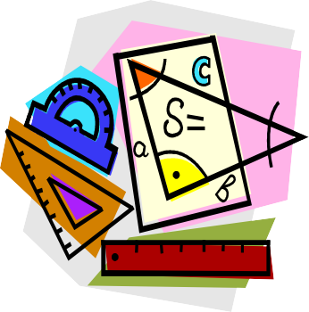
4

8

5

8

4

6

2

5

8

Maths Answers
Speed and Accuracy Test
8 15 48 12 17
24 56 9 15 4
5 4 3 28 19
48 9 12 7 81
35 11 5 7 6
5 7 96 5 8
10 9 15 24 8
3 27 3 7 13
72 13 3 11 63
9 4 60 12 11

Spot the mistakes
- 6. The first bracket = 0, the second bracket = 6
- 72 cm. Confusion converting mm back to cm. 1000 mm in a metre, 100 cm in a metre, 10 mm in a cm
- 49 Tens and 6p
The child has looked at the figure in the 10p column but failed to see the question asks each side to equal the other. You need 49 tens for both side to equal £4.96.
- £1.40. Mistake in calculations
- ⁷/8. Mistake in calculation. Have to give each fraction the same denominator. In this case 8 is the easiest so ½ becomes ⁴/8 and we can then add ⁴/8 and ³/8 = ⁷/8

Mental Maths Skills Development
1) 228
- £11.20
- 14
- 212
- 16
- 2.7
- 52
- 120
- 8.7
10) 150

Mental Maths
- 44p
- 67cm
- 9
- 37mm
- 7mm
- 12.27
- 105
- 750g
- 18
- £15
- £7.01
- 4
- 23kg
- 0.78
- £2.70

- 0.688km
- 109
- 8
- 40p
- 3.7cm

Revision Test 1

- Vertical
- Right
- Horizontal
- 18
- 10 + 40 = 50
- 96
- 12
- 27
- 103
- 4
- 900
- 25
- 100
- 72
- 120
- 108
- 6
- 121
- 132
- 110

Fractions
1. 3
2. 4
- 2
- 2
- 4
- 2
- 3
- 2
- 8
- 5
- 6
- 8
- 5
- 6
- 4
- 6
- 6
- 8
- 5
- 3

