  - Karen has completed her Mental Maths task but unfortunately she’s made a number of mistakes. Her answers are underlined.
  - Circle the mistakes. See if you can work out what she
might have done wrong.

① ⁷/₁₀ of 1 metre = 70 cm
② £3.50 - £1.75 = £1.25
③ 1 litre ÷ 4 = 25 ml
④ £4 = 8 TWENTIES
⑤
(0 x 10) + (10 x 10) + (10 – 0) = 110
⑥
Find the number of days in 7 weeks
= 49

Marks /
⑦
Find ¾ of 32 = 24
⑧
How many 12s are there in
a)120 and b)1200
a) 10
b) 100
⑨
6 x 6 = 4 x 9
⑩
What fraction of 60 is 10? 6/10
⑪
The sum of two numbers is 159. One number is 60. What is the other
number? 99
⑫
Multiply 2 ½ by 6 = 18

Try the following questions. Do as many in your head as possible.
①
0.18 x 7 =
②
8.20am to midday = min
③
3 FIFTIES + TENS = £2
④
371 ÷ = 7
⑤
¼ m = a) cm b) mm
⑥
£0.63 + £0.49 = £
⑦
3.6km - 1800m = m
⑧
2.3kg - 700g = kg
⑨
170ml x 100 = litres
⑩
75p + p = £1.27
⑪ Find in ml 3/10 of 12 litres ml

⑫ 7/8 of a sum of money is £56. Find the whole sum. £

⑬ Complete the series.
680, 705, , , 780

⑭ Divide 4 by 8. Write the answer as a decimal fraction.

⑮ Find the cost of 3 litres if 200ml costs 12p. £

⑯ Find the total distance in km of 550m, 1/2km and 800m. km

⑰ Two angles of a triangle measure 45° and 80°, what is the measurement of the third? °

⑱ Divide the sum of the digits from 1 to 8 inclusive by 6.

⑲ Subtract 2 6/7 from 5.

⑳ Find the difference in g between ¾ kg and 2/10 of kg. g

Marks /20

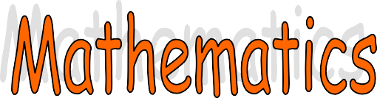

Speed test this week – get someone to time you.

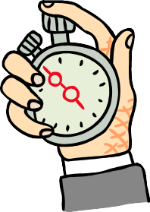
- 4 x 4 = 11. 5 x 4 =

- 7 x 6 =
- 20 =

- 14 =
5
2
- 7 x 8 =

- 4²= 14. 5 x 6 =

- 3 x 9 =
15. 30 =

- 4 x 8 = . 16. 30 =
6
5

- 7 x 7 = 17. 12 x 2 =

- 7² = 18. 3 x 7 =

- 3 x 8 = 19. 12 x 5 =

- 8 x 3 = 20. 7 x 4 =

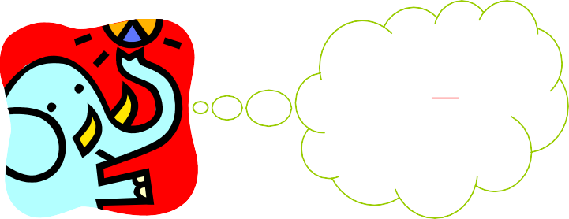
Marks this week
Don’t forget
6
Means: divide.
that 30

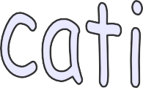

23 x 14
I don’t know my 14 times table but I do know my 10 and
4 times tables.
We can do this sum in 2 stages.
  - First we will multiply the units, then the tens.
  - Then we add the answers together. Here is an example:
out the sum

Now work these out and check your answers on a calculator:
23 x
14
92
230 +
322
1
Now you add up the 2 answers (92 + 230) to find the answer to the sum. We don’t need to know hard tables to do these!
The yellow highlight shows the 10 of the 14 – cover it with your finger.
First of all work out the sum 23 x 4 and set your answer out in the usual way.
- If you cover the ten (highlighted in yellow), it will help you to do the sum easily. The answer is 92.
- Now cross out the 4 because you have finished with it.
- Now you must multiply 23 x 10.
- The easiest way is to put down a 0 (highlighted in green) before you start. This is because you are multiplying by 10. Make sure the 0 is under the units column – this is important!
- Simply multiply the other numbers (1 x 23).
- 1 x 3 = 3 1 x 2 = 2
36 x 24 42 x 25 31 x 29 24 x 25
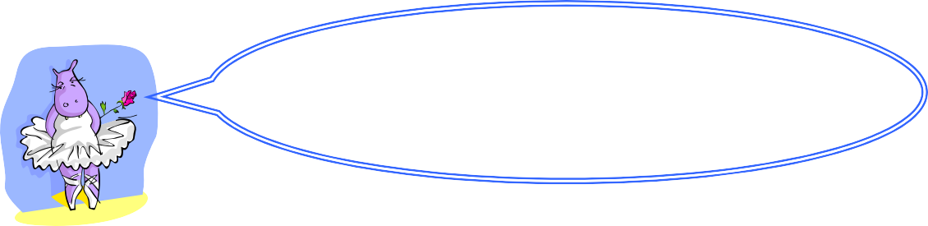
Don’t forget to put the 0 down.
You won’t get your sums correct unless you do.
Number correct:



and
Unshaded
Shaded
What fraction of each of these shapes is (a) shaded, and (b) unshaded?

1. 3
2.

4. 6.
5.

7. 8. 9.

11. 12.
10.

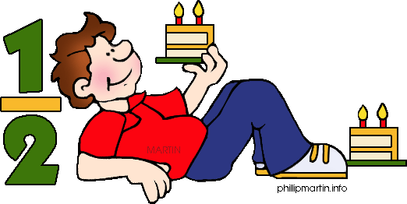
These questions are designed to get your mind whirring - so have a go. If you can’t do it first time then try, try again. It is important to persevere.

Start with 0.
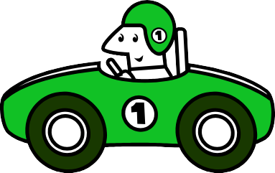
Make your way from ‘Start’ to ‘End’ by following the
arrows.
- Find a route that ends with exactly 100.
- Find the route with the lowest ending value.
- Find the route with the highest ending value.
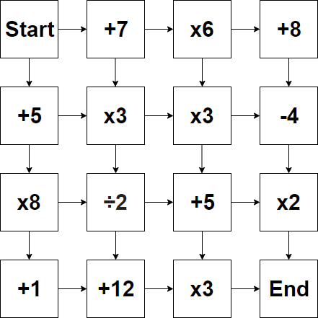
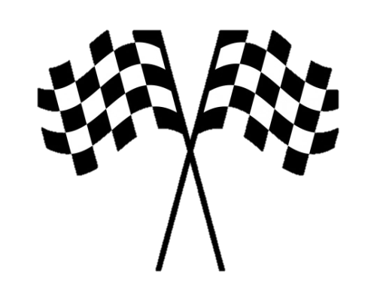

ANSWERS – COMPLETE MATHS – PART 6

Maths
Spot the mistakes
② This is attention to detail. The correct answer is £1.75. This type of mistake is normally just carelessness and would be found by doing a quick back-check -
£1.75 + £1.25 = £3 not £3.50
③ The correct answer is 250ml, 1 litre is equal to 100cl or 1000ml. Children often try to do 1 ÷ 4 here but don’t spend enough time thinking about the units.
④ The correct answer is 20. 20 x TWENTY pence pieces = £4 (20 x £0.20). Children sometimes allow their mind to do the wrong sum. In this case there’s a relationship between 4, 8 and 2 which can be confusing

⑩ The answer is ¹⁰/60 which can be simplified to 1/₆. The given answer shows Karen has not yet fully understood fractions and this area needs more focus.

⑫ The answer is 15. The child has done 2 x 6 to get 12 and thought half of 12 is 6 so 6 + 12 = 18. They should have realised that 2 x 6 = 12 and ½ of 6 = 3 so 12 + 3 = 15

Mental Maths
1) 1.26
- 220min
- 5 TENS
- 53
- a) 25cm b) 250mm
- £1.12
- 1800m
- 1.6kg
- 17 litres
- 52p
- 3600ml = 3.6 litres
- £64
- 730, 755
- 0.5
- £1.80
- 1.85km
- 55°
- 6
- 2 1/7
- 550g

Revision Test 3
1. 16
2. 42
3. 7
4. 16
5. 27
- 32
- 49
- 49
- 24
- 24
- 20
- 4

- 56
- 30
- 5
- 6
- 24
- 21
- 60
- 28

Long Multiplication
1. 864
2. 1050
3. 899
4. 600

ANSWERS – COMPLETE MATHS – PART 6

8. | 3  7 | 4  7
9. | 7 10 | 3 10
10. | 1  6 | 5  6
11. | 1  3 | 2  3
12. | 5 16 | 11  16

Maths Reasoning
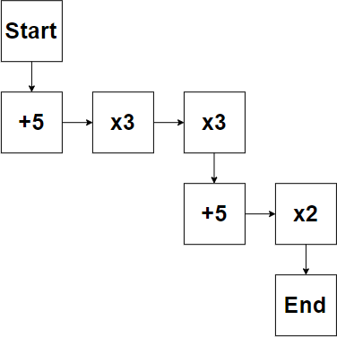
- The route that equals exactly 100:

Fraction – Shaded/Unshaded

 | Fraction shaded | Fraction unshaded
1. | 5 12 | 7 12
2. | 4  9 | 5  9
3. | 7  8 | 1  8
4. | 1 2 | 1 2
5. | 3  4 | 1  4
6. | 2  5 | 3  5
7. | 11 20 | 9  20

- The lowest value route gives a value of 25:
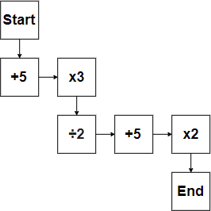

- The highest value route gives a value of 393:
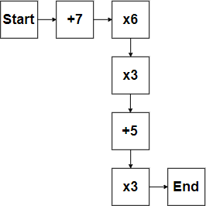

t

