Section 2

On the left of the example below are two shapes with an arrow between them. Decide how the second is related to the first. After these there is a third shape, then an arrow and then five more shapes. Decide which of the five shapes goes with the third one to make a pair like the two on the left. Its letter has been marked on your answer sheet.
Example

A B C D E
Answer: B
The shape rotates 180° but doesn’t change size. Now do the two practice questions below.
P1

A B C D E

In the two shapes on the left, we can see that the shape changes from a shield to a square but the size remains the same and so does the line style. This means that the dashed shield will change to a dashed square of the same size. This makes C the correct answer.
P2

A B C D E

In the two shapes on the left, we can see that the shapes stay the same but there is a reversal of shading. The third shape is a small white ‘keyhole’ inside a black shaded six-sided figure so shape four must be the same but with reverse shading. Therefore, A is the correct answer.

21

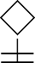
A B C D E
22
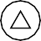
A B C D E
23
A B C D E
24
A B C D E
25

A B C D E

26

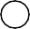
A B C D E
27

A B C D E
28
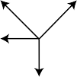
A B C D E
29
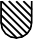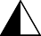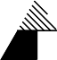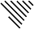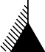
A B C D E
30

A B C D E

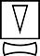
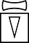
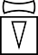
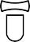
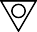


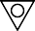
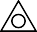


Answers
21. B
22. E
23. A
24. B
25. C
26. A
27. D
28. A
29. A
30. B

