
Opposites Match-up
Below you will see words from the opposites you have just learnt. Match each word from the box below with its opposite in the list below.
adult alive answer arrive
asleep
back backward bad beautiful
bent
better abroad absence accept
ancestor
ancient assemble
barren

awake
child
dead
depart
descendant
disperse/dismantle
fertile
forward
front
good
home
modern
presence
question
refuse
straight
ugly
worse



Some words have more than one meaning, they are called homographs.

For example:
I will show you how it is done. They went to the theatre to see a show.
bark boil badger ball bear bolt bat arm bow band
- Write in the word from the list above to complete the meaning:
- My hurt.
The politician decided to his troops.

- He kicked the into the net.
The midnight was always such fun.

- The played all night.

He used a rubber

- The dog had a very loud
to keep them together.

.

The

- Without a
was crumbling off the tree trunk.

he couldn’t hit the ball.

The flew over the house.

- She couldn’t sleep without her cuddly .
He couldn’t it any longer.

- Her favourite way to cook potatoes was to them. The on his face was getting bigger.

- He used the to secure the gate. The horse made a for it.

- He was told to as the King approached. She sat at the of the boat.

- His favourite animal was the .
He decided to the boys until they played with him.

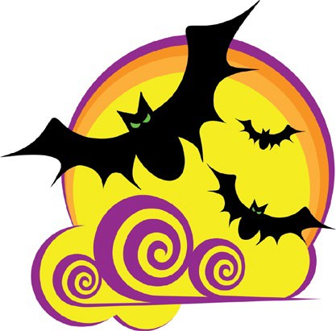
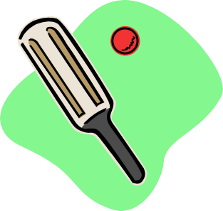
Both are bats

ANSWERS - COMPLETE VOCABULARY – PART 3

Opposites Match-up
asleep adult alive arrive ancestor assemble barren backward back
bad abroad ancient absence answer accept bent beautiful better

Words With More Than One Meaning

- arm
- ball
- band
- bark
- bat
- bear
- boil
- bolt
- bow
- badger

