Shadow Set 1

Instructions
- Use black ink or ball-point pen.
- Fill in the boxes at the top of this page with your name,
centre number and candidate number.
- Answer all questions.
- Answer the questions in the spaces provided
– there may be more space than you need.
- You must show all your working.
- Diagrams are NOT accurately drawn, unless otherwise indicated.
- Calculators may not be used.

Information
- The total mark for this paper is 80
- The marks for each question are shown in brackets
– use this as a guide as to how much time to spend on each question.

Advice
- Read each question carefully before you start to answer it.
- Try to answer every question.
- Check your answers if you have time at the end.
Answer ALL questions.
Write your answers in the spaces provided.
You must write down all the stages in your working.

1 Write 0.7 as a fraction.

.......................................................
(Total for Question 1 is 1 mark)
___________________________________________________________________________

2 Work out 5²

.......................................................
(Total for Question 2 is 1 mark)
___________________________________________________________________________

3 Work out 30 ÷ (3 + 2)

.......................................................
(Total for Question 3 is 1 mark)
___________________________________________________________________________

4 Write down a factor of 90 that is between 12 and 16

.......................................................
(Total for Question 4 is 1 mark)
___________________________________________________________________________

5 Simplify 4 × a × 6 × b

.......................................................
(Total for Question 5 is 1 mark)
___________________________________________________________________________

6 Janice is planning a trip to a pantomime for 1 adult and 2 children.

These are the costs for the trip.

Total cost of petrol £26
Tickets to pantomime £32 each adult
£14.50 each child
Meals £16.50 each adult
£12 each child

Janice has £150 to spend.
She pays all the costs.

How much money does she have left?

£.......................................................
(Total for Question 6 is 4 marks)
___________________________________________________________________________

7 Here is a list of 8 letters.

F | G | G | G | H | H | J | K
(a) Write down the mode.

.......................................................
(1)
One of the 8 letters is going to be picked at random.
(b) (i) On the probability scale, mark with a cross (×) the probability that this letter will be J

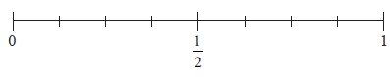
(1)
(ii) Find the probability that this letter will be H.

.......................................................
(1)
(Total for Question 7 is 3 marks)
___________________________________________________________________________

8 (a) Solve k − 4 = 9

k = .......................................................
(1)
(b) Solve 5n + n = 36

n = .......................................................
(2)
(Total for Question 8 is 3 marks)
___________________________________________________________________________
9
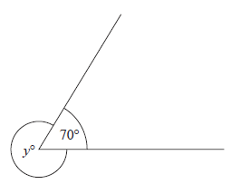
65°
x°
(a) Find the value of x.

x = .......................................................
(1)
(b) Give a reason for your answer.

......................................................................................................................................................

......................................................................................................................................................

......................................................................................................................................................
(1)
(Total for Question 9 is 2 marks)
___________________________________________________________________________

10 A shop sells jars of marmalade.
Each jar of marmalade costs £3

Gus has £19

(a) Work out the greatest number of jars of coffee Gus can buy.

.......................................................
(2)
In a sale on Friday, jars of marmalade are sold at half price.

Gus thinks that he can now buy exactly twice the number of jars of marmalade for £19

(b) Is Gus correct?
You must give a reason for your answer.

......................................................................................................................................................

......................................................................................................................................................

......................................................................................................................................................
(1)
(Total for Question 10 is 3 marks)
___________________________________________________________________________

11 Here are two triangles on a grid.
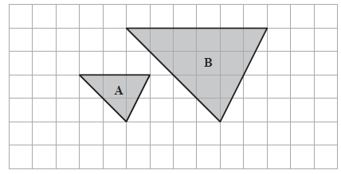
A
B
Triangle B is an enlargement of triangle A.
(a) (i) Write down the scale factor of the enlargement.

.......................................................
(1)
(ii) On the grid, mark with a cross (×) the centre of enlargement.
(1)
Here are two parallelograms on a coordinate grid.

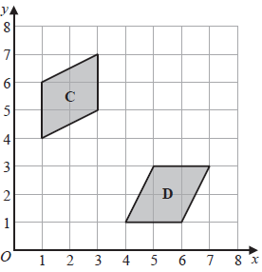
D
C

Parallelogram D is a reflection of parallelogram C.
(b) (i) On the grid, draw the mirror line.
(1)
(ii) Write down an equation of this mirror line.
.......................................................
(1)
(Total for Question 11 is 4 marks)
___________________________________________________________________________
12 Anita spent 140 minutes at a gallery.
She looked at paintings for 40 minutes.
She looked at sculptures for of the 140 minutes.
She looked at photographs for 30% of the 140 minutes.
She then spent the rest of the 140 minutes in the gift shop.

(a) Work out the total time, in minutes, that Anita spent in the gift shop.

....................................................... minutes
(4)
Anita got to the gallery at 2.15 p.m.
She had asked her friend to meet her in the gift shop at 4 p.m.

(b) Did Anita get to the gift shop by 4 p.m?
Give a reason for your answer.

......................................................................................................................................................

......................................................................................................................................................

......................................................................................................................................................
(1)
(Total for Question 12 is 5 marks)
___________________________________________________________________________

13 The composite bar chart shows information about the number of people living in a village.

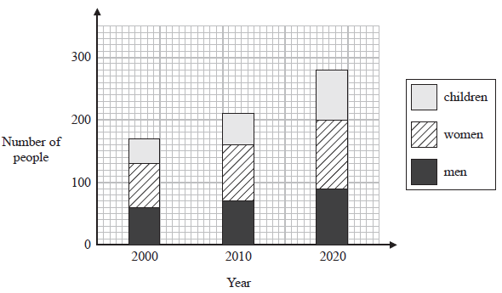

(a) Write down the number of men living in the village in the year 2010

.......................................................
(1)
(b) Find the number of children living in the village in the year 2020

.......................................................
(1)
For the people living in the village in the year 2000

(c) find the ratio of the number of men to the number of women.

.......................................................
(2)
(Total for Question 13 is 4 marks)
___________________________________________________________________________

14 Kerry drives from London to Norwich at an average speed of 64 km per hour.
She drives for 2hours.
(a) Work out the distance from London to Norwich.

....................................................... km
(2)
Roger is using a map.
The map has a scale of 1 : 15 000
On the map a footpath has a length of 8 cm.
(b) Work out the length, in kilometres, of the real footpath.

....................................................... kilometres
(3)
(Total for Question 14 is 5 marks)
___________________________________________________________________________

15

Find the coordinates of the midpoint of AP.

( ............................ , ............................ )
(Total for Question 15 is 2 marks)
___________________________________________________________________________

16 Here is a quadrilateral ABCD.
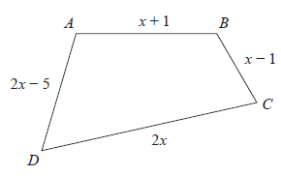
3x + 1
x – 2
2x – 1
All the measurements are in centimetres.
The perimeter of ABCD is 61 centimetres.
Work out the length of AB.

....................................................... centimetres
(Total for Question 16 is 4 marks)
___________________________________________________________________________

17 There are only orange counters, black counters, red counters and blue counters in a bag.

The table shows the number of orange counters in the bag.

Colour | orange | black | red | blue
Number of counters | 15

There is a total of 100 counters in the bag.

Clive takes at random a counter from the bag.

(a) Find the probability that the counter is not orange.

.......................................................
(2)
The ratio of the number of orange counters to the number of black counters is 3 : 7
(b) Work out the number of black counters in the bag.

.......................................................
(2)
Ronald says,

“The number of red counters in the bag is the same as the number of blue counters in the bag.”

(c) Can Ronald be correct?
Give a reason for your answer.

......................................................................................................................................................

......................................................................................................................................................

......................................................................................................................................................
(1)
(Total for Question 17 is 5 marks)
___________________________________________________________________________

18 There are 300 bags of sweets in a shop.
Each bag contains mints or jelly beans or wine gums.

the number of bags  of mints | : | the number of bags  of jelly beans | : | the number of bags  of wine gums | = | 5 : 4 : 3

of the bags of jelly beans and of the bags of wine gums are bought by customers and removed from the shop.
Work out the number of bags of mints as a percentage of the total number of bags of
sweets remaining in the shop.

.......................................................%
(Total for Question 18 is 5 marks)
___________________________________________________________________________

19 Write 490 as a product of powers of its prime factors.

.......................................................
(Total for Question 19 is 3 marks)
___________________________________________________________________________

20 (a) Work out 2 + 1
Give your answer as a mixed number.

.......................................................
(2)
(b) Show that 5 ÷ 6 =

(2)
(Total for Question 20 is 4 marks)
___________________________________________________________________________

21 Simplify (3⁴ × 3^{–7})²

Give your answer as a power of 3

.......................................................
(Total for Question 21 is 2 marks)
___________________________________________________________________________

22 Work out 0.006 × 0.28

.......................................................
(Total for Question 22 is 2 marks)
___________________________________________________________________________

23 A bakery is going to make four different cakes A, B, C and D.
90 people are asked which of the four cakes they would be most likely to buy.
The table shows information about the results.

Cake | Number of people
A | 19
B | 21
C | 27
D | 23

The bakery is planning to make 60 000 cakes next month.
Work out how many type C cakes the bakery should make next month.

.......................................................
(Total for Question 23 is 2 marks)
___________________________________________________________________________

24 Ian writes down three numbers a, b and c

a : b = 2 : 3
b : c = 9 : 4

(a) (i) Find a : b : c

.......................................................
(2)
(ii) Express b as a fraction of the total of the three numbers a, b and c

.......................................................
(2)
Cilla writes down three numbers p, q and r
q = 5p
r = 3q
(b) Find p : r

.......................................................
(2)
(Total for Question 24 is 6 marks)
___________________________________________________________________________
25
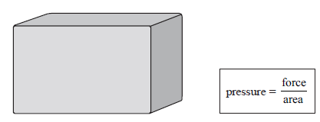

A sculpture exerts a force of 36 000 newtons on the ground.
The base of the sculpture in contact with the ground is a 6 m by 3 m rectangle.
Work out the pressure on the ground due to the sculpture.

....................................................... newtons / m²
(Total for Question 25 is 2 marks)
___________________________________________________________________________

26 (a) Solve + 4 > 18

.......................................................
(3)
(b) Factorise x² + 13x + 12

.......................................................
(2)
(Total for Question 26 is 5 marks)
___________________________________________________________________________
TOTAL FOR PAPER IS 80 MARKS

