







1.

How many apples are there?






2.

How many bananas are there?










3.

How many apples are there?







4.

How many lemons are there?

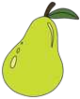


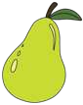
5.

How many pears are there?

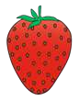
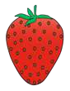

6.

How many strawberries are there?

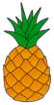









7.

How many pineapples are there?





1.

How many apples are there?







2.

How many bananas are there?


3.

How many apples are there?






4.

How many lemons are there?








5.

How many pears are there?



6.

How many strawberries are there?









7.

How many pineapples are there?







1.

How many apples are there?

2.

How many bananas are there?








3.

How many apples are there?





4.

How many lemons are there?



5.

How many pears are there?

6.

How many strawberries are there?




7.

How many pineapples are there?

