Ionic bonding = the gaining or losing of an electron, creates a lattice structure and is formed of oppositely charged ions. Has strong electrostatic forces, compounds usually formed from a metal and a non-metal.
Positive ion (cation)= any element that loses 1 or more electron to form a full outer shell
Negative ion (anion)= any element that gains 1 or more electrons to form a full outer shell
In solid ionic structure = no conductivity as electrons are fixed in position.
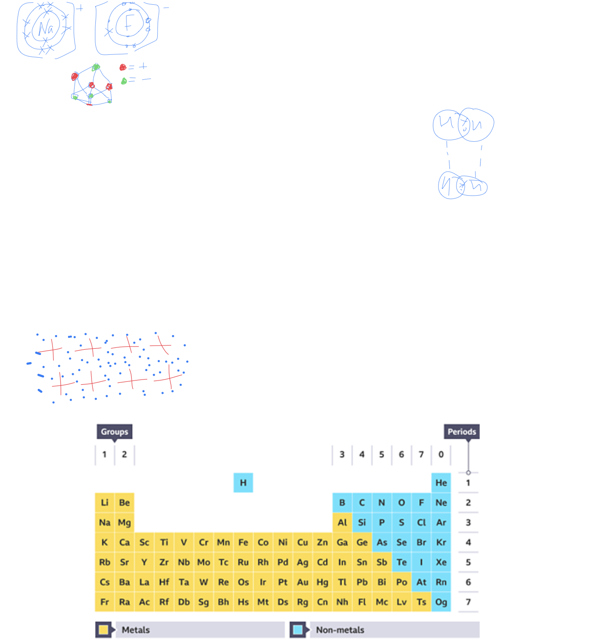
In molten or aqueous ionic solutions = conductivity as electrons are free to move.
Metallic bonding = occurs in metal elements and in alloys (a mix of metals).
The bonding in metal consists of a positive ion surrounded by delocalised electrons in a regular pattern.
Delocalised electrons can move freely throughout the structure
Delocalised electrons can carry a charge therefore metals can conduct electricity.

Covalent bonding = when 2 atoms of either the same element or a different element share a pair of electrons.
Within a molecule, the covalent bond is very strong but the intermolecular bond holding 2 different molecules together is weak.

Diamond= 1 carbon covalently bonded to 4 other carbon. Very strong, high ,eating point, cannot conduct electricity

Graphite = 1 Carbon covalently bonded to 3 other carbons. Has weak intermolecular forces between the layers (makes it soft and the layers can Slide Over each other). Can conduct electricity as each carbon has 1 free moving electrons

Graphene = 1 layer of graphite. So 1 carbon covalently bonded to 3 other carbons. Can conduct electricity. Doesn’t not have layers.

