Lime Silo Skip Misroute
scope and requirements

Description or Document Category
March 02, 2023

Revision History

Date | Document Version | Author | Revision
03-02-2023 | 1.0 | V. Uribe | Initial Draft

Contents
1 Overview 4
2 Customer Reference 4
3 Product Information 4
4 Requirements 5
4.1 Hardware Integration 5
4.2 Software Integration 5
5 Approval 6

Overview
Bald Mountain has requested an enhancement to the OP Pro fleet management system to supress misroutes when hauling trucks arrive at the Lime Silo. The customer has a traffic control system on site to direct trucks to the Lime Silo when necessary and doesn’t want truck arrivals at the Lime Silo to alert dispatcher to a misroute.
The misroutes are shown even when the truck travels along the best path on the way to its destination dump because it arrives at a Lime Silo (needed for processing materials). Truck arrivals at Lime Silo are being recorded to help with EPA (Environmental Protection Agency) reporting and as well as chemical engineering for material processing, so the trucks must ‘Arrive’ at the Lime Silo when directed to do so.
Advantages of this change will provide the customer a workflow for operators without requiring worker input which is often unreliable and requires training. Currently other sites rely on operator interactions with the haul cycle which are unreliable or in some cases malicious.

Customer Reference

Customer | Site | Reference
Kinross Gold | Bald Mountain

Product Information

Product | MineOperate OP Pro
Current Release | OP Pro v2.8-002
Target Release | TBC

Requirements

Software Integration
When the truck arrives at Silo (location type) the truck will not send a misroute to the Dispatcher. The truck will need to meet the requirements below to not send a misroute.
Truck requirements:
- Truck Activity is not found in misroute_ignore_activities
- Material Type is not found in misroute_ignore_materials
Configurations for misroute to ignore in csv format Activities, and Material Type.
Module | Value | Comment
enable_misroute_bypass | true/false | Boolean value will control if the truck should alert for all or only non-excluded location types.
misroute_ignore_location_type | 412,345,768 | Integer values that represent the location types to ignore for misroute logic. Allow multiple location types (csv format)
misroute_ignore_activities | 100,123,14 | Integer value will represent the id of activities to ignore for arrival at (e.g., Hauling, Inactive) in csv format.
misroute_ignore_materials | 1145,1412 | Integer value of the id of material types to ignore (e.g., Leach, Pag) in csv format.
For clarity the flow chart below can be used to help with the logic being requested.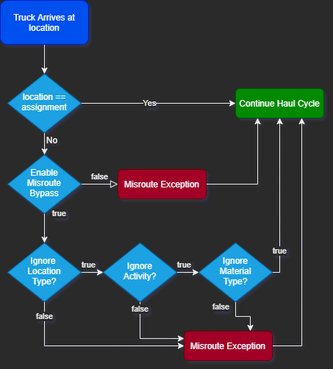

Approval

HxGN Product Manager
Name
Position
Signature
Date

HxGN Service & Support Manager
Name
Position
Signature
Date

Customer Representative
Name
Position
Company
Signature
Date

Note: Electronic approval via Docusign is accepted

