WHY GIT?

Git is one of the most popular solutions for companies for cooperating many developers during work. It is not the simplest way but one of the most full-control of management ways.

HOW TO USE IT?

Simplest way (NOBODY IS CHANGING CODE OF HIS COLLEAGUE, EVERYBODY WORKS ON DIFFERENT FILES)

1. Install git bash
2. Open git bash (it is like linux bash, same commands)
3. Cd to directory where you want to have project example : cd C://Sylwia//Desktop//io_work
4. Clone repository : git clone <https://github.com/io2mini/io2.git>
5. There you should get no errors
6. Check if everything is ok, open your directory manually where you wanted to have your project and chech if all files are copied
7. Open in visual studio project cloned (rememeber that all projects are in folder SoftEngineeringProjects
8. Develop
9. Open git bash (if you have closed it)
10. Cd to directory where you have your cloned repository : git cd C:\\Users\\plsylno\\Desktop\\SoftEngin
11. Make this command to ensure that everything is up to date or to get changes from your colleague: git pull
12. For no on there should be no conflicts (the simplest way) now write : git gui
13. The window with changes should be shown. Now on left there are changes that you’ve done. You should click on each row and select it, than click stage change button. Write commit message in the same window (there is special place for it) and click commit
14. Close window for commiting and in git bash “command line” write : git push (there should be message that there is counting objects and everything is fine)
15. Check on git hub if everything is ok.

TIPS :

Git is special program. Firstly we will assume that everybody is working on the same branch – master. In the future there will be division. REMEMBER code on branch master must BUILD. No fuckups!

There is special command : gitk –all it shows changes, branches example. Branch remotes/origin/master is branch always pulled from repository. But it’s not the most important thing for now on.

Pictures of commitig, changing etc. :

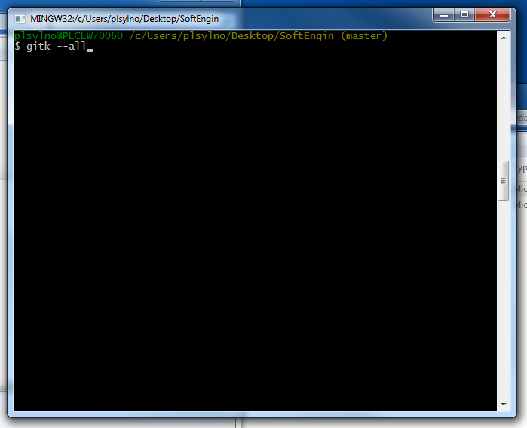

|  |  |
| --- | --- |
|  |  |

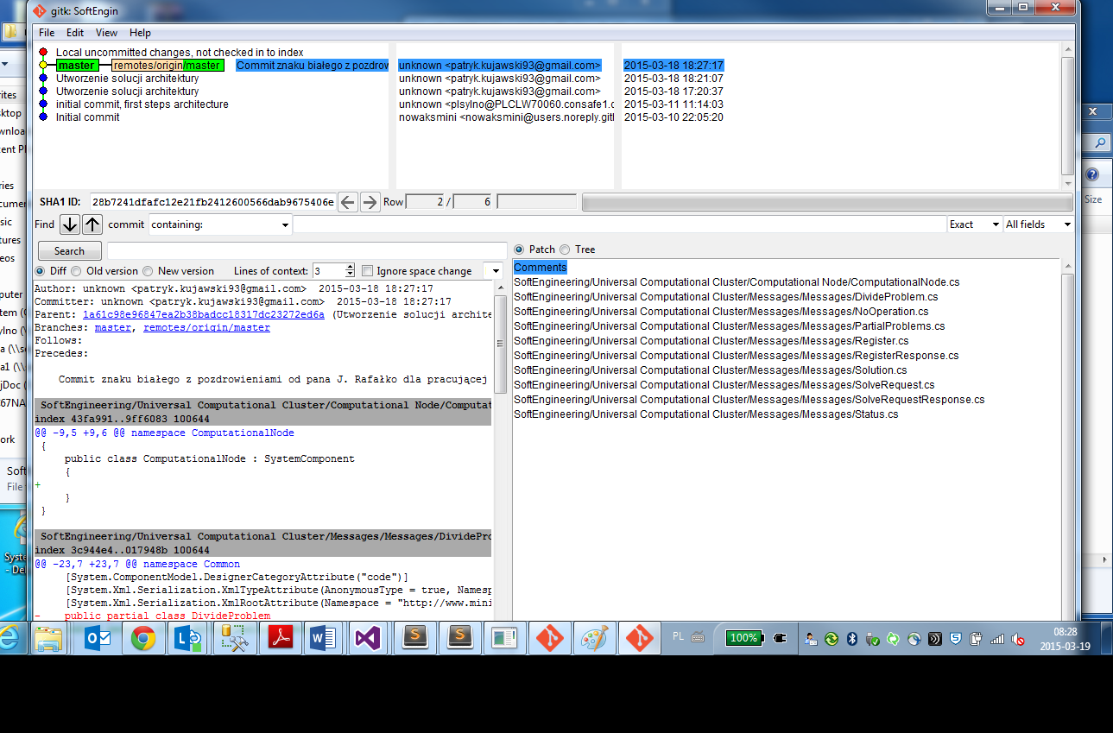

As you can see there are local changes not commited. I will make my commit now

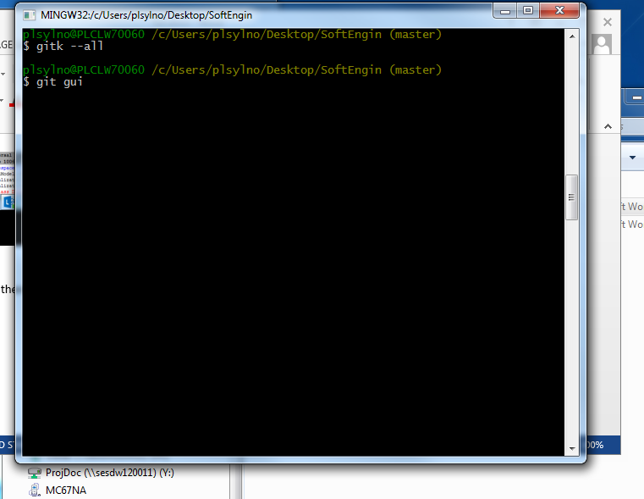

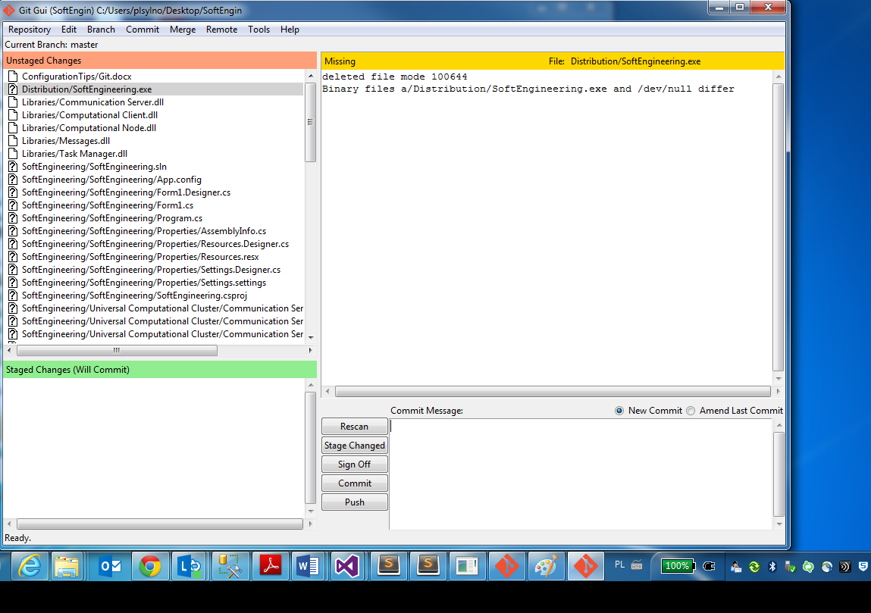

Now we click stage change to files we want to commit, I want to commit everything I’ve done :