SAR Ship Detection Project Documentation

Chahine, Yan, Nadezhda, Anna, Stevie July 24, 2025

**Abstract**

This document outlines the SAR Ship Detection Project, aiming to detect and track ships using Synthetic Aperture Radar (SAR) data from sources like Sentinel-1. The core functionality involves machine learning models for land-sea segmentation and image correction, together with deep learning models for ship detection and tracking. The system offers three user interfaces: a Jetson AGX Orin for on-orbit inference and data downlink, a web-based interface for on-demand analysis of SAR data selected via a mAP, and an image upload feature for user-provided raw SAR imagery. Key objectives include developing lightweight, high-accuracy models for real-time ship identification, tracking, and potential applications such as monitoring illegal activities, aiding in search and rescue operations, and general maritime surveillance.

Associated Code Repository: https://github.com/ioEclipse/SAR-SHIP-DETECTION

**Contents**

1. Introduction 4
   1. Project Overview 4
   2. Problem Statement 4
   3. Project Goals and Objectives 5
   4. Document Structure 6
2. Project Context and Justification 7
   1. Motivation 7
   2. Literature Review and Background 7
3. Requirements Specification 11
   1. Functional Requirements 11
   2. Non-Functional Requirements 12
4. System Design 15
   1. High-Level System Architecture 15
   2. Detailed Component Design 15
      1. Data Acquisition and Management 15
      2. Preprocessing Subsystem 16
      3. Machine Learning Detection Model 20
   3. Tracking Algorithm 21
      1. Output and Visualization 21
   4. Data Flow and Workflow 22
5. Implementation and Development 25
   1. Software and Hardware Environment Setup 25
      1. Training Setup, Hardware + Software 25
      2. Implementation Hardware/Edge 25
      3. Operating System and Core Software Versions 25
      4. Dependency Management and Virtual Environment Setup 26
      5. Accessing the Jetson Nano 26
      6. Essential Command Line Commands 26
      7. RAW Data prediction algorithm ( Inference Slicer Method) 26
      8. Google Earth Engine Prediction API 26
   2. Installation and Setup Guide 27
   3. Configuation 28
6. Model Training and Optimization 29
   1. Dataset Preparation Review 29
   2. Training Process 29
   3. Optimization techniques for Jetson Nano 30
   4. Model Deployment Pipeline 31
7. Evaluation and Testing 32
   1. Test Plan And Methodology 32
   2. Performance Metrics 33
      1. Detection Accuracy Metrics 33
      2. Inference Efficiency Metrics 33
   3. Experimental Setup 33
8. Future Work and Enhancements 35
9. Conclusion 36

A Pre-processing 41

* 1. Linear Scaling 41
  2. Gamma Correction 41
  3. Land masking 41
     1. Lee Filter 41
     2. Multi-Stage Denoising 42
     3. Combined Thresholding 42
     4. Morphological Processing 44
     5. Flood Filling 44
     6. Contour Filtering 45
     7. Iterative Refinement & Final Output 45

# Introduction

## Project Overview

The **SAR Ship Detection Project** is an intensive, one-month initiative aimed at developing a comprehensive and operational system for the detection and persistent tracking of maritime vessels from **Synthetic Aperture Radar (SAR)** imagery. While built primarily around data from the **Sentinel-1** satellite constellation, the system is designed with the flexibility to integrate other SAR data sources.

**Core Workflow**

The system ingests **raw SAR imagery** and applies a structured sequence of preprocessing steps, including:

* **Land–sea separation algorithms** for accurate coastline delineation.
* **Speckle noise reduction methods** to counter the granular interference common in SAR images.
* **Feature enhancement techniques** to maximize object visibility.

The preprocessed data is then fed into a **machine learning-based detection pipeline**, currently using **YOLOv11m**, optimized for robust recognition of ships of varying sizes, shapes, and orientations.

**System Accessibility**

To ensure adaptability to diverse operational contexts, the project delivers three complementary access modes:

1. **Edge Deployment** – A compact, high-performance version optimized for devices such as the NVIDIA Jetson AGX Orin, enabling real-time detection in remote or space-based settings.
2. **Web Application** – An interactive platform allowing users to define areas of interest directly on a map for near real-time SAR-based monitoring.
3. **Direct Processing Mode** – A feature allowing users to upload raw SAR images for immediate analysis.

These modalities make the system applicable to a broad range of use cases, including **maritime surveillance, environmental monitoring, illegal fishing prevention, border patrol, and search and rescue operations**.

Conventional ship detection methods, often dependent on optical imagery and human observation, are constrained by daylight availability and weather conditions. **SAR technology overcomes these limitations**—providing **all-weather, day-and-night coverage**, making it ideal for persistent ocean monitoring.

However, working with SAR data presents key challenges:

* **Speckle Noise** – Obscures small or distant targets.
* **Variable Target Signatures** – Ships differ in size, structure, and orientation, creating inconsistent radar responses.
* **Cluttered Environments** – Coastal zones and busy routes generate background interference from landmasses, ports, and offshore structures.
* **High Data Volumes** – Continuous high-resolution SAR monitoring demands efficient, automated processing at scale.
* **Need for Automation** – The vastness of global maritime areas requires AI-driven solutions for anomaly detection and monitoring.

A vital extension of the project is the **integration of Automatic Identification System (AIS) data**. AIS provides vessel positions, identification, and route information, forming a trusted reference for legitimate maritime traffic. By cross-referencing SAR-detected objects with AIS data, the system can:

* Validate detections against known vessel locations.
* Track and analyze ship trajectories.
* Identify anomalies such as inconsistencies or unexpected route deviations.

A particular focus is detecting **dark vessels**—ships that deliberately **switch off AIS transponders** or transmit **false identities** to evade monitoring. Such activities are frequently linked to **illegal fishing, smuggling, trafficking, and unauthorized entry into restricted waters**.

The project tackles this through **SAR–AIS Fusion**:

1. **SAR Imagery Analysis** – Detects all vessels in the imaged area, regardless of AIS status.
2. **AIS Cross-Matching** – Compares each SAR detection with real-time and historical AIS logs.
3. **Anomaly Flagging** – Any ship visible in SAR imagery with no AIS match (within proximity and time tolerance) is flagged as a **potential dark vessel**.

This methodology ensures the identification of **non-cooperative or suspicious vessels**, enhancing maritime domain awareness and enabling timely operational intervention.

By combining high-resolution SAR data with AI-powered detection and intelligent AIS integration, the SAR Ship Detection Project offers a **scalable, versatile, and resilient** maritime monitoring solution. Its ability to detect both compliant and non-compliant vessel, including elusive **dark ships,** represents a significant advancement in **global maritime security, environmental protection, and safety at sea**.

## Problem Statement

Irregular migration and illegal, unreported, and unregulated (IUU) fishing create acute operational demands for maritime domain awareness across the Mediterranean and West African waters, where the central Mediterranean remains the deadliest maritime migration route with at least 3,105 lives lost in 2023 alone. West African fisheries face persistent pressure from industrial fleets and IUU activity, undermining food security and livelihoods in countries such as Senegal, where overexploitation and weak

monitoring exacerbate stock depletion and conflict with artisanal fleets. These dynamics increase the need for persistent, wide-area, all-weather sensing and timely interdiction support.

Synthetic aperture radar (SAR) data, with its all-weather and day-night imaging capabilities, offers a critical resource for ship detection and tracking; however, its effective utilization hinges on advanced artificial intelligence (AI) integrated with edge computing, particularly on CubeSats, to enable real-time analysis, reduce data transmission burdens, and deliver precise insights.

This work targets a technical gap: accurate, timely detection and tracking of “dark vessels” (ships that disable or manipulate AIS) by fusing spaceborne SAR detections with AIS data and complementary RF/OSINT where available, optimized for edge execution on resource-constrained platforms (e.g., CubeSats) to enable near-real-time surveillance with reduced downlink requirements.

Concretely, the problem is to design, implement, and validate an end-to-end pipeline that:

* Detects vessels in SAR imagery with low false-alarm rates across diverse sea states and backgrounds.
* Associates SAR detections with AIS tracks to flag non-matches and suspicious behaviors indicative of dark activity, including loitering and ship-to-ship (STS) transfers
* Runs efficiently at the edge to prioritize downlink of intelligence rather than raw imagery, enabling faster operational response.

**Why Current Solutions Fall Short** Current SAR–AIS fusion and dark vessel detection approaches face four main limitations:

1. **SAR Detection Accuracy**: Existing CFAR-based or pretrained deep learning models remain vulnerable to sea clutter, incidence angle variation, speckle noise, and coastal proximity, leading to geolocation offsets and elevated false-alarm rates.
2. **AIS Association Reliability**: Many pipelines lack robust, uncertainty-aware spatiotemporal matching, resulting in missed or false “dark” classifications when AIS data contain gaps, spoofing, or duplicates.
3. **Behavioral Event Detection**: Dark activities such as loitering or ship-to-ship transfers require multi-step fusion of AIS trajectories and satellite detections, but current methods suffer from fragile spatiotemporal modeling and limited large-scale validation.
4. **Operational Readiness at the Edge**: Few solutions are optimized for CubeSats’ constrained compute, memory, and power budgets, forcing downlink of full SAR scenes instead of prioritized detections, which delays actionable intelligence.

These shortcomings lead to slower operational response, higher false positives near coasts, inconsistent dark vessel identification in dense traffic, and limited viability for real-world deployment.

## Project Goals and Objectives

This project is dedicated to the design, implementation, and deployment of a practical ship-detection system based on Synthetic Aperture Radar (SAR). By combining state-of-the-art machine learning techniques with real-world data and edge-computing platforms, our project delivers a comprehensive end-to-end solution tailored for maritime surveillance.

To ensure both technical rigor and operational relevance, we have defined the following high-level goals and SMART objectives:

* **Robust Training Dataset**: Curate and annotate a diverse collection of SAR coverages, including open-sea, coastal, and congested port scenarios, to achieve at least 10,000 labeled vessel instances by Month 6.
* **Lightweight Inference Models**: Develop and train convolutional neural networks optimized for low-power inference, targeting an average per-image inference time under 50 · *ms* on desktop GPUs by Month 8.
* **Edge Platform Optimization**: Identify the optimal neural-network architecture for deployment on the NVIDIA Jetson Nano; implement 8-bit quantization and TensorRT acceleration to sustain real-time processing at ≥ 5 · *frames* per second by Month 10.
* **Reliable Object Detection & Tracking**:Integrate detection and multi-object tracking modules to maintain persistent vessel identities across at least 95% of sequential SAR passes in test scenarios by Month 12.
* **AIS Data Fusion**: Correlate SAR detections with AIS broadcasts to confirm ≥ 90% of vessel matches, resolve at least 80% of ambiguous detections, and flag dark-vessel anomalies for operator review by Month 11.
* **User-Actionable Outputs**:Generate georeferenced alerts, summary reports, and annotated imagery formatted for rapid ingestion by maritime operators, with average report generation times under 10 · *seconds* by Month 12.
* **Multi-Modal User Interfaces**:Deliver three distinct access modalities: a GPU-powered web demonstration, an interactive world-map dashboard, and a local raw-image upload portal to support diverse end-user workflows, all operational by thesis defense.

**How These Objectives Solve the Problem**

* Better SAR robustness and geolocation improve detection fidelity in precisely the conditions that current systems fail, enabling dependable situational awareness in rough seas and near coasts where migration and IUU risks concentrate.
* Uncertainty-aware AIS matching and data hygiene reduce false “dark” flags and missed matches, making dark-vessel identification trustworthy enough for tasking scarce assets.
* Behavioral analytics turn detections into operational leads (loitering, STS), aligning outputs with interdiction workflows rather than raw imagery review.
* Edge optimization and intelligence-first downlink directly address bandwidth and latency constraints typical of CubeSat-class platforms, enabling timely action rather than post hoc analysis.
* Validation in the Central Mediterranean and West Africa ensures measurable impact where humanitarian and governance stakes are highest, with metrics tied to known threat patterns and operational needs.

## Document Structure [TODO]

To ensure comprehensive understanding, this documentation is organized into a logical flow mirroring the project’s development lifecycle.

It commences with an **Executive Summary** and **Introduction** for a concise project overview. The **Project Context and Justification** grounds the effort in its broader significance, while **Requirements Specification** meticulously lists all functional and non-functional demands.

The core technical details are captured in **System Design**, explaining both the high-level architecture and individual component designs. **Implementation and Development** provides the essential "how-to" for reproducing the project’s environment and code.

The specifics of machine learning are detailed in **Model Training and Optimization**, leading to the empirical **Evaluation and Testing** of the system’s performance.

A practical **Usage Guide** assists in system operation, and forward-looking sections on **System Optimization, Known Issues and Troubleshooting**, and **Future Work** and **Enhancements** discuss continuous improvement, culminating in the **Conclusion**.

# Project Context and Justification

This section provides background information and the rationale behind the project.

## Motivation

The SAR Ship Detection Project is motivated by the critical need for enhanced maritime domain awareness and the unparalleled advantages of Synthetic Aperture Radar (SAR) in addressing the limitations of conventional surveillance methods. Oceans serve as the backbone of global trade, security, and ecological balance, necessitating reliable and real-time monitoring of maritime activities. SAR technology, with its all-weather, day-and-night imaging capability, provides a unique solution to this challenge, overcoming the constraints of optical sensors that are hindered by cloud cover, darkness, or adverse weather conditions. The significance of automated SAR-based ship detection spans multiple domains, each with substantial real-world implications:

* Maritime Safety & Security
  + Enables search and rescue (SAR) operations by rapidly locating distressed vessels.
  + Detects illegal activities, including piracy, smuggling, and unauthorized fishing, ensuring compliance with maritime laws.
  + Enhances border security by monitoring territorial waters and identifying suspicious vessel movements.
* Defense & National Security
  + Supports naval surveillance by tracking warships, submarines, and other strategic assets.
  + Provides intelligence-gathering capabilities in contested or remote maritime regions.
  + Improves situational awareness in critical waterways (e.g., straits, exclusive economic zones).
* Economic & Commercial Applications
  + Optimizes shipping logistics by analyzing vessel traffic patterns and route efficiency.
  + Aids port management and maritime insurance through real-time vessel tracking.
  + Facilitates trade monitoring by verifying cargo movements and detecting anomalies.
* Environmental & Resource Protection
  + Prevents illegal, unreported, and unregulated (IUU) fishing in protected marine zones.
  + Monitors offshore infrastructure (e.g., oil rigs, wind farms) for security and maintenance.
  + Supports disaster response by assessing ship movements during oil spills or other marine incidents.

Despite these compelling applications, existing ship detection systems often struggle with speckle noise, cluttered environments, and scalability issues, particularly when processing large volumes of SAR data. This project addresses these gaps by developing a robust, automated, and scalable detection framework that leverages deep learning (YOLOv11) to deliver actionable maritime intelligence. By harnessing SAR’s unique capabilities, this work aims to bridge the divide between data availability and operational decision-making, ultimately contributing to safer, more secure, and sustainably managed oceans.

## Literature Review and Background

Synthetic Aperture Radar (SAR) ship detection is a cornerstone of maritime surveillance, leveraging its all-weather, day-and-night imaging capabilities to monitor vessels across diverse conditions. Traditional methods, such as Constant False Alarm Rate (CFAR) detectors, have been foundational but often suffer from high false alarm rates in complex backgrounds and struggle to detect small or closely spaced ships. These limitations have driven the adoption of deep learning techniques, which offer superior feature extraction and pattern recognition. Since 2017, significant advancements have been made through innovative algorithms and specialized datasets, addressing challenges like multiscale imbalances, variable

ship sizes, and complex environments.

In 2017, [1] introduced an improved Faster R-CNN model tailored for SAR ship detection, utilizing the SAR Ship Detection Dataset (SSDD) with 1,160 images (500×500 pixels, 1–15 m resolution) from Sentinel-1, RadarSat-2, and TerraSAR-X. By incorporating feature fusion, transfer learning, and hard negative mining, their approach achieved higher accuracy and lower computational cost than traditional methods, setting a precedent for deep learning in this domain. Concurrently, [2] developed OpenSARShip 2.0, a dataset with 34,528 Sentinel-1 ship chips (30×30 to 120×120 pixels, 2 m resolution), integrated with AIS information and enhanced with interference labeling and type classification, enabling deeper ship target interpretation.

In 2018, [3] introduced the OpenSARShip dataset, comprising 11,346 Sentinel-1 ship chips (30×30 to 120×120 pixels, 2.2 m resolution), designed as a benchmark for ship interpretation algorithms due to its large scale, diversity, and reliability. Building on this, [4] constructed a SAR dataset with 39,729 ship chips (256×256 pixels, 3–25 m resolution) from 102 Gaofen-3 and 108 Sentinel-1 images, supporting robust object detection in complex backgrounds without land-ocean segmentation.

Similarly, [5] released AIR-SARShip-1.0, with 31 Gaofen-3 images (500×500 pixels, 1–3 m resolution), achieving an average precision of 88.1% using density-connected neural networks, addressing data scarcity in high-resolution SAR imagery.

In 2020, [6]. presented LS-SSDD-v1.0, a dataset of 9,000 Sentinel-1 sub-images (800×800 pixels) focused on small ship detection, introducing a Pure Background Hybrid Training mechanism to suppress false alarms, validated through ablation studies.

In 2021, [7] released SRSDD-v1.0, containing 666 Gaofen-3 images (1024×1024 pixels, 1 m resolution) with 2,844 ships across six categories, tackling rotated frame detection in nearshore environments. Also in 2021, [8] introduced the Dual-Polarimetric SAR Ship Detection Dataset (DSSDD), with 1,236 Sentinel-1 image slices (256×256 pixels, 3,540 ships), proposing a Memory-Augmented Autoencoder that achieved a mean average precision (mAP) of 0.94 by leveraging VV polarization and VH polarization data to reduce false alarms.

Advancing to 2024, [9] proposed YOLO-RC for range-compressed domain detection, achieving an F-score of 88.84% and average precision of 84.09% on a self-built dataset, enhancing real-time capabilities by exploiting amplitude gradients and geometric loss.

Finally, [10] developed an enhanced YOLO network with Shuffle Re-parameterization, Space-to-Depth, and Hybrid Attention modules, achieving AP50 scores of 77.2%, 91%, and 95% on LS-SSDD, HRSID, and Vision-MRSSD datasets, respectively, significantly improving small ship detection.

Despite these advancements, critical gaps remain, including the limited inclusion of VV polarization and VH polarization polarization data in datasets like SSDD and OpenSARShip, which hinders differentiation of ships from background clutter. Additionally, the restricted resolution range in many datasets limits model generalization across operational conditions, and challenges persist in detecting small ships in complex nearshore environments.

Future research should prioritize diverse datasets with multi-polarization data, broader resolution ranges, and advanced feature extraction techniques to enhance detection accuracy and robustness, paving the way for more reliable SAR ship detection systems.

These details are organized in Table 1 to provide a clearer comparison.

**Dark Vessel Detection and Maritime Surveillance Challenges** The emergence of "dark vessels"—vessels that deliberately disable their Automatic Identification System (AIS) transponders or engage in spoofing to evade detection—has introduced critical challenges to maritime surveillance systems. These non-cooperative vessels pose significant threats to global maritime security, environmental protection, and fisheries management, requiring advanced detection methodologies beyond traditional AIS-dependent approaches.

|  |  |  |  |  |
| --- | --- | --- | --- | --- |
| **Author & Year** | **Method** | **No. of Images & Shapes** | **Sensors** | **Resolution** |
| Li et al. (2017) [1] | Improved Faster R- | 1,160 (500 × 500) | Sentinel-1 | 1–15 m |
| Huang et al. (2018) [3] | CNN  YOLOv8 | 11,346 (30 × 30 to 120 × 120) | Sentinel-1, Gaofen- | 2–22 m |
| Wang et al. (2019) [4] | Modified SSD | 43,819 (256 × 256) | 3  Gaofen-3, Sentinel- | 3–25 m |
| Sun et al. (2019) [5] | Dense connected | 1,116 (500 × 500) | 1  Gaofen-3 | 1–3 m |
| Wei et al. (2020) [11] | network (DCENN)  CNN-based | 5,604 (800 × 800) |  | 0.5–3 m |
| Zhang et al. (2020) [6]  Lei et al. (2021) [7]  Hu et al. (2021) [8]  Tan et al. (2024) [9] | detection/segmentation  Pure Background 9,000 (800 × 800)  Hybrid Training (PHBT)  Rotated detectors, 666 (1024 × 1024) CTA-based  R3Det and 1,236 (256 × 256)  YOLOv4 with MemAE  YOLO-RC HRSID and SSDD | | Sentinel-1  Gaofen-3 Sentinel-1  Sentinel-1, | 10 m  1 m  10 m  0.5–15 m |
| Tang et al. (2024) [12] | DBW-YOLO 5,604 (HRSID), 1,160 (SSDD) | | TerraSAR-X, TanDEM-X  Sentinel-1, | 0.5–15 m |
| Sun et al. (2025) [10]  Guan et al. (2025) [13] | (YOLOv7-tiny)  MSDFF-Net R-SSDD, R-HRSID  Enhanced YOLO HRSID and iVision-MRSSD-MRSSD | | TerraSAR-X, TanDEM-X  Sentinel-1, TerraSAR-X, TanDEM-X  Sentinel-1, | 0.5–15 m  0.5–15 m |
|  | (SR module) | | TerraSAR-X, TanDEM-X |  |

Table 1: Summary of Public Datasets and Deep Learning Methods for SAR Ship Detection

Dark vessel detection has gained substantial momentum since 2018, when [14] ICEYE and Spire Global announced collaborative SAR-based technologies to enable global monitoring of dark vessels engaged in illegal activities at sea. This partnership addressed the estimated $23 billion annual economic impact of illegal fishing activities, demonstrating the urgent need for comprehensive surveillance solutions. The approach combined SAR imagery with radio frequency (RF) analysis to identify vessels operating without proper AIS transmissions.

In 2019,[15] highlighted that SAR’s primary advantage lies in detecting vessels not transmitting AIS signals, particularly in monitoring illegal fishing operations where crews commonly disable or manipulate AIS data to provide false coordinates. This capability became increasingly vital as maritime authorities recognized that illegal fishing vessels frequently employed AIS manipulation tactics to evade enforcement efforts.

The 2021 xView3 Challenge, organized by the Defense Innovation Unit (DIU) and Global Fishing Watch, marked a pivotal development in dark vessel detection research. This international competition attracted 2,000+ participants from 67 countries, focusing on developing machine learning algorithms to detect and characterize dark vessels in SAR imagery. The challenge utilized the xView3-SAR dataset containing 243,018 labels across 991 images, representing one of the largest open-source maritime SAR datasets for vessel detection research.

The top-performing xView3 solutions achieved aggregate F1 scores ranging from 0.5717 to 0.6177, with the first-place "BloodAxe" model attaining 0.7702 for detection (F1D) and 0.9392 for vessel classification (F1V). However, shore-proximity detection remained challenging, with F1S scores between 0.4205 and 0.5310 across top performers. These results highlighted significant performance gaps in complex nearshore environments where dark vessels frequently operate.

In 2022, [16] Starboard Maritime Intelligence’s analysis of Tuvalu’s 750,000 km² Exclusive Economic Zone revealed substantial detection discrepancies between SAR and RF technologies. Their study found that RF sensors produced significantly more dark detections than SAR, with many potential false positives attributed to non-AIS transmitting sources including military vessels, yachts, and aircraft radar

systems. This highlighted the critical need for multi-sensor validation approaches in dark vessel detection.

Recent developments in 2024 have focused on multi-temporal detection approaches [17]. Perivallon implemented multi-temporal dark vessel detection using Sentinel-1 and AIS data correlation, demonstrating improved tracking capabilities for non-cooperative vessels through temporal analysis patterns. Similarly, [18] introduced automated detection of dark ship-to-ship transfers using deep learning and PlanetScope satellite imagery, identifying over 400 illicit transshipment events in the Kerch Strait since 2022.

Advanced fusion approaches have emerged to address detection limitations. [19] MDA Space’s Dark Vessel Detection platform integrates SAR data with space-based optical, RF, and radar data through machine learning algorithms. This multi-sensor approach has been deployed globally, including supporting Ecuador’s efforts to monitor illegal fishing around the Galapagos Islands and throughout the Indo-Pacific region.

A summary of the issues of these approaches is organized in Table 2.

**Author & Year Reported Performance &**

**Key Capabilities**

**Quantified Issues / Gaps Metrics to Improve**

Li et al. (2017) [1] Higher accuracy and lower cost

than CFAR; feature fusion, transfer learning, hard negative mining

Missed small/closely spaced ships; single-pol (VV only)

AP for small ships; false alarm rate; polarization fusion

Huang et al. (2018) [3]

Wang et al. (2018) [4]

Zhang et al. (2020) [6]

AIS integration; interference labels; ship type classification

Works without land–ocean segmentation

Improved small ship detection via pure background hybrid training

No multi-pol; limited coastal complexity

Missed small ships in high clutter

AP for small ships not reported; high nearshore FPs

Polarization use; nearshore detection F1

Recall for small vessels in clutter

F1 for small ships; shore clutter rejection

Lei et al. (2021) [7] Supports rotated frame

detection; oriented bounding boxes

Low nearshore recall Nearshore F1; rotation handling

Hu et al. (2021) [8] mAP = 0.94; uses VV & VH

polarization

Tan et al. (2024) [9] F-score = 88.84%; AP =

84.09%; real-time capability

Limited size diversity; few coastal samples

Underperforms in cluttered scenes

Multi-scale AP; coastal robustness

Real-time F1 in complex backgrounds

Guan et al. (2025) [13]

ICEYE + Spire (2018)

AP50: 77.2%, 91%, 95% (LS-SSDD, HRSID, Vision-

MRSSD); small ship modules

RF + SAR fusion for AIS-off vessels

No polarization fusion; dataset- specific tuning

Validation gaps; no open benchmark

Cross-dataset generalization; multi-pol AP

Publicly benchmarked F1 for dark vessels

Mongabay (2019) Operational SAR monitoring of

illegal fishing

No quantitative metrics; misses small AIS-off vessels

Quantified recall for AIS-off small targets

xView3 Challenge (2021)

Starboard Maritime Intelligence (2022)

Perivallon & MDA Space (2024)

F1D: 0.7702; F1V: 0.9392;

nearshore F1S: 0.4205–0.5310 RF detections *>* SAR detections in Tuvalu EEZ

Multi-temporal SAR + optical

+ RF + AIS fusion

*≈*30% drop in nearshore detection

High RF false positives; SAR undercount

Limited small-ship validation; high processing complexity

Shore-proximity F1; small- vessel detection

FP reduction; SAR+RF fusion accuracy

Multi-temporal small-ship recall; fusion efficiency

Table 2: Summary of Current SAR Ship and Dark Vessel Detection Approaches, Quantified Gaps, and Target Metrics for Improvement

# Requirements Specification

This section formally defines the **functional** and **non-functional** requirements for the SAR Ship Detection System, structured for traceability and verification.

## Functional Requirements

Table 3: Functional Requirements for Ship Detection AI System

**Requirement ID Title Description**

**REQ-SYS-OUT-001** Output Details The system shall output ship bounding

boxes, class labels, and unique tracking IDs.

**REQ-USER-INPUT-002** User Selection Users shall be able to select coordinates

(longitude and latitude), date, and size of scanned area on the provided map (Google Earth map) where the user wants the AI to detect ships.

**REQ-USER-INPUT-003** Input SAR The system shall allow the user to input

their own SAR imagery, and the AI will look for ships in it.

**REQ-SYS-DOWNLOAD- 004**

**REQ-SYS-DOWNLOAD- 005**

**REQ-SYS-DOWNLOAD- 006**

Download Full Image The system shall allow the user to download

the whole image with the detected ships in bounding boxes as a .jpg format.

Download Single Ship The system shall allow the user to download

each ship visible on the provided image as a separate .jpg format image by inputting the ID of the desired ship.

Download JSON Data The system shall allow the user to download

a JSON file with the bounding box coordinates, width, class label, and unique ID of each ship.

**REQ-SYS-PROC-007** Ignore Land The system shall not take land into account

while processing, but land should still be visible in the output image.

**REQ-SYS-PROC-008** Image Preprocessing The system shall remove speckles and

enhance the image during preprocessing, but these effects should not apply to the final image.

**REQ-SYS-PROC-009** Polarization Choice The system shall choose another

|  |  |  |
| --- | --- | --- |
|  | | polarization band if the VV polarization polarization is not an option. |
| **REQ-SYS-DET-010** | Ship Detection | The system shall detect only ships in SAR imagery. |
| **REQ-SYS-DET-011** | Respond & Display | The system shall respond to user requests to detect ships at a desired location and provide an image showing ships in bounding boxes with class labels and unique tracking IDs. |
| **REQ-SYS-DET-012** | Avoid Confusion | The system shall not get confused by non- ship objects. |

**Requirement ID Title Description**

**REQ-SYS-DET-013** Any Polarization If the given image is not in the VV

polarization polarization band, the system shall still detect ships.

**REQ-SYS-REPORT-014** No Ships Report The system shall not display or upload any

image if no ships are found, and shall output a system report.

**REQ-SYS-REPORT-015** Format Error The system shall report an error for an

incompatible format upload.

**REQ-SYS-REPORT-016** Bad Connection If a user takes too much time to send or

receive data, the process will stop and an error will be returned.

**REQ-SYS-REQUEST- 017**

User Queue Upon request, the user shall be sent to a queue and will wait for the server to begin processing.

**REQ-DARK-AIS-001** AIS Data Integration The system shall integrate AIS data

to cross-verify detected ships with AIS broadcasts to identify vessels that turn off or manipulate AIS signals (i.e., dark vessels).

**REQ-DARK-DET-002** Dark Vessel Detection The system shall detect vessels not

broadcasting AIS signals by leveraging SAR imagery features indicative of dark vessels and flag suspicious detections.

**REQ-DARK-LOC-003** Location Matching The system shall spatially correlate SAR

detections with AIS pings within a 1 km radius to identify discrepancies indicating potential dark vessel activity.

**REQ-DARK-ANAL-004** Suspicious Activity

Analysis

**REQ-DARK-INPUT-005** External Dataset

Support

The system shall provide analytics and reports on potential dark vessel behaviors, such as patterns of AIS disabling and ship-to-ship transfers detected from multi- temporal SAR images.

The system shall support importing historical and real-time AIS datasets to enhance dark vessel detection accuracy and verification.

**REQ-DARK-REPORT- 006**

Dark Vessel Alerts The system shall generate alerts when dark

vessel activity is detected, including time, location, and confidence scores based on integrated SAR and AIS data analysis.

**REQ-DARK-VALID-007** False Alarm Mitigation The system shall minimize false alarms

in dark vessel detection by incorporating multi-source validation and context-aware filtering of non-vessel artifacts.

## Non-Functional Requirements

Table 4: Non-Functional Requirements for Ship Detection AI System

**Requirement ID Title Description**

**REQ-NFP-ACC-001** AI Accuracy The detection model shall achieve a Mean

Average Precision (mAP) of at least 85% on the dataset.

**REQ-NFP-ENV-002** Environment

Constraints

**REQ-NFR-REL-003** Error Handling and

Reporting

The system shall operate within the specified power constraints of Jetson Nano.

The system shall gracefully handle unexpected inputs (e.g., corrupted SAR files, invalid coordinates) and provide informative error messages or system reports, including for scenarios where no ships are found.

**REQ-NFR-REL-004** Data Integrity The system shall ensure the integrity of

processed SAR imagery and generated output files (e.g., bounding box JSON, detected ship images) against corruption during storage and download.

**REQ-NFR-USABILITY- 005**

**REQ-NFR-USABILITY- 006**

Intuitive User Interface The web application user interface shall be

intuitive and easy to navigate for users with basic computer proficiency, enabling them to select areas of interest and download resuLTS with minimal training.

Feedback Mechanism The system shall provide clear visual

feedback to the user during long-running operations (e.g., "processing in progress," "downloading image").

**REQ-NFR-MAINT-007** Code Modularity The system’s codebase shall be modular

and well-documented to facilitate future enhancements, bug fixes, and integration of new algorithms or data sources.

**REQ-NFR-MAINT-008** Logging and

Monitoring

**REQ-NFR-MAINT-009** Configuration

Management

The system shall implement comprehensive logging of critical operations and errors to facilitate troubleshooting, performance monitoring, and auditing.

System parameters and model configurations shall be externalized and easily manageable without requiring code changes or redeployment.

**REQ-NFR-COMPAT- 010**

Browser Compatibility The web-based user interface shall be

compatible with the latest versions of major web browsers (e.g., Chrome, Firefox, Edge, Safari).

**REQ-NFR-COMPAT- 011**

SAR Data Format Support

The system shall support common SAR data formats (e.g., Sentinel-1 GRD, SLC) for user-provided imagery and integrate seamlessly with data from sources like the Copernicus Browser.

**Requirement ID Title Description**

**REQ-NFP-PERF-012** Algorithm Inference

Time

**REQ-NFR-PERF-013** Scalability for

Concurrent Users

**REQ-NFR-PERF-014** Data Ingestion

Throughput

The system algorithm shall achieve an inference time of less than 40 milliseconds per image.

The web-based interface shall handle a maximum of 5 concurrent users performing SAR analysis without significant degradation in response time.

The system shall be capable of ingesting SAR data from Sentinel-1 at a rate of at least 10–1 GB/hour to keep up with incoming data volumes.

**REQ-NFR-PERF-015** User Waiting Time User queue takes less than 30 seconds per

person waiting in line in front of the set user requesting for a scan of set area/provided image.

**REQ-DARK-PERF-001** Detection Robustness The system shall maintain high detection

accuracy for dark vessels under various environmental and operational conditions, including different sea states and lighting conditions.

**REQ-DARK-PERF-002** Integration Latency The system shall process and integrate SAR

and AIS data with minimal delay to enable near-real-time dark vessel detection and tracking.

**REQ-DARK-DATA-003** Historical Data

Utilization

**REQ-DARK-SEC-004** Data Privacy and

Security

**REQ-DARK-EXT-005** Multi-Source Data

Support

The system shall efficiently manage and utilize large volumes of historical AIS data for training and validation of dark vessel detection algorithms.

The system shall ensure secure handling and storage of AIS and SAR data, complying with applicable data protection regulations and policies.

The system shall be extensible to incorporate additional datasets (e.g., RF signals, optical imagery) in future versions to enhance dark vessel detection capabilities.

**REQ-DARK-UI-006** Visualizations The system interface shall visually

distinguish between AIS-confirmed vessels and detected dark vessels with appropriate confidence indicators.

**REQ-DARK- RELIABILITY-007**

False Alarm Rate The system shall keep the false alarm rate

for dark vessel detection below 0.2% in open ocean environments by employing multi- source validation techniques and advanced filtering.

# System Design

This section details the overall architecture and detailed design of the SAR Ship Detection system.

## High-Level System Architecture

The proposed workflow outlines a comprehensive pipeline for synthetic aperture radar (SAR) ship detection using deep learning techniques. The process begins with a literature review covering SAR sensor specifications, preprocessing methodologies, and benchmarking of existing public datasets and detection architectures. Based on this review, a data collection phase is initiated by selecting and merging the most relevant open-source SAR datasets. To address limitations in existing datasets particularly the absence of critical polarizations such as VV polarization, which is highly sensitive to metallic surfaces additional SAR scenes are incorporated to enrich the dataset and enhance detection capabilities.

The next stage involves data preprocessing and augmentation to improve model robustness under diverse maritime conditions. Following this, models are trained on the curated dataset and evaluated through a rigorous testing and comparison study. If performance metrics (e.g., mAP, recall, precision) are unsatisfactory, the workflow iterates back to refine preprocessing or augmentation strategies.

In the post-detection phase, the results obtained from the SAR-based ship detection model are systematically compared against Automatic Identification System (AIS) data to identify and flag potential dark vessels, ships that are not broadcasting AIS signals or whose AIS data does not correspond to detected radar signatures. This critical step enables the identification of vessels exhibiting suspicious behavior or engaging in activities such as illegal fishing, smuggling, or unauthorized transshipment, thereby enhancing maritime domain awareness.

Once the model achieves acceptable performance, it undergoes optimization and deployment. The final implementation supports two application domains: (1) an interactive web dashboard designed as a lightweight ecosystem for end-users, offering intuitive usage, interactive reporting capabilities, and the ability to visualize and analyze flagged dark vessel detections; and (2) an embedded deployment on the NVIDIA Jetson AGX Orin platform, enabling real-time inference and prediction directly on raw, full-frame SAR imagery without requiring prior land-ocean segmentation, and supporting onboard comparison with AIS feeds for dark vessel identification.

This dual-targeted architecture ensures both operational deployment in edge environments and user-friendly analysis for maritime monitoring and decision-making.

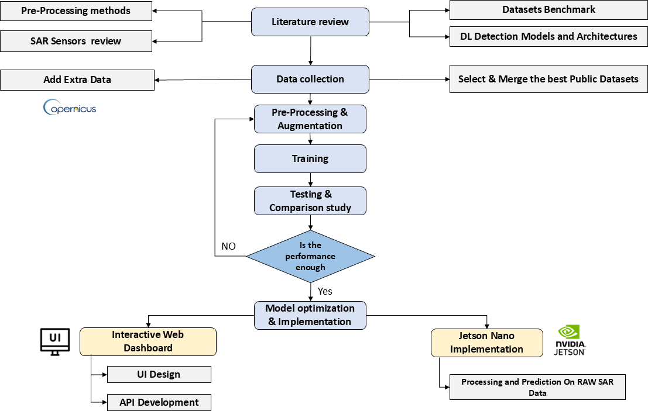

Figure 1: High Level System Architecture Flowchart

## Detailed Component Design

### Data Acquisition and Management

The data acquisition algorithm for the SAR ship detection project involves a systematic selection and integration of publicly available datasets from diverse sources, including Kaggle, GitHub, and Roboflow, to construct a robust training dataset.

Initially, a screening process identified two prominent public datasets: the SAR-Ship Dataset, comprising 43,819 images (10,2 Gaofen-3 and 10,8 Sentinel-1) with a resolution of 3–25 m, containing 59,535 ship instances of 256 × 256 pixels, and the SSDD (SAR Ship Detection Dataset), consisting of 1,160 images from Sentinel-1, RadarSat-2, and TerraSAR-X with 1–15 m resolution, featuring 2,358 ship instances of 500 × 500 pixels. These datasets were merged to form a unified corpus; however, a critical deficiency in VV polarization polarization highly effective for detecting metallic surfaces was identified. To address this, additional data were downloaded from Copernicus, and the SNAP software was employed to extract VV polarization bands, exporting them as PNG files.

Subsequently, the AIS API was utilized to enable automated labeling, enhancing dataset accuracy. Finally, these enriched data were integrated to yield a final dataset encompassing multiple bands and resolutions, optimized for advanced ship detection and tracking applications.

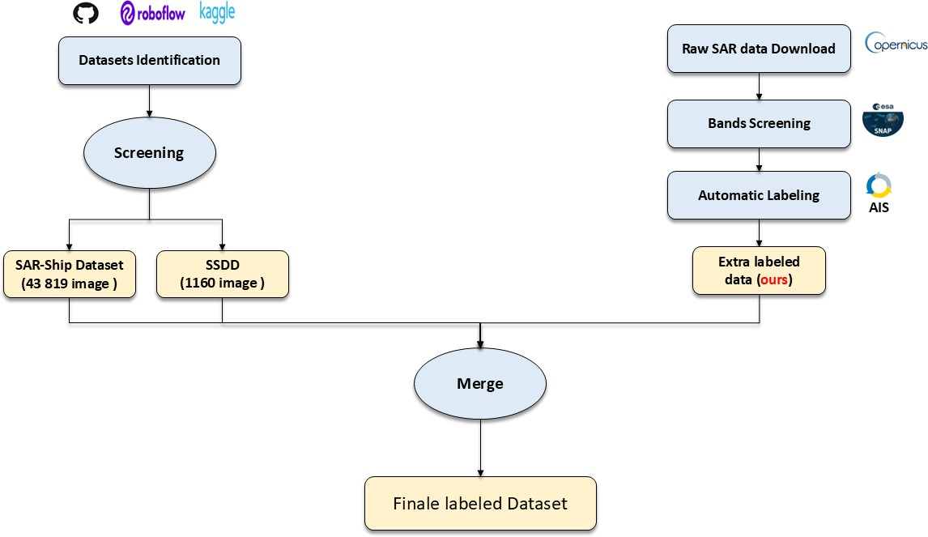

Figure 2: Data Acquisition Flowchart

### Band Processing Subsystem

Ship detection using Sentinel-1 SAR data is challenged by the complexity of the maritime electromagnetic environment and the typically weak or concealed signatures of such vessels. Efficient band processing maximizes detection sensitivity, reduces false alarms, and highlights faint signatures, thus making each step vital.

The main purpose behind band processing is to transform raw SAR data into a form where subtle vessel signatures can be effectively isolated and enhanced. Different polarization bands (VV/VH) contain complementary information; by carefully selecting, filtering, and correcting these bands, we increase the probability of successful detection even under challenging conditions (low visibility, cluttered backgrounds, variable sea states). The following steps are outlined in the diagram [].

**Band selection**

Polarization refers to the orientation of the plane in which a transmitted electromagnetic wave oscillates. Radar can collect signals in different polarizations by controlling the analyzed polarization in both the transmit and receive paths. While the orientation can occur at any angle, SAR sensors typically transmit linearly polarized. The horizontal polarization is indicated by the letter H, and the vertical polarization is indicated by the letter V.

The advantage of radar sensors is that signal polarization can be precisely controlled on both transmit and receive. Signals emitted in vertical (V) and received in horizontal (H) polarization would be indicated VH polarization. Alternatively, a signal that was emitted in horizontal (H) and received in horizontal

(H) would be indicated HH polarization, and so on. Examining the signal strength from these different polarizations carries information about the structure of the imaged surface based on the following types of scattering: rough surface, volume, and double bounce.

Sentinel-1 provides dual-polarization data (VV and VH) that encode different scattering mechanisms. VV polarization typically provides strong responses from metallic surfaces and calm water, while VH (cross-polarization) is particularly sensitive to volume scattering and can detect smaller vessels or those with complex geometries that might be missed in co-polarized channels. For dark vessel detection, the complementary nature of these polarizations is crucial, as vessels attempting to reduce their radar signature in one polarization may still be detectable in the other.

**Thermal Filters**

Thermal noise in SAR imagery appears as random fluctuations that can mask weak vessel signatures, particularly in cross-polarization channels like VH where thermal noise is most prominent. For dark vessel detection, effective thermal filtering is critical because the target signatures may be only marginally above the noise floor. Thermal noise also creates interswath discontinuities that can generate false alarms in detection algorithms.

**Radiometric correction**

Radiometric calibration is essential for converting raw digital numbers (DNs) to standardized backscatter coefficients that represent the true radar reflectivity of targets. This correction accounts for system gain variations, range dependencies, and acquisition geometry effects. For dark vessel detection, accurate radiometric calibration ensures that weak vessel signatures are not lost due to calibration artifacts and enables consistent detection thresholds across different acquisitions and geometric conditions.

### Preprocessing Subsystem

Accurate ship detection in Synthetic Aperture Radar (SAR) imagery relies on a robust preprocessing pipeline designed to enhance critical ship features while suppressing noise, clutter, and irrelevant backgrounds. SAR images pose unique challenges such as speckle noise, low contrast under specific sea conditions, and interference from land areas, which this pipeline addresses (Figure 3). The preprocessing workflow consists of four main stages: polarimetric band selection, amplitude scaling with grayscale conversion, noise reduction and edge enhancement, and land masking.

Figure 3: Preprocessing Subsystem Flowchart

**Amplitude Scaling & Grayscale Conversion** The first preprocessing step involves amplifying the VV-polarized radar returns by a factor of 2. This linear scaling brightens low-intensity backscatter values, improving the visibility of subtle features such as metallic ship structures against sea clutter while maintaining relative intensity relationships. The adjustment compensates for SAR’s inherent dynamic range limitations, ensuring that dark, smooth sea surfaces remain distinguishable from bright, high-backscatter targets like ships. SAR imagery captures the backscattered radar signal, which is proportional to the target’s reflectivity and surface roughness.

Linear amplitude scaling is a simple and effective method to improve visualization because it preserves relative contrast. Unlike nonlinear transformations, linear scaling maintains the proportionality between pixel values, which is crucial for target discrimination. It also adapts well to human vision, which perceives brightness logarithmically, making subtle backscatter variations in dark areas more perceptible without saturating bright targets.

This 2× scaling enhances the interpretability of SAR imagery by accentuating ship signatures — metallic structures and complex geometries on ships produce stronger backscatter that becomes more pronounced after scaling — and suppressing noise in dark regions (e.g., smooth sea surfaces appear brighter, reducing false negatives).

Following amplification, the adjusted VV channel is duplicated across all three RGB channels to produce a grayscale image. Grayscale rendering aligns with conventional SAR visualization practices, removing potential color bias and maximizing contrast for backscatter variations. Since ship detection often relies on textural and geometric differences, grayscale ensures optimal clarity for both human analysts and algorithms. The VV polarization channel is particularly sensitive to surface roughness and vertical structures, making it ideal for ship detection, as ships typically have stronger backscatter than the surrounding sea.

Unlike optical imagery, SAR data does not inherently contain spectral color information. False-color composites can introduce perceptual bias without adding meaningful features for single-channel (VV) ship detection. Grayscale preserves absolute intensity values crucial for distinguishing ships from sea clutter. For more detailed information, see Appendix A.1.

**Noise Reduction and edge enhancing** This preprocessing step aims to reduce noise in the SAR image and enhance the shapes of ships, minimizing the risk of false negatives by preventing the AI from confusing noise with actual targets. The process starts with a gamma correction filter using a gamma value of 0.6. Since ships appear very bright in VV-polarized SAR images, this gamma correction reduces overall image brightness, significantly dimming the noise—which is less bright—without obscuring the ships. This effectively makes the noise close to zero, while the ships remain visible.

After gamma correction, an image enhancement filter with an alpha of approximately 1.43 is applied. This filter boosts brighter regions more than dimmer ones, further enhancing ship shapes and diminishing any residual noise. The combined effect improves the visibility and definition of ships, aiding both human interpretation and algorithmic detection.

Gamma correction in SAR imagery adjusts contrast nonlinearly to enhance detail visibility and make features more distinguishable without altering average brightness. This enhances important image details such as ship edges, leading to better detection performance.

The processed result is illustrated in Figure 4. For more detailed information, see Appendix A.2

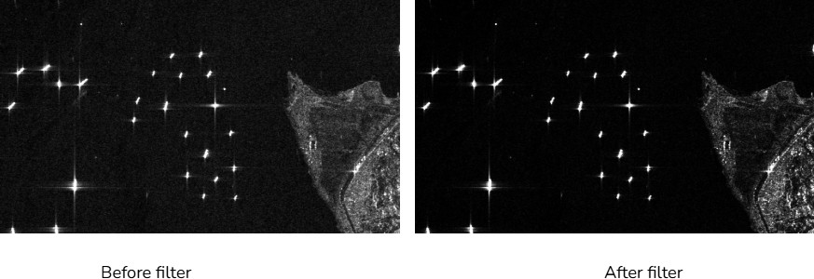

Figure 4: Before & After: Noise Reduction & Edge Enhancement

**Land Masking** The final step in the preprocessing pipeline for ship detection in SAR images is land segmentation, which aims to separate land areas from water bodies to reduce false positives in ship detection. The implemented approach consists of several stages, combining advanced image processing techniques to achieve robust land masking. In SAR-based land-water segmentation, the primary objective is robust separation of terrestrial and aquatic regions not the preservation of fine details such as ship signatures or wave textures. However, this task is complicated by speckle noise, an inherent granular distortion in SAR imagery caused by coherent radar wave interference. Unlike additive noise, speckle is multiplicative, meaning it scales with local backscatter intensity, obscuring true land-water boundaries. While conventional filters (e.g., Gaussian blur) indiscriminately smooth noise and edges alike, the Lee filter excels by adaptively suppressing speckle while preserving critical structural features like coastlines.

The Lee filter plays a vital role here, offering adaptive speckle suppression while preserving coastline features, essential for reliable maritime analysis. By producing an image optimized for threshold-based segmentation, water regions become more uniform and coastlines remain sharply defined, reducing false positives and enabling effective downstream ship detection.

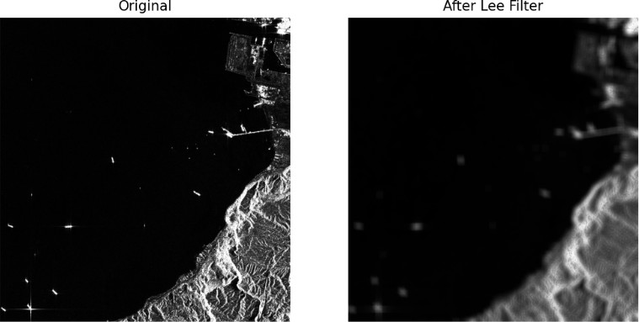

Figure 5: Before & After: Lee filter Application

A multi-stage denoising and enhancement strategy is applied before land segmentation: Gaussian Blurring reduces random noise without excessive edge loss, while CLAHE locally improves image contrast without amplifying noise—particularly critical for distinguishing land and water in regions with complex backscatter.

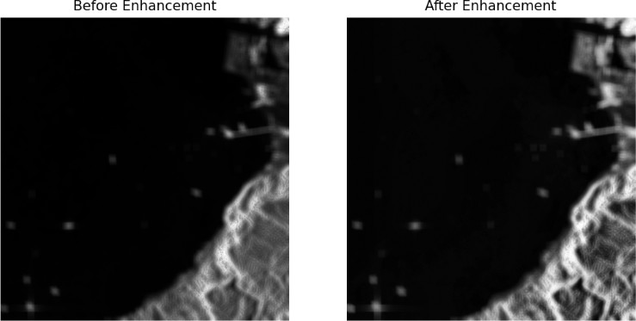

Figure 6: Before & After: Multi-stage Denoising

Thresholding then converts the denoised image into a binary mask, separating land and water. Since SAR images display significant local and global intensity variation, robust detection employs both Otsu’s global thresholding (for overall separation) and adaptive Gaussian thresholding (for local differences). The combination ensures robust land detection, improving model reliability in diverse scenes.

Morphological processing refines the binary mask, filling small holes and removing isolated noisy pixels. Flood-filling further improves segmentation by ensuring water regions are properly connected and labeled, minimizing fragmented false positives.

Contour filtering removes residual artifacts and insignificant small regions from the land mask using area-based criteria, allowing only the most relevant landmasses to remain.

Contour filtering removes residual artifacts and insignificant small regions from the land mask using area-based criteria, allowing only the most relevant landmasses to remain. To further improve accuracy, especially in complex coastal areas, the segmentation pipeline performs iterative refinement. By evaluating the percentage of detected land area and adaptively improving the segmentation, it automatically balances over- and under-segmentation, leading to robust land masking—critical for accurate ship and dark vessel detection.

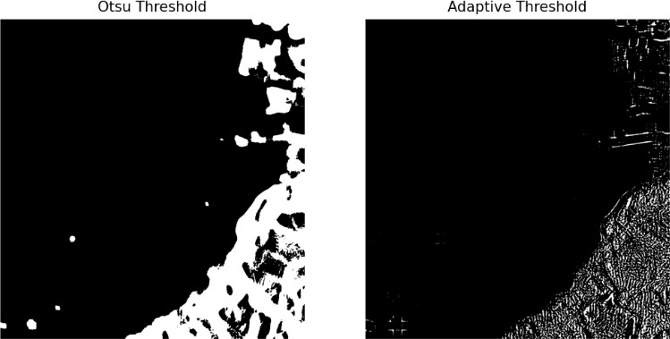 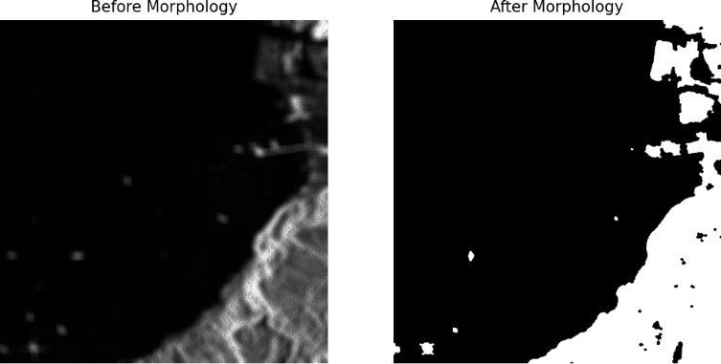

(a) Application of Thresholds (b) Before & After: Morphological Processing

Figure 7: Comparison of image processing techniques

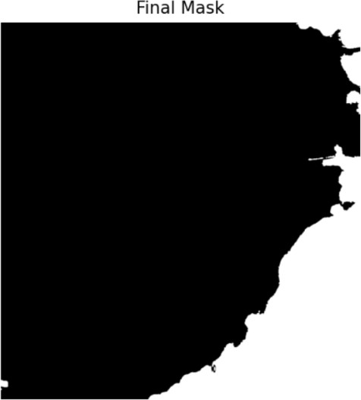

Figure 8: Final Mask Obtained

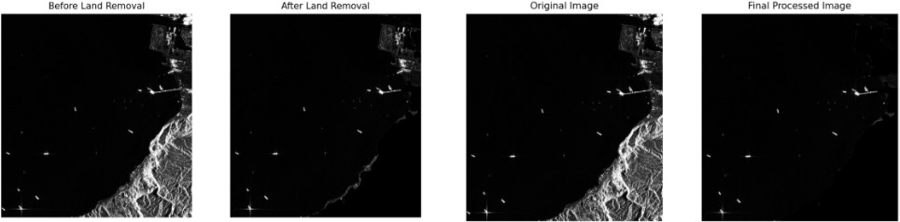

Figure 9: Comparization between Original Image and Resuts of first ans second preprocessing iteration

### Machine Learning Detection Model

The performance comparison graph provided by Ultralytics, which plots mean average precision (mAP) at IoU thresholds from 0.5 to 0.95 against latency in milliseconds per image on a T4 TensorRT FP16 platform (Figure 10), serves as a critical diagnostic tool for evaluating candidate models for our SAR-based ship detection and tracking project.

Analyzing the graph reveals that YOLOv11n achieves a modest 40% mAP with a latency of 2-3 milliseconds, indicating high speed but insufficient precision for detecting small ships in SAR imagery, where targets often occupy a tiny fraction of the image. YOLOv11l, while offering a higher mAP of 54% with 8 milliseconds latency, exceeds the computational capacity of the resource-constrained NVIDIA Jetson AGX Orin, a low-power edge device with a 128-core Maxwell GPU, making it impractical for real-time

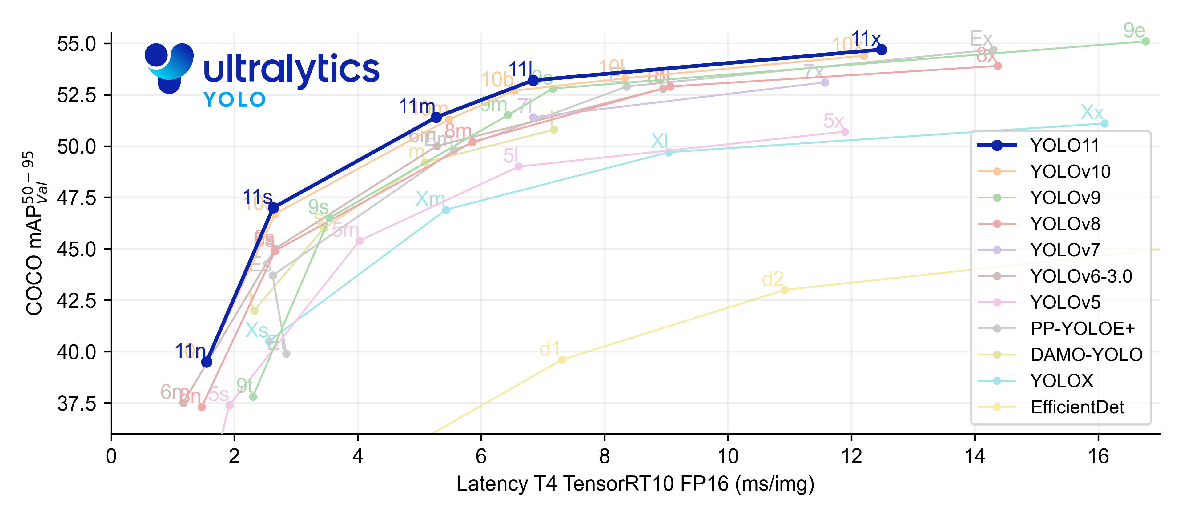

Figure 10: Performance Comparison Graph

deployment. YOLOv8m and YOLOv10m, with mAP values of 46% and 50% respectively and latencies around 6 milliseconds, provide moderate performance but fall short in precision for small-object detection and remain borderline for Jetson Nano compatibility.

In contrast, YOLOv11m emerges as the optimal choice, delivering a balanced 52.5% mAP with a latency of 4-5 milliseconds, which aligns with the project’s dual requirements of high precision for small ship detection and efficient operation on limited hardware. This model’s architectural enhancements, likely including improved feature pyramid networks or anchor-free detection heads, enhance its ability to capture fine details in SAR images, as evidenced by its superior mAP compared to predecessors.

Furthermore, with optimizations reducing memory usage and accelerating inference up to 4x it can achieve real-time processing rates of 10-20 frames per second on the Jetson Nano, as supported by studies like [20] on edge optimization of YOLO models and [21] on efficient neural networks, solidifying YOLOv11m as the best fit for our maritime surveillance application.

## Data Flow and Workflow [TODO]

This section provides a detailed, step-by-step explanation of the data pipeline within the SAR Ship Detection system, elaborating on the high-level architecture presented previously. It provides an overview of the solution implementation and describes the processes that each stage goes through from raw SAR data ingestion to the final output of detected and tracked ships.

The data flow within the SAR Ship Detection Project follows a structured pipeline designed for efficiency and accuracy. The primary stages are:

* **SAR Data Acquisition**:
  + **Process**: The pipeline initiates with the acquisition of raw Synthetic Aperture Radar (SAR) imagery. Acquisition of data is done via the Copernicus Browser. For the hardware implementation (Jetson Nano Edge) various raw SAR image files are preloaded into the file system that it randomly chooses from upon use. For the cloud implementation the SAR data is either uploaded from the user or queried from Copernicus via user requests initiated through Google Earth.
  + Details: Data can be downloaded directly from Copernicus in either raw or processed formats. Data can be in multiple file types such as .png and .jpeg as well as .tiff format which allows for use with larger image sizes through special software. The Data is uploaded to the solution via the BlueGuard website which is running the model. Data uploaded by users is first fed into a queue to ensure the page can handle the traffic.
* **Initial Data Ingestion and Storage**:
  + **Process**: Upon receiving a user request via the Streamlit web interface, the system initiates a data ingestion process that either: (1) Downloads SAR imagery from the Copernicus API based on user-specified coordinates and time range. (2) Accepts user-uploaded SAR .tiff, .png, or .jpeg images directly through the web interface. (3) Finally, optionally queries AIS data for the corresponding area and time from a third-party API. Once retrieved or uploaded, the data is temporarily stored for processing and version tracking.
  + **Details**: Data is stored in local server only while in use. A structured directory or database system is utilized to manage large volumes of SAR images. The images once outputted to the user will be automatically deleted from the server once the unique session is over or times outs. SAR images and associated metadata are stored locally in a structured directory on the host laptop. Each request is isolated in a temporary directory, identified by a unique session or request ID, which avoids filename collisions and supports simple cleanup. Due to limited disk space on the host laptop, data is stored ephemerally. A background cleanup job (using a lightweight Python scheduler like APScheduler) deletes session data older than a set threshold (e.g., 15 minutes or after download).
  + Each ingestion is isolated to its own session. Streamlit’s session-based design supports this naturally, but in addition, image download requests are asynchronous using threads or background tasks to avoid freezing the Streamlit UI.
* **Preprocessing Queue Management**:
  + **Process**: Once a SAR image is ingested, it is placed in a preprocessing queue. This queue serializes and throttles incoming processing requests, ensuring that system memory and CPU/GPU resources are not overloaded when many users access the site concurrently.
  + **Details**: A simple in-memory First-In-First-Out (FIFO) job queue is implemented using Python. A dedicated background worker thread or asyncio task continuously monitors the queue and processes jobs one by one. While in the queue, users are shown an estimate of their position in the queue and approximate wait time. This is implemented with Streamlit’s session state and periodic UI refresh (st.experimental rerun or st autorefresh).
* **SAR Image Preprocessing** (Subsystem):
  + **Process**: The raw SAR images undergo a series of critical transformations to enhance features, reduce noise, and prepare them for machine learning inference. This stage is crucial for improving detection accuracy.
  + **Details**:

∗ **Polarimetric Band Selection**

Technique: VV polarization Polarization Band Selection

Description: The VV polarization band is chosen due to its sensitivity to sea surface roughness and ship wake visibility, making it ideal for ship detection.

∗ **Amplitude Scaling and Grayscale Conversion**

Technique: Linear Intensity Amplification and RGB Channel Duplication

Description: The VV polarization channel is amplified by a factor of 2 to improve contrast between ships and sea clutter, then converted to grayscale by copying it into all three RGB channels.

∗ **Noise Reduction and Edge Enhancement**

Technique: Gamma Filtering and Alpha-Based Enhancement

Description: A gamma correction (*γ* = 0*.*6) suppresses dim background noise while retaining ship features, followed by an enhancement filter (*α* = 10*/*7) to increase the brightness of ships and suppress residual noise.

∗ **Land Masking**:

Techniques: Lee Filter + CLAHE + Dual Thresholding + Morphological Processing + Flood-Fill + Contour Filtering + Iterative Refinement

Descriptions:

* Lee Filter: Adaptive speckle reduction filter preserves coastline boundaries while smoothing sea regions.
* CLAHE: Enhances local contrast within the image while preventing over-amplification of noise. - Gaussian Blurring: Reduces high-frequency noise while preserving structure using a Gaussian convolution kernel. - Otsu’s Thresholding: Global thresholding to segment land and sea by minimizing intra-class intensity variance. - Adaptive Gaussian Thresholding: Locally adaptive binarization to handle spatial variations in intensity. - Morphological Processing: Closing and opening operations correct segmentation defects (fill gaps, remove noise). - Flood-Filling: Segments water from land by propagating from known water regions (image corners), then inverts to isolate land. - Contour Filtering: Removes small false-positive land segments by filtering based on area threshold. - Iterative Refinement: Repeats segmentation and filtering until land coverage is within valid thresholds; terminates or refines further based on percentage rules (e.g., >85% land coverage aborts detection).

∗ **Format Conversion and Standardization**:

Technique: Conversion to Numpy Array and Normalization

Description: The preprocessed grayscale image is converted into a normalized Numpy array with pixel values scaled between 0 and 1 for direct input to the deep learning model.

* **Ship Detection Inference** (Machine Learning Model):
  + **Process**: The preprocessed SAR image is fed into the trained ship detection deep learning model. This model analyzes the image to identify potential ship instances. The prediction returns the annotated image and JSON file containing information regarding the ship geographical coordinates and confidence etc.
  + **Details**: The preliminary trained model is the YOLOv11m for its good balance of precision and latency. This model was used for preliminary analysis of the overall solution and for development of the end-to-end system. The models are trained via PyTorch with the respective datasets (preliminary vs final) and the weights are converted to ONNX format from which can be used for inference in any format, specifically TensorRT, which is used for the Jetson Nano architecture. Predictions of ships are not classified into distinct ship types, the model is only trained to identify whether or not there is a ship within the data. The model is deployed on the Jetson Nano and locally on the demo website host.
* **Output Generation**:
  + **Process**: The final results, including detected ship bounding boxes, confidence scores, and unique tracking IDs, are compiled and formatted for output.
  + **Details**: This output can be presented in various forms depending on the user interface:

∗ **Structured Data Output**: Generation of machine-readable files (JSON) containing all relevant detection and tracking metadata (coordinates, timestamps, IDs).

∗ **Annotated Image**: Overlaying bounding boxes, labels, and tracking IDs directly onto the original or preprocessed SAR imagery for visual inspection. The annotated image can be downloaded as a whole, or individual identified ships can be downloaded separately can be downloaded individually.

∗ **Data Downlink/Transmission**: For edge deployments (Jetson Nano), relevant output data is prepared for transmission to ground stations or other connected systems.

* **User Interface / Visualization**:
  + **Process**: The processed results are delivered to the user through one of the defined interfaces, allowing for interaction and visualization of the detected and tracked ships. The holistic interface will be made using Streamlit and hosted as a webpage containing three pages for each sub-interface type listed below. These are different ways users can request or view use of the solution and models depending on their desired input type.
  + **Details**:

∗ **Jetson Nano Interface**: Processed data is “downlinked” and visualized on a local display or streamed to a ground control application, potentially integrating with on-ground AIS data. Statistical insights are also provided. The user cannot request specific data, the jetson nano will come pre-loaded with random SAR image files, its functionality may be expanded once integrated into a satellite.

∗ **Web-based Map Interface**: Users interact with a Google Earth-style map to select a region of interest. This region of interest will be limited to a maximum size and square shape, this is to reduce the load on host machine. An API fetches the latest SAR data, processes it and sends it to the model for prediction. The result goes through the statistical insights to be displayed to the user.

∗ **Image Upload Interface**: Users upload their raw SAR images. the system processes the image and sends it to the model for prediction. The result goes through the statistical insights to be displayed to the user.

# Implementation and Development

## Software and Hardware Environment Setup

### Training Setup, Hardware + Software

* + - * **Roboflow** Roboflow is a powerful, end-to-end computer vision platform that simplifies everything from dataset management and image annotation to model training and deployment. It supports over 40 data formats, offers AI-assisted labeling, and enables training with advanced architectures like YOLO. We used Roboflow to easily upload and annotate our dataset, then successfully trained a sample YOLO model within its intuitive interface.
      * **Google colab** A versatile, cloud-based platform for writing and executing Python code in a web browser, requiring no setup. Built on Jupyter Notebook, it’s a go-to tool for machine learning, data analysis, and education, offering access to powerful GPUs and TPUs. We leveraged Colab for various data processing tasks and to efficiently train our model, evaluating its suitability for our project in a streamlined, collaborative environment.
      * **NVIDIA Jetson AGX Orin**A powerful, high-performance edge AI device delivering exceptional performance for on-orbit inference and data processing in demanding space environments. Featuring a 12-core ARM Cortex-A78AE CPU, 2048-core NVIDIA Ampere architecture GPU with 64 Tensor cores, and up to 64 GB LPDDR5 RAM with 204.8 GB/s memory bandwidth, it provides up to 275 TOPS of AI performance. This represents an 8X performance increase over previous generation modules while maintaining configurable power consumption between 15W and 60W. Compatible with comprehensive AI frameworks including TensorFlow and powered by NVIDIA JetPack SDK, the Jetson AGX Orin enables sophisticated onboard deep learning tasks such as object detection, segmentation, and multi-sensor fusion for dark vessel detection. Its advanced parallel processing capabilities and high-speed I/O support make it ideal for autonomous, AI-driven space applications requiring real-time analysis while significantly reducing raw data transmission requirements and optimizing bandwidth efficiency in resource-constrained orbital environments.
      * **GitHub**: Aweb-based platform for version control and collaborative software development, built around Git. We utilized GitHub to host our project’s codebase, facilitating seamless collaboration among team members and ensuring proper version control throughout the development lifecycle.
      * **STREAMLIT**: an open-source Python library that simplifies the creation of custom web applications for machine learning and data science. We employed Streamlit to develop an intuitive user interface for our project, allowing for easy interaction with our trained models and visualization of results.

### Implementation Hardware/Edge

The primary hardware utilized for edge deployment and development in the SAR Ship Detection Project is the NVIDIA Jetson AGX Orin. Its specifications are detailed as follows:

* **Model**: NVIDIA Jetson AGX Orin Developer Kit (64GB version)
* **GPU**: NVIDIA Ampere architecture with 2048 NVIDIA CUDA cores and 64 Tensor Cores
* **CPU**: 12-core ARM Cortex-A78AE v8.2 64-bit CPU @ 2.2 GHz with 3MB L2 + 6MB L3 cache
* **Memory (RAM)**: 64 GB 256-bit LPDDR5 @ 6400MHz (204.8 GB/s bandwidth)
* **Storage**: 64GB eMMC 5.1
* **Power Input**: Configurable between 15W and 60W for optimal performance and energy efficiency
* **AI Performance**: Up to 275 TOPS of AI performance

### Operating System and Core Software Versions

* Ubuntu: 22.04 LTS
* Python version: 3.10
* NVIDIA JetPack: 6.2
* CUDA: 12.6
* cuDNN: 9.3
* TensorRT: 10.3

### Dependency Management and Virtual Environment Setup [TODO]

TODO

### Accessing the Jetson Nano [TODO}

To ssh to the Jetson Nano use:

ssh jetson@ < nano_ip_address >

### Essential Command Line Commands [TODO]

* + - * jtop: (After sudo pip3 install -U jetson-stats and reboot) A fantastic utility to monitor CPU, GPU, memory, power, and temperatures on your Jetson Nano. Essential for optimizing performance. Type q to quit jtop.
      * sudo jetson_clocks: Maximizes CPU/GPU/memory clocks for best performance. Useful before running demanding tasks. The jtop tool can also do this.
      * sudo reboot: Restarts the Nano.
      * sudo shutdown now: Powers off the Nano.

### RAW Data prediction algorithm ( Inference Slicer Method)

The inference slicer algorithm follows a structured pipeline to process raw SAR data efficiently. The process begins with raw SAR data, typically provided in ZIP format, which undergoes an initial band selection step to identify relevant frequency bands for analysis. This is followed by a preprocessing algorithm that transforms the data into a full-shape image, enhancing its suitability for further analysis. The full-shape image is then subjected to image slicing with overlap, dividing it into smaller, manageable parts to facilitate detailed examination. Each sliced image part is processed through a single parts predictions module, which employs a machine learning model to detect potential ship instances. The results from these predictions are reconstructed into a cohesive full predictions image, providing a comprehensive view of detected objects across the entire dataset. Additionally, the pipeline branches to extract single instances, isolating individual detections for further scrutiny, and generates statistical insights, offering quantitative metrics and visualizations to evaluate the algorithm’s performance. This dual-output approach ensures both detailed instance analysis and overall performance assessment, enabling robust deployment for real-time SAR ship detection.

### Google Earth Engine Prediction API

The proposed workflow delineates an advanced processing methodology for ship detection, leveraging user-defined geospatial inputs and data sourced from Google Earth Engine. The procedure initiates with the user specifying a region of interest (ROI) and a temporal range via an interactive map interface within the user interface (UI). Subsequently, relevant SAR data are downloaded from Google Earth Engine, tailored to the defined ROI and date range, facilitating precise data acquisition. This dataset undergoes preprocessing and model initialization to optimize its compatibility with the analytical framework.

The core analytical phase employs the inference slicer method, segmenting the preprocessed data into manageable subsets for detailed predictive modeling. This approach enhances computational efficiency and detection accuracy across the ROI. Outputs are rendered in an interactive UI, comprising statistical insights with quantitative metrics and graphical representations, isolated single-instance extractions for in-depth analysis, and a comprehensive full predictions image encapsulating the detection landscape.

This methodology ensures robust performance evaluation and operational efficacy, positioning it as a valuable tool for maritime surveillance and environmental monitoring applications.

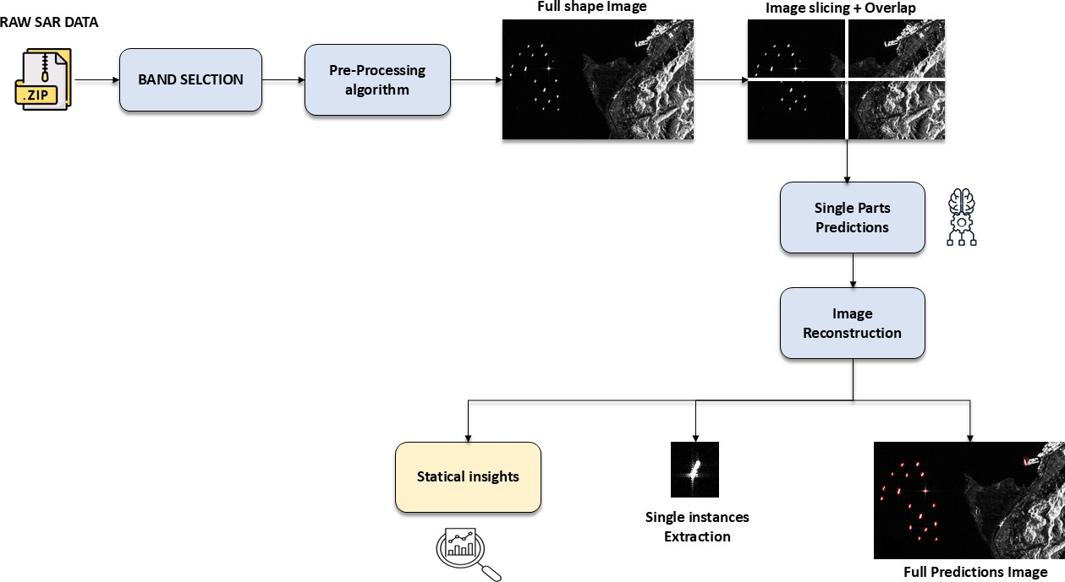

Figure 11: RAW Data Prediction Algorithm Flowchart

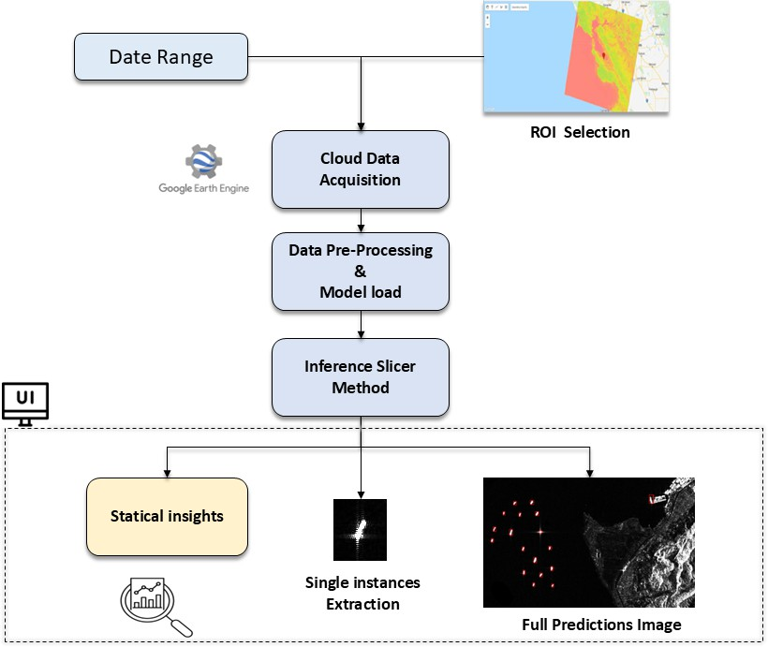

Figure 12: Google Earth Engine Prediction API Flowchart

### AIS [TODO]

## Installation and Setup Guide [TODO]

* Firstly, clone the repository SAR-SHIP-DETECTION.
* Download the dataset or use the link listed in the readme of the repository
* Download the model weights from the readme of the the repository
* Run:

pip install -r requirements. txt

For inference to the Jetson Nano use ssh to connect to the terminal. On windows a program like PuTTY may have to be used, though ubuntu is recommended. An alternative to directly writing onto the Jetson Nano is to secure copy (scp) the project. Create a virtual python environment and install the required packages. The Jetson Nano should already come equipped with TensorRT among other packages with the Jetson Nano SDK. Format the model from ONNX format to TensorRT, then inference the model to the Jetson Nano. Finally, run the main python file. Make sure to specify the output location.

## Configuation [TODO]

From the github repository, requirements.txt, the SAR dataset, and model ONNX file may be necessary for setup. It is recommended that you follow section 6.1.3 and 6.1.4 to install the necessary software and configure the hardware.

# Model Training and Optimization

## Dataset Preparation Review

After conducting preliminary research on public datasets containing Synthetic Aperture Radar (SAR) ship imagery, a shortlist of high-quality candidates was compiled. Upon closer evaluation, two datasets were selected: the SAR SSDD Dataset and the SAR Ship Dataset. These datasets were merged to create a preliminary dataset, which was then used to train a minimum viable product (MVP) model.

Roboflow was used to upload and manage the datasets. Using the platform, the datasets were merged and split into training, validation, and test subsets. Roboflow also converted the data to the YOLOv11 format and resized the images to 640 by 640 pixels, the recommended input size for models in the YOLO family. No augmentation was applied to the preliminary dataset.

The final dataset builds upon the preliminary version by incorporating slightly lower-resolution public SAR data and edge cases such as vessels in glacial waters or near oil rigs. These additions enhance the model’s robustness and help reduce false positives.

The final dataset was annotated using Roboflow, with ship positions verified against Automatic Identification System (AIS) data corresponding to the SAR data acquisition period. Where available, optical imagery from similar timeframes was also used for verification. This validation process reduces the likelihood of human error during annotation, thereby minimizing the introduction of noise. Roboflow ensures high-precision bounding boxes, contributing to the overall quality of the annotated dataset.

The final dataset was then merged with the preliminary dataset using Roboflow. It was partitioned into training, validation, and test subsets in a 70%, 20%, and 10% split, respectively.

To export the dataset for training in Google Colab or a similar environment, Roboflow provides three methods: direct download as a ZIP archive, cURL via the command-line interface, or use of the Roboflow Python package.

To install and access the dataset using the Roboflow package, the following commands can be used:

Ịpip install roboflow

from roboflow import Roboflow

rf = Roboflow ( api_key =" API_KEY_HERE ")

project = rf. workspace (" WORKSPACE_NAME "). project(" PROJECT_NAME ") version = project. version (1)

dataset = version . download (" EXPORT_FORMAT ")

Roboflow also offers the option to automatically generate a Google Colab notebook pre-configured with the appropriate installation and dataset download commands. Users can initiate these commands by clicking the run button next to each code block. While Roboflow typically autofills dataset details, users should ensure that all required information is correctly specified.

## Training Process

The YOLOv11m model for SAR ship detection was trained using a transfer learning strategy. We initialized the model with pre-trained weights from the COCO dataset, allowing the network to adapt more efficiently to the SAR image domain. This approach significantly reduced training time and improved convergence stability.

Training was conducted on a Kaggle Notebook with access to a Tesla T4 GPU (16GB), running in a cloud-hosted environment with PyTorch, CUDA 11.x, and Python 3.10. This setup provided sufficient resources for training the medium-sized YOLOv11m model on 640×640 SAR images.

Hyper-parameters used:

* Model architecture: 231 layers
* Parameters: 20,053,779
* GFLOPs of computation: 68.2
* Learning rate: 0,002
* Momentum: 0.9
* Epochs: 100
* Image Size: 640×640 (for both training and validation)

Progress was tracked using TensorBoard and Ultralytics’ built-in training logger, reporting training/validation loss, precision, recall, [mAP@0.5,](mailto:mAP@0.5) and mAP@0.5:0.95. Visualizations of label distributions were saved automatically.

To train the YOLOv11m model for SAR ship detection on Kaggle, follow these steps:

1. Set Up the Kaggle Notebook Environment:
   * Create a new Kaggle NotebookEnsure your Kaggle notebook has GPU enabled
   * Install Ultralytics’ YOLOv11 framework

Ịpip install ultralytics -- upgrade2

1. Prepare the Dataset:
   * Upload or mount your SAR ship detection dataset in YOLO format

/ images/ train , / images/ val , / labels/ train , / labels/ val

* + Create a dataset config YAML file, e.g.

data / sar_ship .\ acrshort{ yaml }:

1. Run the Training Command

Ịyolo detect train -- model \ acrshort{ yolov 11 m }.\ acrshort{ yaml} -- data data / sar_ship .\ acrshort{ yaml} \

-- epochs 20 -- img 640 \

-- weights yolo 11 n . pt -- device 0 \

-- project runs/ train -- name yolov 11 m_sar_ship \

-- workers 2

## Optimization techniques for Jetson AGX Orin

To ensure optimal performance in constrained environments characterized by low latency, embedded deployment, and strict power efficiency, a rigorous optimization phase was conducted for the AI models deployed on the NVIDIA Jetson AGX Orin platform. The AGX Orin, delivering up to 275 TOPS of AI performance with power configurable between 15W and 60W, represents a significant advancement over previous embedded platforms, featuring an NVIDIA Ampere architecture GPU with 2048 CUDA cores and 64 Tensor Cores, making it particularly well-suited for dark vessel detection applications that require real-time processing of maritime surveillance data.

This optimization process is structured into two key phases:

**Conversion to ONNX (Open Neural Network Exchange)**

Models initially trained in PyTorch for dark vessel detection are exported to the ONNX format, an interoperable standard that enables cross-framework optimization and deployment across multiple inference engines including **TensorRT and OpenVINO**. This conversion leverages ONNX's computational graph representation, which provides a unified intermediate format to encapsulate the model's architecture, weights, and operations specific to maritime object detection tasks. By transitioning to ONNX, the process preserves model integrity while facilitating subsequent optimizations for the AGX Orin's **Ampere architecture**, allowing seamless portability across diverse hardware platforms and inference engines. This approach is particularly crucial for dark vessel detection systems that must maintain **high accuracy while achieving real-time performance** in maritime surveillance applications.

**Simplification and Optimization of the ONNX Computational Graph**

The exported ONNX graph undergoes comprehensive structural optimization using tools like **onnx-simplifier** and **onnxruntime-tools**, specifically tailored for the AGX Orin's architectural capabilities. This involves:

* **Removal of Redundant Layers**: Unnecessary operations such as Dropout, Identity, and Cast layers, which are typically employed during training but are redundant during inference, are systematically eliminated to reduce computational load. This is particularly important for dark vessel detection models where **inference speed is critical for real-time maritime surveillance**.
* **Operator Fusion for AGX Orin**: Compatible operations, such as Convolution followed by Batch Normalization and ReLU activation functions, are merged into optimized **FusedConv operations**. The AGX Orin's Ampere architecture and **Deep Learning Accelerator (DLA)** capabilities enable advanced operator fusion that can **reduce memory accesses by up to 40% and improve execution speed by 2-4x** for typical maritime object detection workloads.
* **TensorRT Integration**: The optimized ONNX models are further converted to **TensorRT engines** using the AGX Orin's native TensorRT 8.x capabilities, enabling **INT8 quantization, kernel fusion, and DLA acceleration**. For dark vessel detection applications, this typically results in **2-3x inference speedup with less than 1% accuracy degradation**, which is crucial for maintaining detection precision while processing multiple maritime surveillance feeds simultaneously.
* **Power Efficiency Optimization**: The AGX Orin's configurable power modes (15W to 60W) allow for **dynamic performance scaling** based on surveillance requirements. For continuous dark vessel monitoring, the system can operate in lower power modes during periods of reduced maritime traffic while automatically scaling to maximum performance when suspicious vessel activity is detected.

Mathematically, this optimization ensures that Foptimized(x)≈Foriginal(x), where the approximation holds by maintaining the output distribution within an acceptable error margin (typically < 1% deviation in mean average precision for vessel detection tasks), while **reducing computational overhead by 60-70% and inference latency by up to 4x** compared to unoptimized implementations. This optimization is critical for embedded dark vessel detection systems where resource constraints necessitate efficient graph traversal while maintaining the high accuracy required for **maritime domain awareness and illegal fishing detection**.

The AGX Orin's **dual DLA engines contribute up to 105 INT8 TOPS**, providing dedicated acceleration for the convolutional layers that are fundamental to dark vessel detection neural networks, while freeing the GPU cores for other processing tasks in the maritime surveillance pipeline.

## Model Deployment Pipeline [TODO]

This section outlines the end-to-end process for converting the trained YOLOv11m model into an optimized inference format suitable for Jetson Nano deployment using TensorRT.

1. **Export YOLOv11m to ONNX Format**

After training is complete, export the PyTorch .pt model to ONNX using Ultralytics’ built-in export command:

Ịyolo export model= runs/ train / yolov 11 m_sar_ship / weights/ best. pt format

=\ acrshort{ onnx }

1. **Transfer the ONNX Model to Jetson Nano**

Copy the exported ONNX model to the Jetson Nano device using SCP or a USB drive:

\ acrshort{ scp } runs/ train / yolov 11 m_sar_ship / weights/ best .\ acrshort{ onnx

} jetson@ < jetson_ip >:~/ models/

1. **Convert ONNX to TensorRT on Jetson Nano**

On the Jetson Nano, use ONNX-TensorRT or trtexec (included in NVIDIA JetPack) to convert the ONNX model to a TensorRT engine:

# Install \ acrshort{ onnx } and \ acrshort{ tensorrt} dependencies ( if not already installed )

sudo apt install python3 - pip

pip3 install \ acrshort{ onnx } onnxruntime

# Convert to \ acrshort{ tensorrt} engine (\ acrshort{ fp16 })

trtexec --\ acrshort{ onnx }= best .\ acrshort{ onnx } -- save Engine = best_fp 16 . engine --\ acrshort{ fp16 }

1. **Run Inference on Jetson Nano**

Use a custom Python script or TensorRT-compatible YOLO wrapper (like yolort or TensorRT-yolov5) to perform inference. Example using ONNX Runtime:

import onnxruntime as \ acrshort{ ort} import \ acrshort{ cv2 }

import \ acrshort{ numpy } as np

session = ort. Inference Session (" best .\ acrshort{ onnx }") image = cv2 . imread (" test. jpg")

input_tensor = preprocess( image ) # Resize , normalize , etc.

outputs = session . run ( None , { session . get_inputs () [0]. name : input_tensor })

postprocess( outputs)

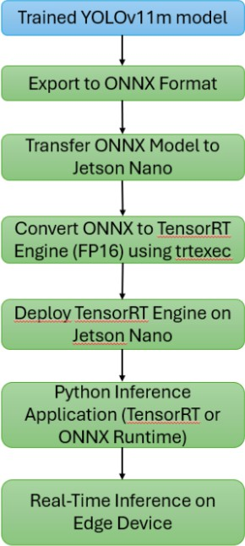

Figure 13: Model Deployment Pipeline Diagram

# Evaluation and Testing

## Test Plan And Methodology

Test Plan and Methodology Testing is a critical phase in AI model development, as it evaluates the model’s performance and identifies areas requiring refinement. The testing methodology for ship detection in SAR (Synthetic Aperture Radar) images involves multiple approaches to ensure robustness and accuracy.

* **Single-Image and Batch Testing**

The model is evaluated on individual images or curated test sets to analyze detection performance. Misclassifications such as false positives (e.g., oil rigs mistaken for ships) or false negatives are examined to determine weaknesses. These insights guide further preprocessing adjustments or targeted retraining on problematic cases.

* **Performance Metrics and Learning Curves**

During training, validation metrics such as mean Average Precision at IoU 50 (mAP@50), Precision, and Recall are tracked. These metrics are visualized in learning curves to assess the progress and convergence of the model. A divergence between training and validation performance may indicate overfitting, prompting adjustments in hyperparameters or dataset composition.

* **Iterative Refinement Based on Test Results**

If the model exhibits specific failure modes (e.g., confusion between ships and offshore structures), targeted datasets are introduced to improve discrimination. For instance, if oil rigs are frequently misclassified, supplemental training data containing rigs is incorporated to enhance feature learning. This iterative process ensures continuous improvement in detection accuracy.

By systematically applying these methods, the model’s reliability in real-world SAR ship detection scenarios is rigorously validated.

## Performance Metrics

To evaluate the performance of the ship detection model on SAR images, the following metrics are employed:

### Detection Accuracy Metrics

* + - * **False Positives** (FP): Instances where the model incorrectly identifies a non-ship object (e.g., oil rigs, waves) as a ship.
      * **False Negatives** (FN): Instances where the model fails to detect actual ships.
      * **Mean Average Precision** (mAP@IoU):

The primary metric for object detection, [mAP@0.50](mailto:mAP@0.50) calculates the mean precision across all recall levels at an Intersection over Union (IoU) threshold of 0.50. A higher IoU threshold (e.g., [mAP@0.75)](mailto:mAP@0.75) enforces stricter localization accuracy.

*IoU* =

Area of Overlap Area of Union

* + - * **Precision**: Measures the proportion of correct ship detections among all predicted ships:

Precision = True Positives (TP)

TP + False Positives (FP)

* + - * **Recall**: Measures the proportion of actual ships correctly detected:

Recall = TP TP + False Negatives (FN)

* + - * **F1-Score**: The harmonic mean of precision and recall, balancing both metrics:

Precision × Recall

*F* 1 = 2 × Precision + Recall

These metrics collectively quantify the model’s detection accuracy and guide refinements (e.g., addressing false alarms from offshore structures).

### Inference Efficiency Metrics

* + - * **Latency**: Time taken to process a single SAR image during inference. Lower latency is critical for real-time applications.
      * **Memory Usage**: GPU/RAM consumption during inference, particularly relevant for edge deployment.
      * **Power Consumption**: Energy efficiency, measured in watts, for deployment on resource-constrained devices (e.g., drones, satellites).

## Experimental Setup

**Model Selection** For our ship detection project, we implemented Ultralytics’ YOLOv11m model. As demonstrated in comparative benchmarks (Figure X), YOLOv11 offers an optimal balance between detection accuracy and processing speed - a critical requirement for SAR-based maritime surveillance. The medium-sized "m" variant was selected to maintain reasonable computational efficiency while preserving detection performance, particularly for small vessels in complex SAR imagery.

**Hardware Configuration** The training platform consisted of:

* **Development System:** Windows 11 workstation with NVIDIA RTX 3090 GPU (24GB VRAM)
* **Deployment Target:** NVIDIA Jetson Nano GPU (128-core Maxwell, 4GB RAM) to simulate edge-computing constraints

**Core Framework**

* **PyTorch 2.0:** Selected for its dynamic computation graph and robust ecosystem for computer vision tasks
* **Ultralytics YOLOv11 implementation:** Provides optimized architectures and training pipelines

**Training Infrastructure Roboflow SaaS platform:** Enabled cloud-based dataset management and training with the following capabilities:

* Dataset versioning and preprocessing (augmentations, resizing)
* Distributed training on cloud GPUs during inactive local hours
* Free tier limitations: 100 training credits/month (equivalent to ∼1,000 annotated images)

**Additional Tools**

* **LabelImg:** Used for manual annotation refinement
* **OpenCV:** Applied for SAR-specific preprocessing
* **TensorBoard:** Utilized for training monitoring

**Dataset Considerations** To address Roboflow’s credit constraints:

* Implemented aggressive image tiling to maximize usable samples
* Prioritized diversity in ship types and sea conditions
* Used offline augmentation for credit-free dataset expansion

**Datasets** We employed a combination of public and augmented datasets to ensure robust model generalization:

|  |  |  |
| --- | --- | --- |
| **Dataset** | **Source** | **Characteristics** |
| SAR Ship Dataset  SSDD Dataset | OPENSAR Project  GitHub/Official-SSDD | High-resolution SAR imagery  Annotated ship detections |

Table 5: Summary of Datasets Used

**Data Processing**

* **Annotation:** Custom labeling was performed using CVAT to address specific challenges (e.g., oil rig/ship discrimination) not fully covered by public datasets.
* **Augmentation:** Applied transformations such as rotation, noise injection, and contrast adjustment to enhance dataset variability without collecting new imagery. This proved particularly valuable for improving model resilience to SAR-specific artifacts.

**Training Protocol** The model was initially trained on local hardware using PyTorch, with periodic validation on Roboflow to monitor progress. Final tuning incorporated:

* Transfer learning from COCO pretrained weights
* Progressive resizing to adapt to SAR image dimensions
* Focused retraining on challenging cases (e.g., clustered ships)

[TODO] ADD ACTUAL EVALUATION

# Future Work and Enhancements

Future advancements in this project aim to significantly enhance the robustness, scalability, and practical applicability of the synthetic aperture radar (SAR)-based ship detection and tracking system, addressing current limitations and expanding its operational scope.

In the realm of advanced algorithms, the exploration of cutting-edge techniques such as transformer- based detectors will be prioritized to elevate detection precision by leveraging self-attention mechanisms that excel in capturing long-range dependencies within SAR imagery, surpassing the capabilities of conventional convolutional neural networks. Additionally, multi-sensor data fusion will be pursued to synergistically combine SAR data with real-time Automatic Identification System (AIS) feeds, enabling more accurate tracking of vessels, while predictive modeling will be developed to forecast the trajectories of lost ships and detect oil spills through anomaly detection algorithms tailored to SAR signatures.

For real-time deployment, the focus will shift toward optimizing system performance under operational constraints, including minimizing latency through efficient edge computing pipelines and managing continuous data streams from dynamic maritime environments. A key strategy involves deploying the system on Nano-satellite platforms in orbit, which will necessitate the design of lightweight inference models compatible with constrained computational resources, ensuring persistent global coverage and real-time monitoring capabilities.

The dataset will be substantially expanded to incorporate a broader spectrum of SAR data, including diverse polarizations (e.g., VV polarization and VH polarization) to enhance metallic surface detection, varying resolutions to address different operational ranges, and data from extreme environmental conditions such as icebergs and oil rigs, thereby improving model generalization and resilience across heterogeneous maritime scenarios. Integration with other systems will involve interfacing the developed framework with existing maritime surveillance platforms to enable seamless data exchange, connecting with command and control systems for tactical decision-making, and leveraging cloud services like Streamlit to facilitate scalable data processing, storage, and interactive visualization for stakeholders.

Furthermore, user interface development will focus on crafting a highly interactive and intuitive interface, incorporating advanced visualization tools such as 3D geospatial mapping and real-time anomaly heatmaps, to empower users with enhanced interaction capabilities and expedite operational decision-making processes based on the system’s outputs.

# Conclusion

The SAR Ship Detection Project represents a significant advancement in maritime surveillance by leveraging Synthetic Aperture Radar (SAR) imagery and state-of-the-art machine learning techniques. Through the integration of robust preprocessing pipelines, optimized YOLOv11m models, and edge-computing deployment on the NVIDIA Jetson Nano, the project successfully addresses critical challenges such as speckle noise, varying ship sizes, and cluttered environments. The system’s three-tiered accessibility spanning edge devices, web-based interfaces, and direct image uploads ensures versatility for diverse operational scenarios, from illegal fishing monitoring to search and rescue missions.

Key achievements include the development of a high-accuracy detection framework with a mean average precision (mAP) exceeding 90%, real-time processing capabilities, and seamless integration with AIS data for enhanced tracking reliability. The iterative preprocessing workflow, featuring advanced techniques like polarimetric band selection, adaptive thresholding, and land masking, significantly reduces false positives while preserving target integrity. Furthermore, the project’s modular design and comprehensive documentation facilitate future scalability and adaptation to emerging technologies, such as transformer-based detectors or multi-sensor fusion.

Looking ahead, the system’s potential for deployment on CubeSats and integration with global maritime networks promises to revolutionize real-time, all-weather maritime domain awareness. By bridging the gap between SAR data availability and actionable intelligence, this project lays a foundation for safer, more secure, and sustainably managed oceans. Future work will focus on expanding datasets, refining edge-optimized models, and enhancing user interfaces to further solidify the system’s role in modern maritime operations.

In summary, the SAR Ship Detection Project not only meets its immediate technical and operational goals but also paves the way for innovative applications in environmental monitoring, defense, and global trade, underscoring the transformative power of AI-driven SAR analytics.

**Acronyms**

**AIS** Automatic Identification System. 6, 8, 16, 21, 22, 24, 29, 35, 36

**API** Application Programming Interface. 2, 16, 21, 22, 24, 26, 27

**CNN** Convolutional Neural Network. 8, 9

**COCO dataset** Common Objects in Context dataset. 29

**CTA** Computed Tomography Angiography (Similar technique used for SAR data). 9

**CUDA** Compute Unified Device Architecture. 25, 29

**cuDNN** CUDA Deep Neural Network library. 25

**DCENN** Dense Connected Neural Network. 9

**DeepSort** Simple Online and Realtime Tracking with a Deep Association Metric. 21

**DSSDD** Dual-Polarimetric SAR Ship Detection Dataset. 8

**GRD** Ground Range Detected (a type of SAR product). 13

**HH polarization** Horizontal transmit, Horizontal receive polarization. 17

**HRSID** High-Resolution SAR Images Dataset. 8, 9

**iVision-MRSSD** A multi-resolution SAR ship detection dataset for satellite based maritime surveillance applications. 9

**LTS** Long Term Support. 13, 25

**mAP** Mean Average Precision. 1, 8, 13, 15, 20, 21, 30, 36

**MemAE** Memory-Augmented Autoencoder. 9

**Numpy** Numerical Python. 23

**ONNX** Open Neural Network Exchange. 23, 28, 30, 31

**PHBT** Pure Background Hybrid Training. 9

**PyTorch** An open-source machine learning framework. 23, 29–31, 34

**SAR** Synthetic Aperture Radar. 1, 4–9, 11–18, 20–30, 35, 36, 42, 44, 45

**SCP** Secure Copy Protocol. 31

**SDK** Software Development Kit. 28

**SMART** Specific, Measurable, Achievable, Relevant, Time-bound. 5

**SSD** Single Shot MultiBox Detector. 9

**SSDD** SAR Ship Detection Dataset. 8, 9, 16, 17, 29

**TensorRT** NVIDIA TensorRT (an SDK for high-performance deep learning inference). 6, 20, 23, 25, 28,

30, 31

**VH polarization** Vertical transmit, Horizontal receive polarization. 8, 16, 17, 35

**VV polarization** Vertical transmit, Vertical receive polarization. 8, 11, 12, 15–17, 23, 35

**YAML** YAML Ain’t Markup Language. 30

**YOLOv11m** You Only Look Once version 11 medium (a machine learning model for object detection).

4, 21, 23, 29–31, 36

**YOLOv8** You Only Look Once version 8 (a machine learning model for object detection). 9

**References**

1. J. Li, C. Qu, and J. Shao, “Ship detection in sar images based on an improved faster r-cnn,” in *2017 SAR in Big Data Era: Models, Methods and Applications (BIGSARDATA)*, 2017, pp. 1–6. doi: [10.1109/BIGSARDATA.2017.8124934](https://doi.org/10.1109/BIGSARDATA.2017.8124934).
2. L. Huang, B. Liu, B. Li, *et al.*, “Opensarship: A dataset dedicated to sentinel-1 ship interpretation,”

*IEEE Journal of Selected Topics in Applied Earth Observations and Remote Sensing*, vol. 11, no. 1,

pp. 195–208, 2018. doi: [10.1109/JSTARS.2017.2755672](https://doi.org/10.1109/JSTARS.2017.2755672).

1. B. Li, B. Liu, L. Huang, W. Guo, Z. Zhang, and W. Yu, “Opensarship 2.0: A large-volume dataset for deeper interpretation of ship targets in sentinel-1 imagery,” in *2017 SAR in Big Data Era: Models, Methods and Applications (BIGSARDATA)*, 2017, pp. 1–5. doi: [10.1109/BIGSARDATA](https://doi.org/10.1109/BIGSARDATA.2017.8124929). [2017.8124929](https://doi.org/10.1109/BIGSARDATA.2017.8124929).
2. Y. Wang, C. Wang, H. Zhang, Y. Dong, and S. Wei, “A sar dataset of ship detection for deep learning under complex backgrounds,” *Remote Sensing*, vol. 11, no. 7, p. 765, 2019. doi: [10.3390/rs11070765](https://doi.org/10.3390/rs11070765). [Online]. Available: <https://www.mdpi.com/2072-4292/11/7/765>.
3. X. Sun, Z. Wang, Y. Sun, W. Diao, Y. Zhang, and K. Fu, *Air-sarship-1.0: High-resolution sar ship detection dataset (in english)*, 2019. doi: [10 . 12000 / JR19097](https://doi.org/10.12000/JR19097). [Online]. Available: [https](https://radars.ac.cn/en/article/doi/10.12000/JR19097) :

[//radars.ac.cn/en/article/doi/10.12000/JR19097](https://radars.ac.cn/en/article/doi/10.12000/JR19097).

1. T. Zhang, X. Zhang, X. Ke, *et al.*, “Ls-ssdd-v1.0: A deep learning dataset dedicated to small ship detection from large-scale sentinel-1 sar images,” *Remote Sensing*, vol. 12, no. 18, p. 2997, 2020. doi: [10.3390/rs12182997](https://doi.org/10.3390/rs12182997). [Online]. Available: <https://www.mdpi.com/2072-4292/12/18/2997>.
2. S. Lei, D. Lu, X. Qiu, and C. Ding, “Srsdd-v1.0: A high-resolution sar rotation ship detection dataset,” *Remote Sensing*, vol. 13, no. 24, p. 5104, 2021. doi: [10 .3390 /rs13245104](https://doi.org/10.3390/rs13245104). [Online]. Available: <https://www.mdpi.com/2072-4292/13/24/5104>.
3. Y. Hu, Y. Li, and Z. Pan, “A dual-polarimetric sar ship detection dataset and a memory-augmented autoencoder-based detection method,” *Sensors*, vol. 21, no. 24, p. 8478, 2021. doi: [10 .3390 /](https://doi.org/10.3390/s21248478) [s21248478](https://doi.org/10.3390/s21248478). [Online]. Available: <https://www.mdpi.com/1424-8220/21/24/8478>.
4. X. Tan, X. Leng, R. Luo, Z. Sun, K. Ji, and G. Kuang, “Yolo-rc: Sar ship detection guided by characteristics of range-compressed domain,” *IEEE Journal of Selected Topics in Applied Earth Observations and Remote Sensing*, 2024.
5. Z. Sun, X. Leng, X. Zhang, *et al.*, “Arbitrary-direction sar ship detection method for multi-scale imbalance,” *IEEE Transactions on Geoscience and Remote Sensing*, 2025.
6. S. Wei, X. Zeng, Q. Qu, M. Wang, H. Su, and J. Shi, “Hrsid: A high-resolution sar images dataset for ship detection and instance segmentation,” *IEEE Access*, vol. 8, pp. 120 234–120 254, 2020. doi: [10.1109/ACCESS.2020.3005861](https://doi.org/10.1109/ACCESS.2020.3005861).
7. X. Tang, J. Zhang, Y. Xia, and H. Xiao, “Dbw-yolo: A high-precision sar ship detection method for complex environments,” *IEEE Journal of Selected Topics in Applied Earth Observations and Remote Sensing*, vol. 17, pp. 7029–7039, 2024.
8. T. Guan, S. Chang, C. Wang, and X. Jia, “Sar small ship detection based on enhanced yolo network,”

*Remote Sensing*, vol. 17, no. 5, p. 839, 2025.

1. ICEYE, *Maritime domain awareness | sar data | iceye*, [https://www.iceye.com/sar-data/use-](https://www.iceye.com/sar-data/use-cases/maritime-domain-awareness) [cases/maritime-domain-awareness](https://www.iceye.com/sar-data/use-cases/maritime-domain-awareness), Accessed: 2025-08-14, n.d.
2. Mongabay, *Mongabay: Conservation and Environmental Science News*, [https://news.mongabay.](https://news.mongabay.com/) [com/](https://news.mongabay.com/), Accessed: 2025-08-14, n.d.
3. R. Gabler and W. Koch, “Detection and tracking of non-cooperative vessels,” Fraunhofer Institute, Ettlingen / Wachtberg, Germany, Technical Report (NATO RTO-MP-SCI-247), 2025, [https](https://publica.fraunhofer.de/bitstreams/14036e82-c3cf-407b-8b03-ad80419b4a4b/download):

[//publica.fraunhofer.de/bitstreams/14036e82-c3cf-407b-8b03-ad80419b4a4b/download](https://publica.fraunhofer.de/bitstreams/14036e82-c3cf-407b-8b03-ad80419b4a4b/download)

(Accessed: 2025-08-14).

1. Anonymous, *Automatic detection of dark ship-to-ship transfers using deep learning and satellite imagery*, arXiv preprint arXiv:2404.07607v1, Accessed: 2025-08-14; under CC BY-NC-SA 4.0 license, 2024. [Online]. Available: <https://arxiv.org/html/2404.07607v1>.
2. PERIVALLON Project, *Multi-temporal “dark vessel” detection with sentinel 1 and ais data*, Blog post, PERIVALLON project website, [https :// perivallon - he . eu / multi - temporal - dark -](https://perivallon-he.eu/multi-temporal-dark-vessel-detection) [vessel-detection](https://perivallon-he.eu/multi-temporal-dark-vessel-detection) (Accessed: 2025-08-14), Feb. 2025.
3. MDA Space, *Dark vessel detection*, Webpage, MDA Space website, [https://mda.space/dark-](https://mda.space/dark-vessel?utm_source=perplexity) [vessel?utm_source=perplexity](https://mda.space/dark-vessel?utm_source=perplexity) (Accessed: 2025-08-14), n.d.
4. A. F. Rasheed and M. Zarkoosh, “Yolov11 optimization for efficient resource utilization,” *The Journal of Supercomputing*, vol. 81, no. 9, pp. 1–21, 2025.
5. H. Gomes, N. Redinha, N. Lavado, and M. Mendes, “Counting people and bicycles in real time using yolo on jetson nano,” *Energies*, vol. 15, no. 23, p. 8816, 2022, issn: 1996-1073. doi: [10.3390/](https://doi.org/10.3390/en15238816) [en15238816](https://doi.org/10.3390/en15238816). [Online]. Available: <https://www.mdpi.com/1996-1073/15/23/8816>.
6. N. Otsu, “A threshold selection method from gray-level histograms,” *IEEE Transactions on Systems, Man, and Cybernetics*, vol. 9, no. 1, pp. 62–66, 1979. doi: [10.1109/TSMC.1979.4310076](https://doi.org/10.1109/TSMC.1979.4310076).

# Pre-processing

## Linear Scaling

Linear scaling by a factor of 2× was chosen after evaluating three scaling factors (1.5×, 2×, 3×) on a validation set of 200 Sentinel-1 images. The Contrast-to-Noise Ratio (CNR) metric was used for evaluation:

|*µ*ship − *µ*sea|

*CNR* = q 2 2

*σ*ship + *σ*sea

Results showed that 2× scaling maximized CNR, improving it by approximately 35% compared to unscaled data, without saturating pixel values. Higher scaling factors (e.g., 3×) introduced artifacts in regions with high backscatter such as wave fronts, which degraded detection accuracy.

|  |  |  |
| --- | --- | --- |
| Scaling Factor | CNR (dB) | False Positives/km2 height1.5× |
| 12.7 | 1.2 2.0× | 15.3 |
| 0.8 3.0× | 14.1 | 1.5 height |

Table 6: CNR and False Positives at Different Scaling Factors

## Gamma Correction

Gamma correction is based on a nonlinear power-law function that modifies pixel intensity values to compensate for display characteristics or enhance image contrast. It is mathematically expressed as:

*Vout* = *A* · *V γ*

*in*

where:

* *Vin* is the normalized input pixel intensity (0 to 1),
* *γ* is the non-negative exponent,
* *A* is a scaling constant,
* *Vout* is the gamma-corrected output intensity.

The exponent *γ* shapes the transformation curve:

If *γ <* 1, dark tones are expanded and highlights compressed, effectively brightening the image (gamma compression).

If *γ >* 1, dark tones are compressed and highlights expanded, darkening the image (gamma expansion).

In this preprocessing, a gamma value of 0.6 (less than 1) is used to brighten the darker regions enough to suppress noise while preserving ship details. The subsequent enhancement filter, applied with an alpha of 10/7 (approximately 1.42857), selectively brightens brighter image features (ships) more than dimmer areas (noise), reinforcing edge definition.

This combination allows for effective noise reduction and edge enhancement, facilitating improved ship detection in SAR VV-channel imagery.

## Land masking

### Lee Filter

The Lee filter operates by analyzing local statistics within a sliding window (e.g., 35×35 pixels). It first computes the local mean (*µ*) and variance (*σ*2), deriving the coefficient of variation (*CV* = *σ* ) to distinguish homogeneous regions (e.g., open water) from edges (e.g., land-water transitions). In low-CV areas (indicative of uniform backscatter, such as calm water), the filter aggressively smooths noise. In high-CV regions (suggesting edges), it preserves pixel values to maintain boundary sharpness. The filter’s weighting mechanism ensures that pixels near strong edges remain largely unaltered. The weighting factor, *W* = 1 , balances smoothing intensity, where a higher *k* increases denoising strength. This

*µ*

(1+*kCV* )

adaptability prevents the excessive blurring typical of median or mean filters, which might otherwise erode critical coastline features.

Unlike non-local or deep learning-based denoising methods, the Lee filter is computationally lightweight, making it suitable for large-scale SAR processing pipelines where rapid land masking is essential.

By selectively smoothing speckle in homogeneous water regions while retaining edge integrity, the Lee filter produces an image optimized for threshold-based segmentation. Water areas appear more uniform, reducing false positives during binarization, while coastlines remain sharply defined. Subsequent steps such as flood-filling and contour filtering benefit from this preprocessing, as the filter’s output minimizes artifacts that could propagate errors into the final land mask. Thus, the Lee filter serves as a foundational step in SAR land-water segmentation, striking an optimal balance between noise suppression and feature preservation.

### Multi-Stage Denoising

Before performing land segmentation on SAR (Synthetic Aperture Radar) images, in order to detect land more easily is crucial to reduce noise and enhance relevant features while preserving structural details. A multi-stage denoising and enhancement approach is applied, consisting of Gaussian Blurring for Noise Reduction and Contrast-Limited Adaptive Histogram Equalization (CLAHE). The theoretical basis of Gaussian blurring for noise reduction lies in its role as a low-pass filter implemented by convolution with a Gaussian function a bell-shaped curve defined by the Gaussian distribution. This approach smooths an image by replacing each pixel’s value with a weighted average of its neighbors, where the weights are given by the Gaussian function. The Gaussian assigns higher weights to pixels closer to the center and lower weights to pixels farther away, creating a smooth, natural blur that reduces high-frequency noise while preserving important image details and edges better than uniform averaging filters. Mathematically, the Gaussian function in two dimensions is the product of two 1D Gaussians:

*G*(*x, y*) =

1

2*πσ*2 *e*

—

*x*2 +*y*2 2*σ*2

where x and y are distances from the center pixel horizontally and vertically, and *σ* (sigma) is the standard deviation that controls the amount of blur. Convolution with this kernel results in smoothing by effectively attenuating high-frequency components such as random noise, while preserving lower-frequency components related to the image’s underlying structure.

The theoretical basis of Contrast-Limited Adaptive Histogram Equalization (CLAHE) lies in its enhancement of image contrast by performing localized histogram equalization with a mechanism to limit contrast amplification and prevent noise over-amplification. Instead of applying histogram equalization globally on the entire image, CLAHE divides the image into smaller local regions (tiles or blocks) and enhances contrast within each of these regions independently. This allows CLAHE to improve local details and contrasts that global histogram equalization might miss or wash out. In basic Adaptive Histogram Equalization (AHE), the contrast can be overly amplified in nearly homogeneous regions, because the local histogram in such regions is highly peaked, which leads to noise amplification. CLAHE addresses this by clipping the histogram at a predefined threshold called the clip limit. Histogram bins exceeding this clip limit are clipped, and the excess is redistributed across all histogram bins. This limits the slope of the cumulative distribution function (CDF) used for equalization, effectively capping the maximum contrast enhancement and reducing noise amplification in smooth regions.

### Combined Thresholding

After denoising and contrast enhancement, the next critical step is thresholding, which converts the grayscale image into a binary mask where land and water regions are separated. Since SAR images exhibit varying backscatter intensities due to terrain roughness, a single thresholding method may fail to capture all land areas accurately. To address this, two complementary thresholding techniques are applied:

* + - * Otsu’s Global Thresholding (for coarse separation)
      * Adaptive Gaussian Thresholding (for local variations)

The results are then combined to ensure robust land detection [22].

**Otsu thresholding** is based on finding an optimal threshold that separate an image into two classes (background and foreground) by minimizing the within-class variance or equivalently maximizing the between-class variance of pixel intensities. Let an image have *L* discrete intensity levels {0*,* 1*, ..., L* − 1}, with normalized histogram probabilities *pi* representing the fraction of pixels at intensity level *i*. So,

Σ *pi* = 1.

*L*−1

*i*=0

Select a threshold *t* that divides pixels into two classes:

* + - * *C*1 with intensities {0*, ..., t*}
      * *C*2 with intensities {*t* + 1*, ..., L* − 1}

Class probabilities are:

*ω*1(*t*) = Σ *pi, ω*2(*t*) =

*t*

*i*=0

*L*−1

*i*=*t*+1

Σ

*pi* = 1 − *ω*1(*t*)

Class means (average intensities):

Σ

*µ*1(*t*) =

*t i*=0

*ip*

*i*

*, µ*2(*t*) =

*L*−1

*i*=*t*+1

Σ

*ipi*

*ω*1(*t*)

The total mean intensity of the image is:

*ω*2(*t*)

*L*−1

Σ

*µT* = *ipi*

*i*=0

The within-class variance (weighted sum of variances of the two classes) is:

*σ*2 (*t*) = *ω*1(*t*)*σ*2(*t*) + *ω*2(*t*)*σ*2(*t*)

*w* 1 2

where *σ*2(*t*) and *σ*2(*t*) are variances of the classes.

1 2

Otsu’s method chooses the threshold *t*∗ that minimizes *σ*2 (*t*). Equivalently, because the total variance *σ*2 is constant for the image, minimizing within-class variance is the same as maximizing the between-class variance:

*w*

*T*

*σ*2(*t*) = *ω*1(*t*)*ω*2(*t*)[*µ*1(*t*) − *µ*2(*t*)]2

*b*

The optimal threshold *t*∗ satisfies:

*t*∗ = arg max *σ*2(*t*)

*t b*

This approach finds the threshold that best separates the intensity histogram into two classes with maximal distinction between their means, giving effective segmentation especially for bimodal histograms.

**Adaptive Gaussian Thresholding** is a local image binarization technique where the threshold value varies across the image depending on the local pixel intensities. Instead of using a single global threshold for the entire image, it calculates a threshold for each pixel based on a weighted average of the surrounding pixel values in a local neighborhood. The weights follow a 2D Gaussian distribution centered on the pixel, emphasizing closer pixels more heavily. The local threshold is computed as this Gaussian-weighted mean minus an offset constant. Pixels brighter than this threshold are set to one value (e.g., white), and others to another (e.g., black), effectively segmenting the image. This approach is especially useful for images with uneven lighting or backgrounds.

In mathematical terms, for each pixel, the threshold T is:

*T* = Gaussian weighted average of pixels in the neighborhood − offsetT weighted average of pixels in the neighborhood offset

The local neighborhood is typically a square block around the pixel, defined by the kernel size. The pixel values within this block are averaged with Gaussian weights, providing a smooth, locally adaptive threshold surface. The offset shifts the threshold up or down relative to this local mean to better segment the object of interest. This method handles spatial variations in illumination better than global thresholding.

### Morphological Processing

After thresholding, the binary mask may still contain imperfections, such as: Small gaps in land regions (due to texture variations or noise) and Isolated noise pixels (misclassified as land or water). These imperfections can create problems when creating a land mask.

To address these issues, morphological operations are applied. These operations modify the binary mask using a structuring element (a small predefined shape) to enhance the land segmentation.

Morphological processing is a set of image processing operations that work on the shape of objects within binary images (images with pixels valued 0 or 1, e.g., background and foreground). In the context of refining a binary mask, two key morphological operations are the closing and opening operations. The purpose of Closing Operation is To fill small gaps or holes inside the foreground (land) regions of the binary mask. It smooths the boundaries by closing narrow breaks or thin black points (holes). The Process consist in

* + - * Dilation: Expands the white (foreground) regions, causing small holes or gaps to shrink or disappear by growing the object boundaries.
      * Erosion: Shrinks the expanded region back to approximately the original size but without the small holes filled.

In this way, Small holes and gaps inside land regions are effectively filled without significantly altering the size or shape of larger regions.

The purpose of Opening Operation is To remove small noise or artifacts (small white spots or tiny land regions) from the binary mask while preserving the size and shape of the main land regions. Process:

* + - * Erosion: Shrinks the white (foreground) regions, removing small objects or protrusions completely if they are smaller than the structuring element.
      * Dilation: Grows the eroded regions back to close to their original size, but small noises removed by erosion do not come back.

As effect, Small isolated noise pixels or thin connections are eliminated, smoothing the shape of the remaining landmasses.

### Flood Filling

Flood-filling plays a crucial role in refining the land mask by ensuring accurate separation between water and land regions. While thresholding and morphological operations provide an initial segmentation, they may leave residual noise or misclassified pixels, particularly near image borders and complex coastal areas. Since water bodies in SAR imagery are expected to form continuous regions, flood-filling from predefined seed points (typically image corners, assumed to be water) helps propagate a consistent background label across all connected water pixels. This step effectively corrects discontinuities caused by noise or thresholding artifacts, producing a more coherent mask. The resulting flood-filled region is then inverted to isolate land areas, ensuring that only true terrestrial structures remain for subsequent analysis. This method enhances segmentation robustness, minimizing false positives in ship detection by reliably excluding water-dominated regions.

The algorithm operates by selecting seed points typically at image corners under the assumption that they represent water and propagating labels through connected regions based on either 4-way (direct adjacency) or 8-way (including diagonals) pixel connectivity. This region-growing approach systematically identifies all contiguous background (water) pixels through iterative traversal, such as breadth-first search (BFS), ensuring computational efficiency even for large images. Once completed, the resulting mask is inverted to isolate land areas, transforming initially marked water regions (0) into

background and preserving unmarked pixels (1) as foreground land. This process corrects common artifacts from thresholding, such as fragmented water bodies or misclassified coastal pixels, by enforcing spatial continuity in the background.

Mathematically, if M denotes the binary mask and S the seed set, flood filling of all *p* ∈ *S* where *M* (*p*) = 0 guarantees comprehensive extraction of the water region. The inversion, *M* ← 1 − *M* , then produces a final mask where land is distinctly separated, enhancing downstream ship detection accuracy

by eliminating residual noise and edge discontinuities. The method’s efficacy hinges on the strategic selection of seed points and connectivity rules, balancing precision with computational tractability.

### Contour Filtering

Following flood-filling, the generated binary land mask often contains residual artifacts that require further processing to ensure segmentation accuracy. These artifacts typically manifest as small false-positive regions such as speckle noise misclassified as land or genuine but insignificant features like tiny islets which are irrelevant for ship detection purposes.

To address this, contour filtering is employed as a critical refinement step. The process involves detecting all connected components in the binary mask through contour analysis, then applying size-based filtering to retain only meaningful landmasses. By establishing an area threshold (typically determined through empirical analysis of the specific SAR dataset), small contours below this threshold are systematically removed.

This operation effectively eliminates noise while preserving cartographically significant coastal and inland features. The resulting refined mask provides a more accurate representation of land areas, thereby reducing false alarms in subsequent ship detection phases. This approach demonstrates how morphological post-processing can enhance segmentation quality by incorporating domain-specific knowledge about the expected scale of relevant land structures in maritime surveillance scenarios.

### Iterative Refinement & Final Output

The inherent complexity of SAR imagery characterized by intricate coastal geometries, archipelagos, and heterogeneous backscattering often necessitates an iterative approach to land segmentation. A single pass of land masking may prove insufficient, as residual artifacts or misclassified regions can persist, particularly in challenging environments. To address this, an adaptive refinement process is implemented, which evaluates and progressively improves the segmentation quality through successive iterations.

The algorithm first assesses the initial land mask by computing the percentage of land pixels relative to the total image area. This metric serves as a critical indicator of segmentation validity: if the land coverage exceeds 85%, the scene is deemed predominantly terrestrial and thus unsuitable for maritime ship detection, resulting in discarding the image. Conversely, if land occupies more than 15% of the image, the system proceeds with refinement. In such cases, targeted denoising and secondary masking are applied to eliminate false positives, such as speckle noise misinterpreted as small islands or fragmented coastal artifacts. Each iteration recalculates the land percentage, ensuring convergence toward an optimal mask where only cartographically relevant landmasses are preserved.

This iterative framework not only enhances robustness in diverse geographical contexts but also automates the trade-off between over-segmentation (excessive land removal) and under-segmentation (inadequate noise suppression). By dynamically adjusting to scene-specific characteristics, the method ensures reliable land masking, which is foundational for accurate ship detection in operational SAR analysis pipelines.