Woodrow Wilson Highschool Website

|  |  |
| --- | --- |
| **Project Information** | |
| Project Name | Woodrow Wilson High School Website |
| Area | Website |
| Document Location | GITHUB REPO |
| Spec Status | Initial Draft |
| Document Security | Public (All GitHub) (X) Private (Only Special Topics group) ( ) |

|  |  |
| --- | --- |
| **Contact Information** | |
| PM Author | Adi Suskic |
| Dev Author | Ryan Tiotuico |
| Design | Arthur Van Der Harst |
| Test Contact | 6th Period AP Computer Science |

|  |  |  |  |
| --- | --- | --- | --- |
| Revision Summary | | | |
| Author | Date | Version | Comments |
| Arthur Van Der Harst | March 3 | 0.1 | Form Testing |
| Arthur Van Der Harst | March 7 | 1.0 | Added a header |
| Arthur Van Der Harst | March 8 | 1.1 | Added intro info |
| Arthur Van Der Harst | March 10-13 | 1.2 | Added memoriam page |
| Arthur Van Der Harst | March 15 | 1.3 | Created response page |
| Ryan Tiotuico | March 15 | 1.4 | Added form |
| Arthur Van Der Harst | March 20 | 1.5.0 | Added php file |
| Arthur Van Der Harst | March 22 | 1.5.1 | Removed php file and switched to using js to receive responses |
| Arthur Van Der Harst | March 24-29 | 1.6 | Completed response page |
| Arthur Van Der Harst | April 1 | 2.0 | Created “sheetsdb” branch making use of its API to send form responses to a google sheet |
| Arthur Van Der Harst | April 1 | 2.1 | Added form verification and a successfully submitted screen |
| Arthur Van Der Harst | April 2 | 2.2 | Switched to bootstrap floating inputs on form |
| Arthur Van Der Harst | April 3 | 2.3 | Made form verification change color of bad input instead of using alert |
| Arthur Van Der Harst | April 3 | 2.4 | Updated header to be svg |
| Arthur Van Der Harst | April 4 | 2.5 | Added backup form using google form embed for if the main form fails verification 2 |
| Arthur Van Der Harst | April 5 | 2.6 | Added comments to code |
| Arthur Van Der Harst | April 5 | 2.7 | Changed comments form input to text area |
| Arthur Van Der Harst | April 11 | 2.8 | Made corrections based off client feedback |
| Arthur Van Der Harst | April 11 | 3.0 | Published website using google domains |
| Arthur Van Der Harst | April 17 | 3.1 | Made memoriam name sorting automatic using javascript |
| Arthur Van Der Harst | April 18 | 3.2 | More client feedback changes |
|  |  |  |  |

# Website DescRiption

To make a website platform where members of the Woodrow Wilson Class of 73' can sign up for events to mark their 50th anniversary



# 1 Home Page

* Includes:
  + Logo of ram
  + Name of school
  + Short message to invite members of the class to join the festivities celebrating their milestone
  + Logistical information such as time, date, price, etc
  + We used html code to help us format and manage the line spacing
  + Css allowed us to work finishing touches like color and font choice

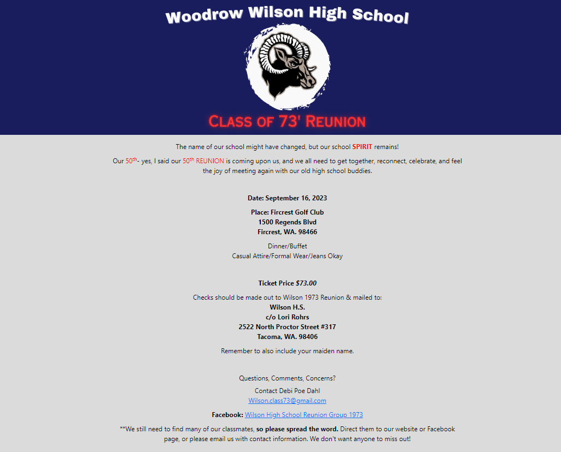

# 2 Form

* The form allows users to put their First Name, Last Name, Maiden Name, Email, Phone number in
* This was written in java script to get the values and submit to a google sheet
* Code was also done to verify email to check if there was a “@” and if all required fields are filled
  + If a field is missing or incorrectly filled, the input box will highlight red
* If the API fails the code sends them to a regular google form to submit
* If it is successful a message pops up that the submission was a success

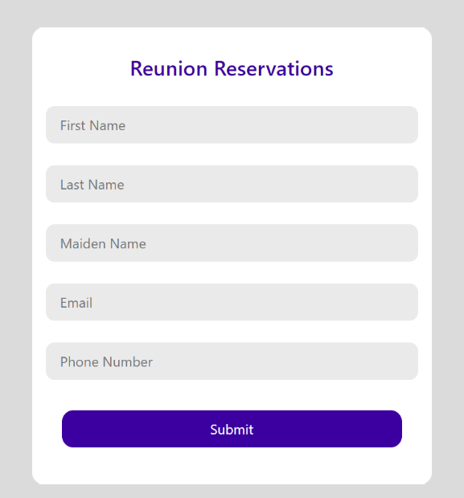

# Google Form

* Uses SheetsDB API to update google form
* Only can make 500 requests per month though

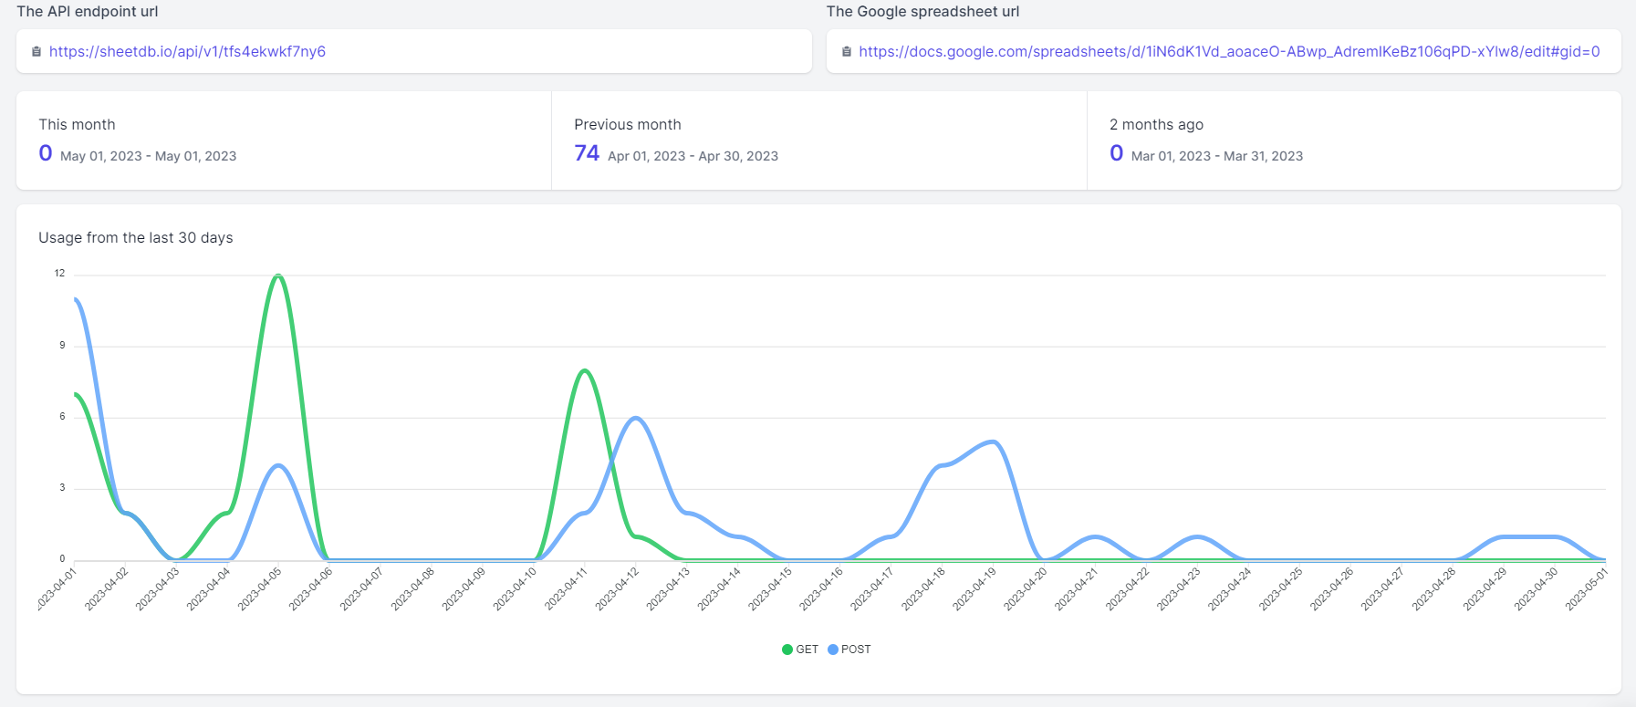

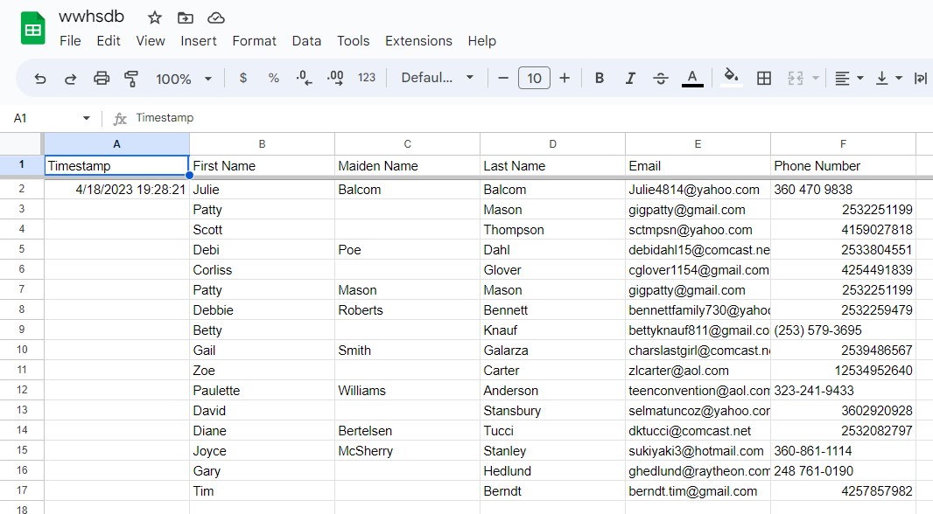

* Also has a google form in case API limit is reached or down

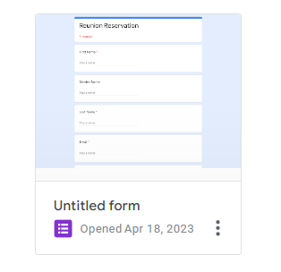

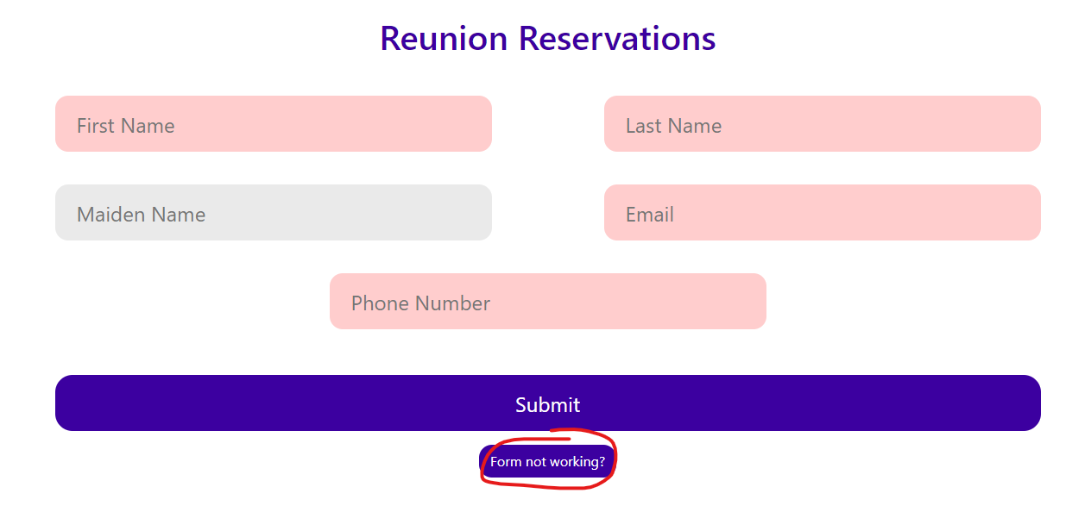

* Pressing “form not working” button will bring up the google form

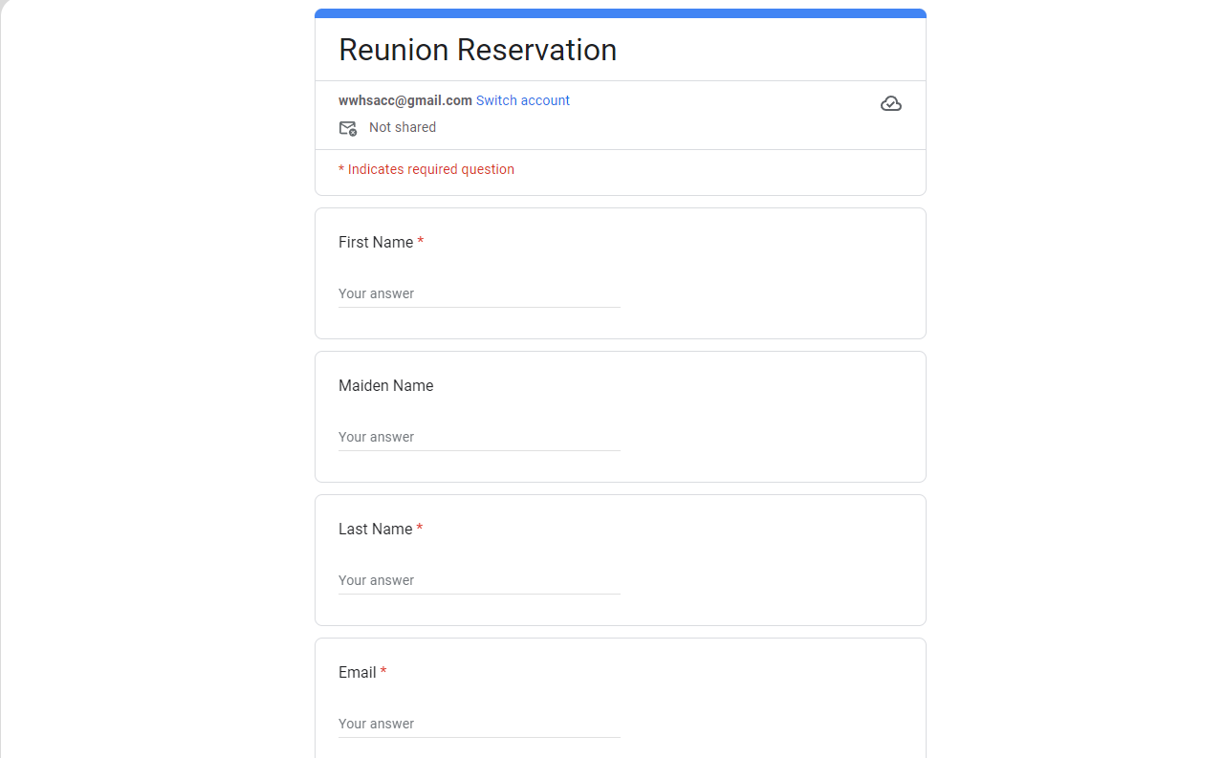

# 6| Activities Page

* Also made with html
* Divide each into div classses to clearly separate each activity
* Added borders as well
* We modeled it after a middle school bulletin site- specifically the clear margins between each event and box layout that supplements for readability

**Middle School Site:**

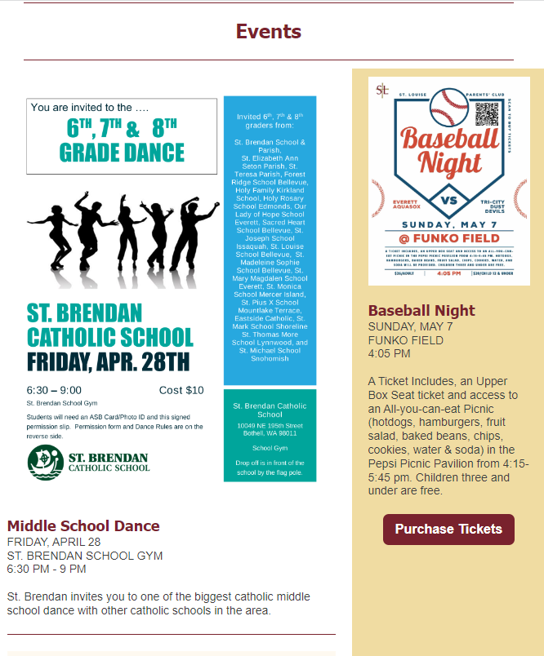

**Our Version:**

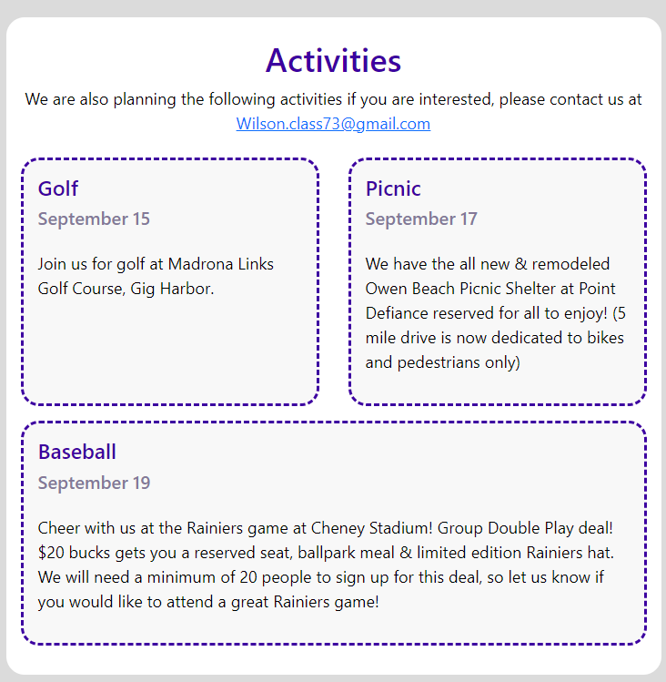

# 6 | Memoriam

* Set selected image as background image in CSS
* Made the image darker using CSS as well to create more readable text
* On larger screen you will have four columns of name due to Bootstrap
* On smaller screens, this interface organizes these names into two columns

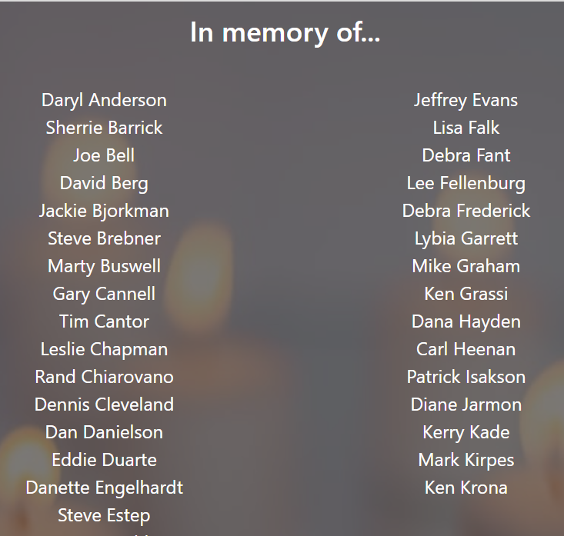**Small Screen Display:**

**Larger Screen Display:**

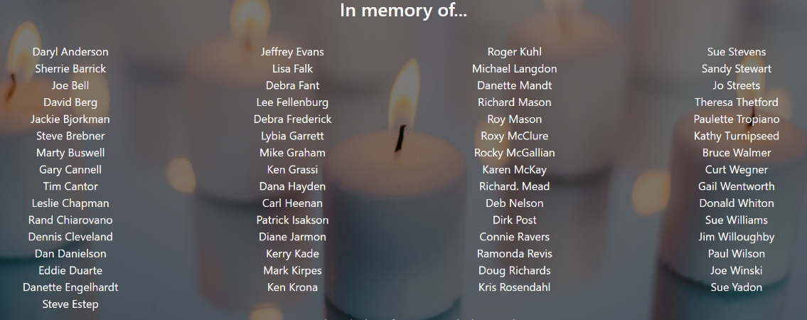

# 7 | Sql Database

# 8 | BoneYard

## 9| SQL Database

* Create a database that saves the users responses
* Have the form directly send information to it
* Have a designated person be the only person to see all information submitted by users

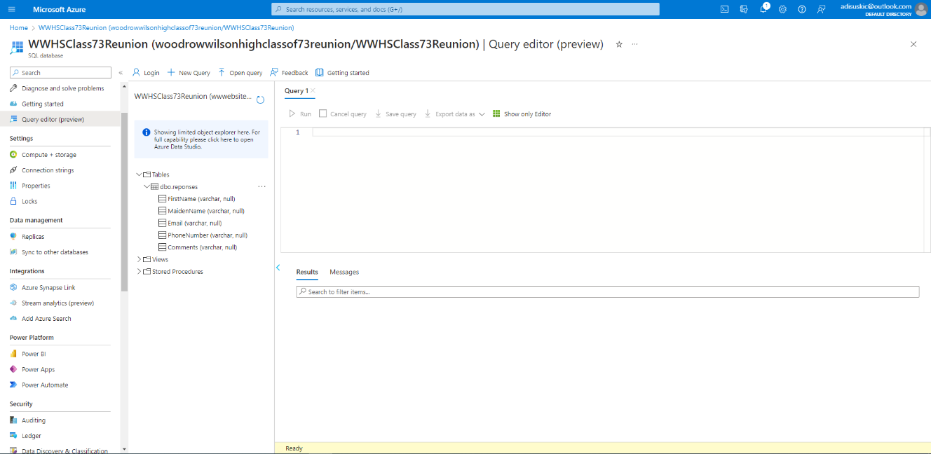

## PHP

* Mr. Magendanz wanted us to use javascript
* We did not have node.js so was unsuccessful

## Google Api