Clockwork Council

Controlled by Einstein’s Followers:

Wanted: An apprentice, skilled in both Physik and Mechanik. Standard hours and above average wages for the right Boy. Excellent chance of advancement in a rapidly growing industry. Apply at Number 3, Winston Road, Serious Applicants Only.

Controls Dolphins

Preliminary design sketch: The Dolphinator

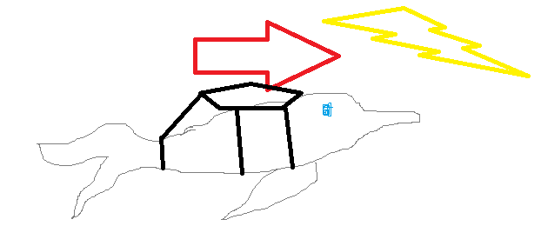

Controlled by Dolphins

Scribbled on the back of Master Frank Smith, Inventor’s hand:

No metal cogs near dolphins, drowning imminent

Controls Church of Nutrition

The Hatter was the first to break the silence. 'What day of the month is it?' he said, turning to Alice: he had taken his watch out of his pocket, and was looking at it uneasily, shaking it every now and then, and holding it to his ear.

Alice considered a little, and then said 'The fourth.'

'Two days wrong!' sighed the Hatter. 'I told you butter wouldn't suit the works!' he added looking angrily at the March Hare.

'It was the **best** butter,' the March Hare meekly replied.

'Yes, but some crumbs must have got in as well,' the Hatter grumbled: 'you shouldn't have put it in with the bread-knife.'

The March Hare took the watch and looked at it gloomily: then he dipped it into his cup of tea, and looked at it again: but he could think of nothing better to say than his first remark, 'It was the **best** butter, you know.' – Alice in Wonderland, Lewis Carroll