Freemasons

Controlled by Priests of Amon-Ra

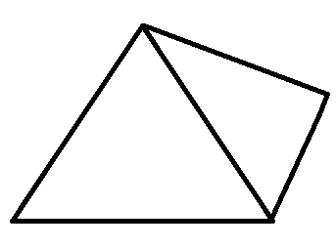

Controls Illuminati

An excerpt from ‘Alternative Methods of Communication’ by J.D. Editus

…take for example the curious wall messages that began appearing in London and New York in May of 1921. The closest approximation is as follows:

øĴ∞Ǿɣ

and as yet no proper translation has been discovered. Burt Haddock once claimed that the message reads “Rejoice, for the Stone has conquered the Light” but no further evidence has been found to support this, and Haddock himself disappeared in mysterious circumstances soon afterwards.

Controlled by Illuminati

An excerpt from ‘Alternative Methods of Communication’ by J.D. Editus

…take for example the curious wall messages that began appearing in London and New York in May of 1921. The closest approximation is as follows:

øĴ∞Ǿɣ

and as yet no proper translation has been discovered. Burt Haddock once claimed that the message reads “Rejoice, for the Light has conquered the Stone” but no further evidence has been found to support this, and Haddock himself disappeared in mysterious circumstances soon afterwards.

Controls Aether Research Society

Text from a fortune cookie:

And stone is to air as fish is to a bicycle.