**Machine Learning: Supervised Classification  
A comparison of different algorithms**

**-State of The Art-**

For this project, I decided to compare results of different classifiers for supervised machine learning on the same data set. The data set I chose for this experiment is a set of songs with different attributes (e.g. artist name, tempo, key, mode etc.) that are classified in different genres.

**Music Genre Classification using Machine Learning Algorithms: A comparison**

**Authors**: Snigdha Chillara, Kavitha A S, Shwetha A Neginhal, Shreya Haldia, Vidyullatha K S

**Article source**: <https://d1wqtxts1xzle7.cloudfront.net/59934287/IRJET-V6I517420190704-120568-1u4iafr-libre.pdf?1562308085=&response-content-disposition=inline%3B+filename%3DIRJET_Music_Genre_Classification_using_M.pdf&Expires=1684803507&Signature=WRTSjL3UdTHE0T9jsEaX1hgpdX~mgVYLSOGDG-G0KTVXLdzpzPyofUC8GJFrNDB4~uUglGKSJmAlCxVPKYp6f2TLSnQrRELnbgZTdwGtLYHHo8pz3~GZbxhwcn4klIqLJAOmHq9UvB6eRbwnahWYgFoQzaRa-ljxG4bwNculU1-R3QJ96nGRS~pUUcvsz2tKfKJn9-WQslx~8lJ~iNWdaMJ3cfCp9pPbd~1H7r6U5pqVnxI7NorHnwceQXLkr32rwMQa~vnEpscYVmFe4oBahPKLyTncQsHCp271RXjKDCPdWrEXbSD3P5YMZbaEc-a84-EXcub39d8CK8qv2S1xig__&Key-Pair-Id=APKAJLOHF5GGSLRBV4ZA>

**Main purpose**: In this article, the authors intend to find a better machine learning algorithm than the models that predicts the genre of songs. To do this, they train multiple algorithms over the Free Music Archive (FMA) and compare their results in terms of prediction accuracies. For the songs, they use spectrograms and audio features. Music Analysis is done based on a song’s digital signatures for some factors, including acoustics, danceability, tempo, energy etc., to determine the kind of songs that a person is interested to listen to.

**Objectives**:

1. Developing a ML model that automatically classifies music into genres based on different features, instead of manually doing it.
2. Reaching good accuracy so that the program predictions are reliable.
3. Obtaining better results than at least a few pre-existing models.

**Dataset:** They made use of a subset of FMA that is a balanced dataset which contains audio from 8000 songs arranged in a hierarchical taxonomy of 8 genres. This set has 30 seconds of audio and also pre-computed features, tags and free form text such as biographies. It also contains track level and user level metadata. As it can be seen in the next table, the data is actually perfectly balanced, having an equal number of songs for each music genre.

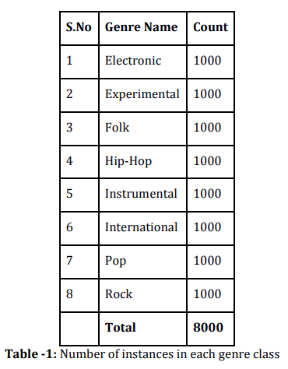

**Methodology:**

1. *Deep Neural Networks*: They use Convolutional Neural Networks (CNN) to classify images – the spectrograms of the audio resources from the dataset.

A spectrogram is a 2D representation of a signal, having time on the x-axis and frequency on the y-axis. In this study, each audio signal was converted into a MEL spectrogram (having MEL frequency bins on the y-axis). They observe that there exist some characteristic patterns in the spectrograms of the audio signals belonging to different classes. Hence spectrograms can be considered as ‘images’ and can be given as input to a CNN.

They want to analyze the performance that can be achieved by the CNNs, so they trained a Convolutional Recurrent Neural Network, which is a combination of convolutional neural networks and recurrent neural networks. These are a type of artificial neural network designed to recognize patterns in sequences of data. RNNs are applicable even to images, which can be decomposed into a series of patches and treated as a sequence.

1. *Feature extraction*: They extracted features that can be split in two categories:
   1. *Time domain features:*
      1. Central moments – mean, stdev, skewness and kurtosis of the amplitude
      2. Zero crossing rate (ZCR) - the point where signal changes sign from positive to negative
      3. Root mean square energy - calculated frame by frame and then the average and standard deviation across all frames is taken.
      4. Tempo – how fast or slow a piece of music is
   2. *Frequency domain features:*
      1. Mel-Frequency Cepstral Coefficients (MFCC)
      2. Chroma Features - a vector which corresponds to the total energy of the signal in each of the 12 pitch classes. (C, C#, D, D#, E ,F, F#, G, G#, A, A#, B). Then the aggregate of the chroma vectors is taken to get the mean and standard deviation
      3. Spectral Centroid - corresponds to the frequency around which most of the energy is centered
      4. Spectral Contrast
      5. Spectral Roll-off - corresponds to the value of frequency below which 85% of the total energy in the spectrum lies
2. *Classifiers:*
   1. *Logistic Regression:* This linear classifier is generally used for binary classification tasks. For this multi-class classification task, the LR is implemented as a one-vs-rest method.
   2. *Simple Artificial Neural Network:* An artificial neuron network (ANN) is a computational model based on the structure and functions of biological neural networks. This model takes a csv file of the handcrafted features that are extracted from the audio clips using librosa library and gives an output with the functionality similar to the Logistic Regression logic that is described above.

**Evaluation and Results**

1. *Metrics*: as a metric they chose to use accuracy.
2. *Results*: The best performance in terms of accuracy is observed for the CNN model that uses only the spectrogram as an input to predict the music genre with a test accuracy of 88.54%.

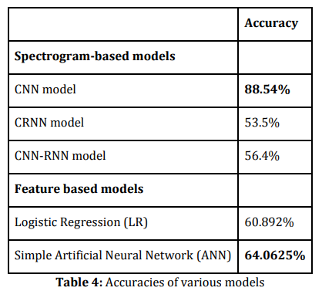

**Performance Comparison of Machine Learning Classifiers for Fake News Detection**

**Authors**: Smitha. N, Bharath .R - Department of Computer Science & Engineering, CMR Institute of Technology Bengaluru, India

**Article source**: <https://www.researchgate.net/profile/Smitha-Nl/publication/344050009_Performance_Comparison_of_Machine_Learning_Classifiers_for_Fake_News_Detection/links/608107788ea909241e16da7f/Performance-Comparison-of-Machine-Learning-Classifiers-for-Fake-News-Detection.pdf>

**Main purpose**: In this paper, the authors present a comparison on six different Machine Learning classification algorithms for solving the problem of fake news detection. The classifiers are compared considering accuracy, F1 Score, recall, precision.

**Methodology**:

1. *Text Collection*: Datasets are collected from Kaggle, and texts are extracted from 244 websites.
2. *Text Pre*-Processing
   1. All letters are converted to lower case
   2. Numbers are removed
   3. Punctuation and accent marks are removed
   4. White spaces are removed
   5. Stop words are expelled
3. *Feature Extraction*
   1. Bag of Words – this approach takes any text and counts the frequency of words after removing stop words
   2. Countvectorizer - The Count Vectorizer gives a basic method to both tokenize an assortment of content archives and fabricate a jargon of known words, yet additionally to encode new reports utilizing that jargon. An encoded vector is a comeback with a length of the whole jargon and a whole number mean the occasions each word showed up in the record.
   3. TF – IDF – In the next formulas: TF = (Number of times term t appears in a document)/ (Number of terms in the document); N is the number of archives and n is the number of archives a term t has appeared in word

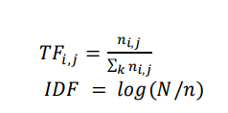

**

* 1. Word Embedding using Spacy - This follows a feature representation concept to produce a vector. Here low dimension, a dense matrix is achieved. Spacy is a Natural Language Processing library used for word embedding to generate numeric vectors which represent a word. It is memory intensive and has undesirable effects.

1. *Classifiers*
   1. Support Vector Machine (SVM) - Machine to precisely classify SVM is used. Unoptimized decision boundaries could result in misclassification, to overcome this SVM are considered as important by looking at extreme cases. Nonlinear SVM could be converted into linear by using some functions. Calculation creates the most ideal hyperplane which characterizes new data normally.
   2. Logistic Regression - It is used for binary classification. Linear regression is used every time to create the best bit line for binary classification.
   3. Random Forest - It’s a troupe tree-based learning calculation. Builds multiple decision trees and merges them to produce more accurate and stable predictions. Trained with the bagging method. High variance obtained in the decision tree converted into low variance by using row sampling and feature sampling.
   4. Gradient Boosting - Machine learning gradient boosting used for regression and classification. It’s a boosting technique. Leaf represents an initial prediction, which is log(odds) which is used for classification, this is converted into a probability with logistic function.
   5. XG – Boost - It’s an extreme Gradient boosting. Designed to be used with large and complicated datasets. It’s an ensemble method, regularized boosting by preventing overfitting.

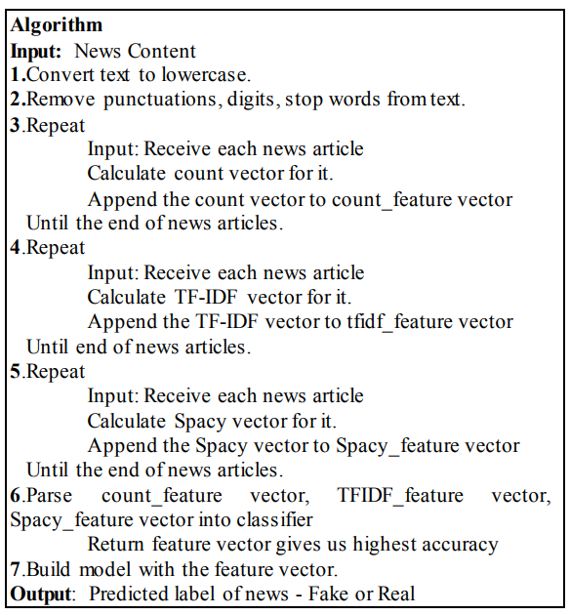

**Evaluation and Results:** Table I. shows performance evaluation of ML classifiers with a count vector where different metrics are used. Table II. shows performance evaluation of ML classifiers with TF-IDF where different metrics are used, same with Table III. for word embedding.

