

**FACULTATEA: Automatică și Calculatoare  
SPECIALIZAREA: Calculatoare Engleză  
DISCIPLINA: Programare Orientata Pe Obiect  
PROIECT: Questions & Answers Application**

**Îndrumător laborator: Studenți:**

**As. Aron Baka-Balint Bumbuc Ioana**

**Cupșa Bogdan**

**Gr. 30421**

**Project Description**

Design an application for asking and answering questions. The user should be able to see questions asked by other users as well as the answers given by the other users. The user can in turn ask their own question and wait for people to answer or answer the questions that already exists. There is a list of categories for the Q&As: Cars, Beauty & Fashion, Love, Music, Sport, Science & Technology.

The user has to log in before entering and there’s the possibility of creating a new account before accessing the content.

**User Interface**

When opening the app, the user is greeted with the login page, where they enter the username and password. If they’re new on the app, they can press on “Register” which opens the registration page.

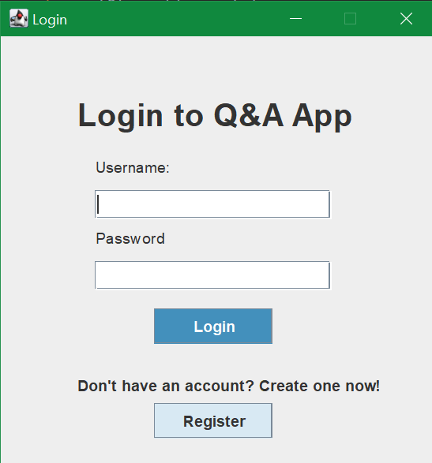

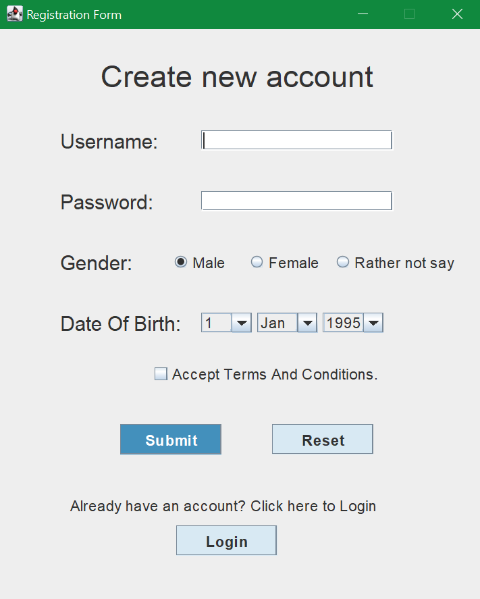

After completing login / registration, the user is directed to the main page of the Q&A app. It displays the most recent questions, as well as buttons for categories and a button for asking their own question.

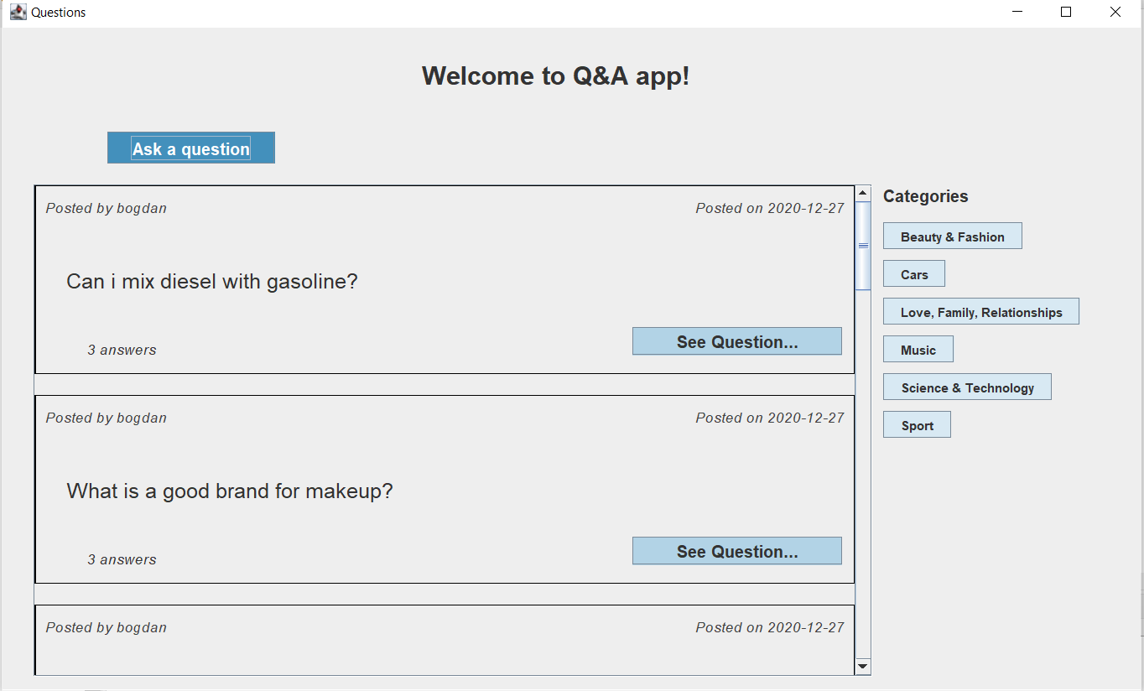

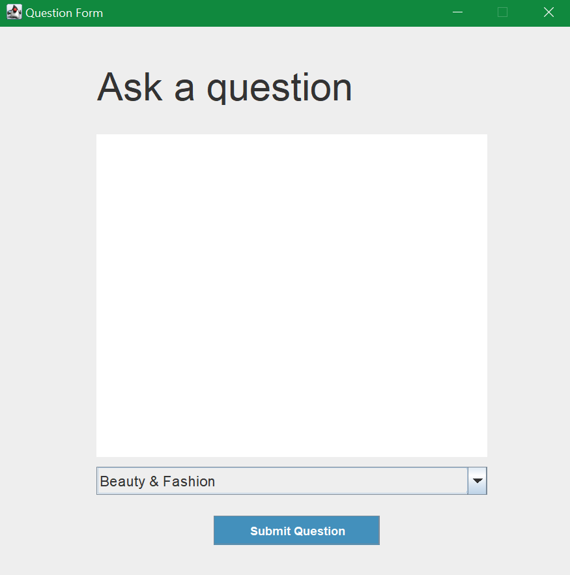

The next image is the page for a single question, where the user can read the provided answers and also answer themselves.

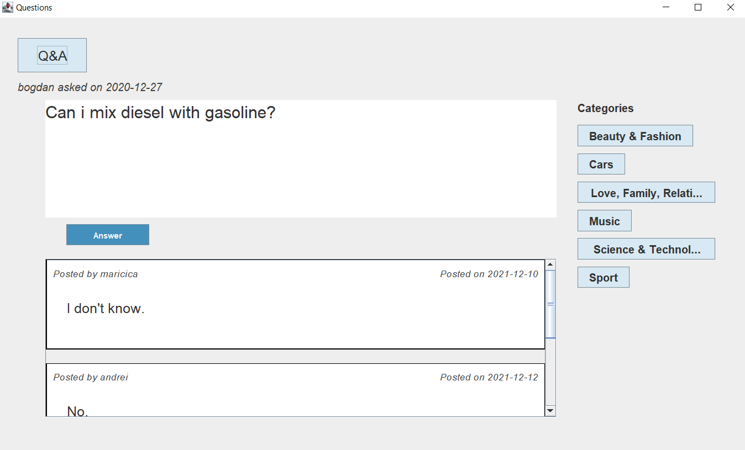

**Data Base**

All questions, answers, login data and so on is stored in the data base. The tables we created are:

* Date – contains login data for each profile
* Questions – contains the question and the category.

Queries were used to retrieve questions depending on the category selected. When a new account is created, it is added to the data base. This happens also when adding a new question

**Use Cases**

**Asking a question – Steps:**

* Login or create account if you don’t already have one
* Click on “Ask a question” on any of the main pages
* Write your question in the text box
* Choose the category where the Q should be displayed
* Press “Submit”
* Click on the chosen category to see your posted question

**Answering a question – Steps**:

* Register or login to the app
* Browse for a question in the main page or choose a category
* Press on “See Question…”
* Press on “Answer”
* Write your answer then press “Submit”

**Solution**

The architecture used for designing the solution is MVC – model, view, controller.

Everything related to user experience belongs to View. In this case, the design of the pages, categories, login or register pages all are part of the view package. The classes created are:

* View – for the main page
* QuestionView – when clicking on “See question…”
* RegistrationView and LoginView
* AnswerView and AddQuestionView – provides the interface for the user to add their own question or answer
* Classes for all categories of questions – Beauty, Cars and so on

In our application, model contains all data that is relevant for the app. Controller makes the connection between model and view, providing, for example, the functionality of the buttons. The model also connects to the data base of the app, in which we store the questions, answers as well as user data (username, password etc.).

**Further Improvements**

*“The biggest room in the world is the room for improvement.”* (Helmut Schmidt)

There are a few improvements that could benefit the Q&A App, on both the user experience part as well as functionality. Related to user experience, the app can be enhanced by adding a few elements that contribute aesthetically, such as: round buttons, profile pictures for users, a “Frequently Asked” section, the ability to remain connected between sessions or remember the username and password.

Considering the functionality, the app can be improved by adding a return button. The app has a button that can take the user back to the main page when accessing another, but there’s no button to take the user back to exactly the page that they were accessing before. Another improvement can be the ability to see your posted questions separately and get a notification when your question has been answered.