Implementation

1. Input

As input, the algorithm uses two XML files, one for the pattern-tree and one that contains the XML tree to be searched for patterns. We chose to model the tree-pattern query as an XML and not give it as a string for two main reasons. Firstly, we avoided parsing the string and extracting the pattern-tree from it. The parsing of the pattern-tree can be done using a SAX parser. And second, the way the input is processed does not influence the execution of the algorithm, so we preferred to focus on the algorithm rather than the input format.

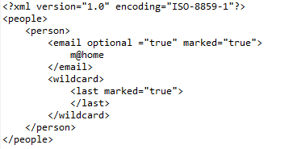

Figure 1. Pattern-tree XML file

As figure 1 shows, the pattern-tree can be easily modeled by using XML tags named after the searched nodes. To support optional nodes, the attribute “optional” can be set true. The nodes that are to be returned as part of the result have an attribute “marked”. For these two attributes, the default value is false. Value predicate are inserted by adding text to the node. As the XML tag names can’t contain the “*” character to mark a wildcard node, we opted for a keyword “wildcard” to mark such nodes. ATTRIBUTES.

The pattern-tree is stored in an tree-like structure, where each node is a PatternNode object. Figure 2 shows the attributes of this class. The names of the attributes are self-explanatory. The parsing of this XML file into the tree structure is implemented in InputParser.java.

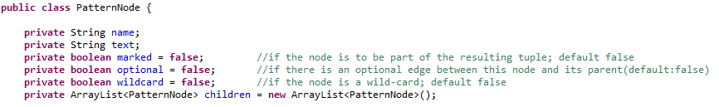

Figure 2. Attributes of PatternNode objects

1. Basic algorithm

**Entities** – The entities of the basic algorithm are abstracted by TPEStack.java, PatterNode.java and Match.java. The nodes in the tree-pattern are represented by a PatternNode object. For each node, a TPEStack is created. The stack contains all the matches found for the corresponding node. There is a one-to-many relation between the TPEStack and the Match objects. Each Match objects contains a reference to its parent Match, the one is linked to, and its child Matches. These references translate into the relation between the nested XML nodes in the analyzed XML file.

**TP algorithm** - The algorithm is implemented in the StackEval class. By using the SAX parser, the class implements the ContentHandler interface. The parsing of the XML file is done by implementing the startElement(...) and endElement(…) methods. The nodes in the XML file are numbered. The opened tags are monitored through a stack which contains the number of the opened XML element. All the TPEStack are held in a list. They will be used during the execution.

* 1. startElement(String uri, String localName, String qName, Attributes attributes) – when encountering a new tag, the TPEStack list is searched for a TPEStack that corresponds to the node that matches the name of the current opening tag. Additionally, if there exists an open tag for the parent of this node in the tree-pattern, then the match is valid and added in TPEStack corresponding to the current PatternNode. This Match is also linked to parent Matches, to keep the tree structure inside the matches. Next, the attributes of the opened tag are checked, in the same manner. Finally, the numbering of the open tags is incremented and the current value is pushed in the open tags stack.
  2. endElement(String uri, String localName, String qName) – when encountering an end tag, the algorithm searches in the list for a TPEStack that corresponds to the node that equals the name of the tag. Again, if there exists an open parent tag and there is a recorded match for this tag, the tag is closed, to keep it in the Match stack inside the TPEStack, but to skip it in following steps. Further pruning is done by checking if the closed Match has all the child Matches, by inspecting the list of children. If at least one child match is missing, the entire match is removed and detached from its parent match.

At the end of the execution, the matches are found in the TPEStack object corresponding to the root PatternNode of the tree-pattern.

**Tuples extraction algorithm** – To compute the resulting tuples, the TPEStack associated with the root node of the tree-pattern is traversed. For each match in the stack, the tree that results when adding the children matches and their descendants is traversed depth-first recursively to obtain the numbers assigned to the matching nodes. In Printer.java, two collection methods are implemented: one for all the matching nodes in the tree-pattern, and one only for the marked nodes.

1. Extensions
   1. Optional nodes

The optional nodes are denoted by an attribute “optional” in the XML file of the tree-pattern and a field in the PatternNode object. The feature is dealt with in the endElement(…) method of the evaluation algorithm. Only the non-optional children of the match are checked. The optional child matches are ignored, since it doesn’t matter if they exist or not.

* 1. Wildcards

The wildcard node in the tree-pattern can be substituted for any node in the XML file. Both startElement(…) and endElement(…) methods are modified. When opening/closing an XML tag, the list of TPEStacks is searched not only for TPEStacks of the nodes whose name equals the name of the tag, but also for a TPEStack that is linked to a node named “wildcard”. This reasoning was explained in the Input paragraph of this section.

* 1. Value predicates

To implement this extension, during the SAX parsing of the document, the text between element tags is stored in a HashMap. The keys of the map are the numbers associated with each tag. Storing and retrieving the text is easy. The text is collected by implementing the characters(**char**[] ch, **int** start, **int** length) method and adding the found text in the HashMap, using as key the preorder number of the last open tag.

Since the PatternNodes have a field “text” that store the value predicate, the only alteration to the algorithm that needs to be done is in the endElement(…). Before checking for child matches, the algorithm checks if there exists a value predicate that needs to be matched and compares it to the text stored in the Map, at the entry set by the number of the tag.

* 1. Subtrees as results

The final extension refers to the formatting of the output: returning subtrees and not only preorder numbers of the tags. The algorithm follows the same implementation as the one for extracting the tuples. Instead of adding the preorder numbers, they are used to retrieve data from the HashMap that contains the collected text elements. This text is wrapped in the name of PatternNode, surrounded by angle brackets.

Example run:

Input: a. tree-pattern [treepattern.png]

b. the example from the book. [XMLexample.png]

Output: [results.png]