**Framework Design – Project**

**Web component element – *json-to-table***

**Solovan Ioana, 248-2**

json-to-table is a web component to present data from a JSON file as a HTML table

**Examples:**

* **Normal**

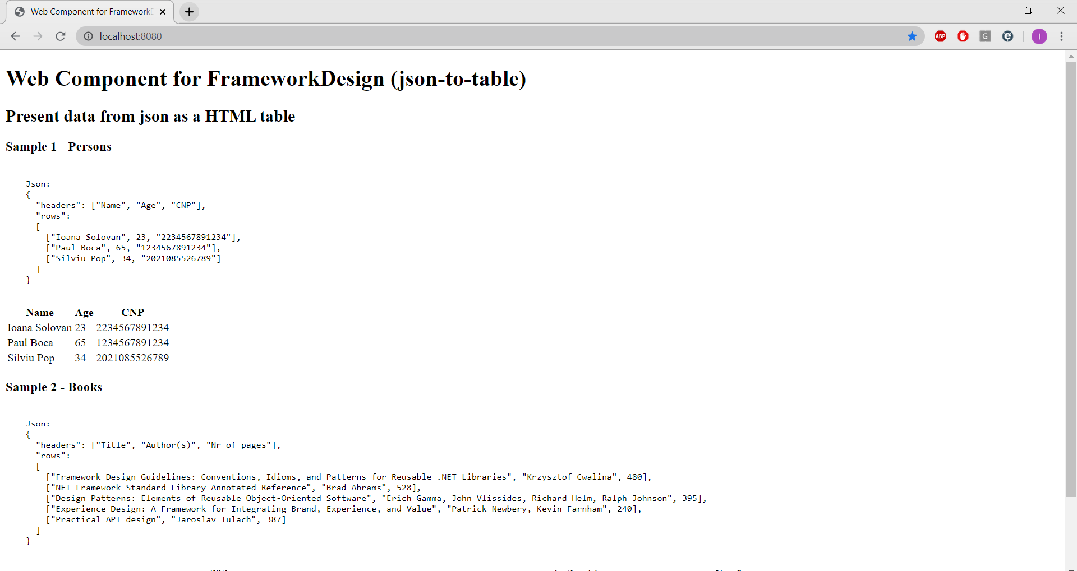

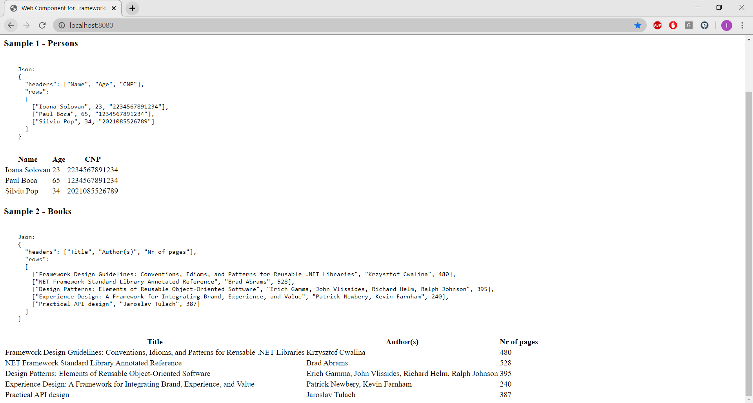

* **With a CSS file (my-style.css)**

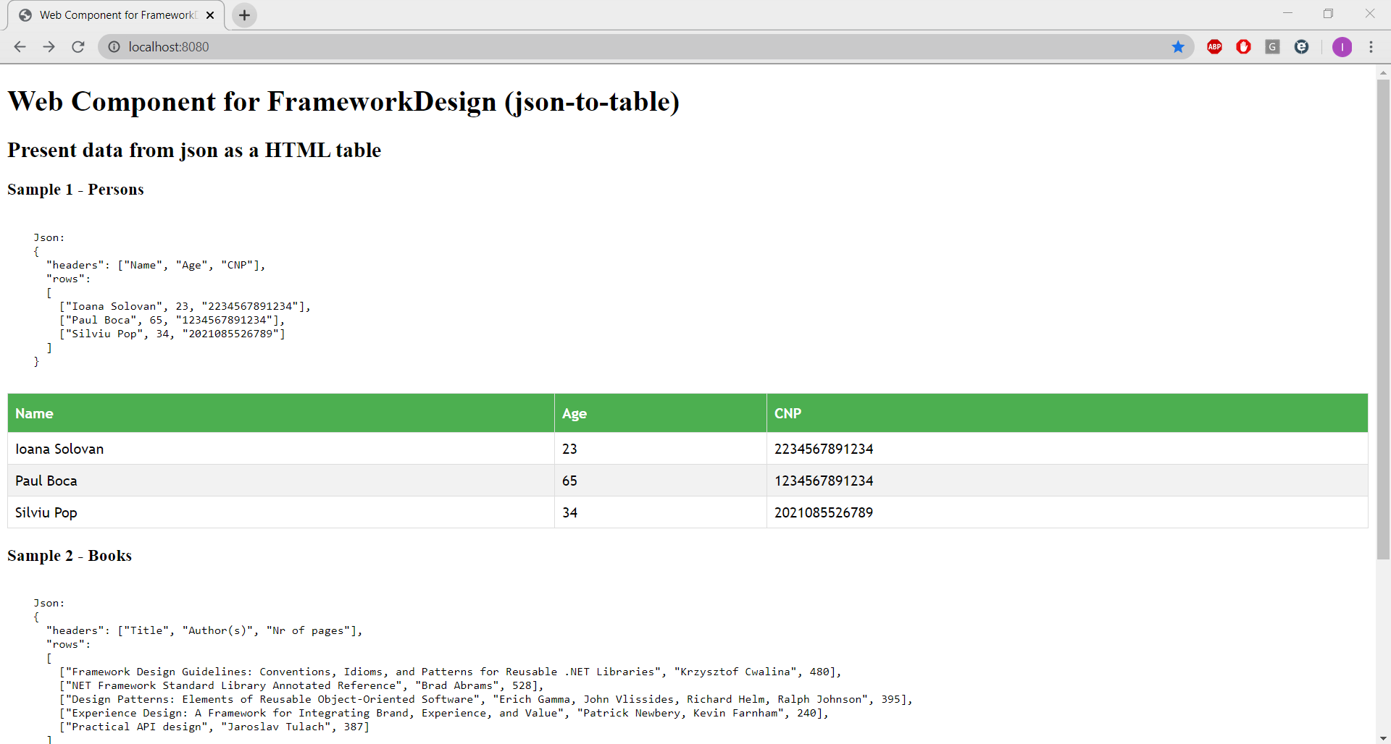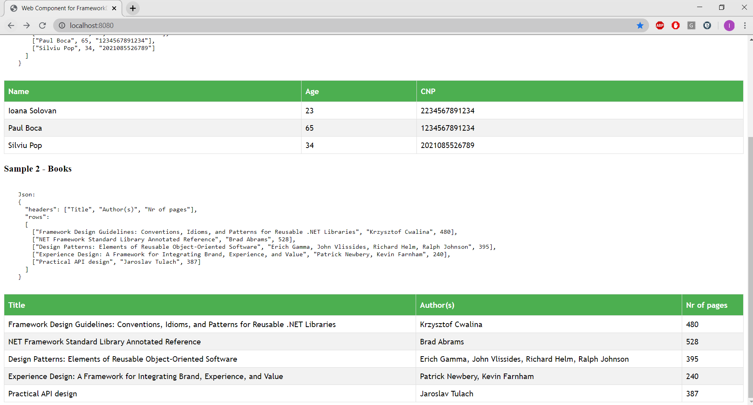

**Where my-style.css:**

table {

  font-family: "Trebuchet MS", Arial, Helvetica, sans-serif;

  border-collapse: collapse;

  width: 100%;

}

th, td {

  border: 1px solid #ddd;

  text-align: left;

  padding: 8px;

}

tr:nth-child(even){background-color: #f2f2f2}

tr:hover {background-color: #4CAF50;}

th {

  background-color: #4CAF50;

  color: white;

  padding-top: 12px;

  padding-bottom: 12px;

}