A Hybrid Graph and Content-Aware Recommendation System for an Online Toy Shop
Course: Machine Learning and Content Analysis
Project: Odos Ermou Toy Recommendation System
Members: [Add full name(s) and student ID(s)]
Date: [Add submission date]

Abstract
This project develops and evaluates a local product recommendation system for an online toy shop. The system learns from 14,178 historical order lines, representing 9,727 orders and 6,257 products, collected between April 2019 and June 2026. Products are represented as nodes in a weighted co-purchase graph. The project combines direct co-purchase evidence, Node2vec-style product embeddings learned with Skip-Gram and negative sampling, structured content metadata, and word/character TF-IDF similarity over product names. A chronological train/development/test protocol protects the final evaluation from model-selection leakage.
The historical test-frozen model assigns 40% of its score to direct co-purchase evidence, 30% to Product2Vec, and 30% to metadata similarity. It improves Hit Rate@10 from 0.293 to 0.373, MRR@10 from 0.112 to 0.154, and catalog coverage from 0.068 to 0.076 on the one-time test set of 75 eligible basket-completion queries. Rare-product Hit Rate@10 rises from 0.108 to 0.162, although this remains the main weakness. A subsequent development-only product-page experiment adds TF-IDF. The selected 40% co-purchase, 10% Product2Vec, 10% metadata, and 40% TF-IDF blend raises dedicated one-SKU development HR@10 from 0.316 to 0.408 and MRR@10 from 0.165 to 0.214. This candidate has not been reevaluated on the old test period. On 24 genuinely later orders, the unchanged candidate achieves HR@10 of 0.292 and MRR@10 of 0.225. An expanded retrieval variant reaches full-pool recall of 1.000 but does not improve top-ten results, so frozen V1 remains selected. The final system is packaged as a persisted local model and a Streamlit product-page interface with one combined Προϊόντα που μπορεί να σας αρέσουν shelf, inventory restrictions, score explanations, and CSV export. The Streamlit shelf uses the new four-signal candidate; the older test figures remain explicitly historical. Online customer impact still requires separate measurement. No external API or personal customer profile is required.

Table of Contents
Open in Word and update this field to display page numbers.

1. Introduction

1.1 Our Project
Online shops often contain thousands of products, making it difficult for a customer to discover relevant accessories, alternatives, or products belonging to the same theme. The business problem addressed in this project is therefore:
> When a customer views one product, which similar alternatives and frequently > co-purchased complements should appear in the combined recommendation shelf?
The project focuses on product-to-product recommendation rather than user profiling. Historical orders provide implicit evidence: two products appearing in the same order form a co-purchase relationship. Structured catalog fields provide content evidence even when a product is rare. For example, purchase data may connect a LEGO set to a storage box, while metadata can identify other LEGO sets as alternatives. The product page combines these relationship types in one ranked list and exposes their component scores for interpretation.
This distinction between complements and substitutes guided the model design. Co-purchase relationships usually indicate complements. Product metadata often indicates substitutes or thematically similar products. The final hybrid uses both signals, allowing the system to remain behaviorally grounded while improving representation of the long tail.

1.2 Our Vision and Goals
The vision is to create a recommendation system that is useful to the shop, methodologically defensible for an academic project, and simple enough to run locally. The concrete goals are:
- discover recurring product combinations in order baskets;
- construct an interpretable product graph with normalized relationship
strengths;
- learn dense representations of graph position with an NLP-inspired
Skip-Gram architecture;
- integrate structured product content without allowing broad metadata hubs
to dominate behavior;
- compare baselines and model variants on chronologically later orders;
- investigate rare products and other error segments, rather than reporting a
single aggregate accuracy value;
- prevent repeated use of the final test set during model selection; and
- deploy the frozen model through an inventory-aware interface.
The project does not attempt to personalize by customer identity. It also does not optimize price, margin, stock, diversity, or conversion because these signals are not available in the analytical dataset. Those limitations define future work rather than hidden assumptions.

2. Methodology

2.1 Data Collection
The source is a private WooCommerce Excel order export. The workbook contains order identifiers, timestamps, order status, SKU, product name, quantity and value fields, and Greek/English catalog attributes. The raw export is excluded from Git because it may contain billing, shipping, or location information. Versioned results exclude names, contact details, addresses, and locations; query-level reproducibility files retain only internal order IDs and SKUs.
Rows with a missing order identifier or unusable SKU are removed. The requested policy retains every exported order status, including cancelled, failed, pending, pickup, refunded, and completed orders. This choice treats an unsuccessful transaction as possible evidence of shopping intent. It is not assumed to be universally correct: status policies are compared on development data, and the all-status policy is retained because it performs best there.
No external API, web scraping, or third-party customer data is used. All processing is reproducible from the local workbook and source code.
A second private WooCommerce CSV supplied the strictly future evaluation. The frozen cutoff and order-overlap checks leave 370 lines from 287 new orders, dated 19 June 2026 at 22:16:17 through 25 August 2026 at 13:20:29. The period contains 253 unique SKUs: 153 known to frozen history and 100 unseen there. Only 24 orders contain at least two known products and qualify for the one-SKU evaluation. All statuses, including cancelled orders, remain included. The raw CSV stays outside Git; its SHA-256 fingerprint is recorded with the results.

2.2 Dataset Overview
After basic validation, the dataset has the following shape:
Property | Value
Order lines | 14,178
Distinct orders | 9,727
Distinct SKUs | 6,257
First timestamp | 15 April 2019
Last timestamp | 19 June 2026
Single-product orders | 7,436 (76.5%)
Multi-product orders | 2,291 (23.5%)
Mean distinct products per order | 1.46

The high proportion of single-product orders is important. Only multi-product orders can directly provide basket-completion queries, and sparse co-purchase data makes rare products difficult. The development and test evaluations therefore contain far fewer queries than total orders.
The catalog uses six principal content fields. Missing catalog values are represented as Unknown after aggregation:
Content field | Unknown products | Share of catalog
Product name | 0 | 0.0%
Product category | 0 | 0.0%
Brand | 584 | 9.3%
Age | 1,026 | 16.4%
Hero/franchise | 4,746 | 75.9%
Gender | 1,025 | 16.4%

Hero/franchise is especially incomplete, so it receives less weight than category or age. Missing content is excluded from similarity calculations rather than treated as a meaningful shared value.

2.3 Data Processing, Annotation, and Normalization

Validation and text preparation
The loader verifies the required order ID, status, and SKU fields. Text is HTML-unescaped, Unicode-normalized with NFKC, stripped, and collapsed to single whitespace. Textual missing markers such as nan, none, null, and n/a become actual missing values. SKUs are retained as strings so leading zeroes are not lost.

Annotation strategy
The project uses existing product attributes as weak structured annotations: category, brand, age, hero, and gender. It does not claim that these fields were manually annotated for this experiment. One catalog row is built for each SKU; when order lines disagree, the most frequent non-null value is selected. This creates deterministic product-level labels while acknowledging that source metadata can be incomplete or inconsistent.

Basket construction
Order lines are grouped by order ID. Duplicate occurrences of a SKU inside one order are collapsed, so a pair count measures orders containing both products, not purchased quantity. Every unordered product pair in a multi-item order becomes graph evidence.

Co-purchase normalization
Raw pair frequency favors globally popular products. The selected graph uses a cosine-style association:
w(i,j) = c(i,j) / sqrt(c(i) × c(j))
Here, c(i,j) is the number of baskets containing both products and c(i) is the number containing product i. For ranking direct neighbors, directional confidence is used:
confidence(i → j) = c(i,j) / c(i)
This answers a practical question: conditional on observing product i, how often was product j also present?

Time normalization
The selected model applies a six-month exponential half-life relative to the end of each training period. Recent baskets contribute more than old baskets, while no development or test timestamp influences training weights. The method adapts to assortment and demand changes without discarding older evidence.

2.4 Algorithms, NLP Architectures, and Systems

FP-Growth
FP-Growth compresses baskets into a frequent-pattern tree and mines recurring itemsets without generating the large candidate sets required by Apriori [1]. The project uses minimum support 0.002 and limits reported sets to three SKUs. This stage is mainly descriptive: it exposes common combinations and validates that the basket construction is plausible.

Co-purchase graph
Each SKU is a node. An undirected edge exists when two products occur in the same basket. The deployment graph has 6,257 product nodes and 8,841 edges. It is sparse, so removing edges with pair count below two or three loses valuable long-tail information. Direct recommendation aggregates evidence from every product in the input cart.

Product2Vec: Node2vec and Skip-Gram
Node2vec learns node representations by generating biased random walks that preserve graph neighborhoods [2]. A walk is treated like an NLP sentence: SKUs are tokens, and nearby walk positions form center-context examples. The local Skip-Gram model predicts graph context from a center product and uses negative sampling, following the representation-learning principle introduced for word embeddings [3]. The result is a 48-dimensional vector per known SKU. Candidate products are retrieved by cosine similarity to the normalized mean vector of the cart.
This is an NLP-inspired architecture, not conventional text-language understanding. The tokens are product and metadata nodes rather than words from descriptions. The distinction is important for accurate reporting.
Seeded reproducibility also requires deterministic traversal. Product nodes, neighbors, metadata memberships, and graph insertions are sorted so Python set or insertion order cannot change walks across separate processes.

Adamic–Adar link prediction
Adamic–Adar scores an unobserved link through shared graph neighbors, giving more weight to uncommon neighbors [4]:
AA(i,j) = Σ 1 / log(degree(z))
The initial cart recommender included Adamic–Adar. Controlled blend selection assigned it zero final weight, indicating that it added no development value after direct co-purchase, Product2Vec, and metadata were present. Reporting a zero weight is an experimental result, not an implementation failure.

Structured content similarity
Content similarity is a weighted average of field-level Jaccard overlaps. Selected field weights are category 0.35, age 0.25, brand 0.20, hero 0.15, and gender 0.05. Unknown values are ignored. Metadata may supply candidates that have little behavioral evidence, which is useful for rare products.

Heterogeneous graph
The final representation graph includes product, category, brand, age, and hero nodes. Product-metadata edges have weight 0.05, compared with 1.0 for co-purchase. Their weight is divided by the square root of metadata-node degree, reducing the influence of broad hubs such as a common age group. Random walks may traverse all node types, but the recommender returns product SKUs only.

Product-name TF-IDF
Product names are Unicode-normalized and case-folded while preserving letters and product-code digits. The model builds word 1–2 grams and character 3–5 grams, calculates smoothed inverse document frequency with log-scaled term frequency, and L2-normalizes sparse vectors. Similarity combines 60% word cosine and 40% character cosine. The word channel captures phrases and brands; the character channel handles Greek/English spelling variation and related model codes. An inverted feature index provides retrieval without a full catalog-to-catalog comparison.

Final hybrid and software system
Each candidate source is min-max normalized before blending:
final_score = 0.40 × co-purchase
+ 0.10 × Product2Vec
+ 0.10 × metadata
+ 0.40 × TF-IDF product-name similarity
+ 0.00 × Adamic–Adar
The frozen configuration is refitted on all approved history for deployment and saved as a trusted local model. A Streamlit product page exposes one-SKU search, inventory uploads, score components, and CSV download. Its single Προϊόντα που μπορεί να σας αρέσουν shelf uses the development-selected four-signal score. The interface does not retrain or reevaluate the test set. The old 40/30/30 test configuration remains preserved separately.

3. Experiments: Setup and Configuration

3.1 Chronological split
Complete orders are sorted by time and kept intact:
Split | Orders | Lines | Unique SKUs | Multi-item orders | Period
Train | 6,808 | 10,310 | 4,797 | 1,810 | 2019-04-15 to 2024-07-13
Development | 1,459 | 1,995 | 1,164 | 265 | 2024-07-14 to 2025-08-21
Test | 1,460 | 1,873 | 1,035 | 216 | 2025-08-21 to 2026-06-19

A chronological split is more realistic than a random line split because it asks the model to predict a later period. Keeping orders intact prevents the same basket from leaking into two splits.

3.2 Evaluation task
The task is leave-one-out basket completion. For each eligible later order, one known product is hidden reproducibly and the remaining products form the query cart. Each order contributes no more than one query. The development stage has 76 eligible queries. The final test has 75 because a query requires at least two products and sufficient overlap with the fitted graph.
The order export does not contain a separate timestamp for each item added to a cart. Consequently, this is not next-item sequence prediction. It evaluates whether the hidden basket partner appears in the top ten recommendations.
This basket-completion task is an offline proxy for learning and comparing signals; it does not mean recommendations are placed on the cart page. The live interface starts from one viewed product and uses the same selected combined hybrid in one recommendation shelf.
To measure that interface more directly, a dedicated protocol evaluates the already-frozen configuration on development orders using exactly one viewed SKU and one hidden partner per order. Both must exist in the training catalog, and every eligible order receives equal weight. The same queries are used for global popularity, category popularity, co-purchase, Product2Vec, metadata, TF-IDF, and the hybrid. A coarse 0.10-step simplex search compares 84 blends in which all four production signals stay active. Candidate recall@100 distinguishes retrieval failures from top-ten ranking failures. The default command does not inspect the test split.

3.3 Controlled model selection
All selection occurs on train and development data. The search compares:
- four order-status policies;
- cosine, Jaccard, lift, and confidence graph variants;
- pair-count thresholds of one, two, and three;
- no time decay and half-lives of 6, 12, 18, 24, and 36 months;
- 20 seeded Product2Vec configurations selected by random search;
- 85 valid signal-weight combinations; and
- four hub-controlled heterogeneous metadata configurations.
Candidates are ordered by Hit Rate@10, then MRR@10, Recall@10, and catalog coverage. After the best development configuration is written to a frozen JSON file, a separate finalization command refits on train plus development and evaluates test exactly once. A sentinel output prevents accidental repeated test evaluation.

3.4 Selected configuration
Component | Selected value
Random seed | 42
Status policy | All exported statuses
Graph weight | Cosine
Direct ranking | Directional confidence
Minimum pair count | 1
Time-decay half-life | 6 months
Embedding dimensions | 48
Walk length | 8
Walks per node | 2
Skip-Gram window | 3
Negative samples | 2
Epochs | 2
Learning rate | 0.05
Node2vec p, q | 1.0, 1.0
Historical test blend | Co-purchase 0.40; P2V 0.30; metadata 0.30; AA 0.00
Product-page blend | Co-purchase 0.40; P2V 0.10; metadata 0.10; TF-IDF 0.40
TF-IDF channels | Word 0.60; character 0.40
TF-IDF n-grams | Words 1–2; characters 3–5

For submission, the exact final JSON configurations are separated from experiment outputs under model_configs/. The serving model is final_product_page_model.json, with a human-readable weight table in final_product_page_weights.csv. The earlier basket-completion model and its weights are preserved separately and labelled historical rather than serving. The experiment programs themselves are isolated under experiments/; reusable model implementations remain under src/.
The project distinguishes selected settings from learned parameters. Graph and Node2vec hyperparameters are listed in model_configs/final_model_hyperparameters.csv. The fitted 8,841 co-purchase edges and 7,029 retained 48-dimensional heterogeneous Node2vec vectors are exported under model_weights/, with hashes in export_manifest.json.

3.5 Model freeze and future assessment
The product-page candidate was frozen on 25 August 2026. Its manifest records SHA-256 fingerprints for the selected configuration, fixed 76-query set, and complete weight-search table. It also fixes the serving training cutoff at 19 June 2026, 14:28:25. Configuration integrity is checked before training or serving. Further tuning on the development queries and reuse of the historical test period are rejected by code.
The next valid offline estimate was required to use every eligible order strictly later than the cutoff, with no overlapping order IDs and no weight changes. The future-period command has no tuning mode and refuses to overwrite an existing result directory. It was run once on 24 eligible queries from 19 June through 25 August 2026. Frozen V1 and the already-defined expanded-candidate V2 were compared on identical queries with K=10, candidate recall at 100, and 2,000 bootstrap samples. No weights or hyperparameters were chosen after observing the export. These 24 queries are now closed to tuning. A preregistered online product-page experiment is still needed to measure interaction outcomes.

3.6 Metrics
Top-N recommendation should be evaluated as a ranking task rather than only as a classification loss [5]. The project reports:
- Precision@10: relevant products divided by ten recommendations;
- Recall@10: retrieved relevant products divided by all relevant products;
- Hit Rate@10 (HR@10): proportion of queries with at least one hit;
- MRR@10: mean reciprocal rank of the first relevant result;
- Catalog coverage@10: share of eligible catalog products appearing in any
top-ten list; and
- candidate cross-entropy: a secondary diagnostic of probability assigned
to the hidden target.
There is one hidden target per query, so Recall@10 equals Hit Rate@10 and Precision@10 equals Hit Rate@10 divided by ten. Two thousand query-level bootstrap samples estimate 95% intervals [7].

4. Results and Quantitative Analysis

4.1 Early baselines
Single-SKU testing initially showed different strengths:
Model | Precision@10 | Recall@10 | Hit Rate@10 | MRR@10 | Coverage
Co-purchase | 0.147 | 0.348 | 0.411 | 0.290 | 0.068
Product2Vec | 0.151 | 0.365 | 0.426 | 0.276 | 0.115

Product2Vec gave broader coverage, while co-purchase placed successful results slightly earlier. These figures use the earlier single-SKU protocol and should not be directly compared with the stricter cart-completion figures below.
The original Phase 6 cart model blended 75% Product2Vec and 25% Adamic–Adar. On 75 basket-completion test queries, it achieved HR/Recall@10 of 0.293, MRR@10 of 0.112, and coverage of 0.068.

4.2 Development ablation
Development model | HR@10 | MRR@10 | Coverage@10
Co-purchase | 0.303 | 0.149 | 0.062
Product2Vec | 0.250 | 0.138 | 0.092
Product2Vec + Adamic–Adar | 0.224 | 0.124 | 0.094
Behavioral hybrid | 0.276 | 0.168 | 0.095
+ metadata similarity | 0.316 | 0.244 | 0.112
+ six-month decay | 0.355 | 0.249 | 0.109
+ heterogeneous Product2Vec | 0.395 | 0.255 | 0.110

The ablation indicates that explicit content, recency weighting, and lightly weighted metadata walks contribute complementary gains. Increasing model size did not automatically help: the original 48-dimensional Product2Vec settings won the expanded 20-candidate search.
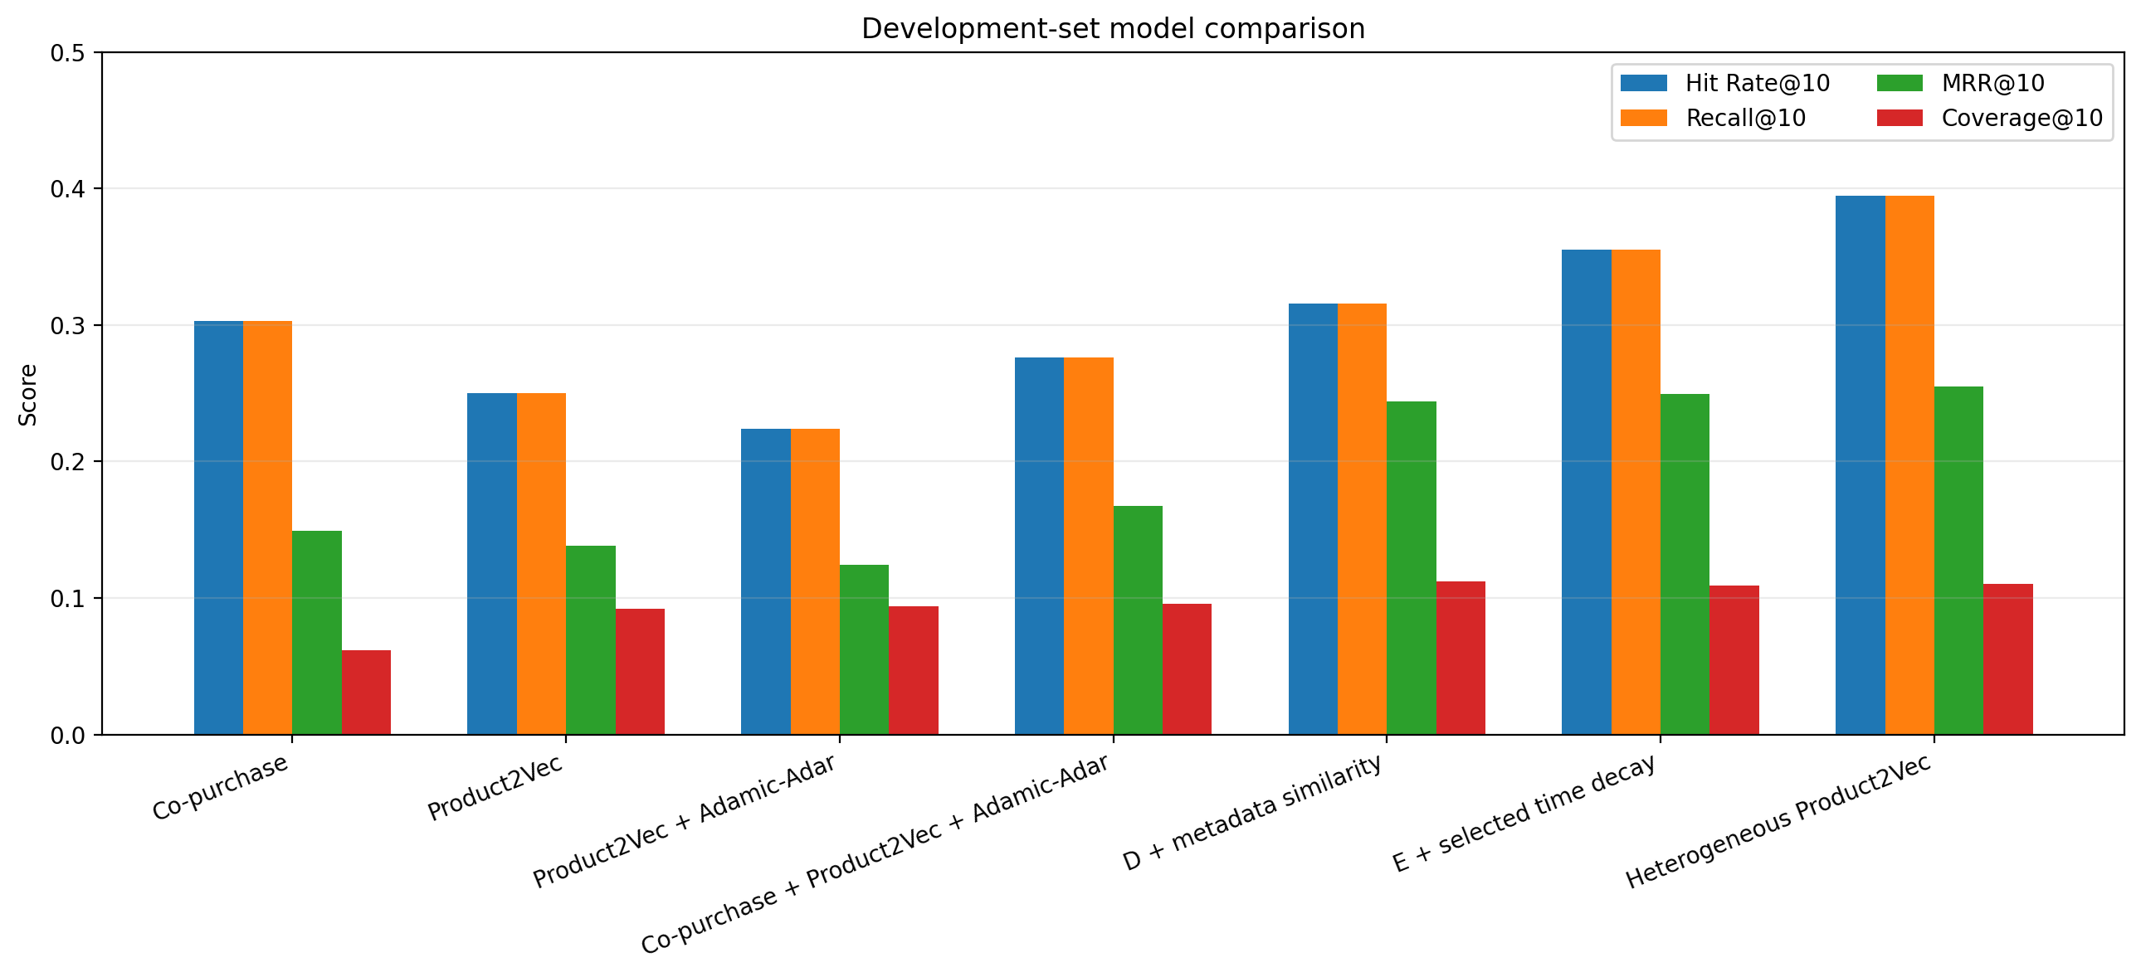
Figure 1. Development ablation
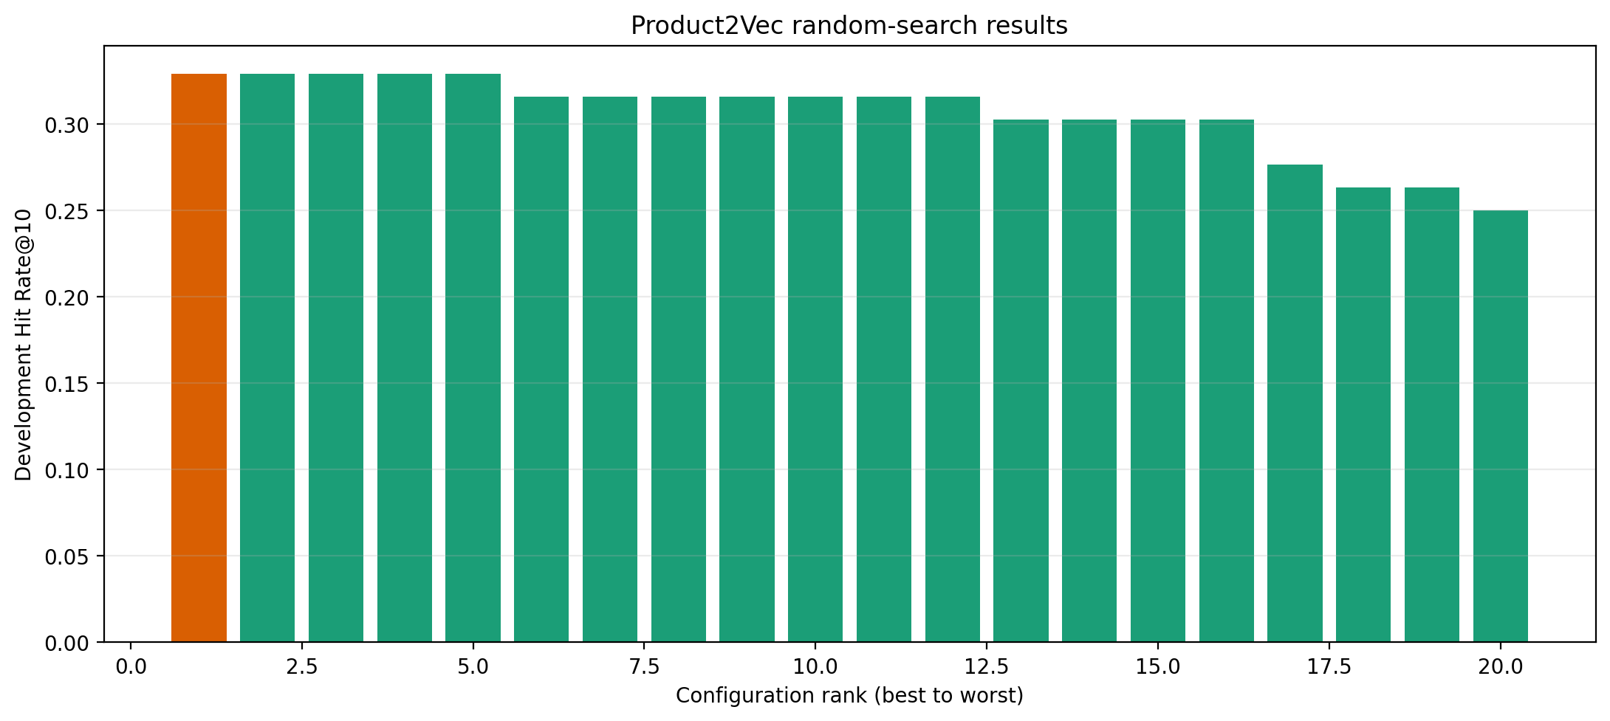
Figure 2. Product2Vec random search

4.3 Dedicated one-SKU product-page evaluation
Development model | HR@10 | MRR@10 | Candidate recall@100 | Coverage@10
Global popularity | 0.092 | 0.029 | 0.197 | 0.002
Category popularity | 0.171 | 0.066 | 0.342 | 0.023
Co-purchase | 0.237 | 0.129 | 0.237 | 0.049
Product2Vec | 0.184 | 0.117 | 0.276 | 0.108
Metadata | 0.224 | 0.089 | 0.513 | 0.102
Product-name TF-IDF | 0.316 | 0.177 | 0.474 | 0.106
Historical 40/30/30 hybrid | 0.316 | 0.165 | 0.539 | 0.106
Tuned four-signal hybrid | 0.408 | 0.214 | 0.553 | 0.108

The selected hybrid retrieves 42 of 76 targets in its first 100 candidates and ranks 31 in the first ten. Its HR@10 bootstrap interval is 0.303–0.513. It adds eight hits and loses one relative to the 24-hit historical hybrid. Eleven retrieved targets remain below rank ten, making re-ranking a clear improvement target. Because the blend was selected on these same development queries, this is selection evidence rather than an unbiased final estimate.

4.4 Strictly future product-page evaluation
The frozen product-page model was evaluated once on the independent later export. Of 287 new orders after the cutoff, 24 contained at least two products known to frozen history and formed eligible directed one-SKU queries.
Model | Precision@10 | Recall/HR@10 | MRR@10 | Candidate recall@100 | Full-pool recall | Coverage@10
Frozen V1 | 0.029 | 0.292 | 0.225 | 0.458 | 0.792 | 0.033
Expanded-candidate V2 | 0.029 | 0.292 | 0.224 | 0.458 | 1.000 | 0.033

Both variants rank the same seven targets in the top ten. Expanded V2 makes all 24 targets available somewhere in its full pool, compared with 19 for V1, but the additional five targets remain below rank 100. Broader retrieval alone therefore does not improve the displayed recommendations. Frozen V1 remains selected and V2 is not promoted.
Both HR@10 estimates have a 95% bootstrap interval of [0.125, 0.500]. V1's MRR@10 interval is [0.083, 0.392], versus [0.083, 0.390] for V2. These wide intervals make the result directional rather than precise. The 24 queries are now observed and must not be reused for tuning.

4.5 One-time historical test result
Model | Precision@10 | Recall/HR@10 | MRR@10 | Coverage@10
Original P2V + AA | 0.029 | 0.293 | 0.112 | 0.068
Selected final model | 0.037 | 0.373 | 0.154 | 0.076
Absolute change | +0.008 | +0.080 | +0.041 | +0.008

The selected model retrieves 28 of 75 hidden products, compared with 22 for the original baseline. Thus, six additional test baskets contain their hidden item in the first ten positions. MRR also rises, suggesting that hits tend to occur earlier, not merely somewhere near position ten.
The 0.373 Hit Rate belongs to the historical 40/30/30 hybrid, not the current TF-IDF product-page candidate. It was measured under offline basket completion and must not be presented as product-page click-through or conversion performance; those require future-period or online measurement.
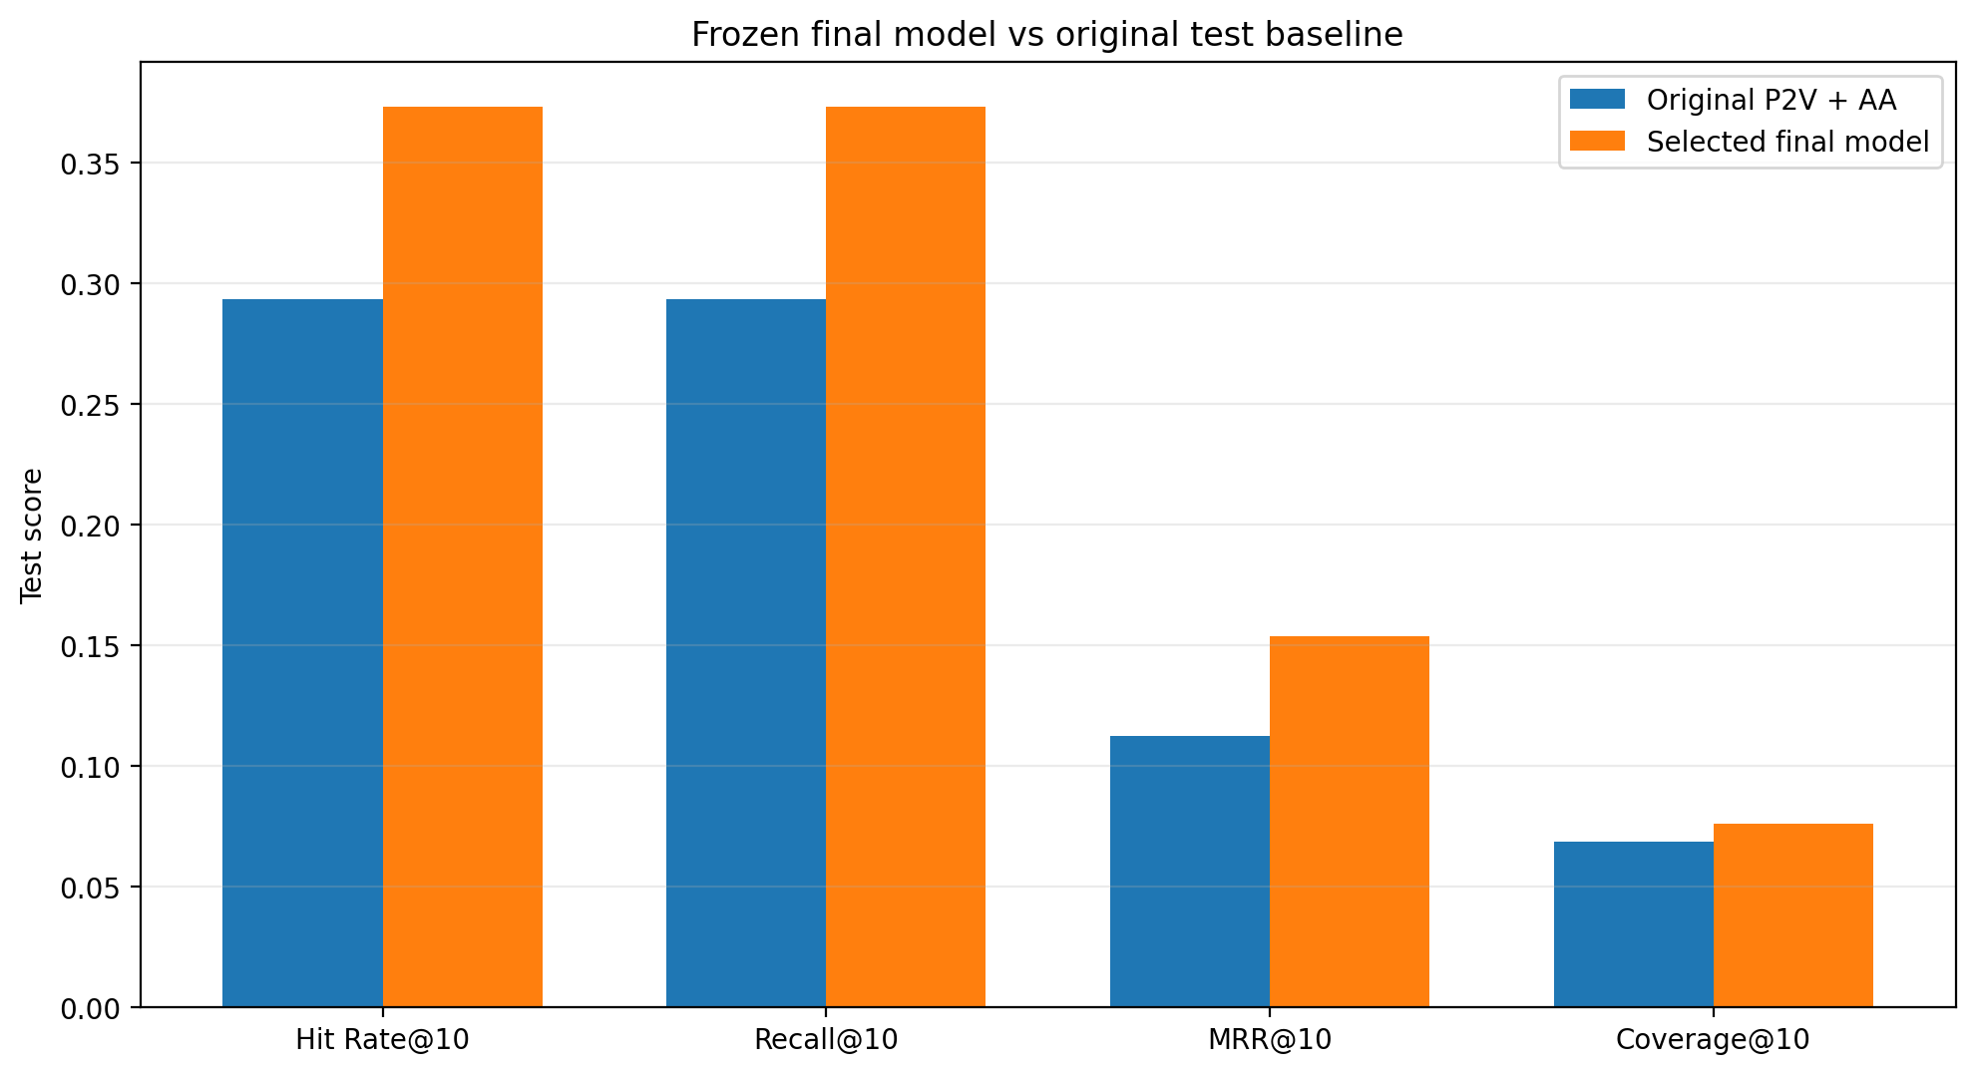
Figure 3. One-time final comparison

4.6 Segment analysis
Segment type | Segment | Queries | HR@10 | MRR@10
Popularity | Rare | 37 | 0.162 | 0.047
Popularity | Medium | 35 | 0.629 | 0.280
Popularity | Popular | 3 | 0.000 | 0.000
Cart size | Small | 49 | 0.327 | 0.159
Cart size | Medium | 20 | 0.400 | 0.098
Cart size | Large | 6 | 0.667 | 0.292

Rare-product HR improves from 0.108 to 0.162, but remains much lower than the medium segment. Large carts reach 0.667 HR, supporting the intuition that more observed items provide a clearer representation of intent. The popular segment has only three queries, so its zero score is not a stable estimate.
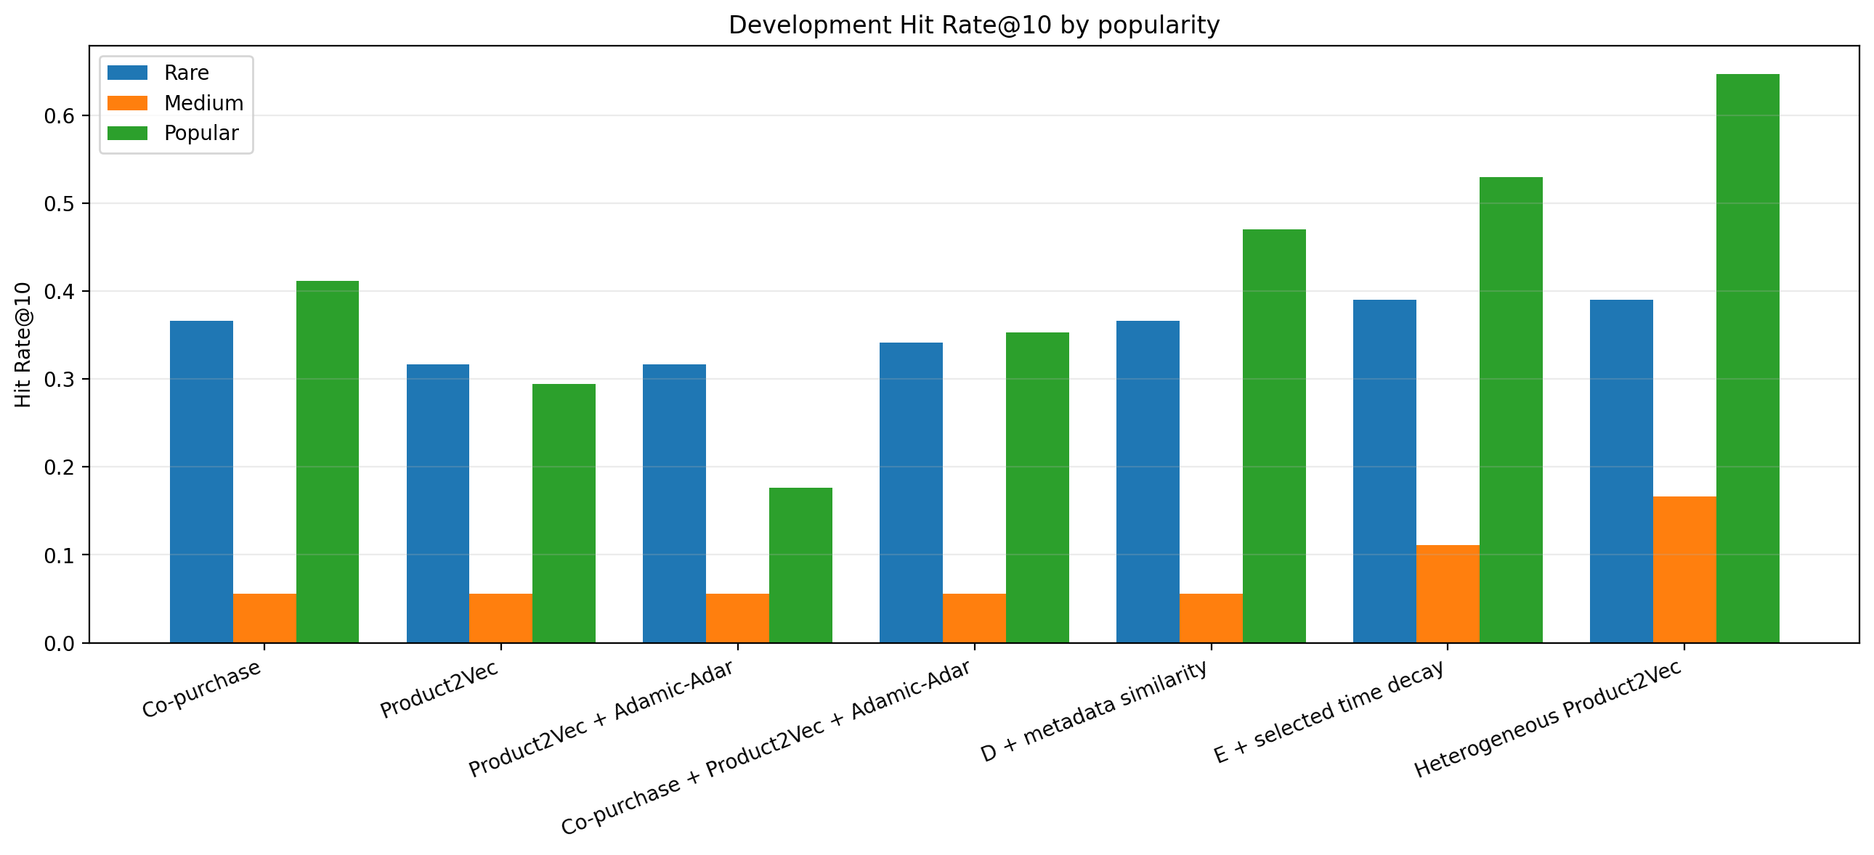
Figure 4. Hit Rate by popularity
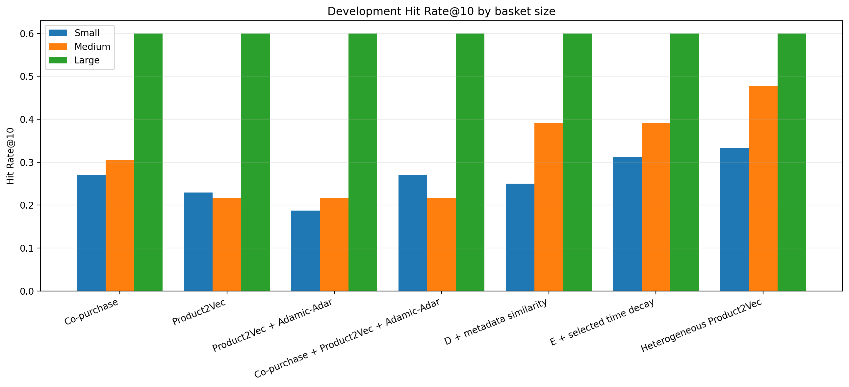
Figure 5. Hit Rate by cart size

4.7 Statistical stability
Metric | Point estimate | 95% bootstrap interval
HR@10 | 0.373 | [0.267, 0.480]
Recall@10 | 0.373 | [0.267, 0.480]
MRR@10 | 0.154 | [0.095, 0.224]

The intervals are wide because only 75 independent query orders are available. The improvement is promising, but the experiment does not establish that the same effect size will hold for future customers or assortments.

4.8 Graph visualization
Plotting all nodes and edges would be unreadable. The report therefore shows a 100-edge backbone and bounded local ego networks. Node size reflects degree, edge width reflects co-purchase weight, and colors distinguish query/product or metadata roles according to each figure's legend.
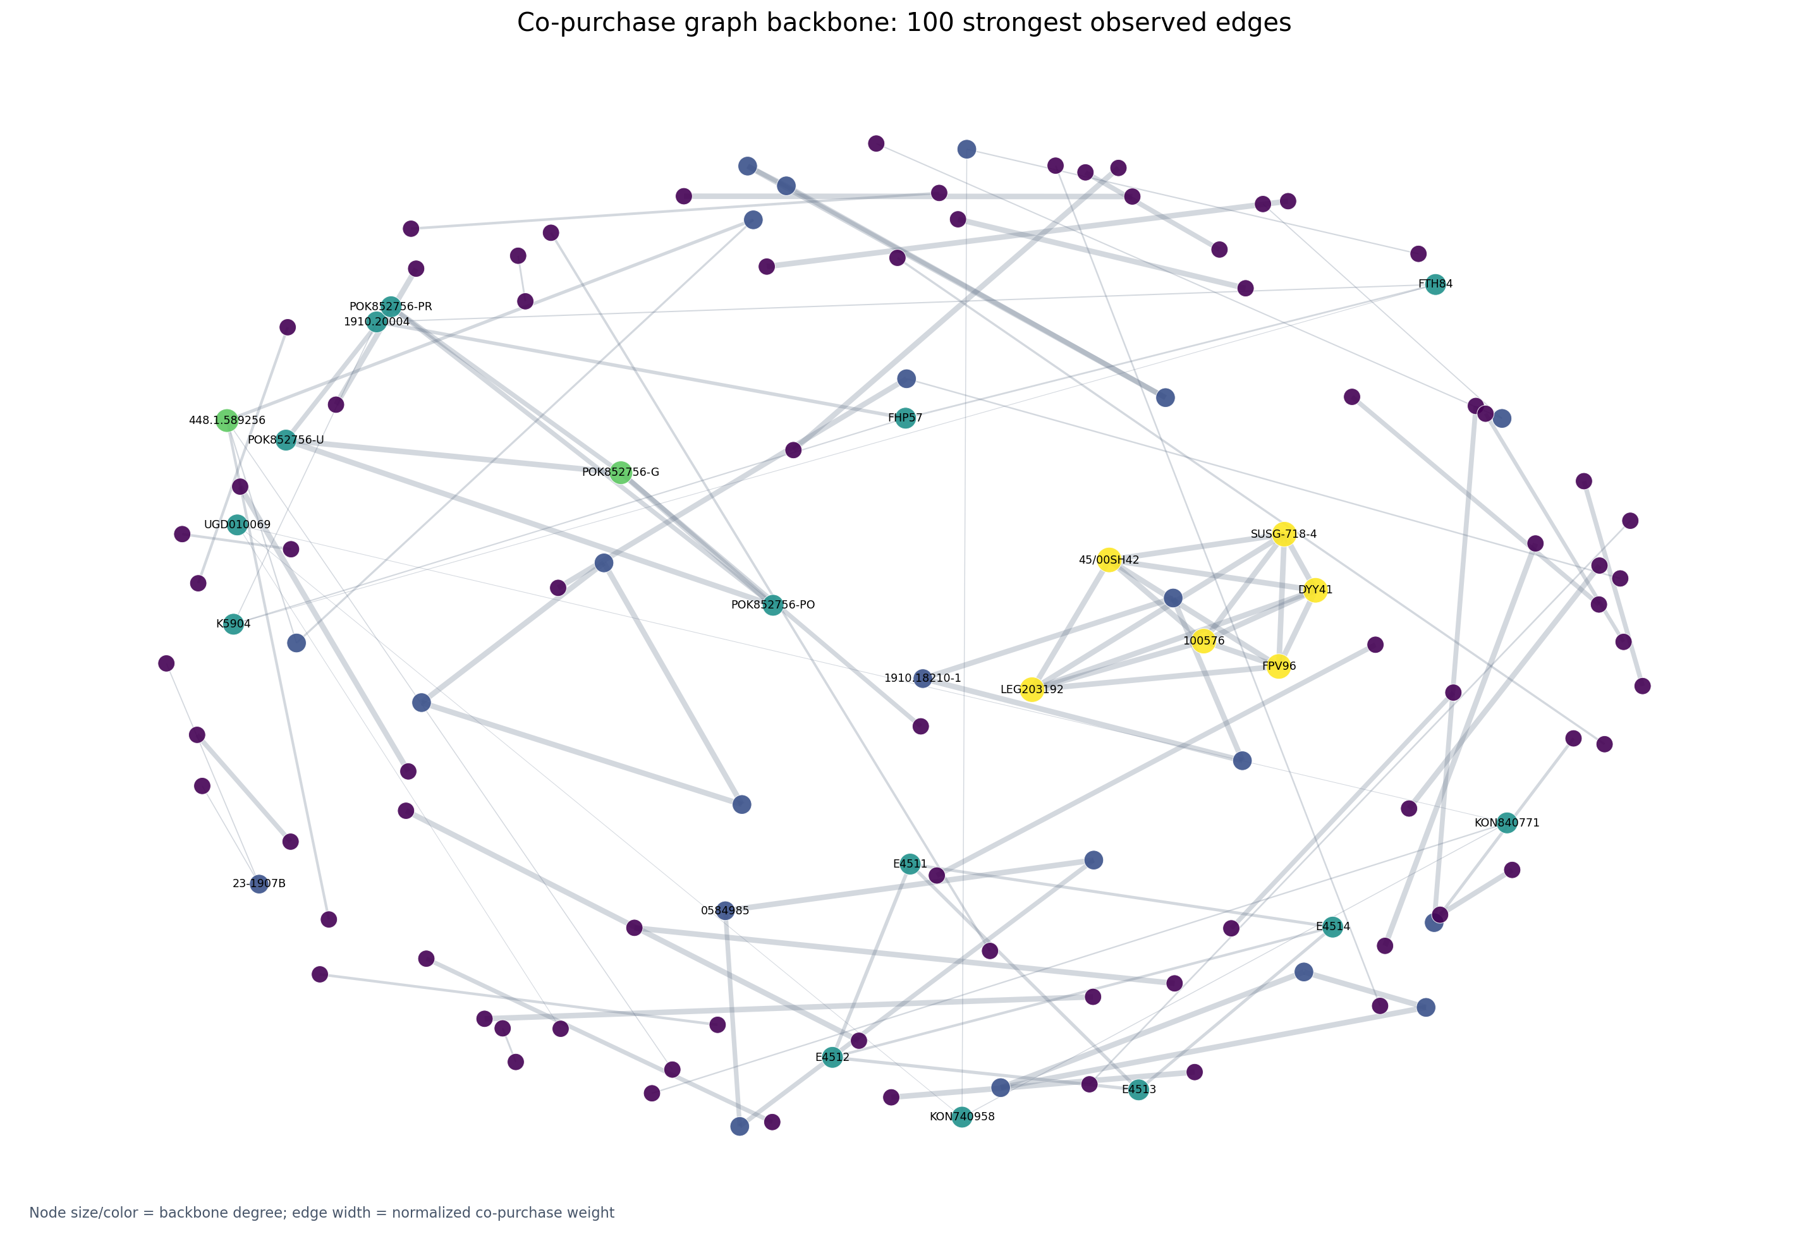
Figure 6. Selected graph backbone
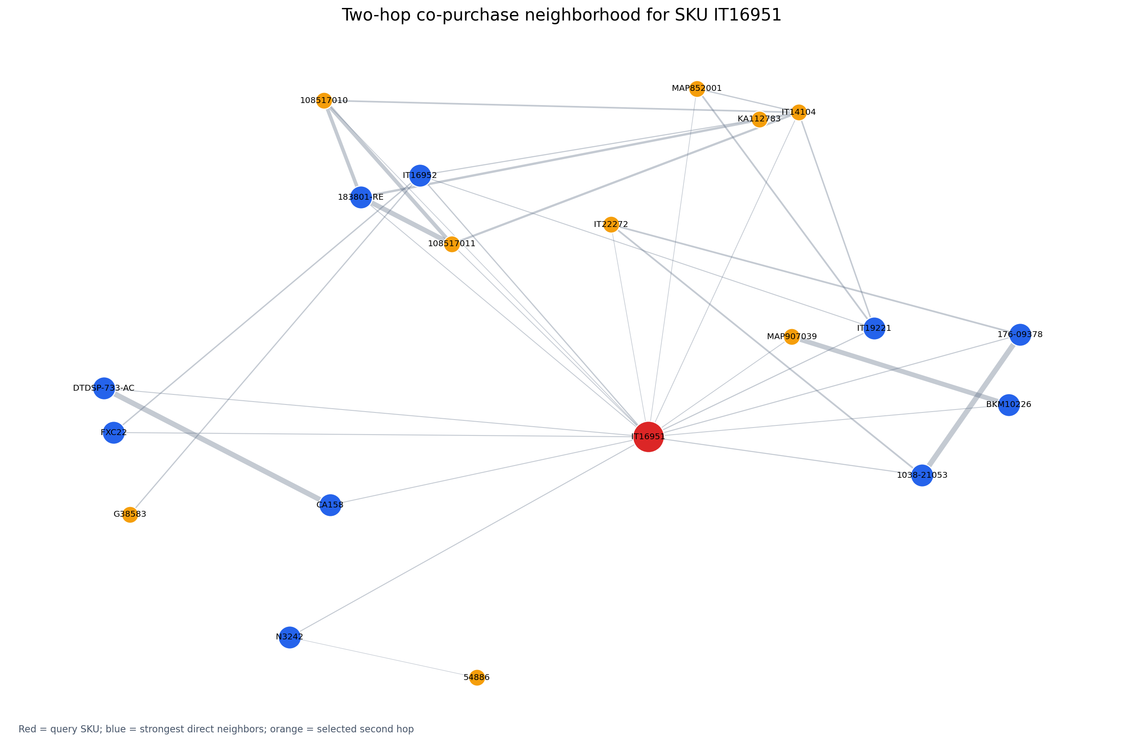
Figure 7. Neighborhood around SKU IT16951

5. Qualitative and Error Analysis
Quantitative metrics say whether the hidden SKU was retrieved, but they do not fully measure whether another recommendation is commercially sensible. Random and segmented examples were therefore inspected using product names, categories, age labels, target rank, and popularity.

5.1 Successful patterns
Themed school products. Given SKU 369-00100, a GIM Naruto double pencil case, the model ranked a Naruto aluminium bottle first and the hidden Naruto trolley bag fourth. Although the first recommendation is not the held-out target, it is a plausible complement sharing a school context and franchise. The example illustrates why top-one exact-target evaluation can undervalue reasonable alternatives.
Rare franchise variants. Given HLW98, a Frozen mini Elsa doll, the rare hidden target HLW99, a Frozen mini Anna doll, appeared at rank two. The top result was another Frozen Elsa doll. Metadata supplies theme and category similarity, while graph evidence distinguishes frequently co-observed variants.
Strong cart context. In a large basket containing many Little People figure SKUs, the hidden HBJ31 figure was ranked first. This agrees with the segment results: multiple related cart products create a stable neighborhood signal.
Clear functional complement. Given portable-printer SKU IT22272, the hidden pack of thermal-paper rolls IT22273 was ranked first. This is the ideal co-purchase use case: a device and its consumable are complementary rather than mere substitutes.

5.2 Failure patterns
Sparse rare products. Given a Paw Patrol bottle, the hidden Marvel Avengers preschool backpack was not in the top ten. The top result was another children's bottle. The recommendation is understandable from product-function evidence, but it fails to infer a broader school-shopping mission from one item.
Near miss outside the cutoff. Given a Faber-Castell pencil with integrated eraser, the hidden color variant appeared at rank 13, outside top ten. The top result was a matching-brand eraser. The system recognized the stationery and brand context but preferred a complement over the exact variant. This exposes the arbitrary effect of the cutoff and the tension between substitute and complement recommendations.
Incomplete metadata. Hero/franchise is unknown for 75.9% of catalog SKUs. For those products, the content component cannot reliably transfer franchise relationships. Broad category or age values can also create superficially similar candidates that are not a logical purchase pair.
Single-item ambiguity. A single observed SKU may represent several intents: replenishment, a themed purchase, a gift, or a broader school basket. The model cannot disambiguate these without another cart item or session behavior.

5.3 Error-analysis conclusions
The errors do not indicate one isolated algorithmic defect. They mainly result from sparse behavior, incomplete annotations, and ambiguity in the evaluation target. This suggests four practical responses: use more cart/session context, improve content completeness, introduce a content-only fallback for unseen items, and evaluate multiple valid recommendations through online interaction rather than assuming the single historical target is the only correct answer.

6. Discussion, Comments, and Future Work

6.1 Interpretation
The final result supports a hybrid design. Co-purchase evidence grounds the system in actual basket behavior. Product2Vec generalizes through graph position. Structured metadata improves long-tail access and introduces content-similar products. Time decay places more emphasis on the current assortment. The heterogeneous graph helps only when metadata edges are lightly weighted and hub-corrected.
Product-name TF-IDF supplies an interpretable fourth signal. It outperforms the three earlier individual components on the dedicated one-SKU development task, and the four-signal blend improves HR@10 from 0.316 to 0.408. The improvement was selected on the same 76 development queries used to report it, but the later untouched period supplies an initial independent estimate: HR@10 is 0.292 and MRR@10 is 0.225 on 24 eligible queries. The small sample prevents a precise conclusion, but it shows that the frozen signals transfer beyond the development period.
Expanded candidate retrieval raises full-pool recall on these future queries from 0.792 to 1.000 without changing candidate recall@100 or HR@10. Retrieval breadth is therefore not enough by itself; V2 needs improved source calibration or reranking before it can replace frozen V1.
All-status training won on development data. This implies that cancelled and pending baskets retain some useful intent in this export, but the conclusion is specific to the dataset. A change in shop processes or status definitions could reverse it. The deployed pipeline should therefore monitor status mix.
Adamic–Adar's zero final weight is also informative. Shared-neighbor link prediction was reasonable in theory, but it did not add value once stronger signals were combined. A sophisticated system does not need to keep every tested algorithm.
The submission preserves more than the four top-level blend coefficients. The complete fitted graph edge table exposes the symmetric cosine walk weight and directional recommendation confidence, while the embedding export exposes all 48 retained values for every product and metadata node. The manifest ties these learned parameters to the trusted pickle and frozen JSON by SHA-256 hash. This improves reproducibility without treating generated parameters as new experimental results.

6.2 Limitations
- The final evaluation contains only 75 eligible queries.
- The test target is one historical basket partner, not a complete set of every
recommendation a customer might consider relevant.
- The offline task does not measure impressions, clicks, conversion, revenue,
margin, novelty, diversity, or satisfaction.
- The product-page shelf has not yet been evaluated with live interaction
metrics.
- The model has no customer or session representation.
- Products absent from training orders require a content or business-rule
fallback.
- Metadata is incomplete and may contain inconsistent source labels.
- A pickle artifact must only be loaded from a trusted source.
- The same historical export has supported several development analyses;
confidence must now come from genuinely new orders.
- The first future evaluation has only 24 eligible queries. It is now observed
and closed to tuning, and its wide interval prevents strong segment claims.

6.3 Future work
Expanded Version 2 candidate retrieval and its unlabeled engineering audit are now implemented separately from the frozen model. Across all 6,257 catalog SKUs, the audit produced no retrieval or invariant failures, a median pool of 1,327 candidates, median latency of 38.8 ms, and p95 latency of 48.6 ms. These figures establish availability, correctness, and speed; they do not measure recommendation relevance and therefore do not replace future-period HR or MRR.
A separate learned-score experiment used three temporal candidate snapshots and L2-regularized logistic regression entirely before frozen development. On its untouched 70-query backtest, the fixed 40/10/10/40 ranker achieved HR@10 0.414 and MRR@10 0.276, while logistic regression achieved only 0.071 and 0.033. Both had 0.800 full-pool recall, proving that the loss came from reranking. The learned ranker is rejected, and these 70 observed orders will not be reused to tune another variant.
- Extend text content. The product-name TF-IDF baseline is complete. Add
cleaned category paths or descriptions as separately weighted fields and compare them on a new development period rather than the current 76 queries.
- Cold-start routing. Use content similarity when an SKU has no graph
history, then shift weight toward behavior as orders accumulate.
- Data enrichment. Improve brand, age, hero, and gender coverage and add
price, margin, availability, and product lifecycle.
- Session data. Collect views, searches, clicks, add-to-cart actions, and
sequence timestamps to distinguish interest from completed purchase.
- Larger new-period validation. Treat the completed 24-query future run as
closed. Accumulate a substantially larger later period and preregister any comparison before inspecting its outcomes.
- Online experiment. Compare the combined product-page shelf with the
current shop logic and record click-through, add-to-cart rate, conversion, and revenue.
- Beyond accuracy. Add diversity, novelty, serendipity, and category/brand
concentration metrics, consistent with broader recommender-system evaluation practice [6].
- Operational monitoring. Track query latency, coverage, drift, status mix,
inventory filtering, and segment performance after every retraining cycle. Regenerate the graph/embedding exports and hash manifest for each approved training snapshot.

6.4 Conclusion
The project demonstrates that a relatively small and sparse retail dataset can support a reproducible graph-and-content recommender. The historical hybrid raises test HR@10 by eight percentage points and retrieves six additional held-out products. The later TF-IDF product-page candidate raises development HR@10 from 0.316 to 0.408, adding eight hits while losing one, and achieves HR@10 of 0.292 on 24 genuinely later queries. Expanded retrieval finds every future target but does not improve the top ten, so frozen V1 remains selected. The system is sufficiently mature for local demonstration, but the limited samples and absence of online feedback require cautious interpretation. The next academic priority is a larger later period or a preregistered online product-page experiment rather than another round of tuning on observed data.

7. Members and Roles
Replace the bracketed fields before submission. If this is an individual project, retain one row and describe all responsibilities honestly.
Member | Student ID | Responsibilities
[Full name] | [ID] | Project design; data processing; graph construction; Product2Vec implementation; experiments; evaluation; Streamlit interface; report writing
[Full name, if applicable] | [ID] | [Specific data, modeling, evaluation, visualization, or writing responsibilities]

Shared responsibilities, if applicable, should list concrete deliverables rather than percentages that cannot be verified. Git history and versioned outputs provide supporting evidence of the technical work.

8. Time Plan
The following is a submission-ready retrospective plan. Replace week numbers with course dates if required.
Period | Work package | Main deliverable | Status
Week 1 | Problem definition and data audit | Research question, privacy scope, column inventory | Complete
Week 2 | Cleaning and normalization | Reproducible loader and product catalog | Complete
Week 3 | Basket analysis | FP-Growth itemsets and basket statistics | Complete
Week 4 | Graph construction | Normalized co-purchase graph | Complete
Week 5 | Representation learning | Random walks and Product2Vec embeddings | Complete
Week 6 | Initial evaluation | Chronological splits and baseline metrics | Complete
Week 7 | Hybrid recommendation | Basket engine, Adamic–Adar, metadata filters | Complete
Week 8 | Error analysis | Popularity/cart-size segments and samples | Complete
Week 9 | Controlled improvement | Status, graph, decay, and embedding search | Complete
Week 10 | Content integration | Metadata similarity and heterogeneous graph | Complete
Week 11 | Final evaluation | Frozen test result, intervals, plots | Complete
Week 12 | Deployment and reporting | Product-page Streamlit UI, final report | Complete
Week 13 | Text content extension | TF-IDF baseline and four-signal product-page blend | Complete
25 Aug 2026 | Model freeze | Hash-locked configuration and closed tuning/test periods | Complete
1 Sep 2026 | First future validation | Frozen V1 versus predefined expanded V2 on 24 untouched queries | Complete
Next iteration | Larger validation | Accumulate a larger later period or run an online experiment | Planned

9. Bibliography
[1] Han, J., Pei, J., & Yin, Y. (2000). Mining frequent patterns without candidate generation. Proceedings of the 2000 ACM SIGMOD International Conference on Management of Data, 1–12. https://doi.org/10.1145/335191.335372
[2] Grover, A., & Leskovec, J. (2016). node2vec: Scalable feature learning for networks. Proceedings of the 22nd ACM SIGKDD International Conference on Knowledge Discovery and Data Mining, 855–864. https://doi.org/10.1145/2939672.2939754
[3] Mikolov, T., Sutskever, I., Chen, K., Corrado, G., & Dean, J. (2013). Distributed representations of words and phrases and their compositionality. Advances in Neural Information Processing Systems, 26. https://papers.neurips.cc/paper/5021-distributed-representations-of-words-and-phrases-and-their-compositionality
[4] Adamic, L. A., & Adar, E. (2003). Friends and neighbors on the Web. Social Networks, 25(3), 211–230. https://doi.org/10.1016/S0378-8733(03)00009-1
[5] Herlocker, J. L., Konstan, J. A., Terveen, L. G., & Riedl, J. T. (2004). Evaluating collaborative filtering recommender systems. ACM Transactions on Information Systems, 22(1), 5–53. https://doi.org/10.1145/963770.963772
[6] Ricci, F., Rokach, L., & Shapira, B. (Eds.). (2022). Recommender Systems Handbook (3rd ed.). Springer. https://doi.org/10.1007/978-1-0716-2197-4
[7] Efron, B., & Tibshirani, R. J. (1993). An Introduction to the Bootstrap. Springer. https://doi.org/10.1007/978-1-4899-4541-9
[8] Salton, G., & Buckley, C. (1988). Term-weighting approaches in automatic text retrieval. Information Processing & Management, 24(5), 513–523. https://doi.org/10.1016/0306-4573(88)90021-0

10. Appendices

Appendix A: Reproducibility commands
Install dependencies:
python -m pip install -r requirements.txt
Run the tests:
python -m unittest discover -s tests -v
Reproduce the locked dedicated one-SKU metrics without model selection:
python -m experiments.single_sku_evaluation
The completed future evaluation used the private CSV and predefined V2 flag:
python -m experiments.future_period_evaluation `
--future "C:\path\to\new-orders.csv" `
--output outputs/future_evaluation/NEW-PERIOD `
--include-expanded-v2
Do not rerun that command against the observed Juneâ€“August file or tune on its 24 queries. A future use requires a later, non-overlapping export and a new output directory.
Train the frozen deployment model on all available history:
python serve_recommendations.py train
Export the fitted graph weights and Node2vec vectors:
python serve_recommendations.py export-weights
Launch the local interface:
python -m streamlit run streamlit_app.py
Generate report plots without reevaluating the final model:
python -m experiments.visualization --center-sku IT16951

Appendix B: Main reproducible artifacts
Artifact | Purpose
model_configs/historical_basket_model.json | Historical test-frozen 40/30/30 configuration
model_configs/historical_basket_weights.csv | Readable weights for the historical comparison model
outputs/improvement_experiments/final/final_test_results.csv | One-time aggregate test metrics
outputs/improvement_experiments/final/final_test_outcomes.csv | Per-query ranks and hits
outputs/improvement_experiments/final/final_test_segments.csv | Popularity and cart-size results
outputs/improvement_experiments/final/bootstrap_intervals.csv | Query-bootstrap uncertainty intervals
outputs/improvement_experiments/plots/ | Versioned result and graph visualizations
model_configs/final_product_page_model.json | Current frozen four-signal serving configuration
model_configs/final_product_page_weights.csv | Readable serving blend and component weights
model_configs/final_model_hyperparameters.csv | Graph, Node2vec, Skip-Gram, and TF-IDF settings
model_weights/final_graph_edges.csv | All fitted co-purchase edge weights and directional evidence
model_weights/final_graph_nodes.csv | Product frequency, time-decayed frequency, degree, and weighted degree
model_weights/final_node2vec_embeddings.csv | Final normalized 48-dimensional vectors for product and metadata nodes
model_weights/export_manifest.json | Model/configuration fingerprints and export row hashes
outputs/single_sku_evaluation/development/four_signal_weight_search.csv | All 84 product-page development blends
outputs/single_sku_evaluation/development/model_freeze_manifest.json | Hashes, cutoffs, locked metrics, and closed-tuning declaration
experiments/future_period_evaluation.py | No-tuning assessment for orders strictly after the cutoff
outputs/future_evaluation/2026-06-19_after_cutoff_to_2026-08-25_v1_v2/ | Untouched-period V1/V2 metrics, outcomes, intervals, shared queries, and configuration
models/final_recommender.pkl | Local trusted deployment artifact; excluded from Git

Appendix C: Metric definitions
For query q, let R_q be the top-10 recommendation set and T_q the hidden target set. In this experiment, |T_q| = 1.
Precision@10(q) = |R_q ∩ T_q| / 10
Recall@10(q) = |R_q ∩ T_q| / |T_q|
HitRate@10(q) = 1 if |R_q ∩ T_q| > 0, otherwise 0
MRR@10(q) = 1 / rank of first target, otherwise 0
Aggregate values are means across eligible query orders. Coverage is the number of distinct recommended products divided by the number of eligible catalog products.

Appendix D: Ethical and privacy notes
The model uses product-level behavior and does not require customer identity. Raw order exports remain local because they may contain personal or location data. Before live use, the shop should define retention, access, and deletion policies; verify that inventory and age constraints are correct; monitor for over-concentration on brands or demographic labels; and make clear that product recommendations are automated ranking outputs rather than safety advice.

