IOANNA PAPAGIANNI 2790 – CHRISTOS GOULAS 2677

QUESTION 1

For this analysis we use Jupyter Notebook and the file is in IPython format. We downloaded “train.json”
a dataset with recipes from Kaggle and both this file and “classifiers.ipynb”
exist in the same folder.

Analysis 1: Compare Classifier metrics CountVectorizer VS TfidfVectorizer

We work with the category “ italian ” and “mexican” at first, in order to make classifiers that differentiates different cuisines.
We extract features with two different techniques, CountVectorizer and TfidfVectorizer and compare the results for metrics such as mean accuracy score, mean precision score, mean recall score, mean f1-measure score and mean confusion-matrix.
The classifiers we use for this experiment are: Logistic Regression, SVM, Decision Trees, K-NN, Naïve Bayes and we use 5-Fold Cross Validation to evaluate our prediction results.

****Logistic Regression mean scores COUNTVECTORIZER****

scores: {'fit_time': array([2.5504601 , 2.18405247, 2.21158576, 1.94333792, 1.90349221]),
'score_time': array([0.02898192, 0.02722764, 0.02730107, 0.02709079, 0.02767682]),
'test_accuracy': array([0.96288515, 0.96672504, 0.97162872, 0.96882662, 0.96812609]),
'test_precision_weighted': array([0.96309073, 0.9668767 , 0.97170751, 0.96893784, 0.96833373]),
'test_recall_weighted': array([0.96288515, 0.96672504, 0.97162872, 0.96882662, 0.96812609]),
'test_f1_weighted': array([0.96283275, 0.96668534, 0.97160427, 0.96879444, 0.96808231])}

mean score test accuracy: 0.967638326784304

mean score test precision weighted: 0.9677893006690403

mean score test recall weighted: 0.967638326784304

mean score test f1-measure weighted: 0.9675998230499061

Confusion Matrix: [[7683 155]
[ 307 6131]]

****Logistic Regression mean scores TFIDFVECTORIZER****

scores: {'fit_time': array([0.52974987, 0.52992105, 0.51307178, 0.4936018 , 0.5006001 ]),
'score_time': array([0.01318645, 0.00974274, 0.00974846, 0.00980425, 0.00980759]),
'test_accuracy': array([0.99264706, 0.99369527, 0.99194396, 0.99579685, 0.99334501]),
'test_precision_weighted': array([0.99274423, 0.99376687, 0.99206049, 0.99582877, 0.99342468]),
'test_recall_weighted': array([0.99264706, 0.99369527, 0.99194396, 0.99579685, 0.99334501]),
'test_f1_weighted': array([0.9926413 , 0.99369109, 0.99193702, 0.99579502, 0.9933403 ])}

mean score test accuracy: 0.993485628927578

mean score test precision weighted: 0.9935650103027747

mean score test recall weighted: 0.993485628927578

mean score test f1-measure weighted: 0.9934809442666724

Confusion Matrix: [[7838 0]
[ 93 6345]]

****SVM mean scores COUNTVECTORIZER****

scores: {'fit_time': array([0.4891715 , 0.49625278, 0.49789715, 0.5144918 , 0.49009752]),
'score_time': array([0.02744508, 0.02796507, 0.02731681, 0.02739477, 0.02725601]),
'test_accuracy': array([0.96113445, 0.96322242, 0.9614711 , 0.96532399, 0.96497373]),
'test_precision_weighted': array([0.96116578, 0.96322223, 0.9614711 , 0.96531882, 0.96497238]),
'test_recall_weighted': array([0.96113445, 0.96322242, 0.9614711 , 0.96532399, 0.96497373]),
'test_f1_weighted': array([0.96110708, 0.96320787, 0.9614711 , 0.96532033, 0.96496109])}

mean score test accuracy: 0.9632251394428174

mean score test precision weighted: 0.9632300630213381

mean score test recall weighted: 0.9632251394428174

mean score test f1-measure weighted: 0.9632134975948101

Confusion Matrix: [[7597 241]
[ 284 6154]]

****SVM mean scores TFIDFVECTORIZER****

scores: {'fit_time': array([0.19516706, 0.19173741, 0.19179201, 0.19114351, 0.19552565]),
'score_time': array([0.0107379 , 0.00990653, 0.00981736, 0.00994205, 0.00989962]),
'test_accuracy': array([0.99614846, 0.99649737, 0.9943958 , 0.9971979 , 0.99579685]),
'test_precision_weighted': array([0.99617529, 0.99651958, 0.99445244, 0.9972056 , 0.99582877]),
'test_recall_weighted': array([0.99614846, 0.99649737, 0.9943958 , 0.9971979 , 0.99579685]),
'test_f1_weighted': array([0.99614693, 0.99649612, 0.99439252, 0.9971973 , 0.99579502])}

mean score test accuracy: 0.9960072750641412

mean score test precision weighted: 0.9960363379540353

mean score test recall weighted: 0.9960072750641412

mean score test f1-measure weighted: 0.9960055765255399

Confusion Matrix: [[7837 1]
[ 56 6382]]

****Decision-Tree mean scores COUNTVECTORIZER****

scores: {'fit_time': array([11.39658332, 33.20916319, 10.85297585, 11.07879996, 16.97399926]),
'score_time': array([0.02721238, 0.02717781, 0.02638102, 0.02665997, 0.02704692]),
'test_accuracy': array([0.93487395, 0.94535902, 0.93134851, 0.93870403, 0.94781086]),
'test_precision_weighted': array([0.93497916, 0.94541877, 0.9313223 , 0.93869318, 0.94793324]),
'test_recall_weighted': array([0.93487395, 0.94535902, 0.93134851, 0.93870403, 0.94781086]),
'test_f1_weighted': array([0.93490394, 0.94537721, 0.93131879, 0.93869756, 0.9477437 ])}

mean score test accuracy: 0.9396192732784883

mean score test precision weighted: 0.9396693301209688

mean score test recall weighted: 0.9396192732784883

mean score test f1-measure weighted: 0.9396082410941424

Confusion Matrix: [[7420 418]
[ 436 6002]]

****Decision-Tree mean scores TFIDFVECTORIZER****

scores: {'fit_time': array([2.93528199, 2.91533303, 2.83061743, 2.92146993, 2.83942223]),
'score_time': array([0.01470017, 0.01477718, 0.01456809, 0.01467276, 0.01457882]),
'test_accuracy': array([0.99894958, 0.99824869, 0.99754816, 0.99894921, 0.99859895]),
'test_precision_weighted': array([0.99895159, 0.99825055, 0.99755907, 0.99895122, 0.99860251]),
'test_recall_weighted': array([0.99894958, 0.99824869, 0.99754816, 0.99894921, 0.99859895]),
'test_f1_weighted': array([0.99894947, 0.9982485 , 0.99754755, 0.9989491 , 0.99859875])}

mean score test accuracy: 0.9984589177177

mean score test precision weighted: 0.9984629859026336

mean score test recall weighted: 0.9984589177177

mean score test f1-measure weighted: 0.9984586754890283

Confusion Matrix: [[7837 1]
[ 19 6419]]

****k-NN mean scores COUNTVECTORIZER****

scores: {'fit_time': array([4.22745609, 4.12844706, 4.11732197, 4.16310835, 4.35632157]),
'score_time': array([173.40004349, 168.35602403, 170.35519505, 172.46086407, 171.29579973]),
'test_accuracy': array([0.88830532, 0.88406305, 0.88231173, 0.88721541, 0.87845884]),
'test_precision_weighted': array([0.88823164, 0.88608528, 0.88566209, 0.89111778, 0.884777 ]),
'test_recall_weighted': array([0.88830532, 0.88406305, 0.88231173, 0.88721541, 0.87845884]),
'test_f1_weighted': array([0.8881997 , 0.88333008, 0.88132628, 0.8861979 , 0.87695044])}

mean score test accuracy: 0.884070871781287

mean score test precision weighted: 0.8871747597288895

mean score test recall weighted: 0.884070871781287

mean score test f1-measure weighted: 0.8832008807972722

Confusion Matrix: [[7345 493]
[1162 5276]]

****k-NN mean scores TFIDFVECTORIZER****

scores: {'fit_time': array([2.26060057, 2.25794148, 2.25653839, 2.29463649, 2.26201057]),
'score_time': array([85.24381018, 85.42045975, 85.69957519, 85.78246546, 85.19833612]),
'test_accuracy': array([0.93277311, 0.92924694, 0.9352014 , 0.94500876, 0.93309982]),
'test_precision_weighted': array([0.94010695, 0.93732614, 0.94204372, 0.95001376, 0.94036414]),
'test_recall_weighted': array([0.93277311, 0.92924694, 0.9352014 , 0.94500876, 0.93309982]),
'test_f1_weighted': array([0.93200522, 0.9283789 , 0.93450048, 0.94453364, 0.9323391 ])}

mean score test accuracy: 0.9350660053863928

mean score test precision weighted: 0.9419709424977883

mean score test recall weighted: 0.9350660053863928

mean score test f1-measure weighted: 0.9343514707413195

Confusion Matrix: [[7838 0]
[ 927 5511]]

****Naive-Bayes mean scores COUNTVECTORIZER****

scores: {'fit_time': array([0.46336746, 0.48547864, 0.46542311, 0.45993423, 0.46202064]),
'score_time': array([0.04326558, 0.02981758, 0.0301919 , 0.02966714, 0.02948952]),
'test_accuracy': array([0.96358543, 0.96462347, 0.96497373, 0.96672504, 0.96532399]),
'test_precision_weighted': array([0.96392113, 0.96502008, 0.96547506, 0.96698809, 0.96576285]),
'test_recall_weighted': array([0.96358543, 0.96462347, 0.96497373, 0.96672504, 0.96532399]),
'test_f1_weighted': array([0.96352096, 0.96455609, 0.96489876, 0.96667345, 0.96525427])}

mean score test accuracy: 0.9650463337699353

mean score test precision weighted: 0.9654334437437194

mean score test recall weighted: 0.9650463337699353

mean score test f1-measure weighted: 0.9649807059388958

Confusion Matrix: [[7704 134]
[ 365 6073]]

****Naive-Bayes mean scores TFIDFVECTORIZER****

scores: {'fit_time': array([0.10076237, 0.09514427, 0.09485245, 0.09402418, 0.09432292]),
'score_time': array([0.01139355, 0.01068044, 0.01070833, 0.01060581, 0.01093888]),
'test_accuracy': array([0.9772409 , 0.97478109, 0.97688266, 0.9765324 , 0.97618214]),
'test_precision_weighted': array([0.9781468 , 0.97588893, 0.97781698, 0.97749407, 0.97717212]),
'test_recall_weighted': array([0.9772409 , 0.97478109, 0.97688266, 0.9765324 , 0.97618214]),
'test_f1_weighted': array([0.9771774 , 0.9747017 , 0.97681713, 0.97646426, 0.97611174])}

mean score test accuracy: 0.9763238360142656

mean score test precision weighted: 0.9773037810783135

mean score test recall weighted: 0.9763238360142656

mean score test f1-measure weighted: 0.9762544433551351

Confusion Matrix: [[7838 0]
[ 338 6100]]
CountVectorizer provides a simple way to keep every ingredient as a whole word and keeps 1 if the specific word exists in the recipe else 0, whereas TfidVectorizer calculates term frequency (TF) of the ingredients in each recipe without keeping the text of the ingredient as a whole word. For example, CountVectorizer would keep ‘jalapenosauce’ but TfidfVectorizer would keep ‘jalapeno’, ‘sauce’. CountVectorizer in our case is in binary form, TfidfVectorizer has in each vector the numbers (weights) represent features tf-idf score.

As we can see the TfidVectorizer performs better in all classifiers. (add more)

Analysis 2: Compare Classifier metrics VS Clustering metrics (both with CountVectorizer

In the second experiment, we work with the category “moroccan”, “filipino” and “british”, implementing the above classifiers and comparing the results with those of agglomerative clustering and k-means that we computed in a previous project on the same dataset (https://github.com/ioannapap/clustering).
The prior difference between classification and clustering is that classification is used in supervised learning technique where predefined labels are assigned to instances by properties and we want to know which class a new object belongs to, on the contrary, clustering is used in unsupervised learning where similar instances are grouped, based on their features or properties.
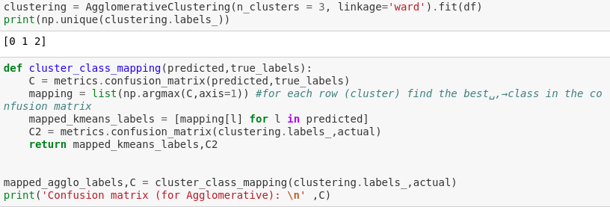

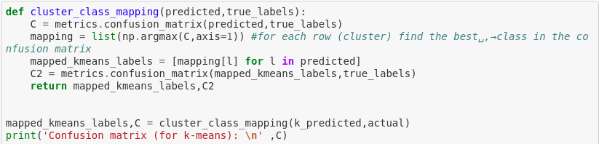

********* Agglomerative Clustering *********
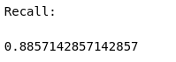
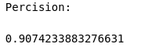
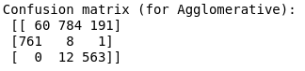

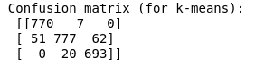
********* K-means Clustering *********
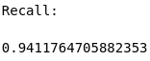
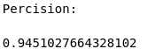
****Logistic Regression mean scores****

mean score test accuracy: 0.930252100840336

mean score test precision weighted: 0.9311110649318362

mean score test recall weighted: 0.930252100840336

mean score test f1-measure weighted: 0.9303521992152968

Confusion Matrix: [[774 34 13]
[ 27 749 28]
[ 14 50 691]]

****SVM mean scores****

mean score test accuracy: 0.9315126050420167

mean score test precision weighted: 0.9318336338131683

mean score test recall weighted: 0.9315126050420167

mean score test f1-measure weighted: 0.9315318350559185

Confusion Matrix: [[781 28 12]
[ 26 741 37]
[ 14 46 695]]

****Decision Tree mean scores****

mean score test accuracy: 0.8176470588235294

mean score test precision weighted: 0.8192663317138272

mean score test recall weighted: 0.8176470588235294

mean score test f1-measure weighted: 0.818011699282092

Confusion Matrix: [[695 77 49]
[ 75 631 98]
[ 31 100 624]]

****k-NN mean scores****

mean score test accuracy: 0.799579831932773

mean score test precision weighted: 0.8017776971681257

mean score test recall weighted: 0.799579831932773

mean score test f1-measure weighted: 0.7994065502172664

Confusion Matrix: [[651 61 109]
[ 86 626 92]
[ 43 86 626]]

****Naive-Bayes mean scores****

mean score test accuracy: 0.911344537815126

mean score test precision weighted: 0.9159718744022938

mean score test recall weighted: 0.911344537815126

mean score test f1-measure weighted: 0.9119924610904245

Confusion Matrix: [[744 67 10]
[ 20 759 25]
[ 14 75 666]]

Clustering performs better in all cases as far as confusion-matrix is considered. However, for precision and recall SVM and Naive-Bayes scales better. (add more)

