IOANNA PAPAGIANNI 2790

QUESTION 5

"Web is our Home Doctor": Analysis on how people per countries use the web search for their health concerns

ABSTRACT - CASE ANALYSIS:

As search engines continue to improve and get more precise and more aware of what a keyword is linked with, people think of it as an easy of “answers” to their questions. Usually, these questions are about topics that are out of the territory for the individual that is looking for the answers.

It has been observed, that one of the most usual cases when an individual searches for important information is when a health concern has arrised. Most of us, when we feel a weird or continuous pain, a headache, when we bump out something we are searching on the internet what that might be and how to overcome it. Furthermore, we might be diagnosed with something and again, we do not ask our doctor all the questions we have about it, we prefer to search on our own on the web for some answers. Another instance, is that there are people in some countries that they do not afford to pay a doctor for a diagnosis, or they might do not afford the treatment and try to find solutions, or “alternative” solutions on the web.

Considering all the above, it is an engrossing subject of interest and research, how people worldwide use these search keys, what answers they seek and what does the popularity of these words mean, for the way these people face their health concerns – issues.

DATA SOURCE:

We are using a dataset from Google Trends, parameterized to serve our analysis purpose. It combines the search terms : ‘ diagnosis’, ‘prevention’, ‘symptoms’, ‘diseases’, ‘treatment’, from 01/01/04 till 11/18/19 based on health category from worldwide web search. The countries (in continent groups) tested are:

America:
Jamaica
United States
Canada
Mexico

Oceania:
Australia
New Zealand

Africa:
South Africa ( the southernmost country on the African continent)
Ghana
Nigeria
Egypt

Kenya

Europe:
Ireland
United Kingdom
Netherlands
Spain
Germany
France

Asia:
Philippines
Singapore
United Arab Emirates
Pakistan
India
Malaysia
Hong Kong
Saudi Arabia
Thailand
Indonesia
Japan

SPECIFYING QUERIES:

Our analysis answers the following questions:

- which are the most popular search keys among these specific words per country

- which are the most popular search keys among these specific words in all the studied countries such as‘ diagnosis’, ‘prevention’, ‘symptoms’, ‘diseases’, ‘treatment’

- how strongly are those words correlated, testing every couple.

RESULTS: Popularity among SearchKeys per Country

Diagnosis WebSearch percentage % per Country Barplot
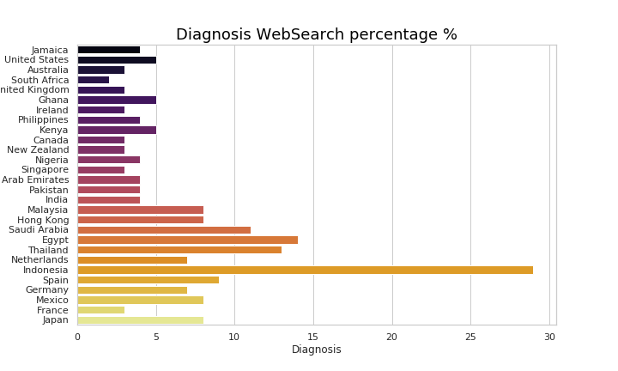
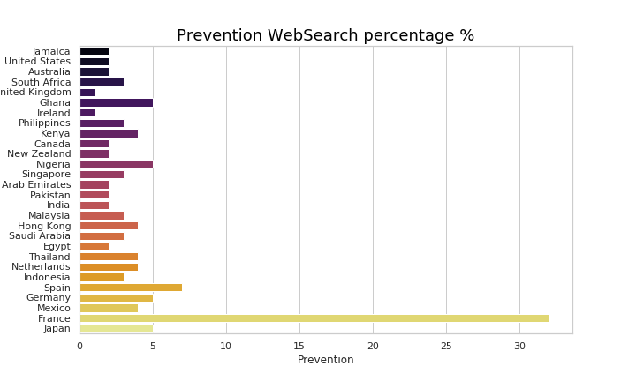
- Percentages are really low, most of them under 15%
- Indonesia is the peak country which searches for diagnosis online.
- South Africa is the least country on the ranking.

Prevention WebSearch percentage % per Country Barplot
- Percentages are really low, most of them under 7%, that is, sad fact because prevention is more important in order to be healthier.
- France, is by far the first country on the list with a high divergence from the other, thus french people are looking for ways to prevent health issues to arise.
- Surprisingly, two Europe continent countries hit the last place, UK and Ireland. Note that UK and Ireland used to be the same country back in the years, hence, they might share the same mentality.

Symptoms WebSearch percentage % per Country Barplot
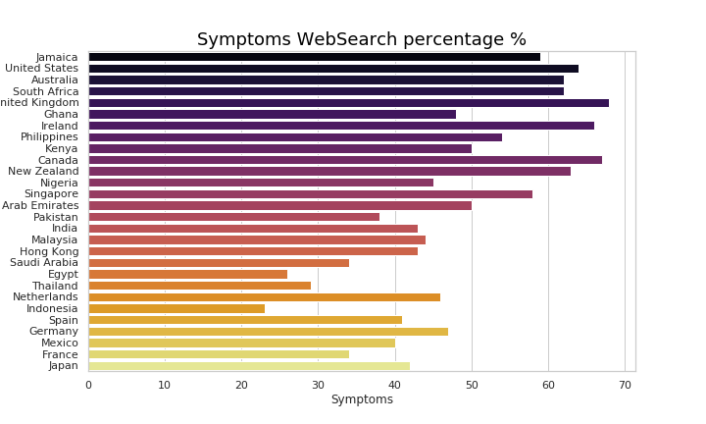
- Percentages are really high, there is a tendency for checking symptoms for health issues.
- UK in this plot comes first, with a small deviance from Canada and Ireland. Again, UK and Ireland share the same attitude towards health concerns.
- Indonesia is the last country that checks for symptoms.

Diseases WebSearch percentage % per Country Barplot
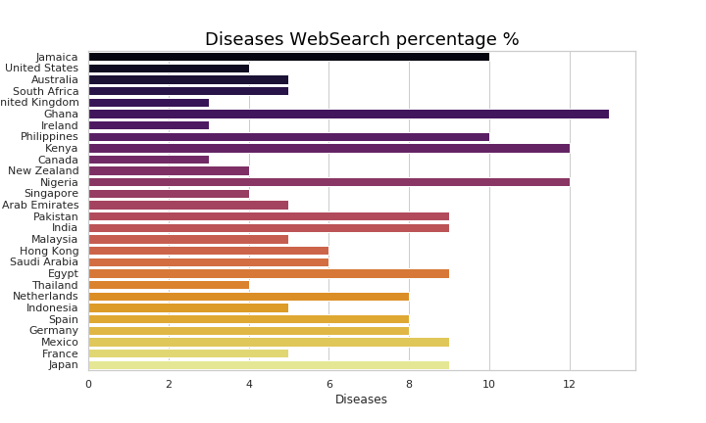
- The percentages are ranging from 3% - 13%.
- Ghana, Kenya and Nigeria (three Africa continent countries) have the first three positions in the "diseases" race.
- UK, Ireland, Canada (again) are the last three countries in the list.

Treatment WebSearch percentage % per Country Barplot
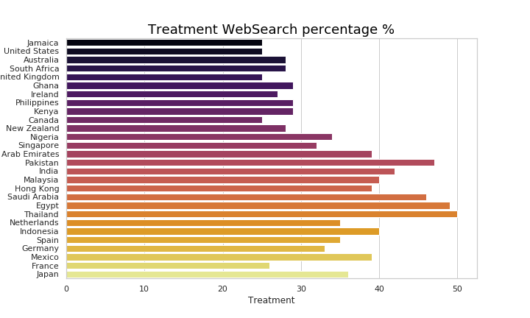

- Rates are moderate, they scale from 25% - 50%
- Thailand searches more about treatment solutions on the web, with Egypt coming second and Pakistan third.
- Lowest rates on treatment searches have Jamaica, USA, UK, Canada.

SearchKeys percentage % per Country Barplot
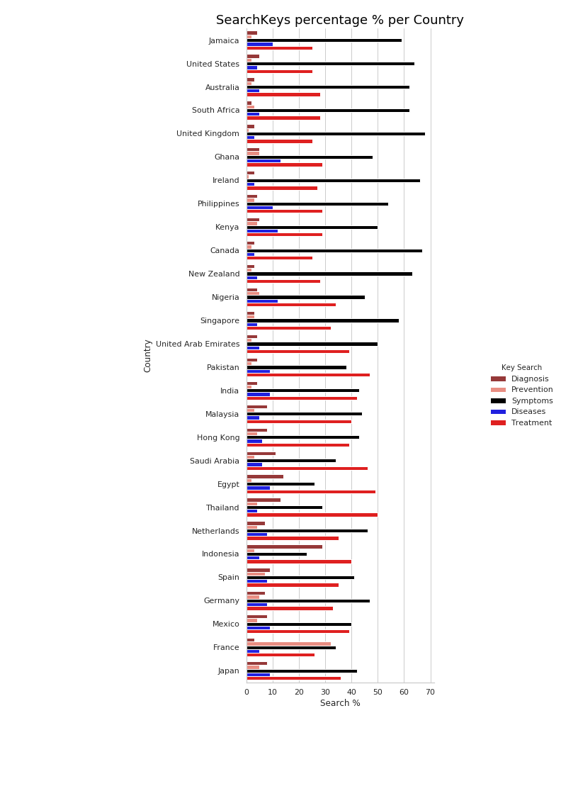

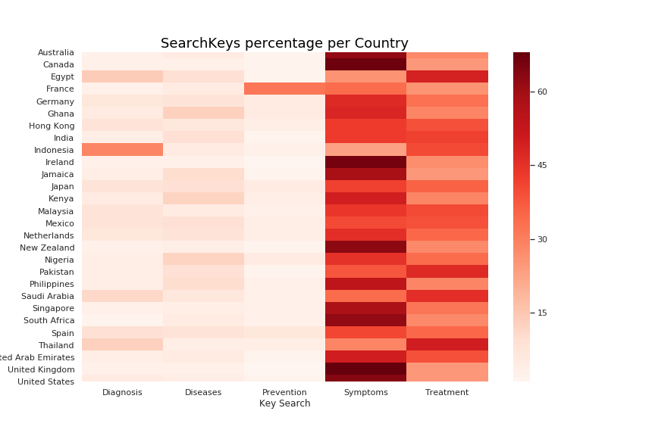

SearchKeys percentage % per Country Barplot
- UK's, Ireland's and Canada's searches are similar. They are the top-3 of symptoms searches countries and they rank the last-3 in prevention, diseases and treatment. They have identical profile towards the way they use the web for their health concerns, that is they are worried to check if they have any symptoms rather than find ways to prevent them, or get to know in general the diseases that exist. Moreover, they are not looking for treatments online.
- Indonesia on the other hand, is the country that mostly seeks diagnosis via internet and is the last country that cares about the symptoms. They try to use web as their "home doctor". It seems that they do not get worried when they have symptoms until it is high time to figure out what they have.
- Thailand, Egypt and Pakistan are the top countries for the treatment search. They look for therapies through the internet. Reasons might be that they cannot afford a doctor diagnosis, that is why also their ratings on diagnois keysearch is moderate to high comperatively with other countries.
- Note that, the only country that cares about preventing a health issue is France, which shows a rightful mindset towards health concerns.

SearchKeys percentage % per Country Heatmap
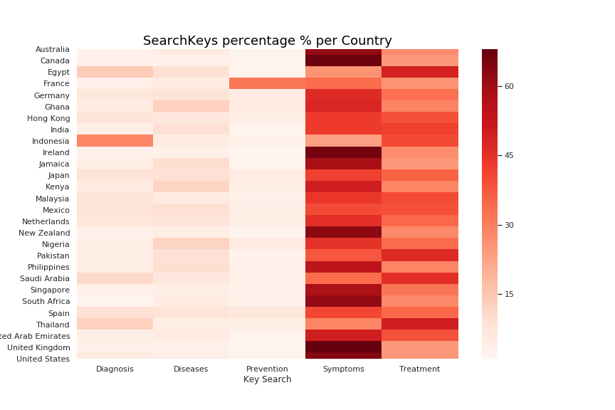
Heatmap visualizes in a better way our statements that we mentioned above

- Symptoms is the most popular search key as see for many countries
- Prevention is the word that is the least popular.

RESULTS: Popularity among SearchKeys in all studied Countries

SearchKeys percentage % in 28 countries Barplot

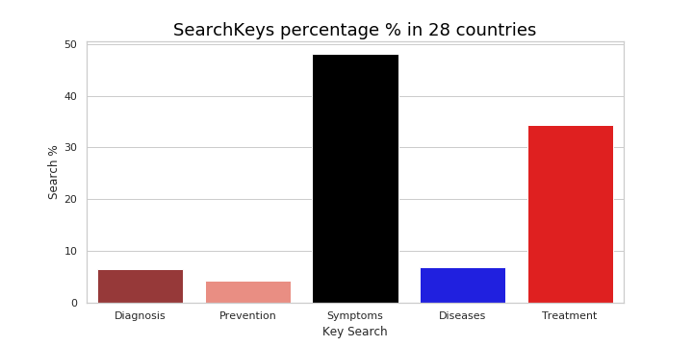

- Symptoms in all countries is the most popular search with almost 50% rate.
- Treatment comes second.
- Diagnosis and diseases share the third place.
- Prevention comes last.

RESULTS: Correlation between SearchKeys per Country

Diagnosis – Prevention
Diagnosis – Symptoms
Diagnosis – Diseases
Diagnonis – Treatment

Prevention – Symptoms
Prevention – Diseases
Prevention – Treatment

Symptoms – Diseases
Symptoms – Treatment

Diseases – Treatment

