IOANNA PAPAGIANNI 2790

QUESTION 4

FROM RAW DATA TO FIXED

Taking a careful look at the dataset of movies.csv file, there are some issues that need to be fixed before moving on with the data analysis.

At first, there are columns that are unnecessary and is better to be dropped off.

These are:
'Unnamed: 0', 'Unnamed: 0.1', 'US Gross', 'US DVD Sales', 'MPAA Rating', 'Running Time (min)', 'Distributor', 'Source', 'Creative Type'

The rest of them (9 columns), are the attributes we need for the data analysis. Note that, all movies are 3201 but they are indices start from 0 to 3200.

- Title attribute is fine.
3201 movies (after pruning Worldwide Gross and Release Date pruning 3187)
Type string

- Worldwide Gross attribute needs some changes. Although it has all 3201 movies there are some marked as “unknown” (7 movies). These movies are pruned. After pruning, data are converted to float. Renamed to: Gross
3201 (after pruning 3187)
Type string (converting to float)

- Release Date attribute format is month/day/year for the most, but there are movies with year only and others cointain alpharithmetics. For our analysis, year only fits the criteria and we keep only that. Firstly, we prune spaces (if any) on the right side of every value for this attribute and then we keep only the last two characters if and only if they are numbers, in two digits format. Anything else is pruned. After pruning, depending on the century they belong (e.g: if the number is 01 → 2000 century, 97 → 1900 century, the logic is [0,19]*→ 2000 century else → 1900 century) two more digits are added in front. Renamed to: Date
3201 movies (after pruning Worldwide Gross and Release Date pruning 3187 )
Type string (converting to int)

* 19 stands for 2019 (the current year). Notice that, there is a movie “Over the Hill to the Poorhouse” that was released in 1920. Fortunately, this dataset contains movies till 2016.

- Mayor Genre attribute has a lot of different genres. Where there is <space> we consider the category as a whole, but where there is </> means that this movie belongs in two categories.
We made a dataframe called genres_df, with ‘First’ and ‘Second’ as columns to store the different genres a movie can be. We do not need titles as long as we have their indices.
Renamed to: Genre
2926 movies
Type string

- Rotten Tomato Rating attribute has ratings on the [0,100] climax. We divide its of them by 10 so as to fit IMDB Rating climax [0,10]. Renamed to RTRating
2321 movies
Type float

- IMDB Rating attribute is fine. Renamed to IMDBRating
2988 movies
Type float

- IMDB Votes attribute is fine. Renamed to IMDBVotes
2988 movies
Type float

- Production Budget attribute is fine. (This attribute is needed for the analysis in part 4.).
Renamed to: Budget
3200 movies (after pruning Worldwide Gross and Release Date pruning 3187 )
Type float

- Director attribute is fine. (This attribute is needed for the analysis in part 4.).
1870 movies
Type float

After Worldwide Gross and Release Date pruning, indices will be reset and renamed as “ID” starting from 1 instead of 0.

HISTOGRAMS AND DISTRIBUTIONS

WORLDWIDE GROSS: Skewed Non Symmetric (Non-Normal) Right-long-tailed Histogram – Geometric Distribution:
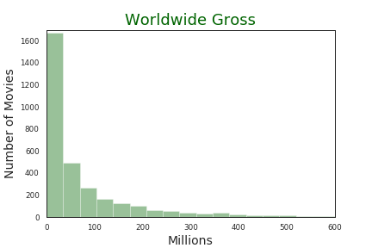

- The data, are located in the left side that means movies’ worldwide gross is estimated mostly between $0 - $50 million dollars but that is not a good representative of the center of distribution (mean is on the rightmost). A better way to conclude where the center is, is by using mean on the horizontal axis to find out where the distribution balances.
- Scale of data: interval [0.0 – 2767891499.0] dollars.
The spread of data is not really wide, basically around $0-$500 million dollars. Note that, data range from $0 up to $2767891499, which means that we cannot include all of them and it is pointless ( they would not appear in the histogram), only one reaches 2 billions and a few 1 million.
- “Skewed” because there is no-mirroring of the data in lower and upper bounds, this distribution is non-symmetric. It has a long tail (on the right) relative to the other tail (left side has no tail at all). This phenomenon occurs, due to the lower bounds on the data that are significantly more frequent than the upper bounds (as we explained above).

ROTTEN TOMATOES RATING: Symmetric and Unimodal Histogram – 1 peak Unimodal short–tailed Distribution
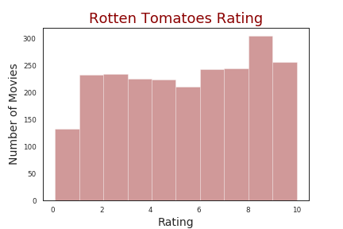

- The data, cluster around a single mode (1 peak unimodal), the most frequently occuring, and distribute themselves with less frequency out into the tails. Tails here, approach zero very fast. We could say that Rotten Tomatoes ratings are well-distributed, ratings vary a lot and overspread through whole data scale .
- Scale of data : interval [0.1,10.0] points**. We managed to contain the whole scale.
- No skewness.

IMDB RATING: Skewed Non-Symmetric Normal moderate-tailed Histogram – Normal Distribution
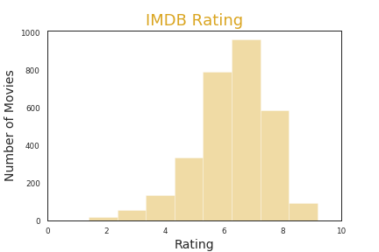

- The data are normally distributed with a litle skewness to the right. IMDB Ratings follow the normal distribution, centrality is around 6 and 7 points and as we can see there is a tendency for higher voting than lower.
- Scale of data : interval [1.4, 9.2] points**. We managed to contain the whole scale.
- There is a litle right skewness and we conclude that most ratings tend to be higher than the average rating (5).

**For all ratings points are between 0 and 10.

IMDB VOTES: Skewed Non Symmetric (Non-Normal) Right-long-tailed Histogram – Geometric Distribution

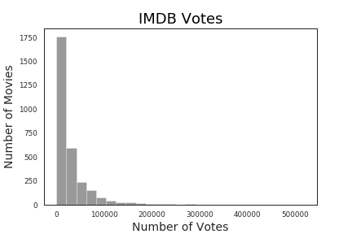

- Most of the data are located in the left side and with a first glance we could say that the centrality of the number of votes is between 0-30000.
- Scale of data : interval [18, 519541] votes. We managed to contain the whole scale. Data are not normally spread all along the interval.
- Again, data are skewed to the left and this distribution is non-symmetric. It has a long tail (on the right) relative to the other tail (left side has no tail at all). This phenomenon occurs, due to the lower bounds on the data that are significantly more frequent than the upper bounds (as we explained above).

MAJOR GENRE: Number of Movies per Genre, Bar Plot “Oh! Too much DRAMA”
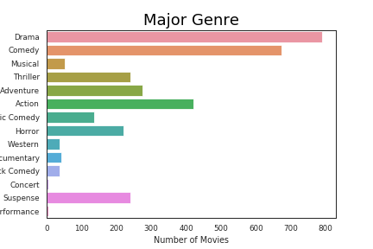

The barplot shows some interesting analytics for what kind of movie, Production Companies, prefer to release. There is a tendency to fund and therefore, produce more “Drama” and “Comedy” movies. The bronze metal goes to “Action” films and “Performance” and “Concert” genres come last.

