IOANNA PAPAGIANNI 2790

QUESTION 3

USER USER COLLABORATIVE FILTERING

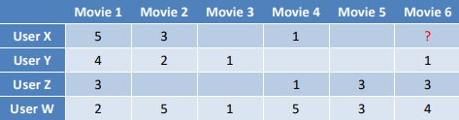

1st edition:

- We fill blank cells with 0 to calculate the cosine. Each user, is a vector:

Vectors x, y are correlated because cos(x, y) = 0,936974961 is close to 1 so x and y are similar.
The second most similar vector is z.

- The sum of cos(x, y) and cos(x, z) is:

sumcos = cos(x, y) + cos(x, z) = 0,936974961+0,830539535 = 1,767514496
- We now evaluate mean(x) :

In order to be more precise, we do not consider blank spaces as zeros 0 when we calculate mean().

- Then, we evaluate mean(y) and mean(z):

- For each of the two similar users y, z we subtract its own mean(y) and mean(z) respectively from the value they have on movie 6 to find their deviation from their mean().

- We multiply each of these differences with their cosine similarity and sum them together.

- Finally, we have all the necessary info we need to predict the number:

- Our dataset is filled with int values for ratings and so, we round() and cast to int our prediction.

int(round(prediction)) = 4

User X rates movie 6 with 4.

2nd edition:

