ECOCARDIOGRAFIE TRANSTORACICA
Data examinarii: {data_examinarii}
Nume si Prenume: {nume_prenume} Varsta: {varsta} ani TA= {ta}mmHg
Calitatea imaginii ecocardiografice: Buna Satisfacatoare Slaba
Ritm sinusal ⁯ Fibrilatie atriala ⁯ Ritm electrostimulat ⁯
Incidenta parasternala:
Ao la inel: {ao_inel} cm (2,2-3,7)
Ao ascendenta: {ao_ascendenta} cm (2,1-3,4)
Deschidere v ao: {deschidere_v_ao} cm (>1,6)
Apectul valvei aortice: Normal Patologic {aspect_v_ao_detalii}
Diam AS: {diam_as} cm (2,7-4,5)
Diam VD: {diam_vd} cm (0,9-2,6)
SIV: {siv} cm (0,6-1,2) Miscare paradoxala SIV: Nu ⁯ Da ⁯
DTDVS: {dtdvs} cm (3,7-5,6)
DTSVS: {dtsvs} cm (2,7-3,7)
PPVS: {ppvs} cm (0,6-1,2)

FS: {fs} % (25-45)
FE Teichholtz: {fe_teichholtz} %
Apectul valvei mitrala: Normal Patologic {aspect_v_mitrala_detalii}
Apical 4 camere: Apical 2 camere:
VTD: {apical_4c_vtd} ml (95,5 +/-19,4) VTD: {apical_2c_vtd} ml
VTS: {apical_4c_vts} ml (38,6 +/-9,5) VTS: {apical_2c_vts} ml
FE planimetric: {apical_4c_fe}% FE planimetric: {apical_2c_fe}%
Volum AS: {volum_as} ml (20-55) Supraf AS :{supraf_as} cm² (<20)
Functie diastolica: Normala ⁯ Disfunctie diastolica tip I ; tip II ; tip III ;

Flux mitral: E={fm_e}m/s (0,72+/-0,14) A={fm_a}m /s (0,40+/-1,10) TDE={fm_tde}ms (160-240),
E´={fm_e_prim}m/s, E/E´={fm_e_per_e_prim} , S´={fm_s_prim}ms
Stenoza mitrala Nu Da Severitate: {sm_severitate} PHT={sm_pht} ms,
Pmed={sm_pmed} mmHg,
Insuficienta mitrala Nu Da Severitate: {im_severitate} Vena contracta={im_vena_contracta} cm
dP/dt= {im_dp_dt} mmHg/ms
Flux aortic : V max={fa_vmax} m/s, Pmax={fa_pmax} mmHg, IVT={fa_ivt} cm,
TEVS={fa_tevs} cm, IVT TEVS={fa_ivt_tevs} cm,
Stenoza aortica Nu ⁯ Da ⁯ Severitate: {sa_severitate},
AVA cont={sa_ava_cont} cm², Splan={sa_splan} cm², Pmed={sa_pmed} mmHg,
Insuficienta aortica Nu ⁯ Da ⁯ Severitate: {ia_severitate}, Vena contracta={ia_vena_contracta} cm
PHT={ia_pht} ms, v td aorta desc={ia_v_td_aorta_desc} cm/s,
Flux tricuspidian: Vmax={ft_vmax} m/s, P max={ft_pmax} mmHg
E= {ft_e} m/s (0,51+/-0,07), A={ft_a} m/s (0,27+/-0,08),
Stenoza tricusp Nu ⁯ Da ⁯ Severitate: {st_severitate}, PHT= {st_pht}ms,
Pmed={st_pmed} mmHg
Insuficienta tricusp Nu ⁯ Da ⁯ Severitate: {it_severitate}, Vena contracta={it_vena_contracta} cm
TAPSE= {it_tapse}cm

Flux pulmonar: : Vmax={fp_vmax} m/s, Pmax={fp_pmax} mmHg, TaccP={fp_taccp} ms,
Stenoza pulm Nu ⁯ Da Severitate: {sp_severitate}, Pmed={sp_pmed} mmHg
Insuficienta pulm Nu ⁯ Da ⁯ Severitate: {ip_severitate} , PSAP={psap} mmHg
Cinetica parietala: Normala ⁯ Anomalii de cinetica parietala
{cinetica_detalii}
{concluzii}
apical 4C apical 2C apical 3C GLS = {gls}%

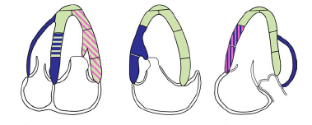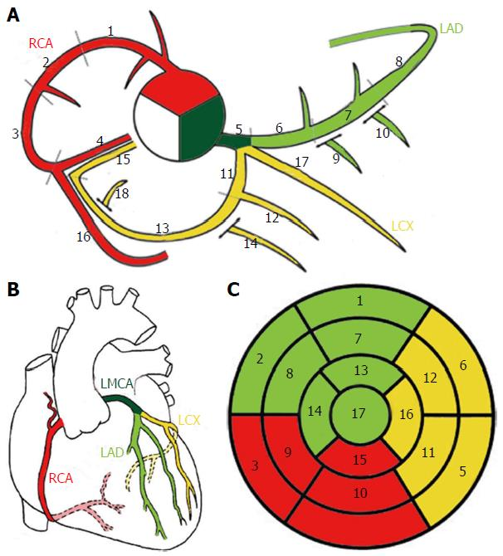
bazal mediu apical
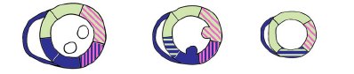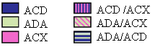
Lichid pericardic: Absent Prezent {lichid_pericardic_detalii}
Concluzii:..........................................................................................................................................................................................................................................................................................................................................................................................................................................................................................................................................................................................................................................................................................................................................................................................................................................................................................................
Diagnostice: {diagnostice} | Recomandari: {recomandari}
Tratament: {tratament}
Medic examinator: {medic_examinator}

