IOCOM in GitHub
180728, updated 5.9.2019/pekka
The library code is stored in:
https://github.com/iocafe/iocom

The IOCOM library relies on the operating system abstraction layer:
https://github.com/iocafe/eosal

I recommend cloning the git repositories in “/coderoot/iocom” and “/coderoot/eosal” directories, or “c:\coderoot\iocom” and “c:\coderoot\eosal” on Windows. Also repository /coderoot/pins will be needed to run example codes (HW independent access to GPIO, ADC/DAC, PWM, etc. We plan eventually to support other root folders than /coderoot, but at least for now using other root folder would require editing a lot of paths and be wasted effort.

Recommendation: GitKraken is good graphic front end to GIT. I specifically like how it shows branches and merges of the development tree. It is free for non-commercial use and inexpensive for commercial use (individual license $30/year at time of writing). GitKraken instructions can be found at https://support.gitkraken.com/start-here/guide/.

See iocafe.org for ready development virtual machines, etc. Or email pekka.lehtikoski@gmail.com

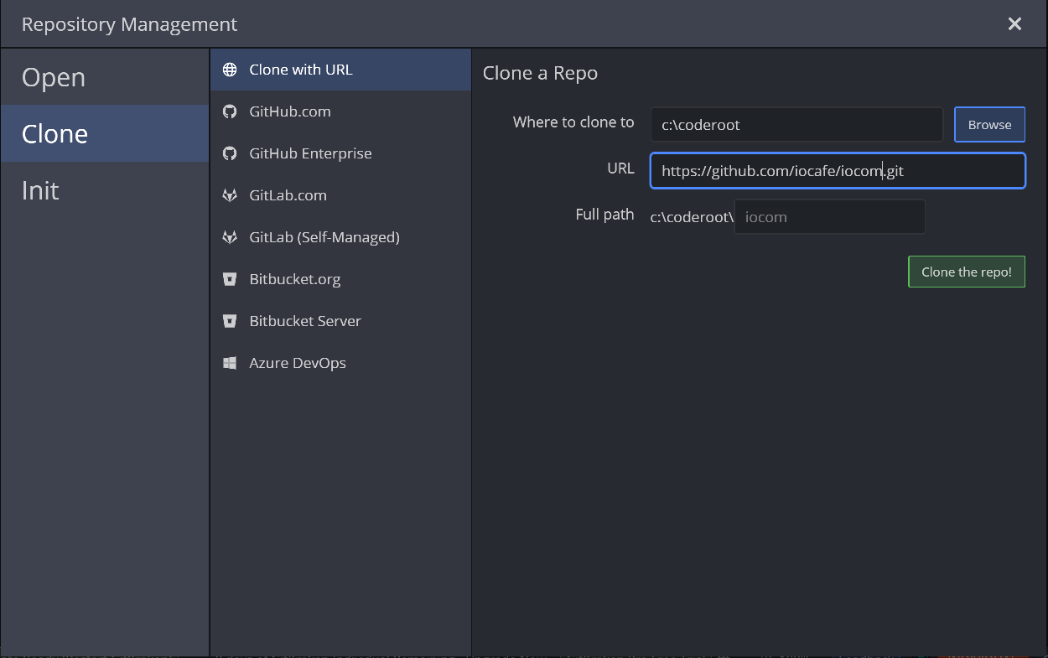
Cloning iocom repository with GIT Kraken on Windows

