Using vmware virtual machines for development
190828, updated 14.9.2019/pekka
There are good reasons to use virtual machines in product development. Ready development environment with all tools, settings and repositories can be copied from a developer to another. These can be prepared separately for different operating systems, micro controllers or development tool sets. It is easy to get started or get a tested reference to compare to when setting up your own development environment. These things are great, but there are downsides. USB devices like JTAG/ST-link and serial ports need to be mapped to virtual machine. To test a micro controller communication with PC code, network needs to be mapped, etc. Virtual machines are large files, often tens of gigabytes. Copying these over Internet can be problematic and one needs considerable amount of fast reliable hard disc space to store these. High RAM requirements may also be a problem on low end computers.

I have found vmware to be better for this purpose than virtual box. The vmware workstation-player can be downloaded from vmware’s web site. It is free for non commercial hobbyist use, but license needs to be bought to use it for work. At the time of writing this, the license price is around $150 USD.

Maintain backup of your virtual machine
Keep back up of your virtual machine, this is very likely to become handy at some point. When working with a bunch of new tools and code, it is only too easy to install or configure something erroneous. Working backup will then save the day. To create a back up, shut down your virtual machine and use 7-Zip, etc, to compress whole virtual machine folder. I recommend to keep at least two backups: Latest proven stable version, and version currently working on.

Using USB devices from virtual machine
ST-Link, JTAG and serial ports are nowadays typically USB devices for the development computer. To use these from a virtual machine, these need to be connected to the virtual machine, not to the host computer’s operating system.

Virtual machines run typically Linux operating system. Windows is more problematic because license would need to be bought separately for each copy of virtual machine and this makes it impractical to use windows virtual machines for sharing development environments.

In Linux, the development tools run mostly on local user accounts, and serial ports require root privileges by default. To allow anyone to use /dev/ttyUSB0, etc:

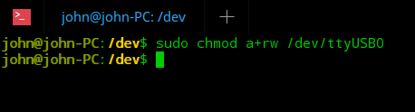

If host computer is also Linux, sometimes it is necessary manually to black list a driver in host operating system to prevent it being loaded. In picture below I have disabled serial port driver cp210xx from the host operating system.

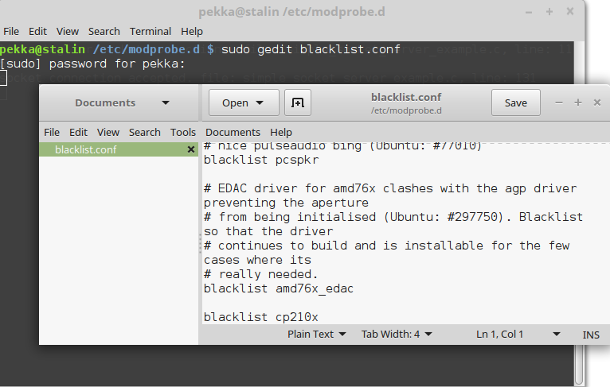

Network considerations
There are basically there ways to approach this.
- Add second network using USB device directly to virtual machine. Map the USB Ethernet or Wi-Fi adapter into virtual machine and just configure it these. Use that network for testing the micro controllers.
- The host’s network (either wired or wireless) can also be used to test the devices. If a micro controller is server and software within the virtual machine is client, not much configuration is needed NAT can be used. NAT means that virtual machine shares host’s IP address. NAT is especially nice if you use VPN on host computer to connect to corporate network, the virtual machine can share this connection.
- If working other way around where the device is client and it needs to connect to software in virtual machine, set up virtual machine network as “bridged”. This means that the virtual machine will appear as completely separate computer from the host computer. Then the virtual machine should pick up network from DHCP, or in none available configure the virtual machine network manually.
