ESP32 with Visual Studio Code, Platform IO, Arduino, and Esp-Prog/JTAG
190915, updated 15.9.2019/pekka
A lot of acronyms in the title. There are many options how to do micro-controller development, and this is one combination. The goal here was to evaluate this choice for the development environment.

Hardware
The micro-controller development board: MELIFE ESP32 Development Board (from Amazon).
External USB/JTAG debugger: ESP-Prog (from Grid Connect).

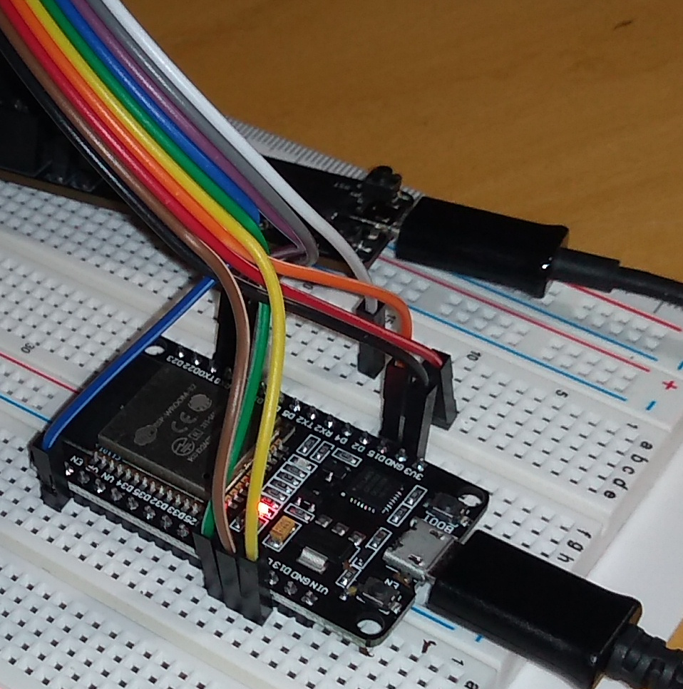
ESP32 development board and ESP-Prog on background

It is a bit of effort to find correct pins to connect. Initially, I powered the ESP32 trough Esp-Prog. This didn’t provide enough current, causing “brownouts” at ESP when Wifi started up. Solved by disconnecting red +3.3V wire between ESP32 and Esp-Proj, and connecting power to ESP32 with it’s own USB connector. I am unsure how will this connect the grounds of the two USB cables together? Anyhow after this hardware worked fine.

ESP-idf – the ESP32 support and development
The first thing needed to develop for ESP32 is esp-idf by Espressif, the chip maker. It is solid and good, and can be used to build, load and monitor ESP32 code as it. But it is not a full-fledged development environment with a debugger, other components are needed. If one wants a GUI, choices are Eclipse or Visual Studio code. I vote for Visual Studio Code, even it is tricky to set up it is still easier than Eclipse and works with Platform IO

Arduino libraries – nice to use and pain to debug
This is a love/hate relationship. I find Arduino libraries easiest way to write micro-controller code which is at least “about portable” from micro-controller to another. Way of distributing libraries as .zip files containing sources is also good, and the best part is that the application stays small, simple and readable. Hardware dependent code is not bundled in.
But then. It is an environment which has not given any taught on debugging, which is painful to put it nicely.
Options that have worked for me are using gdb -tui from the command line (hackaday) or using Visual Studio Code + Platform IO + GDB. Both have their own tricks and are not easy to set up or use, but get the job done. As a preference I think Visual Studio Code is better of the two, still it is painful to get to work if one is not intimately familiar with the Visual Studio Code and Platform IO configuration.
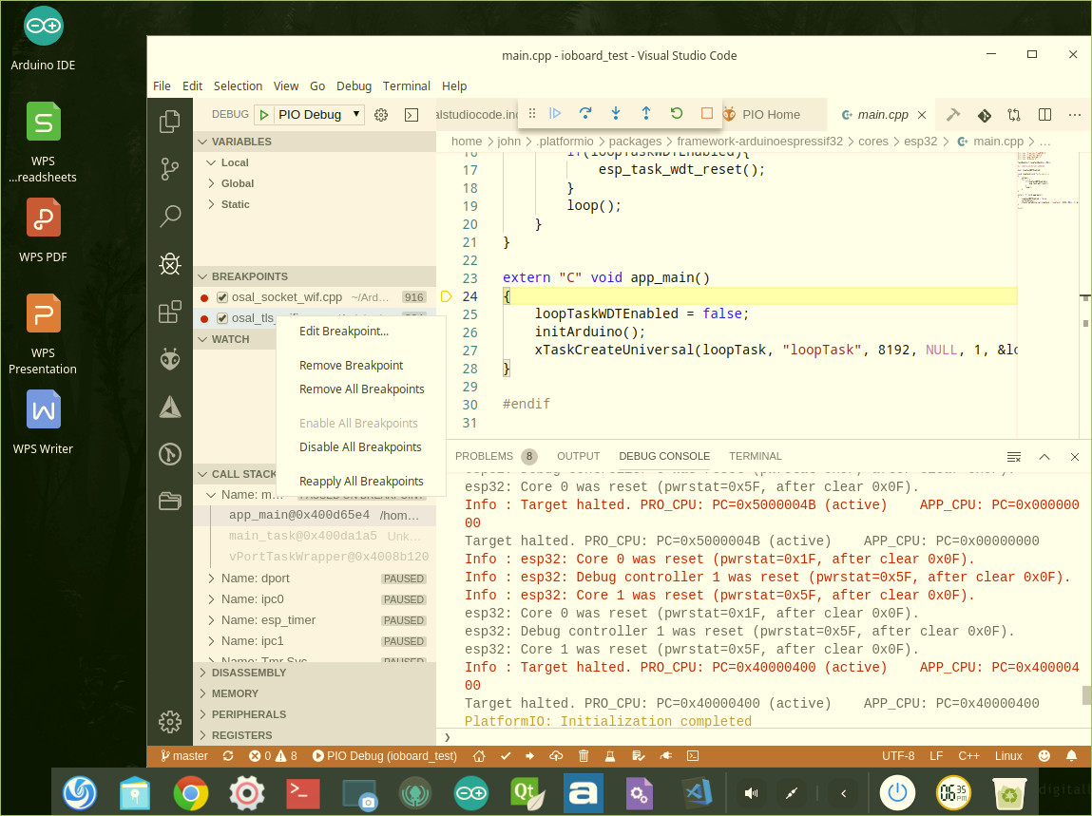
Visual Studio Code/Platform IO/GDB debugging in Deepin virtual machine

TLS – secure transport
The environment comes with Mbed TLS by default. It worked easily > I was happy. The IOCOM library traffic flows nicely from ESP32 to Linux or Windows (or to anything else) trough secure socket. I have still not implemented device identification. So even the communication is encrypted, device and control computer cannot be certain with whom they communicate. This is on to do list.

vmware virtual machines and other easier choices
Setting up micro-controller development environment like this one takes quite a bit of time and Googling. There are many setting, software version requirements, etc, which need to be sorted out. This makes me think that a good way for a new person to get started is to download ready virtual machine for the specific setup. Even if one wants to set up native development environment, the virtual machine can be used as working reference. Then some tools are relatively easy, especially Arduino IDE is simple and easy (without debugging), no need for virtual machine. Atollic True Studio for SMT32 chips is also easy, but tends to bundle much HW dependent code in.
When you get ESP32 make sure that it has USB connector which can be used for debugging (get ESP-WROVER-KIT), no need to fiddle with wires and pins.

