IOCOM in simple multi player game?
191202, updated 2.12.2019/pekka
This test code/example is for IOCOM network topology using Python API (iocompython) and Pyglet game UI library. Network topology for a multi player game can be very similar to IO device network: I run server side app (also python/iocompython) in Amazon’s AWS and client side in my computers. The “game arena” is analogous to “IO device network” and “player” to “IO device”.
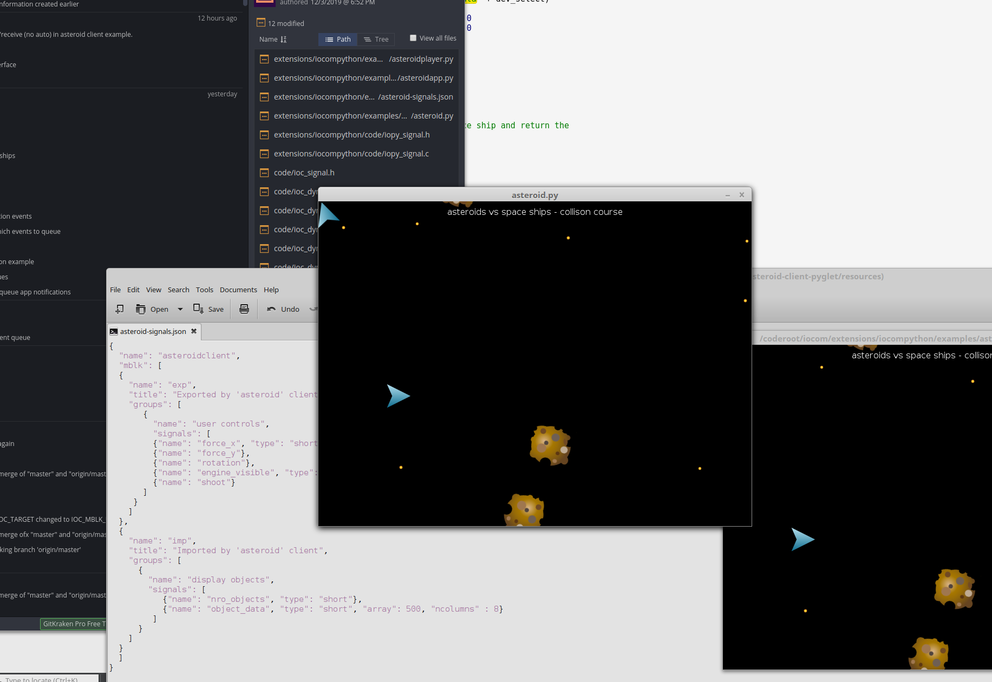

On server side
It is was easy. Amazon EC2 is like Linux computer (virtual one tough) to which I connect with putty terminal. Necessary software like git, cmake, python3-dev, etc. can be just installed to AWS machine by typing “sudo yum install git….” to pytty terminal. Then I use “git clone..” to get “/coderoot/iocom” and “/coderoot/eosal” source code. The iocompython C code /coderoot/iocom/extensions/iocompython builds with cmake to “/coderoot/bin/linux/iocompython.so” on linux (or bin/win32/iocompython.pyd” on windows).

To run the Asteroid game server, use in “iocompython/examples/asteroid-service/asteroidservice.sh”.

On client side.
The “/coderoot/iocom/extensions/iocompython” C code needs to be comiled for client environment, this makes the Python module. Asteroid game’s client side Python code is in “iocompython/examples/asteroid-client-pyglet”.

Linux notes:
Note 1: Build and run dependencies (already in dev. virtual machine)
- sudo apt-get install cmake
- python (3.5 or newer preferred)
- pyglet

Note 2: Build iocompython from C code
- cd /coderoot/iocom/extensions/iocompython
- mkdir tmp
- cd tmp
- rm -R *
- cmake -DCMAKE_BUILD_TYPE=Release ..
- make

Note 3: Check build result
- ls -la /coderoot/bin/linux/iocomp*
- ==> -rwxr-xr-x 1 pekka pekka 244056 Dec 26 22:12 /coderoot/bin/linux/iocompython.so

Note 4: Start asteroid test service
- open new terminal
- cd /coderoot/iocom/extensions/iocompython/examples/asteroid-service
- ./asteroidservice.sh

Note 5: Start asteroid test client
- open new terminal
- cd /coderoot/iocom/extensions/iocompython/examples/asteroid-client-pyglet
- gedit asteroid.py
- modify line connection = Connection(root, "127.0.0.1", "tls,up") to have numeric IP address of computer running the asteroid service. 127.0.0.1 is in same computer. Save the file and close gedit.
- ./asteroid.sh

Note 6: General
- Line "import pyglet" or "import kivy" in .py file causes python to load Pyglet, or Kivy, if the library is installed.
- Python starts with command python3 Python.
- Ofter several different Python 3 versions are installed in same computer, so simetimes we use "/usr/bin/python3" and sometimes just “python3” to start Python.
- Python needs to find /coderoot/bin/linux/iocompython.so. To make this happen environment variable "export PYTHONPATH=/coderoot/bin/linux" is set.
- Startup script ending with “.sh” sets PYLONPATH and starts asteroid test application "/usr/bin/python3 asteroid.py"

