Android application - Blinky
200318, updated 20.3.2020/pekka
Android application is simple: To provide user form to fill in wifi network name, password and other optional configuration settings. When user fills these in and clicks “blink” button, the app starts sending this data repeatedly with LED flash until the “blink” button is clicked again.

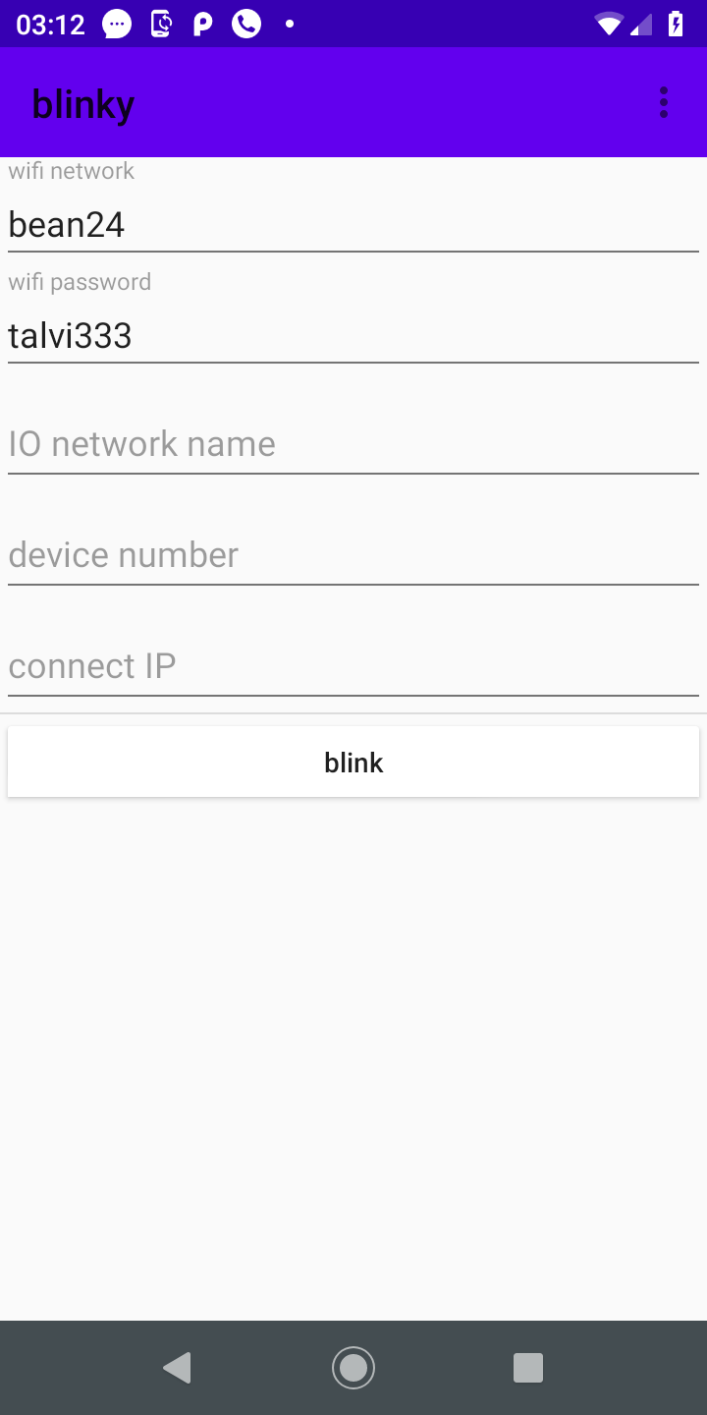

The android application’s Java code is in iocom/extensions/gazerbeam/examples/blinky directory.

