Electronics
200318, updated 20.3.2020/pekka
An LM6144 operational amplifier (U1 and U2) is used to high pass and to digitize the signal of LXD/GB3-A1ELS photo transistor (Q1).
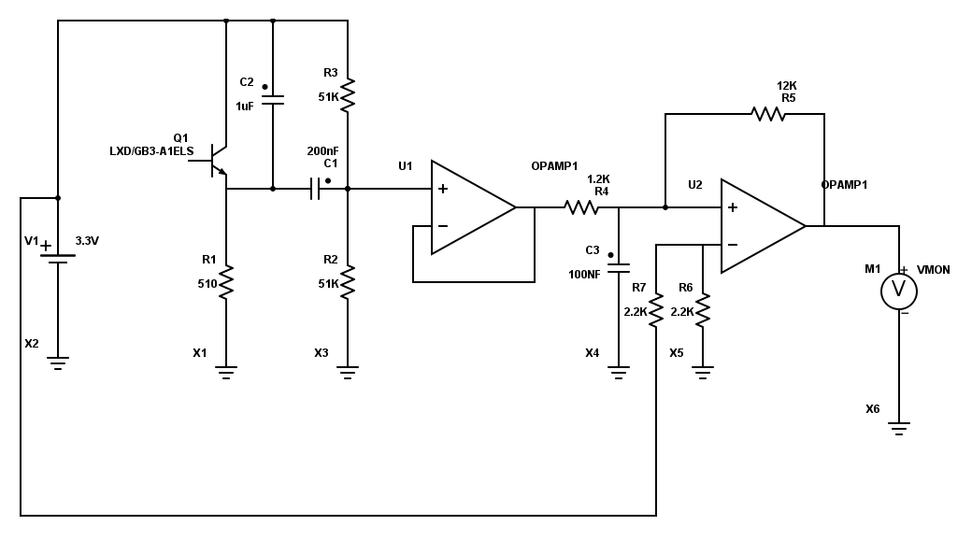
The first operation amplifier U1 does high pass filtering of the signal. This removes ambient light and centers the signal at 1.65V.

The U2 is comparator, which compares if input voltage is less or greater than 1.65 V changes the voltage to 0V or 3.3V (rougly) Resistor R5 adds a threshold to change output state, to prevent output from filtering. In addition there is mild low pass filtering by RC circuit C3/R4.

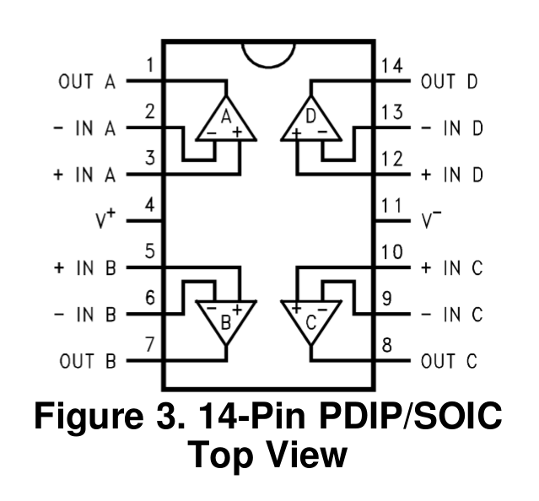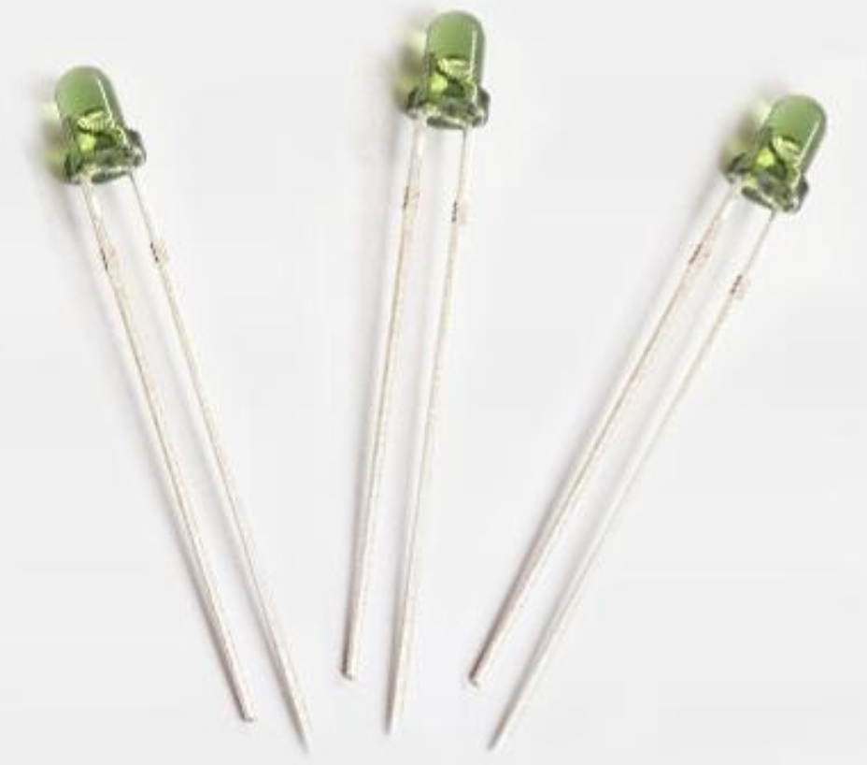
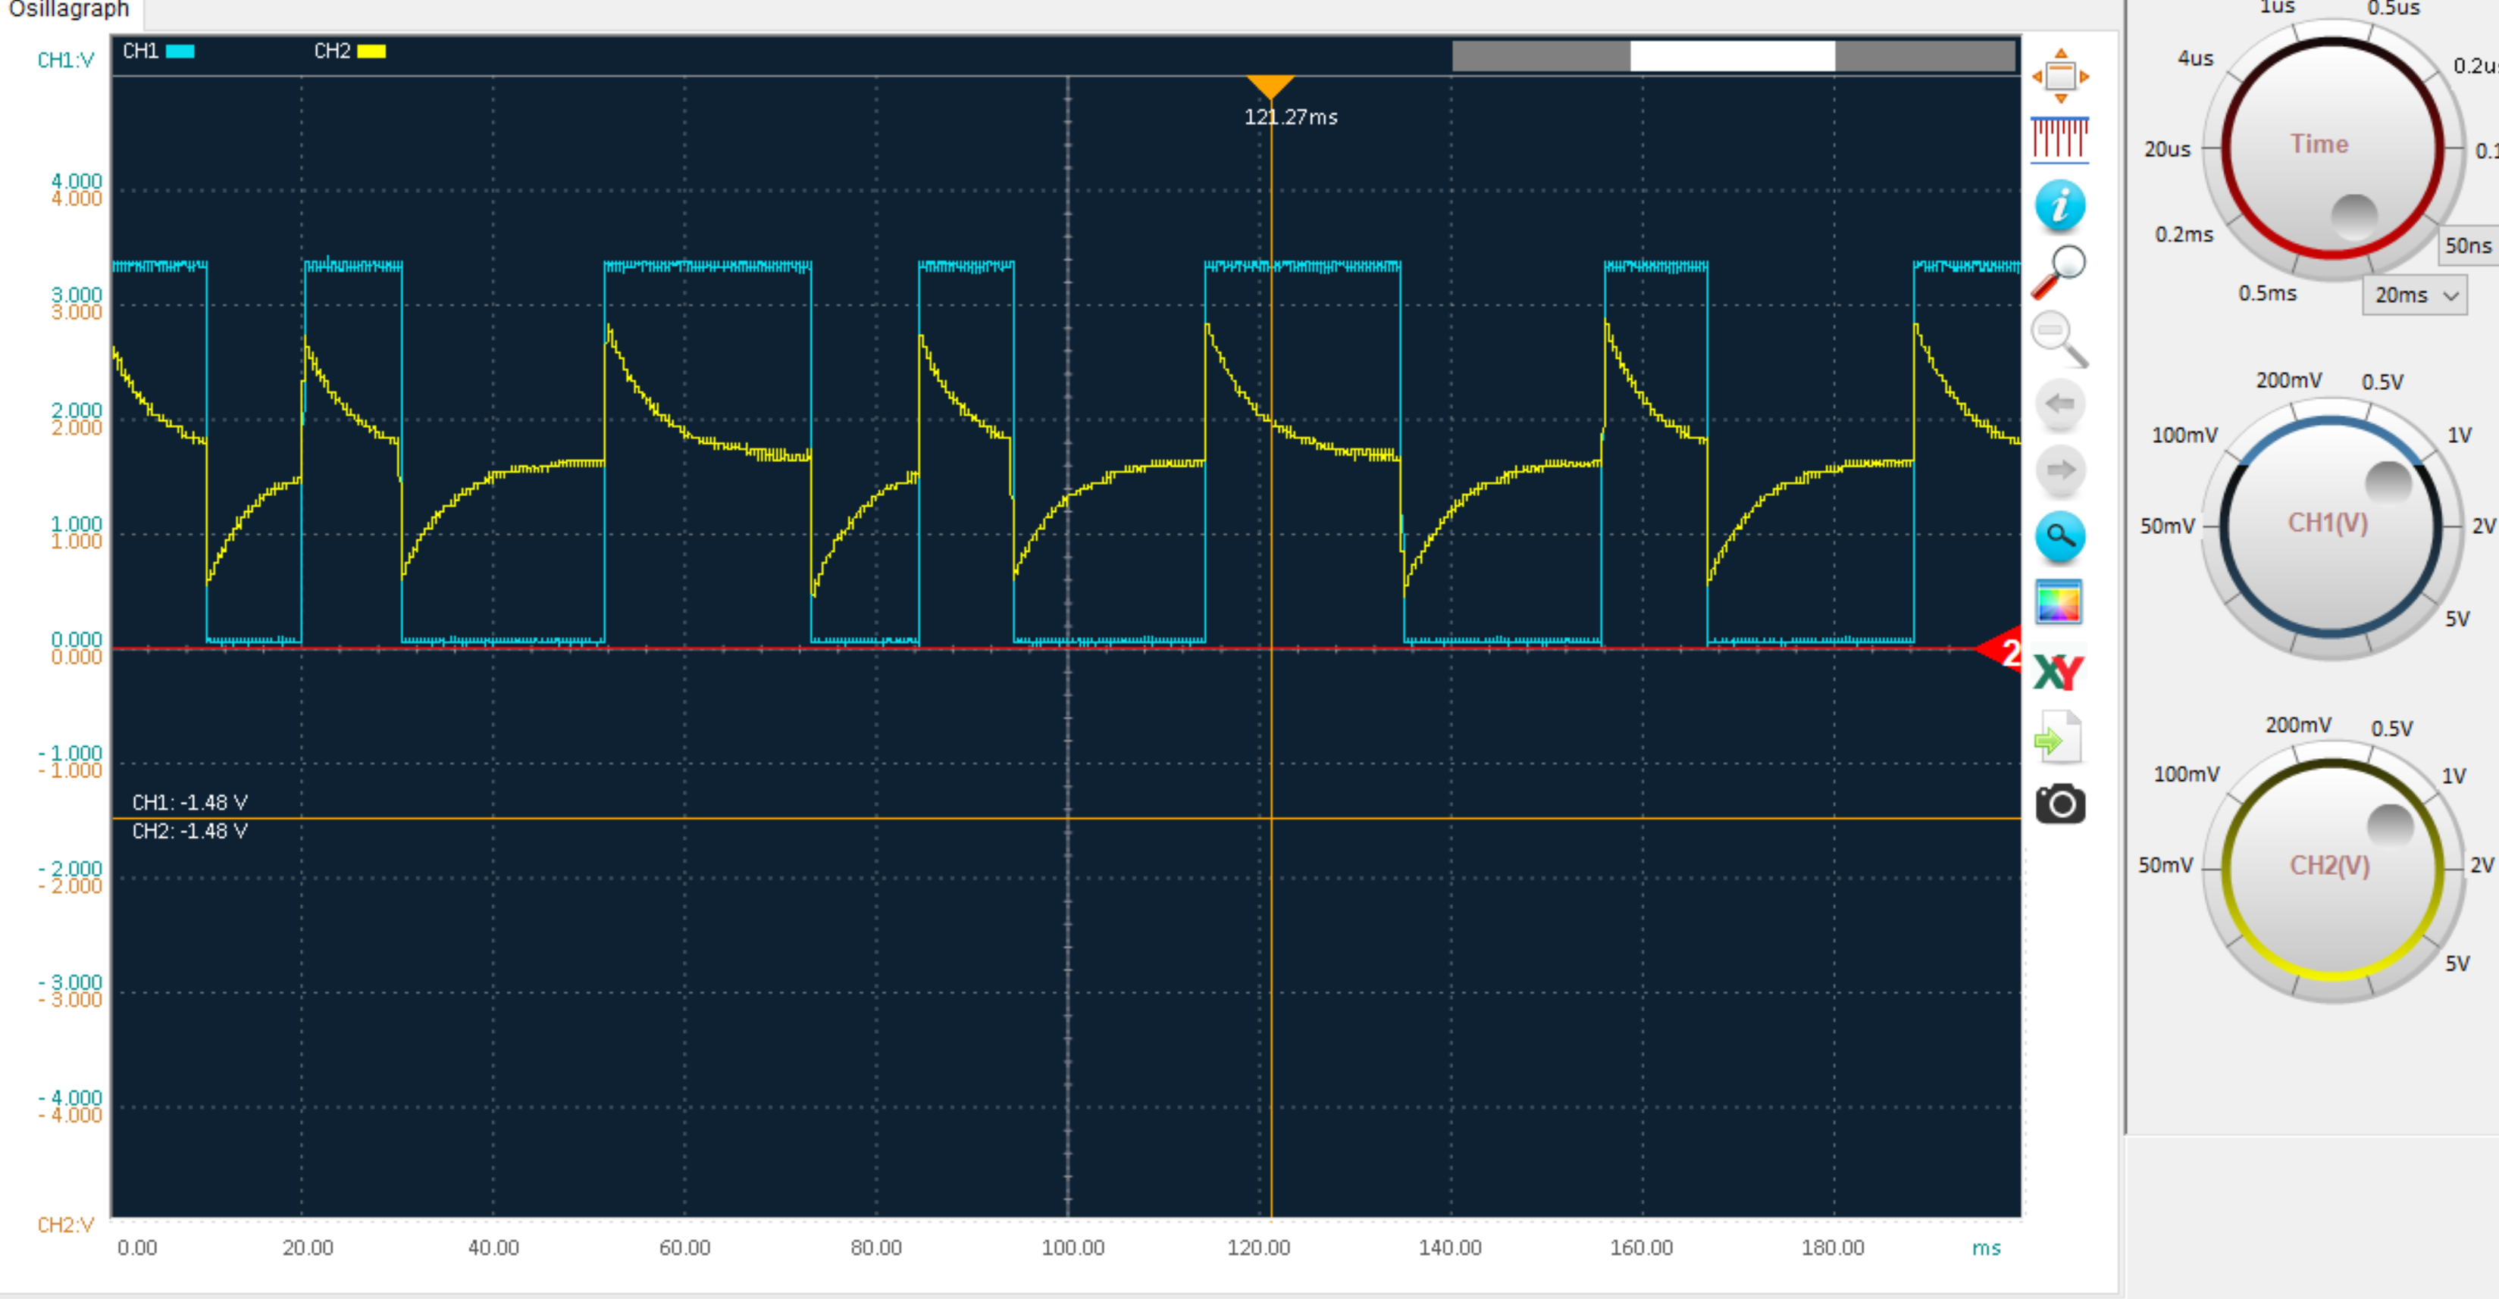
Yellow is high pass filtered signal after first OP-amp U1. The blue is digitalized signal after second OP-amp U2.

