Testing and prototyping hints
200319, updated 20.3.2020/pekka
I am C coder, only hobbyist in electronics. So I draw any analog electronics design with partsim, (free on line tool) and run simulation it. Next I test the setup on breadboard, as in picture below. Components I like to buy from AliExpress and keep extras at home.

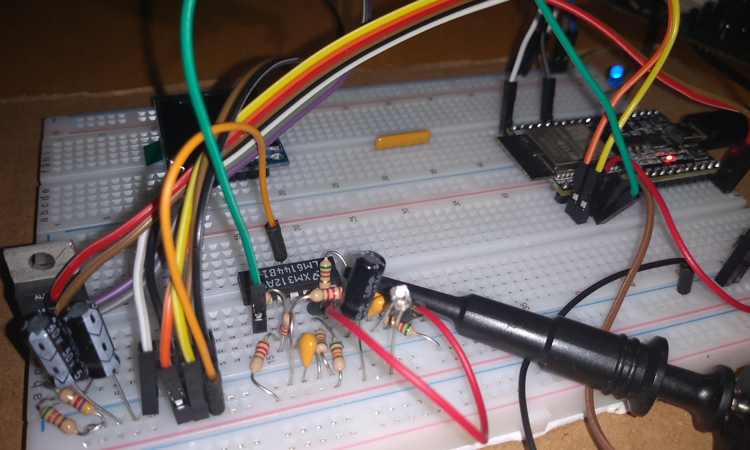
Bread board test. 5 volt regulation on left (ESP32 regulates 5V down to 3.3V, which runs the electronics),
ESP-32 WROOM DEV KIT on back right and Gazerbeam photo transistor and signal filtering around LM6144 chip.

Once ready to make a “product”, which often is just hobby project: I start to think about dimensions, connectors, transients and finally open Eagle CAD (AutoDesk, free for home projects) to and draw the design. I still use old laser printer, heat transfer paper, iron and ferro-chloride. With care and enough time it is possible to make quite nice PCB, although sending Eagle CAD file to China would yield better quality and be perhaps more cost effective.

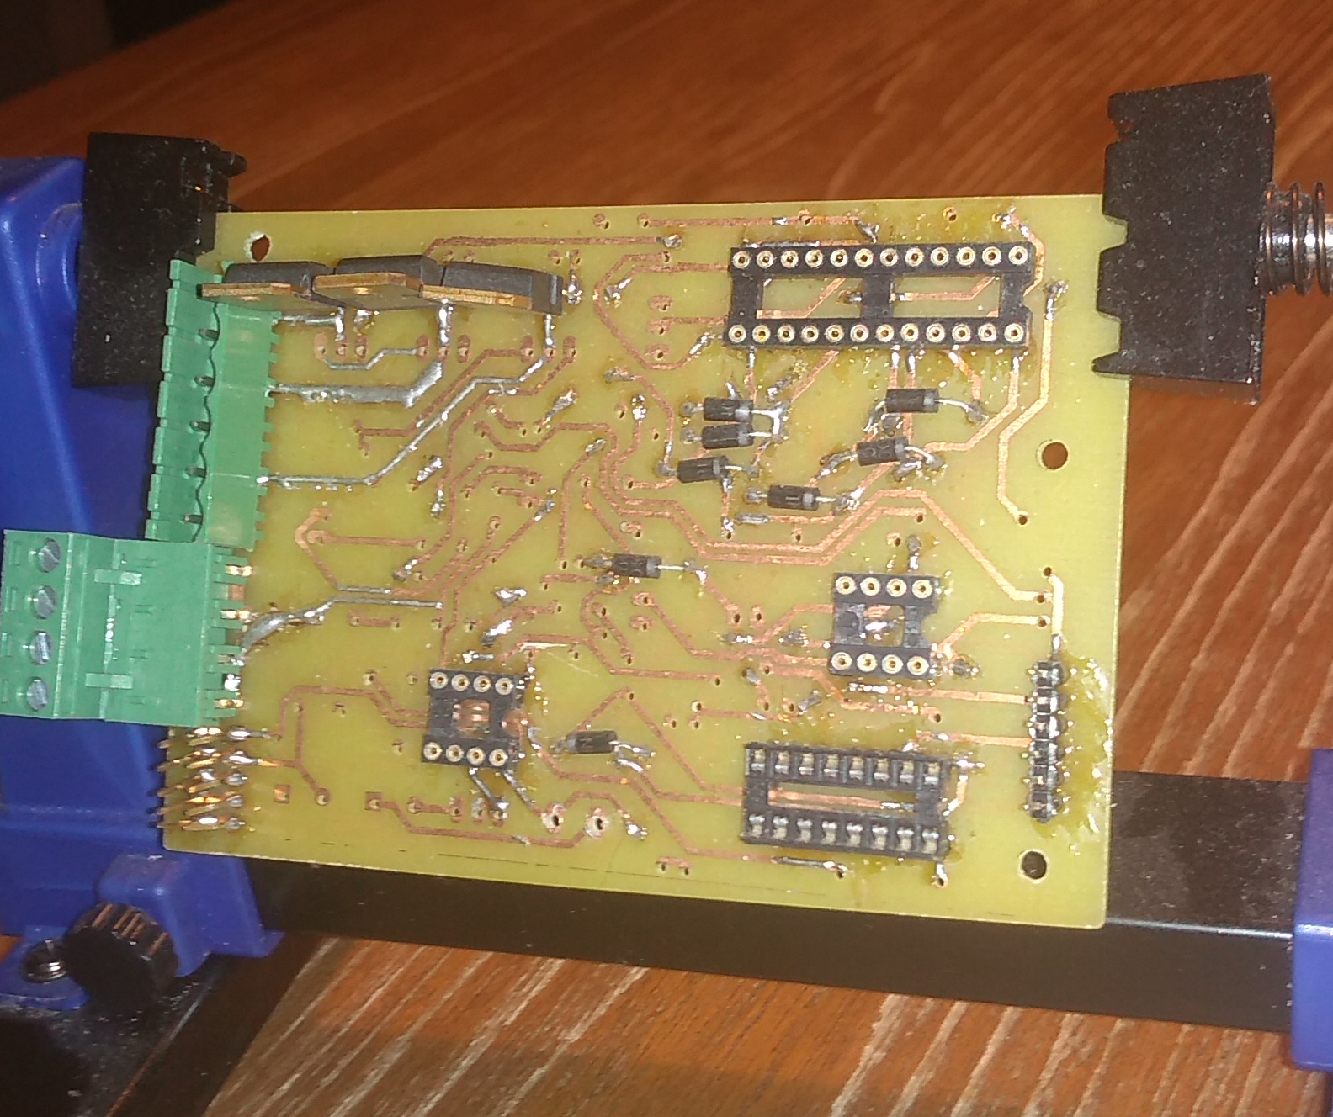

A home made two sided PCB (brush-less motor control). This one was dropped to ferro-chloride straight after transferring laser
print with iron. Using “green” iron foil before etching would make copper wires better and liquid tin afterwards to protect the PCB.

