Windows build environment
180911 notes 11.9.2018/pekka
If source code is placed under different folder than c:\coderoot, some environment variable E_ROOT need to be set. Replace c:\coderoot in this text with path to your source code directory. Setting these can be helpful even if the code is placed in c:\coderoot, because build scripts can be accessed from shell without typing path.

Open “System Properties” dialog from Windows Explorer. Right click “This PC” and select “Properties”.

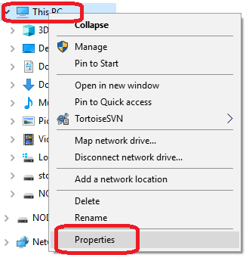

Navigate to “Environment variables” dialog: “Advanced system settings”, “Advanced” tab, “Environment Variables” button.

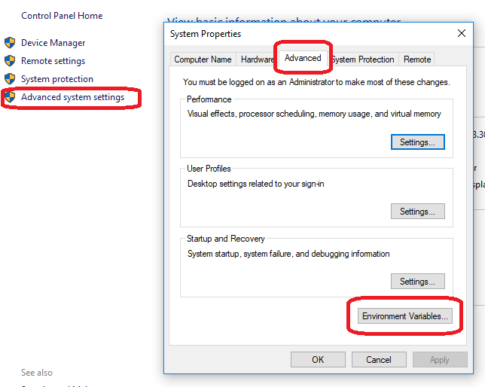

Add “c:\coderoot\eosal\build\bin\windows” and “c:\coderoot\bin\win64” folders to “Path” environment variable.

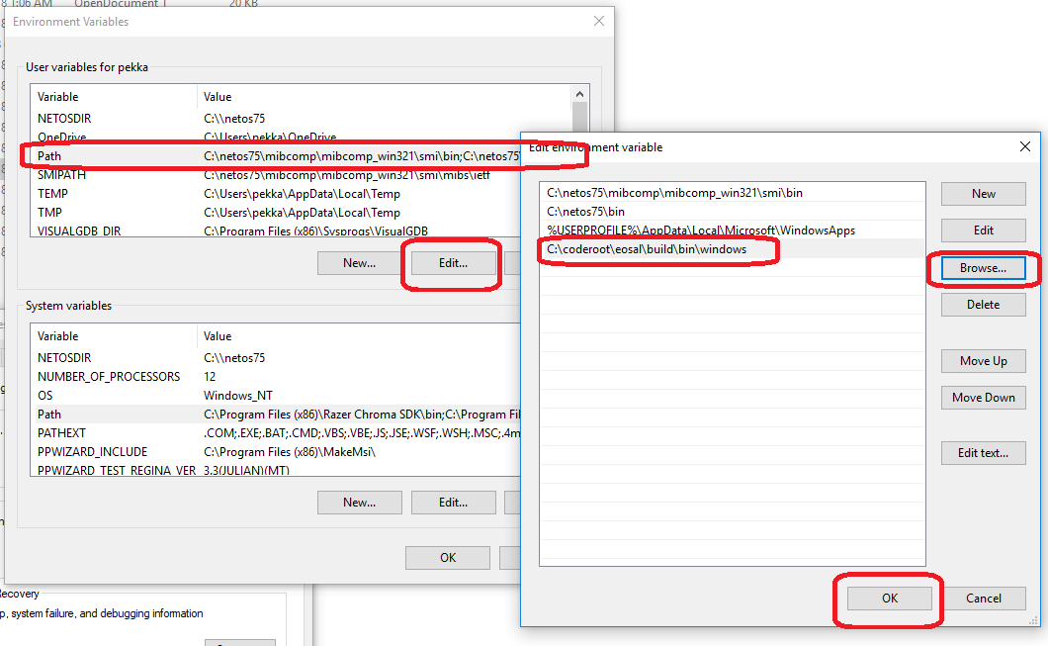

Add new “E_ROOT” environment variable with value “c:/coderoot” (notice the forward slash).

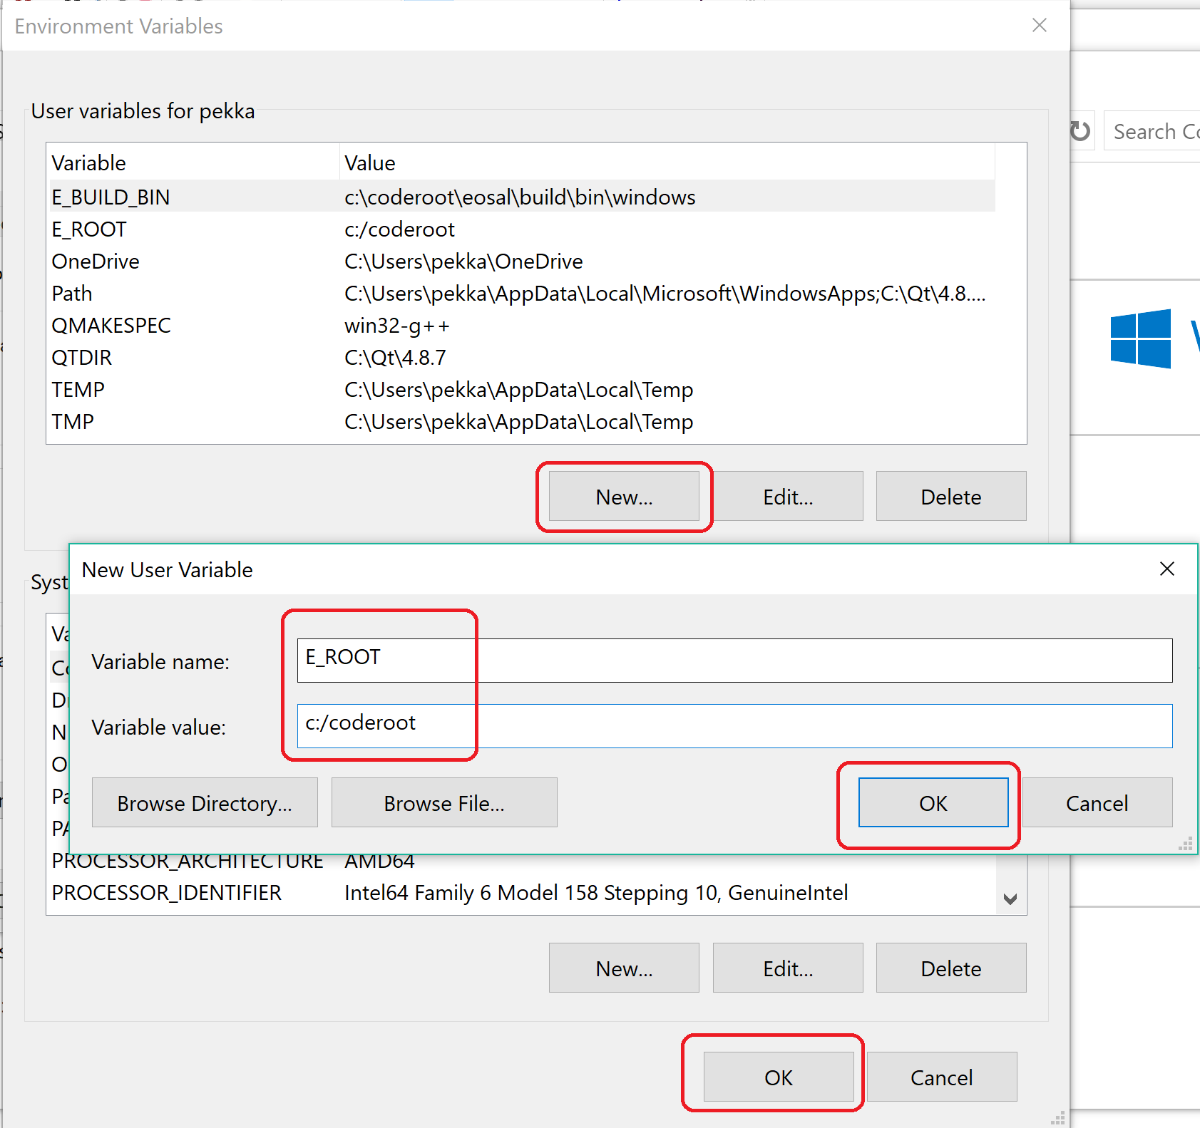

It is proper (if not strictly necessary) add also environment variable E_BUILD_BIN with value “c:\coderoot\eosal\build\bin\windows”. This example added these only for the current user, but could be set for all users as well.

Notice that you need to sign out and back in or reboot the computer to bring these changes to effect.

Helpful batch files
- e-root.bat - This can be started by full path to e-root.bat file. c:\coderoot\eosal\build\bin\windows\e-root.bat”. The batch file sets environment variables for the calling shell. If E_ROOT is not set, c:\coderoot is assumed.
- e-clean.bat – Call git to remove non versioned files under current folder from working copy. For example “cd \coderoot\eosal” followed by “e-clean”.
- e-win64-vs2015.bat – Generate solution and work space files for Visual Studio 2015 in current folder. For example “cd \coderoot\eosal\build\cmake” followed by “e-win64-vs2015”.

