Devices, memory blocks and connections
190502, updated 21.6.2019/pekka
A device holds multiple memory blocks, at minimum one for receiving data and another for sending data. There can be also memory blocks for IO device structure information (metadata), for programming flash, etc. Basic communication doesn’t really care what memory block is for.

Connecting two devices together
A simple example is connecting device A and device B. Both devices “know” that they have memory blocks 1 and 2, and these memory blocks are constructed by ioc_initialize_memory_block() calls at both ends. Once connection is established, the memory blocks which have same number will be transferring data.
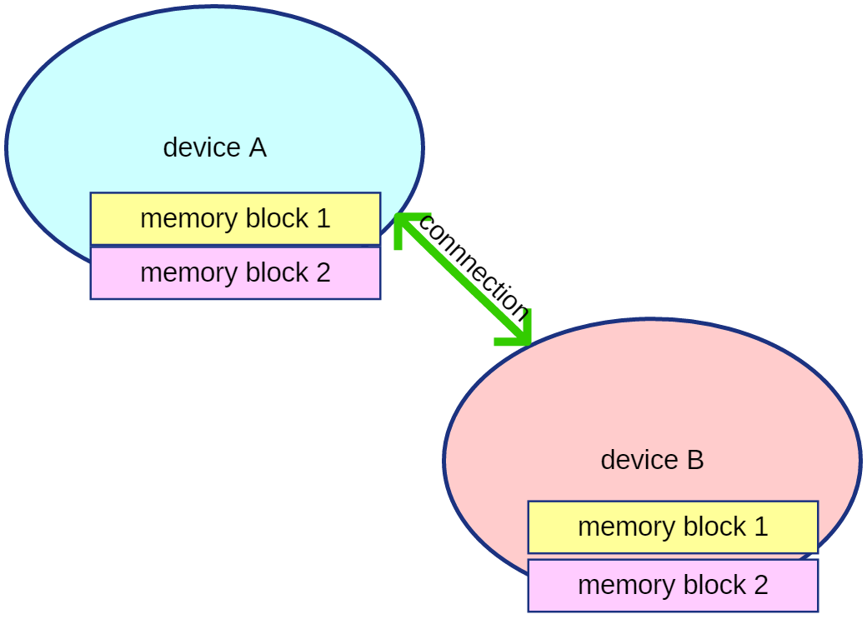

Connecting multiple IO devices to control computer
Usually we need to add some more complexity. For example we have one control computer, which controls two IO devices: One for temperature and other for lights.
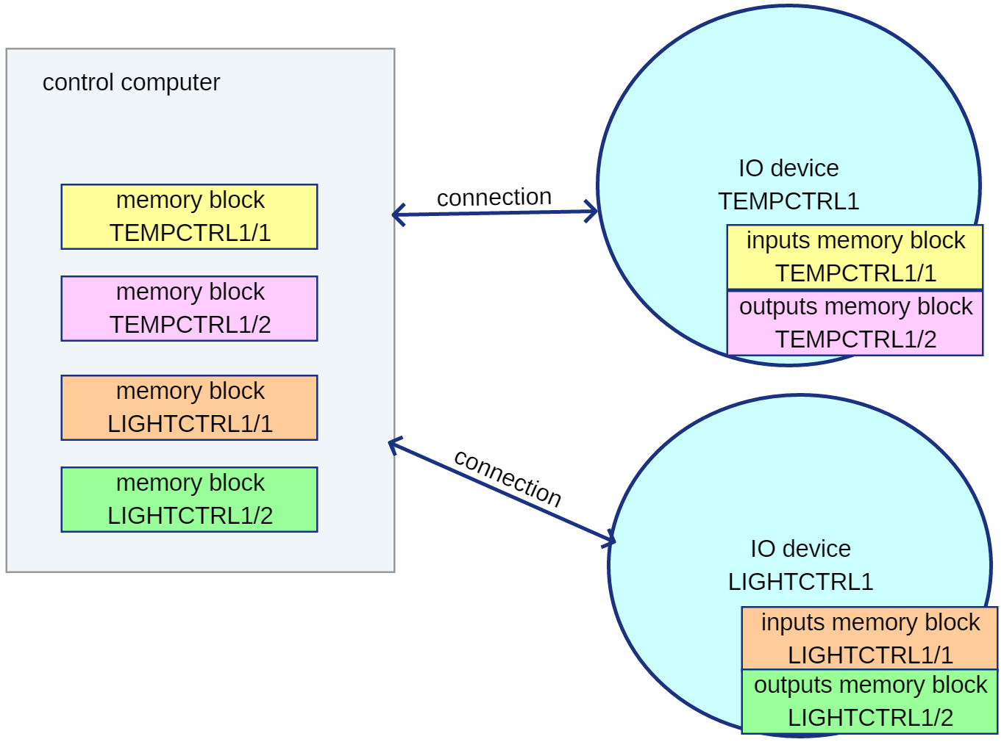

Here the memory blocks are also created before establising the connections between the control PC and the IO devices. Difference is that here in addition to memory block number we give memory blocks also device name and device number. To transfer data between two memory block all three must match.

Device name and number
Device name and device number make an device identifier which is unique within a control system. Device name describes IO board functionality, so two devices with name “LIGHTCTRL” are assumed identical. The device name must be a short string (max 12 characters) with only upper case characters ‘A’ - ‘Z’. Since one
control system may have multiple same kind of IO deviced, these are separated by device number. Usually 1 if first device… The device name is typically hard coded in device software and device number (if needed) either set by jumpers or stored in EEPROM.

Who connects and who listens for connections?
It doesn’t really matter which end listens for socket connection, or if connection is trough serial port. It works just the same. One good choice in own subnet is to assume that IO board “knows” IP address of the control computer and connects to it with TCP socket. The “known” address could be calculated from device’s IP address and subnet mask, for 255.255.255.0 network this could be said “first theree numbers are same as in my own IP address, and the fourth number is always 253”. If in addition DCHP is used to get IO device’s network configuration, this would work like plug and play without using UDP broadcasts/multicasts. This approach works also well with planned future TLS connection.

