Data synchronization
190502, updated 20.6.2019/pekka
The synchronization logic preserves time order of changes. Consequent changes are received in
same order as they were set or in same snapshot. Never in reverse order.
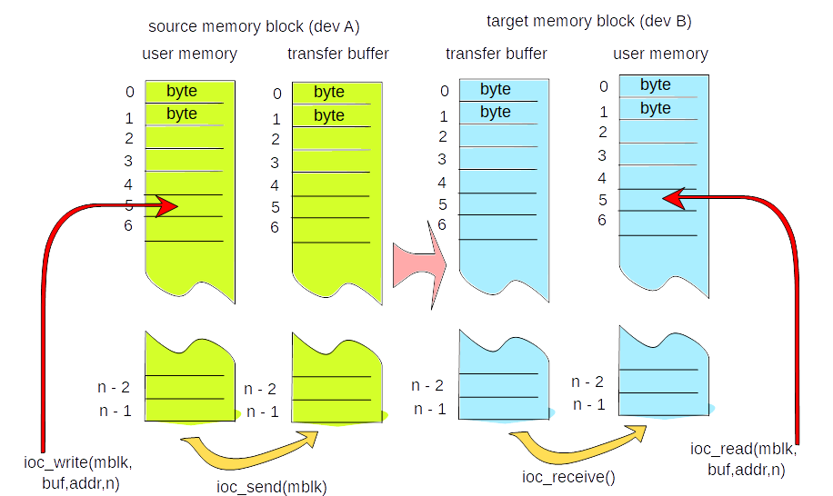

Transfer buffer drawn above here is simplified, implementation detail like real record keeping, buffering and transfer format are not discussed here.

Memory block content is accessed from application code using ioc_write() and ioc_read() functions, or simple ioc_set*() and ioc_get*() functions. Target buffer is read only and source buffer is read/write. On source side, the ioc_send() function copies source memory block to be transferred (or at least modified part of it). If there no space in transfer buffer, an ongoing transfer, the function does nothing. If there are no modifications, the function may do nothing. We can say that ioc_send() records (or may record) a snapshot of user memory for transfer. On target end, the ioc_receive function copies data from transfer buffer to user memory. The copied data is last complete transferred snapshot.

Note about IOC_AUTO_SEND mode: If this flag is given to source memory buffer, ioc_send() is called every time ioc_write() is called. Similarly IOC_AUTO_RECEIVE causes ioc_receive() to be called every time ioc_read() is called. This is not really unefficient, and can be recommended at least to get started.

