Run - keep the connection alive
190502, updated 7.7.2019/pekka
The ioc_connection_run() function keeps the connection the connection alive. This is single thread function which must be called repeatedly. Similar, but more efficient, implementation exists for multi threaded environments mode using select() instead of polling for new data.
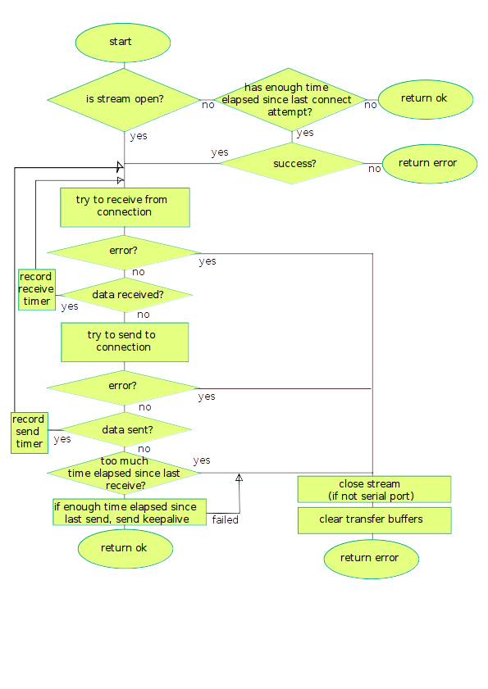
This function calls ioc_connection_send() and ioc_connection() receive functions to send/receive data.

