Memory blocks
180727, updated 22.6.2019/pekka
Communication is based on memory blocks. Device A stores data to be transferred into memory block. Communication maintains identical copy of the memory block in device B. Separate memory blocks are necessary to implement two directional communication.

A memory block is byte array which is copied from a device to another. Under the hood his is quite a bit more complex, since only changes are transferred over communication, there is compression and synchronization, but user of this library should not need to care about this. There can be multiple recipients of one memory block. There are iocom API functions for allocating, reading and writing memory blocks, and for data transfer synchronization.

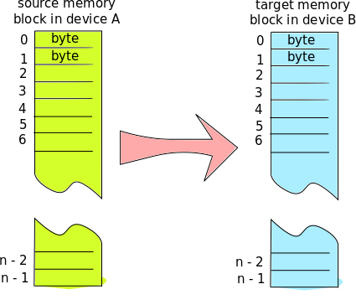

A memory block in device A is copied to identical memory block in device B. If the memory blocks have different size, the extra data is ignored.

Communication between two devices typically involves several memory blocks, for example IO board blocks could be "binary inputs", "analog inputs" and "binary outputs". When deciding how to divide data into memory blocks, consider also synchronization and how often input data changes. If some data changes quickly and some is static, these should be in different groups. Data which need to be synchronized (transferred in specific order), like "my data array" and "data array ready" bit, need to be in the same memory block.

A memory block is presented by iocMemoryBlock structure. The structure stores pointers to buffers, flags and state information. A memory block structure is initialized or allocated by:

iocMemoryBlock *ioc_initialize_memory_block(
iocMemoryBlock *mblk,
iocRoot *root,
iocMemoryBlockParams *prm);

The root object is root of iocom instance’s object hierarchy. It kind of binds memory blocks, connections and source/target buffers together. The root object must be initialized before it can be used, and releasing root object will free all resources allocated within the root.

If mblk argument is OS_NULL, the function allocates memory for the memory block structure. Otherwise it initializes a memory block in application allocated memory.

Once a memory block is no longer needed, it should be released by calling ioc_release_memory_block function. If the memory block was allocated by the ioc_initialize_memory_block function, the allocated memory is released by this function.

void ioc_release_memory_block(
iocMemoryBlock *mblk);

