Redundancy
190502, updated 19.5.2019/pekka
X.
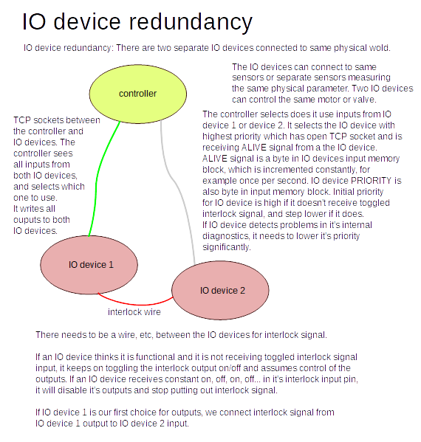

X..

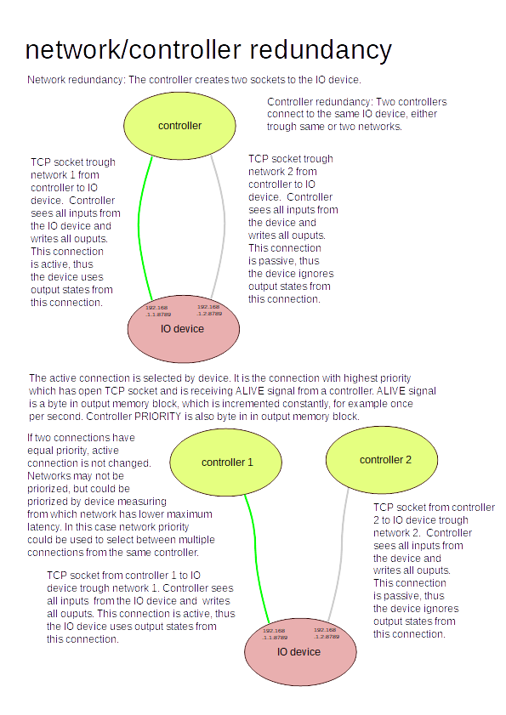
X.

