IOCOM in simple multi player game?
191202, updated 2.12.2019/pekka
I was testing IOCOM network topology using Python API (iocompython) and Pyglet game UI library. Network topology for a multi player game can be very similar to IO device network: I run server side app (also python/iocompython) in Amazon’s AWS and client side in my computers. The “game arena” is analogous to “IO device network” and “player” to “IO device”.
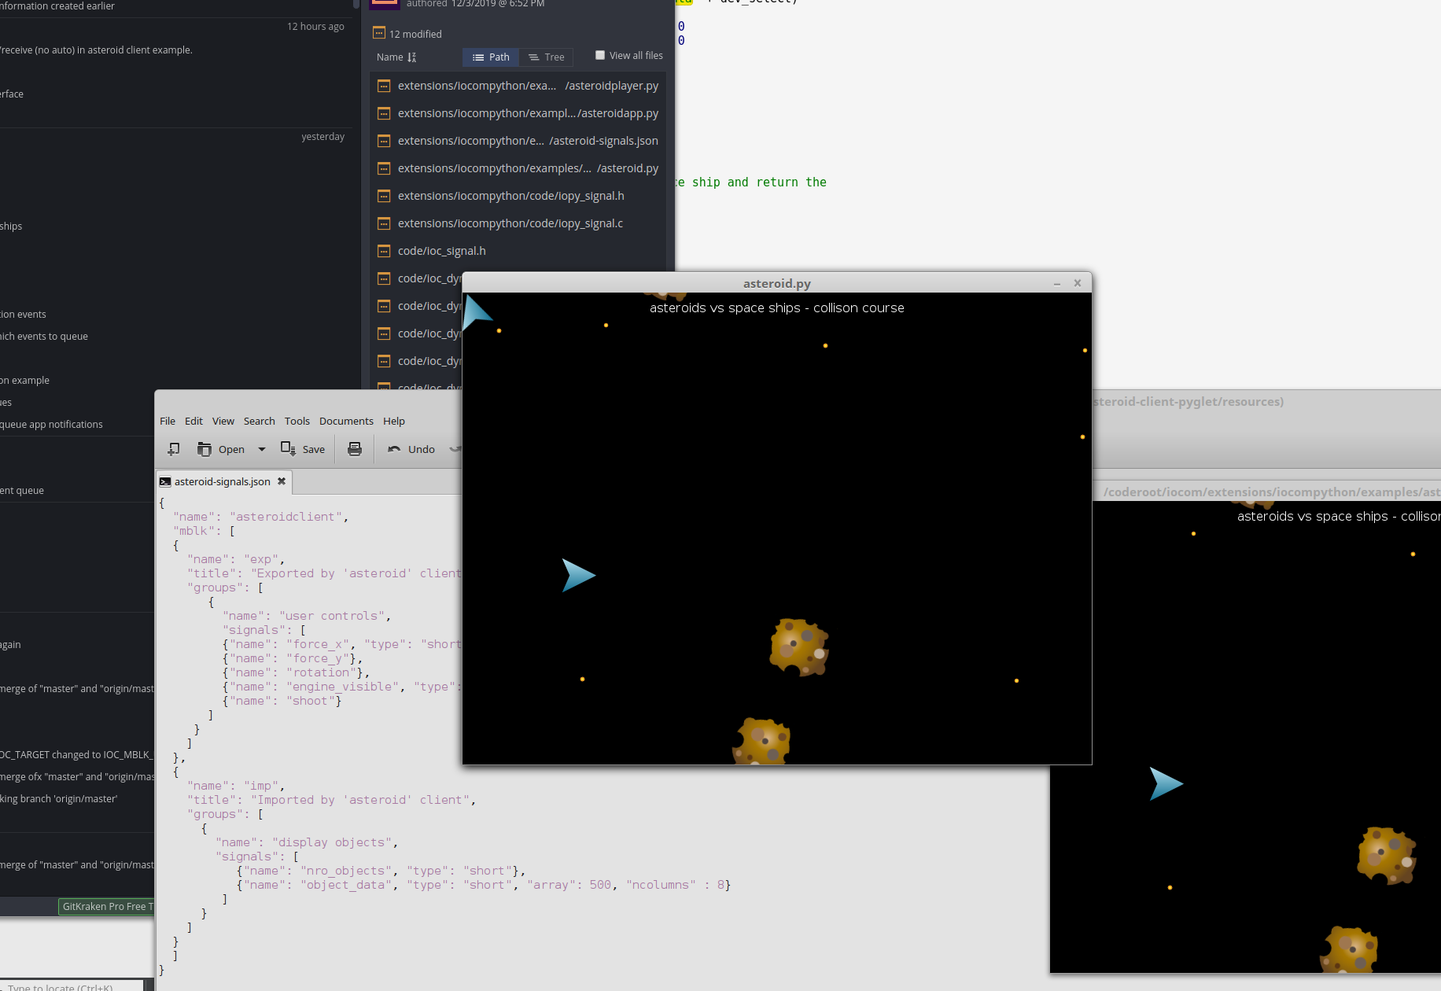

On server side
It is was easy. Amazon EC2 is like Linux computer (virtual one tough) to which I connect with putty terminal. Necessary software like git, cmake, python3-dev, etc. can be just installed to AWS machine by typing “sudo yum install git….” to pytty terminal. Then I use “git clone..” to get “/coderoot/iocom” and “/coderoot/eosal” source code. The iocompython C code /coderoot/iocom/extensions/iocompython builds with cmake to “/coderoot/bin/linux/iocompython.so” on linux (or bin/win32/iocompython.pyd” on windows).

To run the Asteroid game server, use in “iocompython/examples/asteroid-service/asteroidservice.sh”.

On client side.
The “/coderoot/iocom/extensions/iocompython” C code needs to be comiled for client environment, this makes the Python module. Asteroid game’s client side Python code is in “iocompython/examples/asteroid-client-pyglet”.

