Pins example - jane
190918, updated 18.9.2019/pekka
“Jane” is name for “pins” library example IO device application. “Carol” is name for a specific IO board, here MELIFE ESP32 development board which has specific uses for it’s pin.

Carol hardware
It is useful to give name to a IO board so it can be called. My breadboard MELIFE ESP32 test is called “carol”, so the name “carol” means ESP32 with Arduino libraries. This combination can be developed by either Visual Studio Code + Platform IO or Arduino IDE.

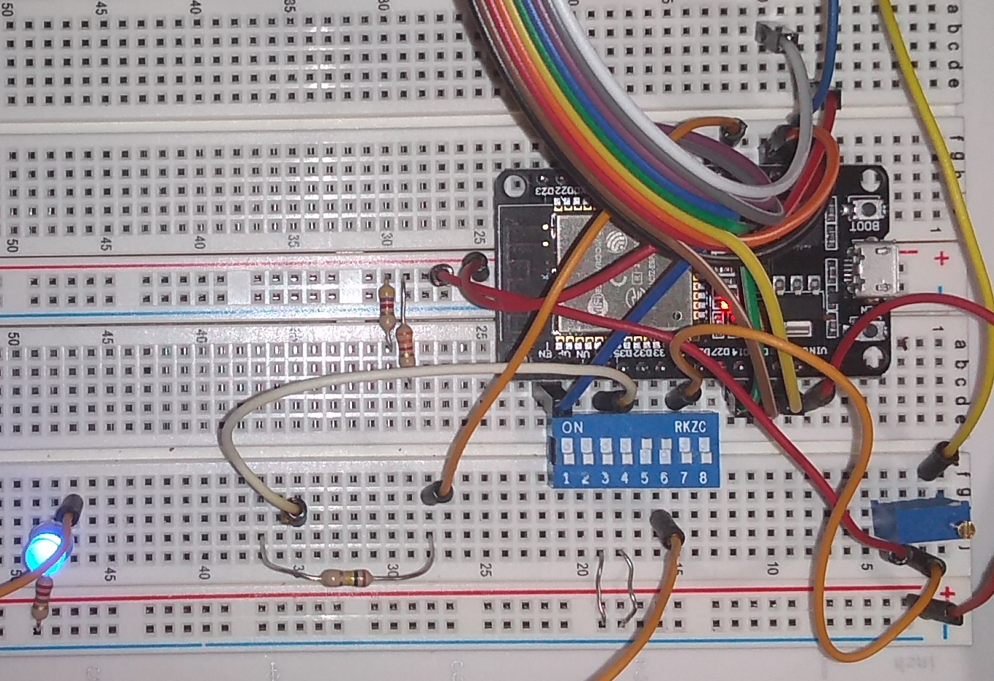
“Carol” is a bit of a mess, it is just for testing IO needs only to survive for a day

D
IO pin name | IO addess (Carol specific)

The IO pin name is name what Jane application uses for specific functionality, like potentiometer, DIP switch 3, or PWM controlled dimmed blue led. IO address is hardware specific, that tells what has been wired to which pin of the ESP32.
- Hardware specific IO headers are not included in application (except when there is need to bypass "pins").
- Hardware addresses, etc. need to be mapped to application at some point. This could be simply written as one C file. But we write it as JSON and then generate the C file automatically by Python script. This enable using the PIN information to automate documentation, IOCOM memory mapping, etc.

CConfiguring About “pins” library

Now if I want to run my Jane application on Raspberry PI, wrapper pins_basics .c needs to be implemented for the Raspberry’s IO:
- I would copy pins/code/arduino/pins_basics.c to to pins/code/linux/pins_basics_pi.c (Raspberry runs linux).
- Arduino’s digtalWrite(), digitalRead(), etc need to be changed to Raspberry’s corresponding functions.
- Create hardware configuration JSON, again by copying jane/pins/carol/jane-io.json to jane/pins/david/jane-io.json, and set there pin addresses adequate for the this specific use of Raspberry PI. Notice that this new hardware configuration got named “David”.
- Script cpins.sh can be also copied and modified to generate C code from the new jane-io.json.
- Final step is to list folder “jane/pins/david” with C code as include folder in the new build.

