Pins example “jane”
190918, updated 17.3.2020/pekka
The “jane” is name for “pins” library example IO device application. “Carol” is name for a specific IO board, here MELIFE ESP32 development board which has specific uses for it’s pin.

Carol hardware
It is useful to give name to a IO board so it can be called. My breadboard MELIFE ESP32 test is called “carol”, so the name “carol” means ESP32 with Arduino libraries. This combination can be developed by either Visual Studio Code + Platform IO or Arduino IDE.

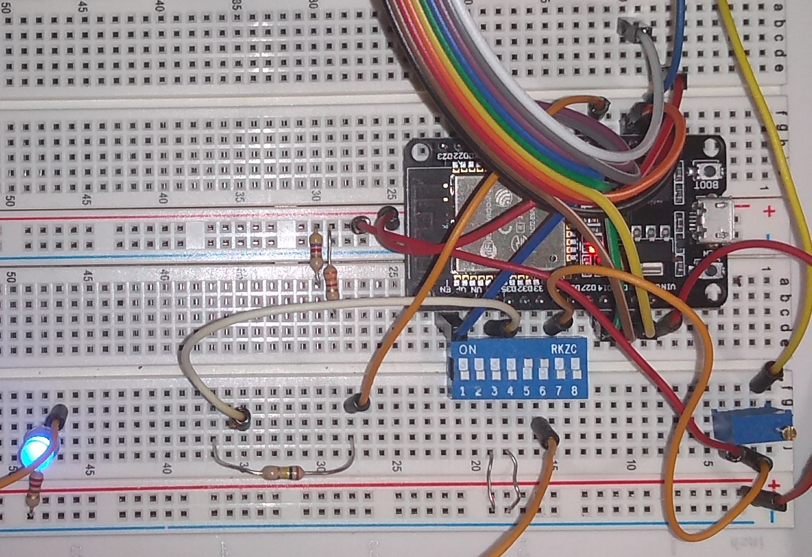
“Carol” is a bit of a mess, it needs to survive for a day of testing

Carol hardware wiring is as follows:

IO pin name | IO pin type | IO address | Description
DIP_SWITCH_3 | digital input | 34 | Blue 8 dip switch block, switch pin 3 grounds the input. Dip switch is also declared as pull-up, but this doesn't seem to do anything on ESP32.
DIP_SWITCH_4 | digital input | 35 | Blue 8 dip switch block, switch pin 4 grounds the input.
GAZERBEAM | digital input | 36 | Photo transistor signal as interrupt.
TOUCH_SENSOR | digital input | 4 | Touch the sensor T0 (GPIO4)
POTENTIOMETER | analog input | 25 | 10k potentiometer wired to give voltage from 0 to 3.3V, ADC channel 8
SERVO | PWM | 22 | Servo PWM control. PWM channel 0 (set as bank) is used with 50 Hz frequency and 12 bits precision, and initialized at middle (2048)
DIMMER_LED | PWM | 33 | LED dimmer PWM control. PWM channel 1 (set as bank) is used with 5000 Hz frequency and 12 bits precision, and initialized at dark (0)

The IO pin name is name what Jane application uses for specific functionality, like potentiometer, DIP switch 3, or PWM controlled dimmed blue led. IO address is hardware specific, that tells what has been wired to which pin of the ESP32. For Arduino libraries, it is Arduino GPIO pin number.

JSON configuration and generated C code
The Jane example was used for this pins library and JSON configuration and generated C code can be found earlier in this document.

The jane application
The jane-example.c is simple single thread example IO device application. It demonstrates how to use IO trough “pins” interface.
- The pins_setup() initialize the IO pins.
- pin_set() set IO pin state
- pin_get() get IO pin state

#include "jane.h"
/* Here we include hardware specific IO code. The file name is always same for jane, but
pins/<hardware> is added compiler's include paths
*/
#include "jane-io.c"
os_timer t;
os_boolean state;
os_int dip3, dip4, touch, dimmer, dimmer_dir, potentiometer;
osalStatus osal_main(
os_int argc,
os_char *argv[])
{
pins_setup(&pins_hdr, 0);
os_get_timer(&t);
state = OS_FALSE;
dip3 = dip4 = touch = -1;
dimmer = 0;
dimmer_dir = 1;
potentiometer = -4095;
/* When emulating micro-controller on PC, run loop. Just save context pointer on
real micro-controller.
*/
osal_simulated_loop(OS_NULL);
return 0;
}
osalStatus osal_loop(
void *app_context)
{
os_int x, delta;
os_char buf[32];
/* Digital output */
if (os_elapsed(&t, 50))
{
os_get_timer(&t);
state = !state;
pin_set(&pins.outputs.led_builtin, state);
}
/* Digital input */
x = pin_get(&pins.inputs.dip_switch_3);
if (x != dip3)
{
dip3 = x;
osal_console_write(dip3 ? "DIP switch 3 turned ON\n" : "DIP switch 3 turned OFF\n");
}
x = pin_get(&pins.inputs.dip_switch_4);
if (x != dip4)
{
dip4 = x;
osal_console_write(dip4 ? "DIP switch 4 turned ON\n" : "DIP switch 4 turned OFF\n");
}
/* Touch sensor */
x = pin_get(&pins.inputs.touch_sensor);
delta = touch - x;
if (delta < 0) delta = -delta;
if (delta > 20)
{
touch = x;
if (touch)
{
osal_console_write("TOUCH_SENSOR: ");
osal_int_to_string(buf, sizeof(buf), touch);
osal_console_write(buf);
osal_console_write("\n");
}
}
/* Analog input */
x = pin_get(&pins.analog_inputs.potentiometer);
delta = potentiometer - x;
if (delta < 0) delta = -delta;
if (delta > 100)
{
potentiometer = x;
osal_console_write("POTENTIOMETER: ");
osal_int_to_string(buf, sizeof(buf), potentiometer);
osal_console_write(buf);
osal_console_write("\n");
}
/* PWM */
dimmer += dimmer_dir;
if (dimmer > 4095 || dimmer < 0) dimmer_dir = -dimmer_dir;
pin_set(&pins.pwm.dimmer_led, dimmer);
return OSAL_SUCCESS;
}
void osal_main_cleanup(
void *app_context)
{
}

What was point of all this complexity?
The goal here is to separate IO device application from specific hardware and write it only once: If we have many somewhat complex IO boards, an IO board application can survive hardware, platform or development tool changes. Secondary goals are to run IO board application as PC simulation, easily to bind IO to communication and to generate documentation from same source data.
This is quite useful for developing more complex applications with long life time. In simple cases, one is probably better off calling hardware specific IO direly from application and something like “pins” library is just unnecessary complexity.

