basel_bad PD model — Executive Brief
Credit committee summary · 2026-04-30
DEPLOY: Logistic Regression (calibrated)
Weighted selection score 95.0/100 (floor 50)
ROC AUC  0.6673  95% CI [0.646, 0.682] | Gini  0.3347 | KS statistic  0.2617 | PR AUC  0.0648  95% CI [0.057, 0.073]
Calibrated Brier  0.0366  lower = better | ECE  n/a  calibration error | Top-10% capture  20.9% | Test sample  6,835  booked-proxy rows

Recommendation rationale
- 4 of 5 candidates clear the absolute weighted-score floor of 50.
- vs. score_RF (benchmark): ΔAUC = +0.0497 (lower CI +0.0210, adj. p = 0.044) — win.
- vs. risk_score_rf (benchmark): ΔAUC = -0.0029 (lower CI -0.0495, adj. p = 1.000) — loss.
- Rolling-OOT stability: PR AUC = 0.0609 (±0.0077) across 4 folds.
Watch-list (issues for monitoring or follow-up)
- PSI high drift on score distributions: CatBoost.
- Trained model loses to risk_score_rf on PR AUC by 0.0255 — feature ceiling vs. existing score (see methodology report §13).
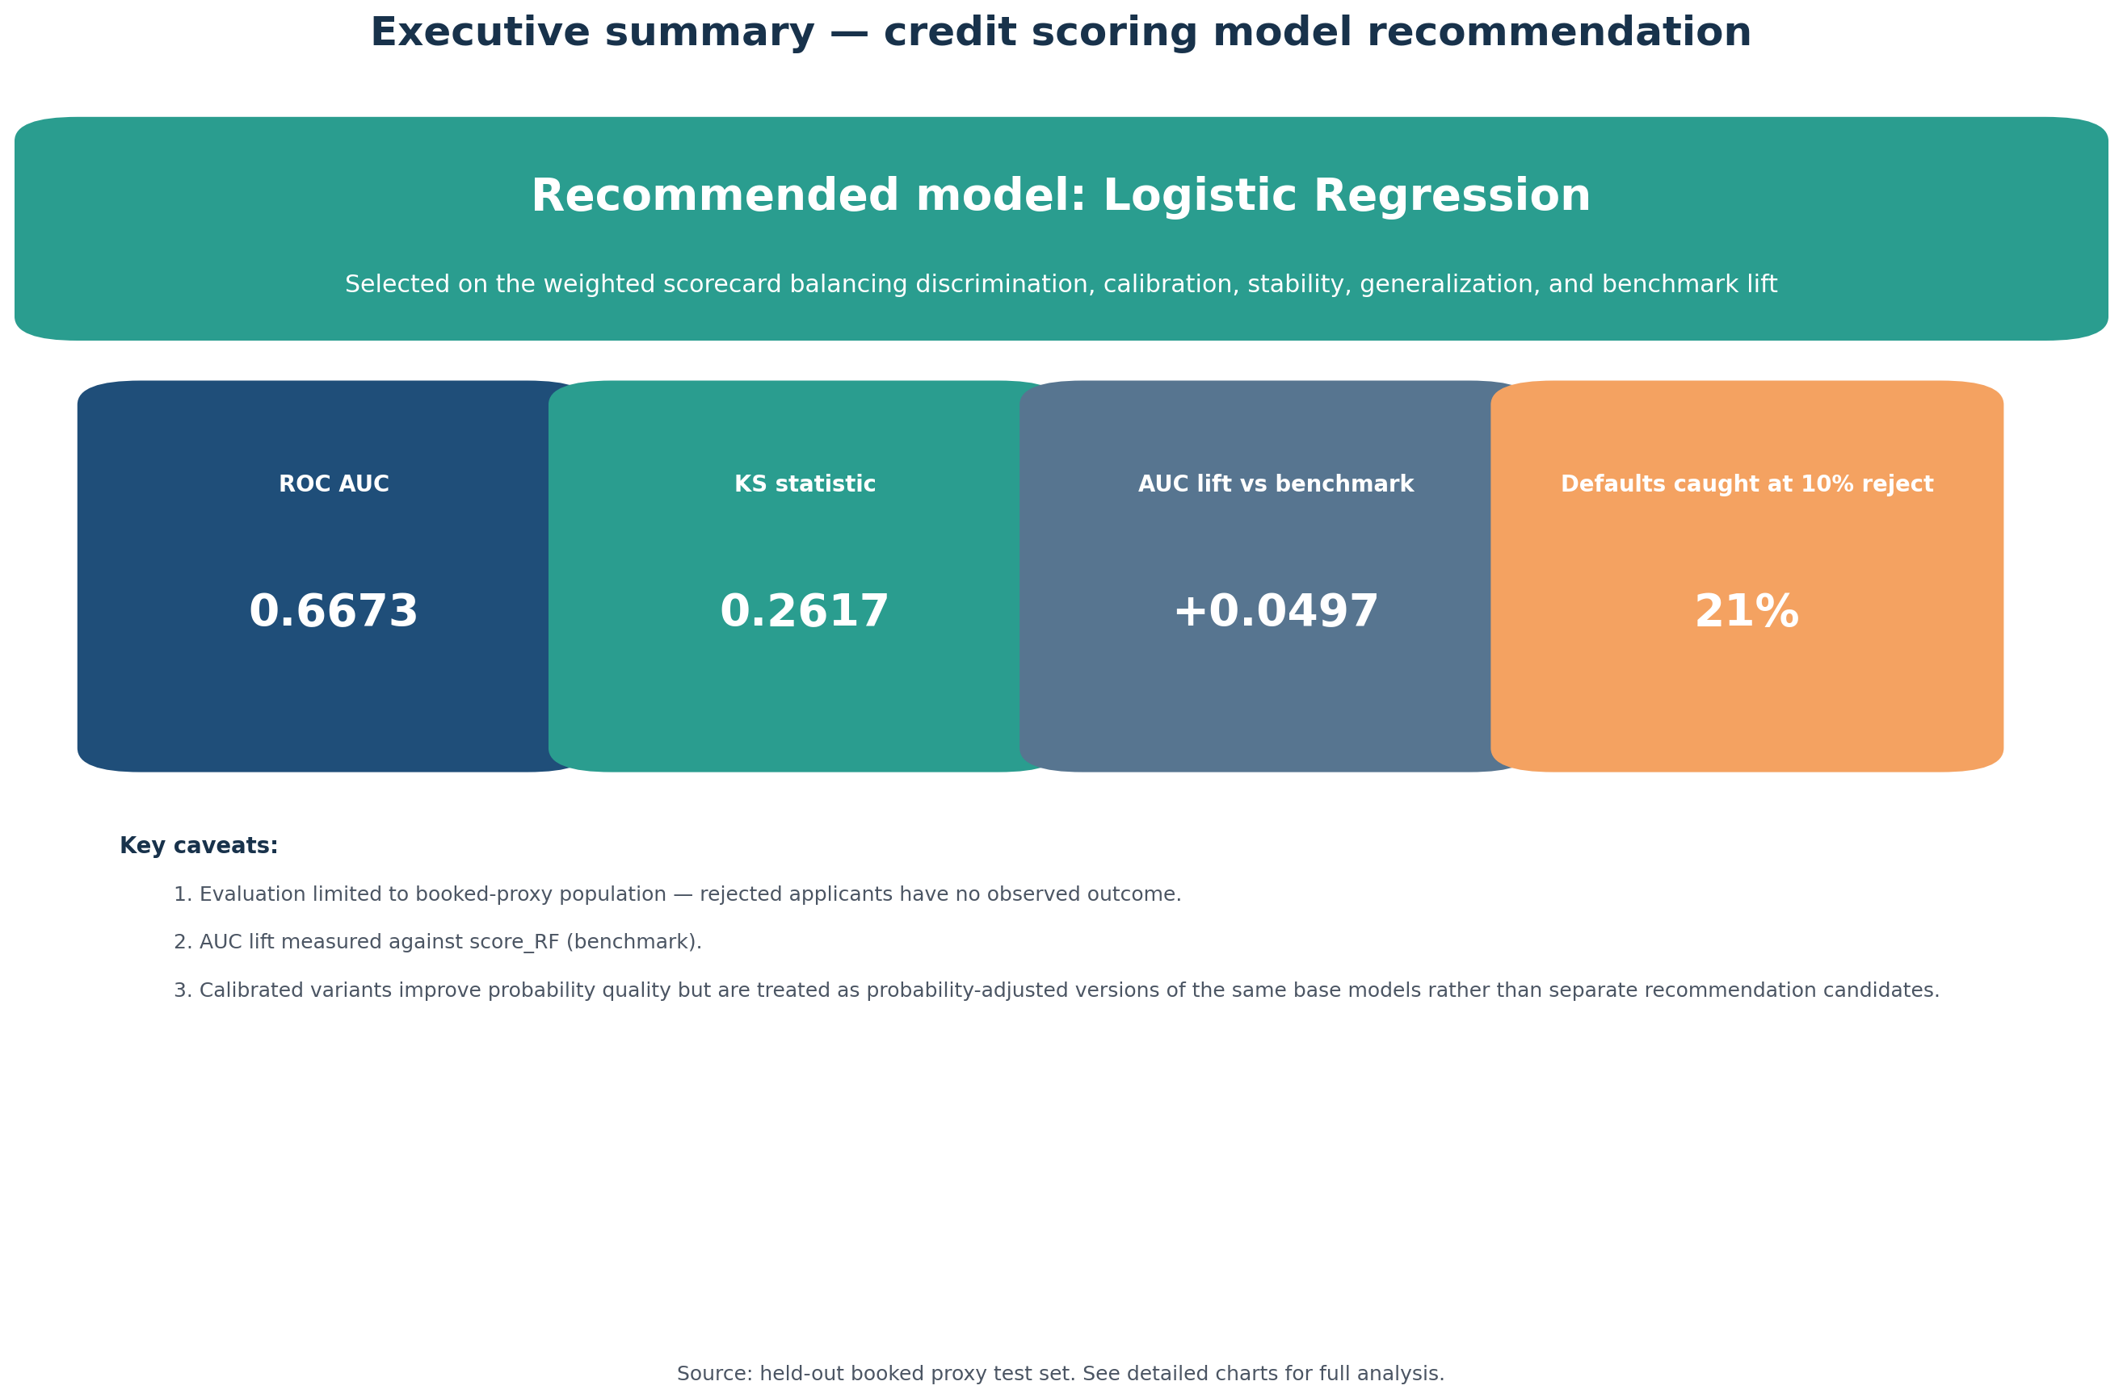

Full methodology + results are documented in methodology_report.docx. Production deployment requires the SHA-256 model checksums in output/models/checksums.json.

