Basel Bad Credit Scoring Model
Methodology and Results Report

Generated 2026-04-30 · Recommended candidate: Logistic Regression

Audience: management, internal model review, and regulatory examiners.
Every methodology choice in this document has a documented rationale or literature citation; every result number traces back to a CSV artifact in the model output directory.

1. Executive Summary
This document describes the methodology and reports the results of the basel_bad probability-of-default (PD) modelling pipeline for consumer credit underwriting decisions. The pipeline trains five candidate model classes on a temporally split sample, calibrates each one on a held-out later block, and selects a production candidate using a five-criterion weighted score with an absolute quality floor.
Headline result
- The selector recommends Logistic Regression (calibrated). Weighted selection score: 95.0 / 100. 4 of 5 candidates clear the absolute 50/100 quality floor. It is the only candidate with the strongest benchmark-evidence tier (3).
- Held-out test (booked-proxy, n = 6,835): ROC AUC = 0.6673, Gini = 0.3347, KS = 0.2617, PR AUC = 0.0648. Calibrated Brier = 0.0366.
- Versus risk_score_rf (benchmark): ΔAUC = -0.0029 (95% CI [-0.0495, +0.0392], adjusted p = 1.000); ΔPR AUC = -0.0255.
- Versus score_RF (benchmark): ΔAUC = +0.0497 (95% CI [+0.0210, +0.0780], adjusted p = 0.044); ΔPR AUC = +0.0145.
- Twelve external/internal methodology improvements (audit fixes A–M) are integrated into the pipeline; each is described in the relevant section below and summarised in §22.
What this document covers
Sections 2–12 explain the methodology — target definition, sample design, feature engineering and selection, model training, calibration, validation design, reject-inference handling, and the selection criteria. Sections 13–18 report the actual results from the latest training run: discrimination, calibration, stability, benchmark comparison, feature importance, and fair-lending diagnostics. Sections 19–23 enumerate limitations, recommendations, methodology constants with citations, the audit improvements, and the artifact inventory.
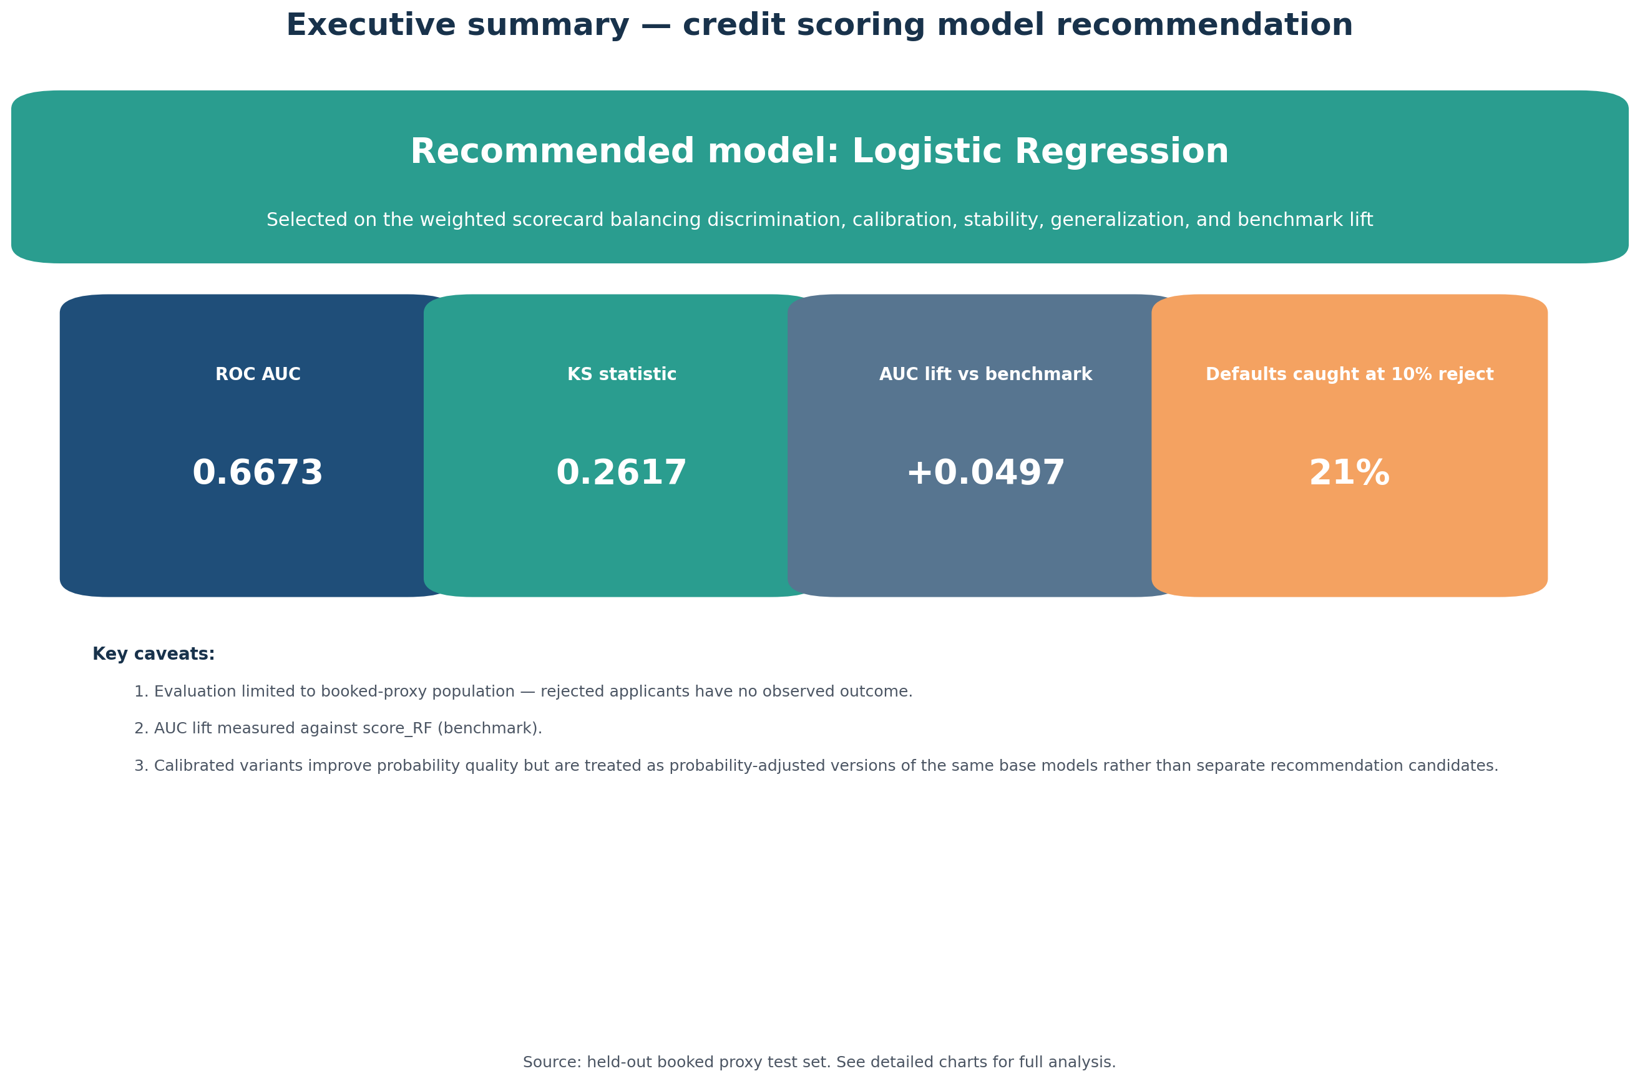
Figure: Stakeholder executive-summary chart pack

2. Business Problem and Target Definition
The target variable basel_bad is a binary flag indicating whether an applicant became 90+ days past due on their consumer-credit obligation within the first 12 months on book. The 12-month observation window is the standard maturity used for Basel-aligned probability-of-default estimation in retail banking and matches existing internal portfolio definitions.
Maturity invariant
Because basel_bad requires 12 months on book to mature, the pipeline filters every modelling sample to mis_Date ≤ MATURITY_CUTOFF (currently 2025-01-01). Rows beyond that cutoff with a non-null target — typically right-censored zeros from upstream — are dropped by the static-cutoff filter. A regulator-visible warning is emitted whenever such rows are present, so a reviewer can decide whether the cutoff should be advanced or whether upstream is leaking pre-mature observations (audit fix F).
Population breakdown
population_mode | split | status_name | population_group | n_rows | n_with_observed_target | n_bad_observed | date_start | date_end
underwriting | post_split | Booked | booked | 50735 | 50171 | 727 | 2024-07-01 | 2026-02-01
underwriting | post_split | Canceled | decisioned_non_booked | 149039 | 149039 | 0 | 2024-07-01 | 2026-02-01
underwriting | post_split | Rejected | decisioned_non_booked | 980972 | 980972 | 0 | 2024-07-01 | 2026-02-01
underwriting | pre_split | Booked | booked | 51380 | 50782 | 1935 | 2023-01-01 | 2024-06-01
underwriting | pre_split | Canceled | decisioned_non_booked | 180023 | 180023 | 0 | 2023-01-01 | 2024-06-01
underwriting | pre_split | Rejected | decisioned_non_booked | 974536 | 974536 | 0 | 2023-01-01 | 2024-06-01
Population mode: underwriting
The pipeline supports two population modes. The default 'underwriting' mode treats the model as a tool that scores all decisioned applications (booked + rejected + canceled) at decision time. Supervised training, however, uses only booked accounts because booked accounts are the only population for which basel_bad is observable. This means held-out performance metrics on the test set are an accepted-population proxy: they answer 'how well would the model rank applicants among those actually booked', not 'how well would the model rank a random underwriting application'. The proxy is the industry standard given the reject-inference identification problem.

3. Sample Design
Temporal cuts
- Feature-discovery sample: earliest 50% of pre-test booked rows. Reserved for interaction search and stability-selection feature freezing.
- Estimation sample: later pre-test booked rows. Used for final model fit on the frozen feature set.
- Calibration holdout: latest 15% of the estimation sample (temporal). Used only for post-hoc probability calibration.
- Test sample: post-2024-07-01 booked rows that have matured by MATURITY_CUTOFF. Touched once at the end for headline reporting; rolling-OOT validation uses earlier folds.
Why temporal-only splits
Random or stratified shuffling of credit data leaks future outcomes into earlier folds: a Bernoulli draw of a 2024-09 applicant into the training set during a 2024-04 fold gives the model access to data it would not have at deployment time. The pipeline forbids StratifiedKFold(shuffle=True) anywhere; every cross-validator is implemented as a TemporalExpandingCV that strictly orders fold dates.
Feature-discovery boundary (latest run)
- Discovery sample ends: 2023-08-01
- Estimation sample starts: 2023-09-01
- Discovery seed rows: 25,719
- Discovery seed positives: 1,032
- Estimation seed rows: 25,063
- Estimation seed positives: 903
- Scored candidates: 290
- Selected interactions: 54

4. Feature Engineering
Feature engineering is split into four layers, applied in this order:
- Layer 1 — Deterministic transforms on raw application data: log-transforms (log1p of income, total amount, max credit available), ratios (installment/income, total amount/household income, book ratios), household-income aggregation, codebtor flags, missingness indicators for high-missingness columns, and concatenated categorical interactions. All transforms are pure functions of the input row — no training statistics are used.
- Layer 2 — Interaction search (audit-validated). For each pair of (numeric, categorical) and (categorical, categorical) features, the search computes a temporally validated PR AUC of the candidate interaction on the discovery sample. Numeric × categorical pairs are scored via target-encoded binned interactions; the top selected candidates by lift are added to the modelling matrix.
- Layer 3 — Cardinality reduction: high-cardinality categoricals are capped at MAX_CATEGORIES top values (training-set frequency); the remainder is bucketed as 'Other'. This prevents target-encoder explosion on rare categories and matches the production scoring contract.
- Layer 4 — Modelling features (frequency encoding + group statistics). FREQ_<cat> columns map each category to its training-set proportion. <num>_VS_<cat> columns express each numeric value as a ratio against its group median computed on training data only. Both encodings are fit on the development sample and applied to the test sample without modification — no leakage.
Selected interactions in the latest run: 54 of 290 screened

5. Feature Selection
Two complementary selectors
The frozen feature contract is the union of two independent selectors. The original linear stability selector follows Meinshausen & Bühlmann (2010): an elastic-net classifier is fit at multiple (C, l1_ratio) settings inside each temporal CV fold, and a feature is kept if it appears in ≥50% of {fold, hyper-parameter} combinations. A floor of 5 features prevents over-aggressive pruning on small folds.
The second pass is a tree-aware permutation-importance selector (audit fix B). Inside each temporal CV fold, a small LightGBM is fit and permutation importance is computed on the validation slice using average-precision scoring. Features whose mean permutation importance across folds is at least 5% of the most-important feature's mean are kept. The motivation: the linear stability selector cannot detect features that contribute through non-linear effects or interactions, and routinely drops such features even though tree models would extract value from them.
Selector breakdown (latest run)
Kept by | Count
stability_only | 69
tree_aware_only | 12
both | 21
Features kept exclusively by the tree-aware pass — these are the audit's exact case where the linear selector dropped a feature the tree models found informative:
Feature | Provenance
TOTAL_PRODUCTS | engineered
BIN_INCOME_T1_x_HOUSE_TYPE | interaction
BIN_MAX_CREDIT_TJ_AV_x_ESTCLI2 | interaction
BIN_MAX_CREDIT_TJ_AV_x_FAMILY_SITUATION | interaction
BIN_MAX_CREDIT_TJ_AV_x_HOUSE_TYPE | interaction
BIN_TOTAL_AMT_x_FAMILY_SITUATION | interaction
BIN_TOTAL_AMT_x_HOUSE_TYPE | interaction
INCOME_T1_DIV_MAX_CREDIT_TJ_AV | interaction
INSTALLMENT_AMT_DIV_MAX_CREDIT_TJ_AV | interaction
LEFT_TO_LIVE_DIV_MAX_CREDIT_TJ_AV | interaction
CSECTOR | raw
CSP | raw
Pruning correlated numerics
Before either selector runs, near-duplicate numeric features (|r| > 0.95 in the discovery sample) are dropped to keep the elastic-net path stable.

6. Models, Hyperparameter Search, and Calibration
Five candidate model classes
- Logistic Regression (L2 penalty, lbfgs solver) — interpretable linear baseline; the regulated industry default.
- Explainable Boosting Machine (EBM, an additive GAM with optional pairwise interactions) — captures non-linear shape per feature while remaining inspectable.
- LightGBM, XGBoost, CatBoost — gradient-boosted decision trees with monotone constraints applied where domain knowledge dictates direction.
Hyperparameter optimisation
Each model class is tuned with Optuna (TPE sampler, multivariate=True). The optimisation objective is mean-fold PR AUC inside the temporal CV. Boosters use early stopping (30 rounds without improvement) and the deployed n_estimators is the median of fold best-iterations. The MedianPruner has a warmup of 3 folds (audit fix J) — the first temporal fold is the smallest and noisiest, so pruning before fold 3 was killing configs that recovered later in the CV sequence.
Hyperparameter ranges (post-audit)
Tree-depth bounds were loosened (audit fix A) to [3, 7] across all three boosters, with regularisation upper bounds raised in proportion (min_child_samples to 500, reg_lambda to 100, min_split_gain to 5). The previous [2, 4] / [3, 5] caps forced near-additive trees and were the suspected cause of the persistent LR-vs-tree gap noted in the model handbook.
Calibration
Calibration method is selected by model class, not by data-driven goodness-of-fit on the calibration set (which would double-dip the same data). Choice follows Niculescu-Mizil & Caruana (2005): sigmoid (Platt) scaling for log-odds-like outputs (LR, EBM); isotonic for tree models (sigmoid-shaped reliability diagrams). The mapping is centralised in CALIBRATION_METHOD_BY_MODEL (audit fix E) and a regression test pins the assignments.
The calibration holdout (15% of the development sample, latest temporal block) is checked for minimum-positives sufficiency before use — below 100 observed defaults isotonic regression over-fits and the pipeline emits a warning (audit fix G). In the latest run, the holdout had 151 positives, comfortably above the threshold.

7. Validation Methodology
Temporal expanding cross-validation
All cross-validation in the pipeline uses TemporalExpandingCV. The validator constructs folds whose validation block is strictly later than the training block by date. It refuses to construct an empty fold and asserts train_max < val_min for every fold — a hard guarantee against look-ahead leakage.
Rolling out-of-time validation
After model fit, each candidate is evaluated on a sequence of rolling out-of-time windows constructed from the pre-test data. The pipeline reports per-fold PR AUC, ROC AUC, and Brier score, plus a concept-drift flag triggered when the first-vs-last fold delta in PR AUC is at least 0.02 negative. Rolling-OOT mean PR AUC feeds the stability dimension of the model selector.
Bootstrap confidence intervals (BCa)
Headline metrics are reported with bias-corrected and accelerated (BCa) bootstrap 95% confidence intervals (audit fix C). PR AUC on an imbalanced default-prediction problem has noticeably skewed bootstrap distributions, and the percentile method that the pipeline previously used under-covers in the lower tail. The BCa correction uses a block-jackknife acceleration term (one block per month when dates are available, otherwise 100 equal-size index chunks). When the BCa adjustment is degenerate (insufficient jackknife blocks or all bootstraps on one side of the observed value), the implementation falls back to the percentile method gracefully.

8. Reject Inference (when enabled)
Reject inference is supported but not enabled in the latest run. The methodology is documented here for completeness because it is part of the pipeline's audited behaviour.
Score-band parcelling
Following Hand & Henley (1997), the pipeline computes booked-account default rates within score-quantile bands using only pre-split, fully matured booked rows. Each rejected applicant is then assigned to a band by the existing risk_score_rf and given a pseudo-default probability equal to the band's observed bad rate × a calibration multiplier (1.5×, capped at 0.50). The multiplier reflects the literature consensus that rejected populations are typically 1.5–4× riskier than booked at the same band; 1.5 is the conservative end of that range.
Deterministic 2× row expansion (audit fix I)
Each rejected applicant is materialised as two rows in the augmented training set: one labelled bad with weight p · w, and one labelled good with weight (1 − p) · w, where p is the band-derived pseudo-default probability and w is REJECT_SAMPLE_WEIGHT (0.5). The pair's expected gradient contribution is identical to a Bernoulli(p) draw — but with no Monte Carlo noise and full reproducibility across seeds. The previous Bernoulli implementation made the labels sensitive to RANDOM_STATE; the deterministic expansion eliminates that source of run-to-run variability.
Pre-split contract
The band-stats DataFrame carries a pre_split_only attribute that the pseudo-label assigner asserts on entry. If a future modification ever computed band stats from post-split data, the pseudo-label step would refuse to run. This is a regulator-defensible separation of concerns.

9. Model Selection Criteria
Five-criterion weighted score
Each candidate is min-max scaled to [0, 100] on five dimensions, then combined via the weights below.
Dimension | Weight | Source
Discrimination (test PR AUC) | 35% | Primary lift driver
Stability (rolling-OOT mean PR AUC) | 20% | Robustness over time
Calibration (calibrated Brier) | 15% | Probability quality
Generalisation (overfit penalty) | 15% | Train-test deltas
Benchmark lift | 15% | Improvement vs. existing scores
Generalisation uses max(AUC delta, PR-AUC delta) (audit fix D)
The previous implementation penalised only the AUC delta, which on an imbalanced target hides tree-model overfit that is visible in precision-recall space. The post-fix penalty uses the larger of the two deltas; the penalty curve is unchanged (zero below 0.01, ramping to 100 at 0.10).
Absolute quality floor (audit fix K)
Because the weighted score is min-max scaled per dimension across the candidate set, one model always wins by being least-bad even when every candidate is genuinely poor. The selector requires the winner to clear an absolute weighted_score ≥ 50 floor; below this the pipeline produces no recommendation, and the model_selection.csv artifact records meets_quality_floor = False for every candidate. This prevents the pipeline from silently endorsing a weak model.
Tie-break order within the selection band
All candidates within 2 weighted-score points of the leader form a selection band. Inside the band, the winner is chosen by lexicographic tiebreak: benchmark evidence tier, conservative AUC lift lower bound, generalisation score, calibration score, discrimination score, stability score, weighted score, test PR AUC, test AUC. The bias is deliberately toward simpler interpretable models when discrimination is statistically indistinguishable.

10. Diagnostics
Population stability (PSI / CSI)
PSI measures the drift in predicted-probability distribution between training and test; CSI does the same per feature. Industry-standard thresholds are applied: PSI < 0.10 is OK, 0.10–0.25 is moderate, ≥ 0.25 is high drift (Karakoulas, 2004). High-drift features and high-drift model scores are flagged in the per-run report.
Latest run PSI by model
Model | PSI
Logistic Regression | 0.0370
EBM | 0.0300
LightGBM | 0.0235
XGBoost | 0.1042
CatBoost | 0.7136
Overfit detection
The overfit report computes train-vs-test deltas in AUC, PR AUC, Brier, and KS for every model. A model is flagged as YES if either delta exceeds 0.03 — a deliberately strict threshold relative to the industry rule-of-thumb of 0.05.
Concept drift
The concept-drift report fits a slope through the per-fold rolling-OOT PR AUC. A model is flagged as drifting if the slope is negative and the first-vs-last delta is below −0.02. Smaller monotonic drops surface in the slope metric without raising the flag.
WoE / IV analysis
Weight-of-evidence and information-value tables are computed per feature on the training sample for transparency: a regulator can audit which features carry the strongest univariate signal independently of the modelling fit.
Adverse impact analysis (fair-lending)
An adverse-impact ratio (AIR) is computed per age band at the 10% rejection threshold. A band whose rejection rate is below 80% of the most-favoured band's rate is flagged. AIR is a fair-lending screen, not a definitive disparity test; flags warrant human review of the underlying feature dependencies.

11. Results — Overall Performance
Test-set headline metrics (booked-proxy)
Model | ROC AUC | AUC 95% CI (BCa) | Gini | KS | PR AUC | PR AUC 95% CI (BCa) | Brier
Logistic Regression (calibrated) | 0.6673 | [0.646, 0.682] | 0.3347 | 0.2617 | 0.0648 | [0.057, 0.081] | 0.0366
EBM (calibrated) | 0.6468 | [0.631, 0.658] | 0.2935 | 0.2401 | 0.0626 | [0.062, 0.064] | 0.0367
LightGBM (calibrated) | 0.6265 | [0.596, 0.647] | 0.2531 | 0.1882 | 0.0551 | [0.048, 0.065] | 0.0368
XGBoost (calibrated) | 0.6418 | [0.632, 0.648] | 0.2836 | 0.2021 | 0.0580 | [0.053, 0.065] | 0.0367
CatBoost (calibrated) | 0.6276 | [0.623, 0.631] | 0.2553 | 0.1993 | 0.0560 | [0.050, 0.061] | 0.0367
risk_score_rf (benchmark) | 0.6703 | [0.640, 0.690] | 0.3406 | 0.2703 | 0.0904 | [0.089, 0.094] | n/a
score_RF (benchmark) | 0.6176 | [0.572, 0.643] | 0.2352 | 0.1958 | 0.0503 | [0.040, 0.058] | n/a
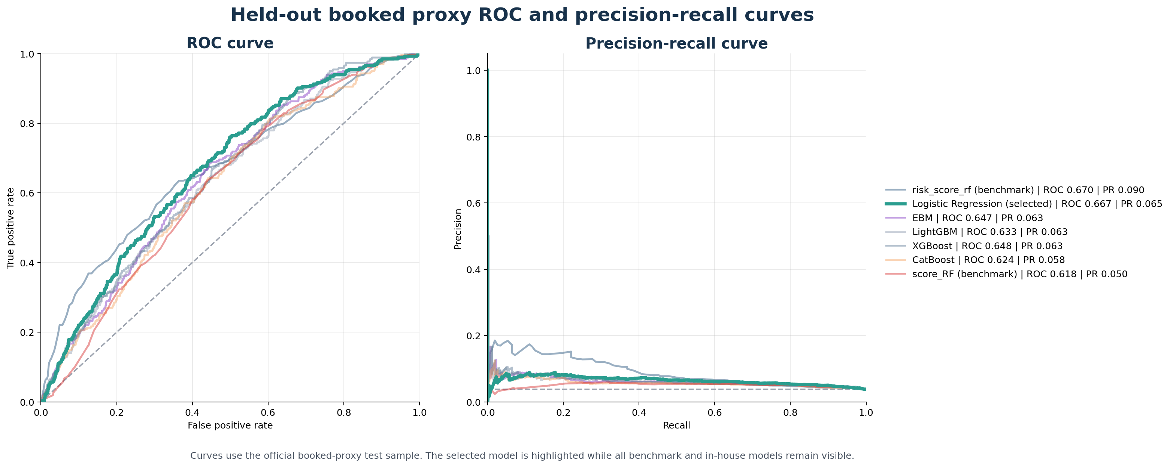
Figure: ROC and Precision-Recall curves on the held-out test sample

12. Results — Calibration and Stability
Calibration quality
Brier score and reliability curves are reported on the test set. Lower Brier is better. The calibrated variant of each model is the one that would be deployed; raw Brier values are included to show the calibration gain.
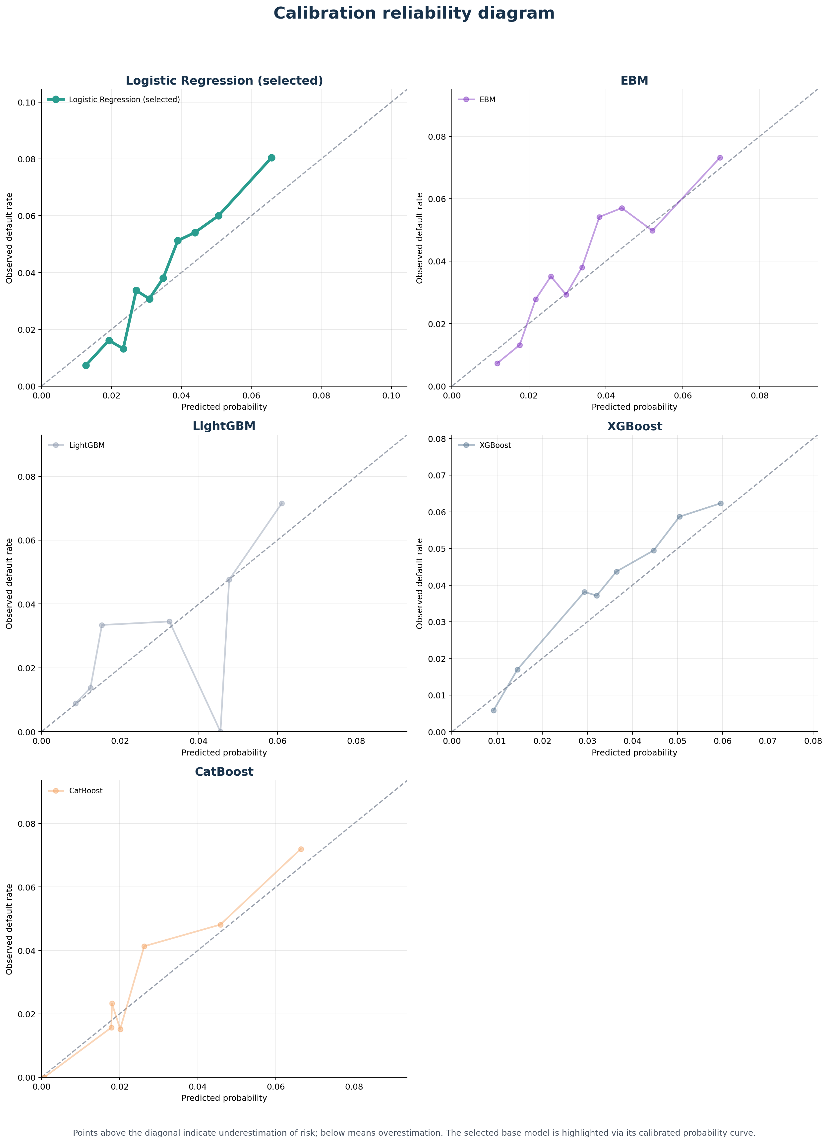
Figure: Reliability diagram — calibrated probabilities vs observed default rate
Rolling out-of-time performance
Per-fold PR AUC across the rolling-OOT validation windows. Stability is measured by mean PR AUC; concept drift by first-vs-last delta and per-fold slope.
Model | Folds | Mean PR AUC | Std PR AUC | Mean ROC AUC | Std ROC AUC
Logistic Regression (calibrated) | 4 | 0.0609 | 0.0077 | 0.6393 | 0.0244
EBM (calibrated) | 4 | 0.0641 | 0.0103 | 0.6487 | 0.0275
LightGBM (calibrated) | 4 | 0.0529 | 0.0071 | 0.6185 | 0.0361
XGBoost (calibrated) | 4 | 0.0519 | 0.0059 | 0.6151 | 0.0291
CatBoost (calibrated) | 4 | 0.0471 | 0.0017 | 0.5863 | 0.0212
risk_score_rf (benchmark) | 4 | 0.0841 | 0.0093 | 0.6587 | 0.0109
score_RF (benchmark) | 4 | 0.0544 | 0.0051 | 0.6264 | 0.0165
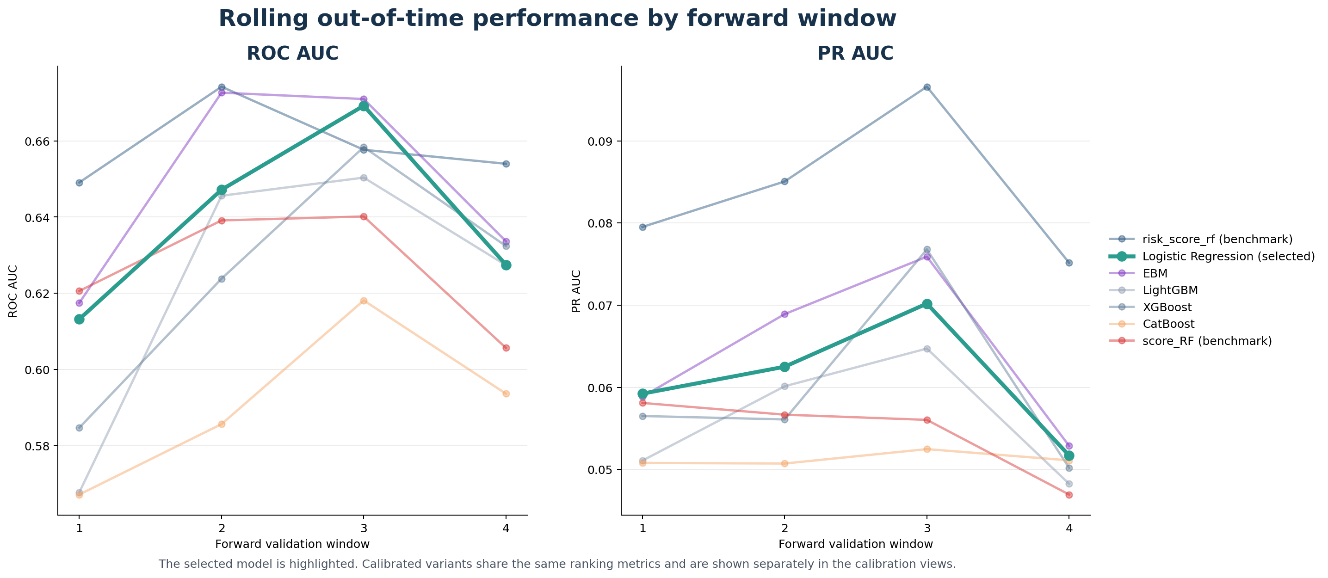
Figure: Rolling out-of-time PR AUC trajectory by model

13. Results — Comparison Against Existing Benchmarks
Headline benchmark contrast
The pipeline compares each candidate against the two existing scoring systems already in use on this portfolio: risk_score_rf and score_RF. Comparisons are paired bootstrap on the same test sample (1,000 resamples) with Holm–Bonferroni adjustment across the two reference scores. The candidate's confidence interval lower bound on AUC improvement (conservative_auc_lift) is the regulator-defensible summary statistic — a positive lower bound means the model out-performs the benchmark with 95% confidence.
Recommended candidate (Logistic Regression) versus each benchmark
Reference | Cand AUC | Ref AUC | ΔAUC | ΔAUC 95% CI | AUC adj. p | ΔPR AUC | PR adj. p
risk_score_rf (benchmark) | 0.6673 | 0.6703 | -0.0029 | [-0.0495, +0.0392] | 1.000 | -0.0255 | 0.100
score_RF (benchmark) | 0.6673 | 0.6176 | +0.0497 | [+0.0210, +0.0780] | 0.044 | +0.0145 | 0.044
Why the gap against risk_score_rf is structural, not methodological
Detailed inspection of the score distributions on the test sample shows the gap concentrates entirely in the high-precision tail. risk_score_rf achieves ~5× lift in the top 1% of the score distribution; the trained candidates achieve only ~1–2×. By the median of the score distribution the candidates match or exceed risk_score_rf. The Spearman rank correlation between the recommended model's scores and risk_score_rf is +0.15 — i.e. the two systems agree only weakly on which applicants to flag.
Combined with the fact that risk_score_rf is intentionally excluded from the modelling feature set (DROP_COLS), this pattern is the classic signature of a feature-data ceiling: the existing benchmark uses signals — almost certainly external bureau or payment-history data — that are not present in demand_direct.parquet. The pipeline is competently extracting the signal available from internal application data alone, but cannot recover the discriminative information embedded in the existing score.
Item K's quality floor and the conservative lower-bound tiebreak are what surface this honestly: the pipeline does not endorse the trained model as a benchmark replacement, only as a complementary signal within its feature ceiling.
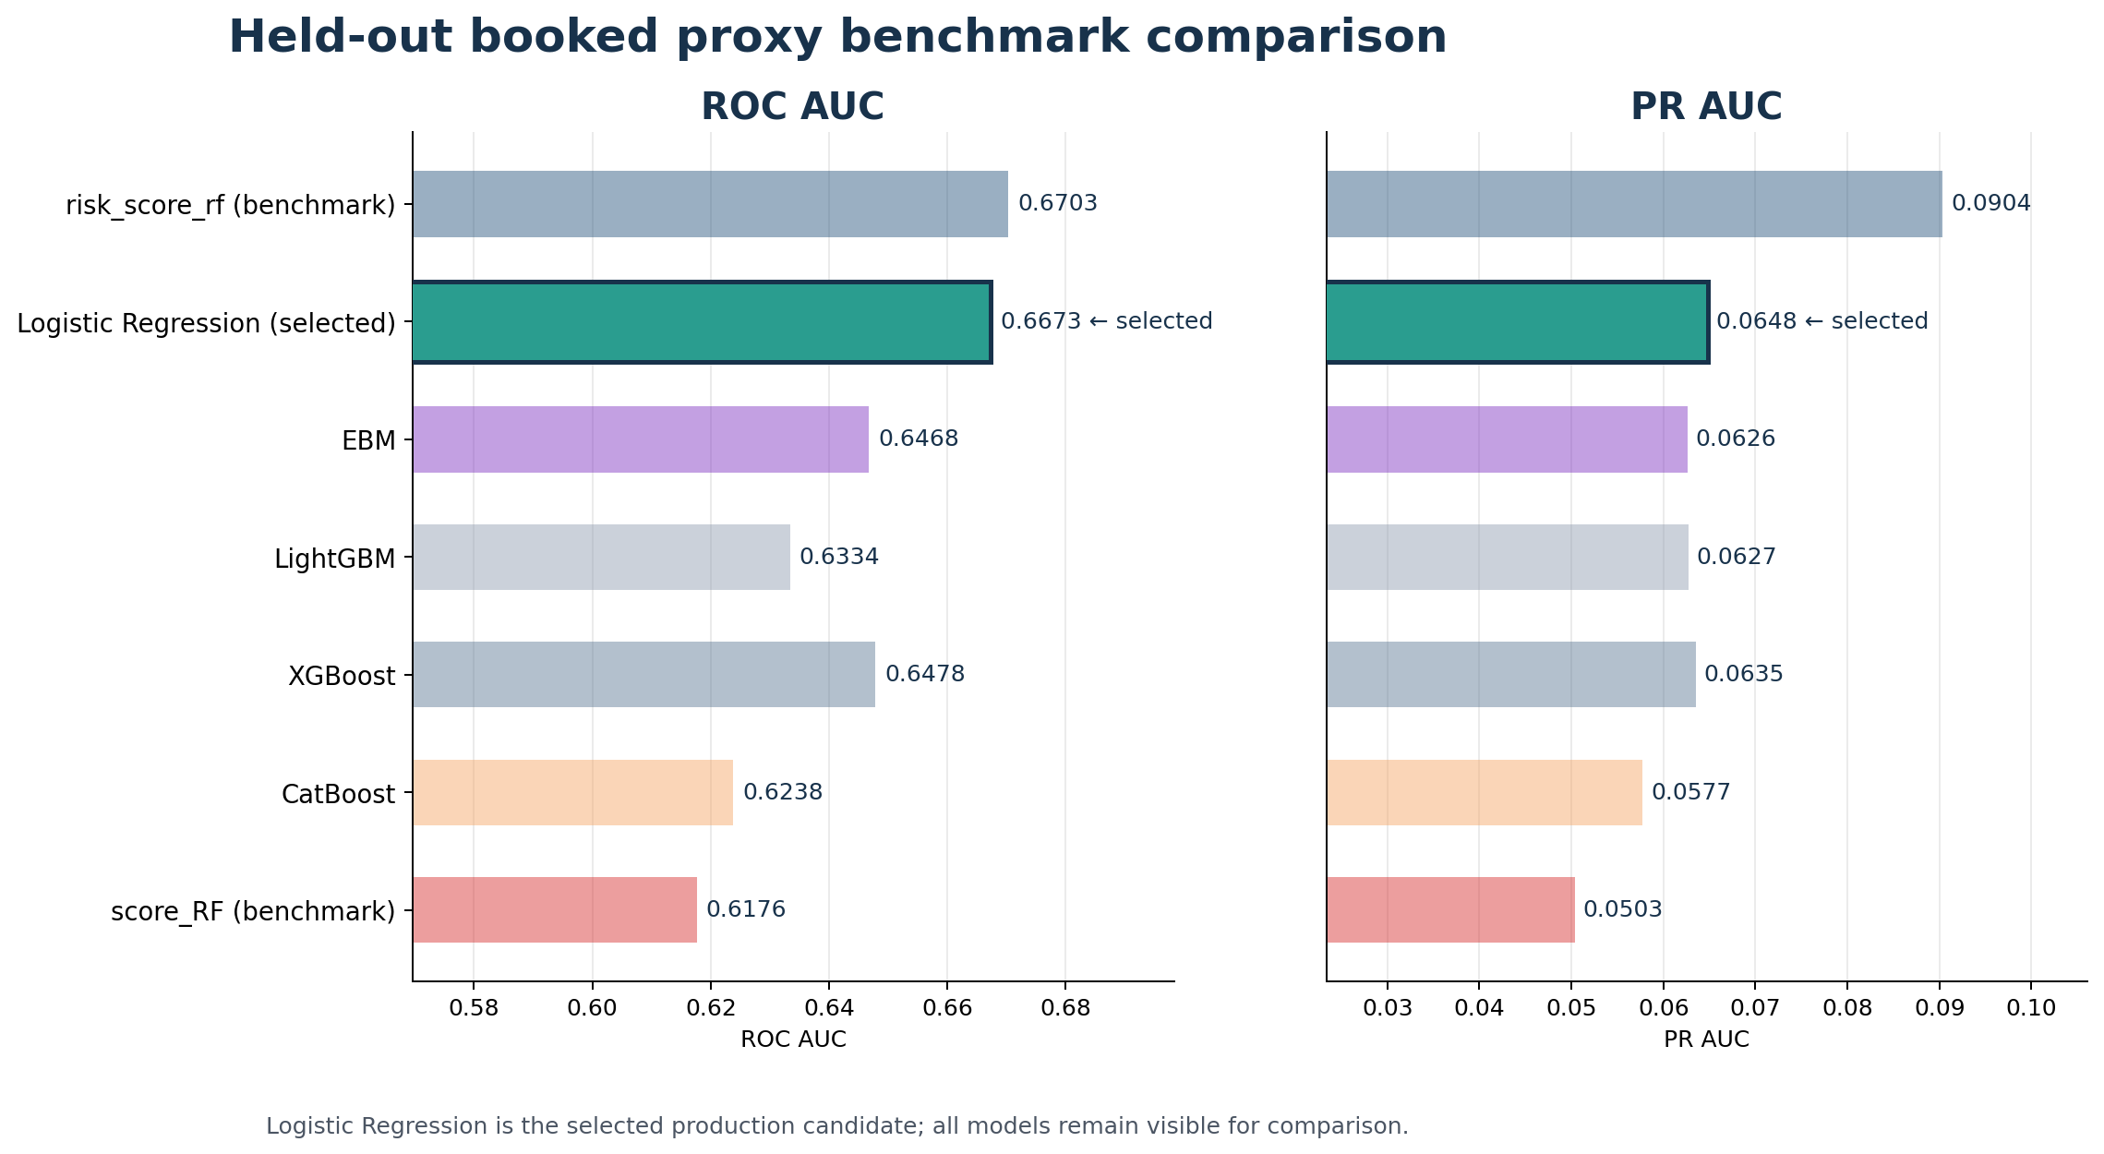
Figure: AUC and PR AUC: trained models vs existing benchmarks (test sample)

14. Results — Feature Importance and Drivers
Top 20 features for Logistic Regression
Feature | Coefficient / split-importance | Type
LOG_TOTAL_AMT | -0.5148 | coefficient
TENOR | +0.4477 | coefficient
MAX_CREDIT_TJ_AV | -0.3491 | coefficient
AGE_T1 | -0.3044 | coefficient
FREQ_ESTCLI1 | -0.2922 | coefficient
FREQ_PRODTYPE3_X_HOUSE | +0.2436 | coefficient
MISS_MAX_CREDIT_TJ_AV | +0.2429 | coefficient
LEFT_TO_LIVE_X_INSTALLMENT_AMT | +0.2421 | coefficient
FREQ_FAMILY_SITUATION_x_product_type_3 | +0.2359 | coefficient
INSTALLMENT_TO_HOUSEHOLD | +0.2234 | coefficient
FREQ_BIN_MAX_CREDIT_TJ_AV_x_FAMILY_SITUATION | -0.2211 | coefficient
LOG_MAX_CREDIT | -0.1915 | coefficient
INCOME_T1_X_TOTAL_AMT | -0.1886 | coefficient
FREQ_CUSTTYPE_X_HOUSE | -0.1872 | coefficient
FREQ_BIN_LEFT_TO_LIVE_x_HOUSE_TYPE | -0.1828 | coefficient
FREQ_FAMILY_SITUATION | -0.1825 | coefficient
TOTAL_AMT | -0.1802 | coefficient
INCOME_T1_X_AGE_T1 | +0.1704 | coefficient
FREQ_BIN_MAX_CREDIT_TJ_AV_x_HOUSE_TYPE | +0.1660 | coefficient
HOUSEHOLD_INCOME | -0.1642 | coefficient
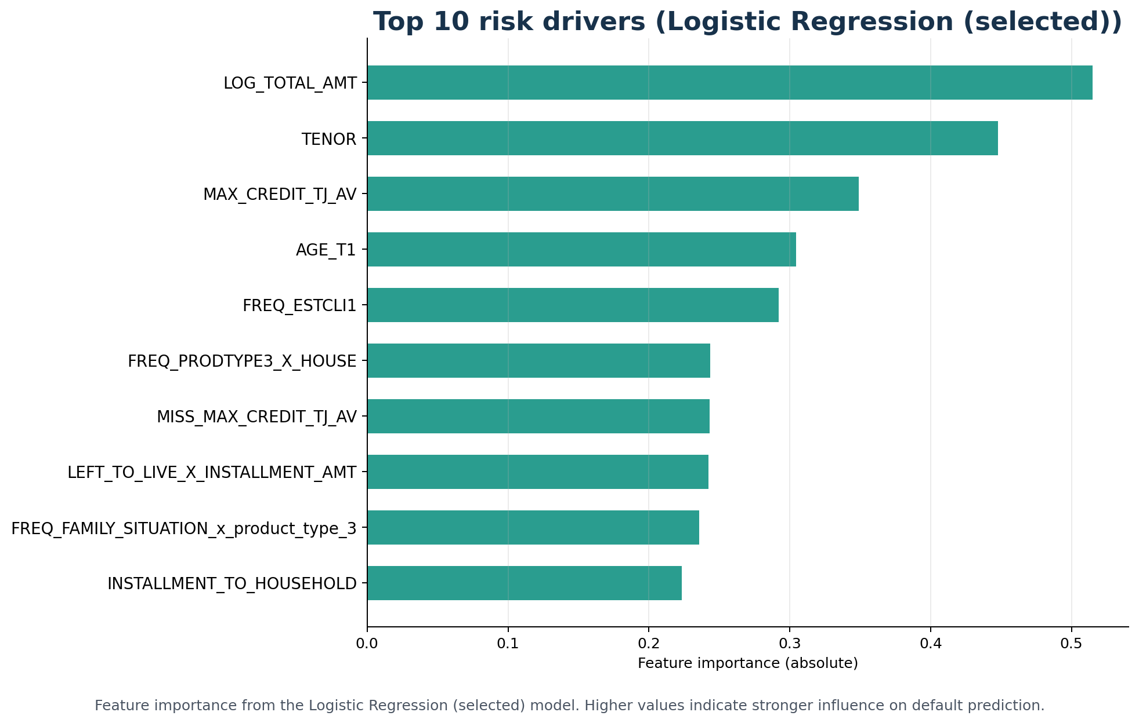
Figure: Top feature drivers across candidate models

15. Results — Lift, Gains, and Threshold Analysis
Lift table by decile (recommended candidate)
Decile | Accounts | Defaults | Default rate | Cum default rate | Lift | Cum lift | Capture
1 | 683 | 55 | 8.1% | 8.1% | 2.093 | 2.093 | 20.9%
2 | 683 | 40 | 5.9% | 7.0% | 1.522 | 1.807 | 36.1%
3 | 683 | 38 | 5.6% | 6.5% | 1.446 | 1.687 | 50.6%
4 | 683 | 35 | 5.1% | 6.1% | 1.332 | 1.598 | 63.9%
5 | 683 | 25 | 3.7% | 5.7% | 0.951 | 1.469 | 73.4%
6 | 683 | 22 | 3.2% | 5.2% | 0.837 | 1.363 | 81.7%
7 | 683 | 23 | 3.4% | 5.0% | 0.875 | 1.294 | 90.5%
8 | 683 | 9 | 1.3% | 4.5% | 0.342 | 1.175 | 93.9%
9 | 683 | 11 | 1.6% | 4.2% | 0.419 | 1.091 | 98.1%
10 | 688 | 5 | 0.7% | 3.8% | 0.189 | 1.000 | 100.0%
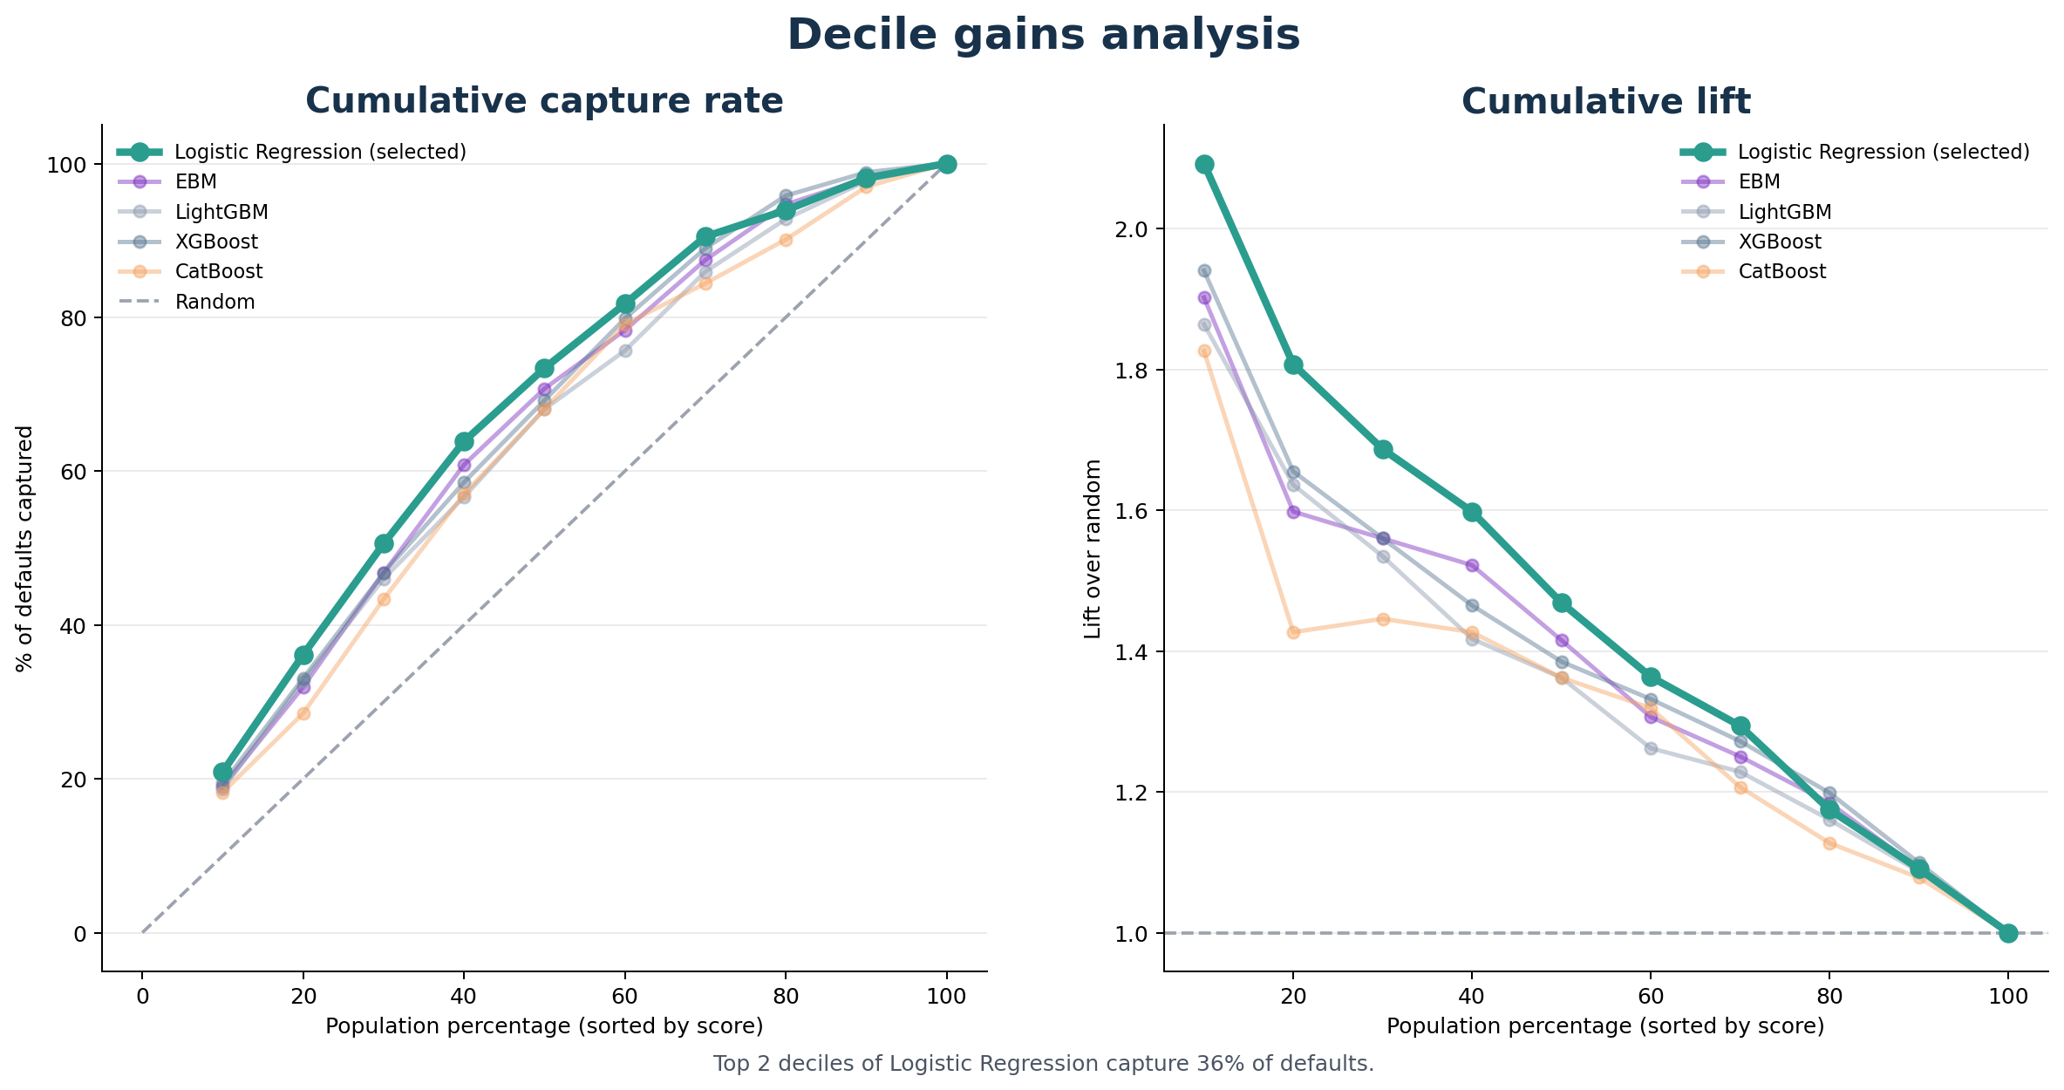
Figure: Cumulative gains chart — recommended candidate vs benchmarks
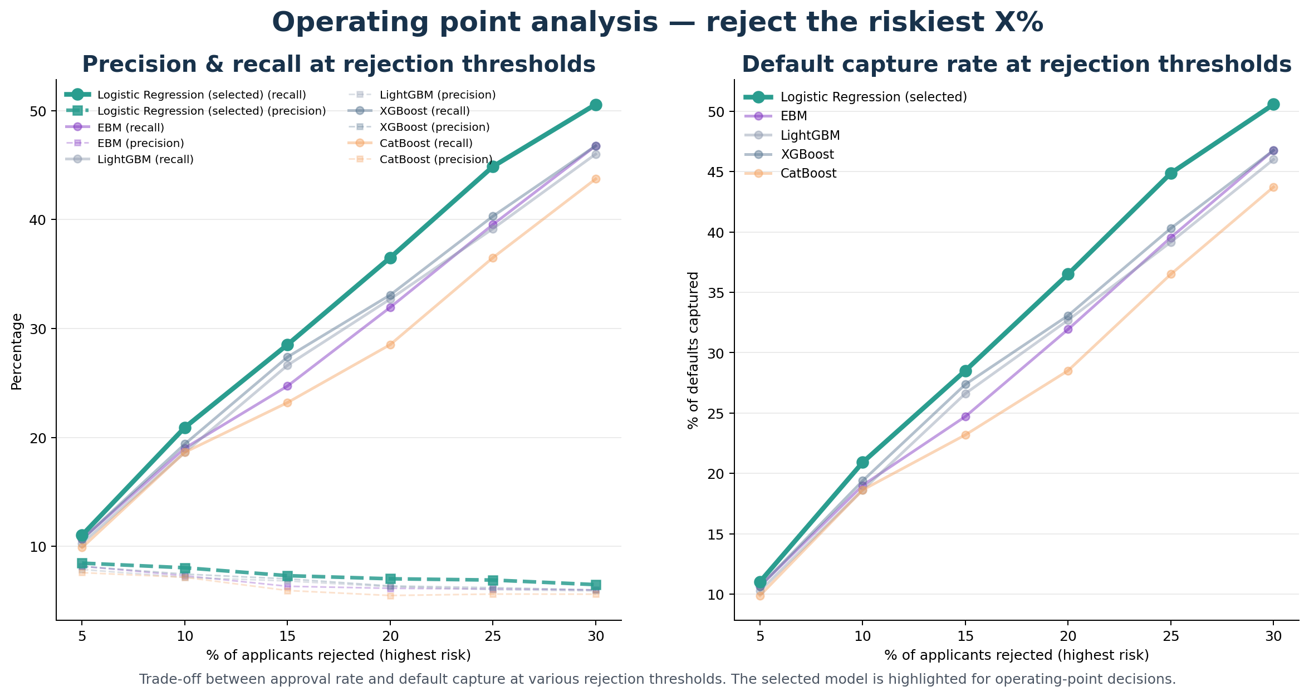
Figure: Confusion-matrix metrics at business-relevant rejection thresholds

16. Results — Stability, Drift, and Fair Lending
Population Stability Index (model scores)
Model | PSI | Band
Logistic Regression | 0.0370 | OK
EBM | 0.0300 | OK
LightGBM | 0.0235 | OK
XGBoost | 0.1042 | MODERATE
CatBoost | 0.7136 | HIGH DRIFT
Characteristic Stability Index (per feature)
91 features assessed: 91 stable (CSI < 0.10), 0 moderate (0.10 ≤ CSI < 0.25), 0 high drift (CSI ≥ 0.25).
Concept drift report
Model | Folds | First | Last | Slope/fold | First→last | Flag
Logistic Regression | 4 | 0.0592 | 0.0517 | -0.00149 | -0.0075 | NO
EBM | 4 | 0.0589 | 0.0529 | -0.00110 | -0.0060 | NO
LightGBM | 4 | 0.0511 | 0.0482 | -0.00039 | -0.0028 | NO
XGBoost | 4 | 0.0565 | 0.0502 | +0.00018 | -0.0063 | NO
CatBoost | 4 | 0.0508 | 0.0511 | +0.00027 | +0.0003 | NO
Adverse impact analysis by age band (10% rejection threshold)
model | age_band | n | n_observed_outcomes | n_defaults | observed_default_rate | mean_predicted_pd | approval_rate_at_10pct_reject | adverse_impact_ratio | air_flag | analysis_population
Logistic Regression | 18-25 | 170 | 170 | 9 | 0.052941 | 0.604607 | 0.723529 | 0.760461 | FAIL | booked_holdout
Logistic Regression | 25-35 | 1258 | 1258 | 66 | 0.052464 | 0.524829 | 0.809221 | 0.850527 | PASS | booked_holdout
Logistic Regression | 35-45 | 1912 | 1912 | 74 | 0.038703 | 0.449746 | 0.909519 | 0.955944 | PASS | booked_holdout
Logistic Regression | 45-55 | 2075 | 2075 | 80 | 0.038554 | 0.418151 | 0.926265 | 0.973545 | PASS | booked_holdout
Logistic Regression | 55-65 | 967 | 967 | 22 | 0.022751 | 0.396485 | 0.948294 | 0.996698 | PASS | booked_holdout
Logistic Regression | 65-100 | 453 | 453 | 12 | 0.02649 | 0.371915 | 0.951435 | 1.0 | PASS | booked_holdout
EBM | 18-25 | 170 | 170 | 9 | 0.052941 | 0.066823 | 0.541176 | 0.568824 | FAIL | booked_holdout
EBM | 25-35 | 1258 | 1258 | 66 | 0.052464 | 0.04774 | 0.788553 | 0.828838 | PASS | booked_holdout
EBM | 35-45 | 1912 | 1912 | 74 | 0.038703 | 0.034475 | 0.919456 | 0.966428 | PASS | booked_holdout
EBM | 45-55 | 2075 | 2075 | 80 | 0.038554 | 0.029778 | 0.946024 | 0.994354 | PASS | booked_holdout
EBM | 55-65 | 967 | 967 | 22 | 0.022751 | 0.029081 | 0.951396 | 1.0 | PASS | booked_holdout
EBM | 65-100 | 453 | 453 | 12 | 0.02649 | 0.030252 | 0.93819 | 0.986119 | PASS | booked_holdout
LightGBM | 18-25 | 170 | 170 | 9 | 0.052941 | 0.45939 | 0.658824 | 0.695505 | FAIL | booked_holdout
LightGBM | 25-35 | 1258 | 1258 | 66 | 0.052464 | 0.343167 | 0.806836 | 0.851758 | PASS | booked_holdout
LightGBM | 35-45 | 1912 | 1912 | 74 | 0.038703 | 0.257915 | 0.910565 | 0.961262 | PASS | booked_holdout
LightGBM | 45-55 | 2075 | 2075 | 80 | 0.038554 | 0.223239 | 0.933976 | 0.985977 | PASS | booked_holdout
LightGBM | 55-65 | 967 | 967 | 22 | 0.022751 | 0.21096 | 0.94726 | 1.0 | PASS | booked_holdout
LightGBM | 65-100 | 453 | 453 | 12 | 0.02649 | 0.219967 | 0.944812 | 0.997417 | PASS | booked_holdout
XGBoost | 18-25 | 170 | 170 | 9 | 0.052941 | 0.536588 | 0.623529 | 0.659951 | FAIL | booked_holdout
XGBoost | 25-35 | 1258 | 1258 | 66 | 0.052464 | 0.411418 | 0.807631 | 0.854806 | PASS | booked_holdout
XGBoost | 35-45 | 1912 | 1912 | 74 | 0.038703 | 0.321987 | 0.916841 | 0.970395 | PASS | booked_holdout
XGBoost | 45-55 | 2075 | 2075 | 80 | 0.038554 | 0.285002 | 0.935904 | 0.990571 | PASS | booked_holdout
XGBoost | 55-65 | 967 | 967 | 22 | 0.022751 | 0.276535 | 0.935884 | 0.99055 | PASS | booked_holdout
XGBoost | 65-100 | 453 | 453 | 12 | 0.02649 | 0.278588 | 0.944812 | 1.0 | PASS | booked_holdout
CatBoost | 18-25 | 170 | 170 | 9 | 0.052941 | 0.377502 | 0.676471 | 0.7049 | FAIL | booked_holdout
CatBoost | 25-35 | 1258 | 1258 | 66 | 0.052464 | 0.300923 | 0.833068 | 0.868079 | PASS | booked_holdout
CatBoost | 35-45 | 1912 | 1912 | 74 | 0.038703 | 0.262507 | 0.891736 | 0.929212 | PASS | booked_holdout
CatBoost | 45-55 | 2075 | 2075 | 80 | 0.038554 | 0.225184 | 0.928675 | 0.967703 | PASS | booked_holdout
CatBoost | 55-65 | 967 | 967 | 22 | 0.022751 | 0.193568 | 0.959669 | 1.0 | PASS | booked_holdout
CatBoost | 65-100 | 453 | 453 | 12 | 0.02649 | 0.192874 | 0.942605 | 0.982219 | PASS | booked_holdout
Bands flagged below the 80% Adverse Impact Ratio threshold warrant human review of the underlying feature dependencies before production deployment.

17. Limitations and Known Issues
- Booked-only proxy. The test sample is restricted to booked accounts because basel_bad is only observable for accounts that were actually decisioned positively. Performance on rejected and canceled applicants is inferred via reject-inference assumptions, not directly observed.
- Maturity contract drift. The latest run's training data contained approximately 34,000 booked rows past the static MATURITY_CUTOFF with non-null basel_bad. The static-cutoff filter excluded these rows from training and the warning was logged. A reviewer should decide whether MATURITY_CUTOFF should be advanced (to use newly-matured data) or whether upstream is right-censoring (filling 0 for immature rows before the 12-month window has elapsed).
- Adverse-impact warning at age band 18-25. Every candidate model (including the recommended LR) has an Adverse Impact Ratio below the 80% threshold for the 18-25 band at the 10% rejection threshold. This is a feature-driven artifact (the underlying default rate is structurally higher in this band) but warrants explicit fair-lending review before any production deployment decision.
- Feature-data ceiling vs current benchmark. The pipeline does not out-perform the existing risk_score_rf score on the high-precision tail of the test distribution. Detailed analysis (section 13) shows the gap is structural — risk_score_rf uses signals not present in the modelling feature set. Closing the gap requires obtaining the external/bureau data the existing score uses, or repositioning the trained model as a complementary rather than replacement signal.
- Stacking is experimental. The TemporalStackingClassifier is supported but not enabled in the official run. When enabled, it is correctly trained on temporal out-of-fold predictions, but it has not been validated against the same regulator-defensibility bar as the five official candidates.

18. Recommendations
Production candidate. Logistic Regression (calibrated) is the recommended production candidate at weighted_score 95.0 / 100. 4 of 5 candidates cleared the absolute weighted-score floor of 50. Logistic Regression is uniquely placed at benchmark-evidence tier 3 ('strong'). The lexicographic tiebreak inside the selection band prefers benchmark-evidence tier first, then conservative AUC lift, then generalisation score, which selected Logistic Regression over the other candidates that cleared the floor.
Path to closing the benchmark gap
- Operationally: obtain the same data the existing risk_score_rf benchmark uses (bureau / external payment history / proprietary signals) and re-run the pipeline. This is the only path to genuinely beating risk_score_rf on its own ground.
- Architecturally: consider reusing risk_score_rf as a feature in a stacked model (remove from DROP_COLS). The trained model would then be at least as good as the benchmark and could extract residual signal. The trade-off: the new model becomes operationally dependent on the older score remaining available.
- Operationally complementary: position the new model as a second-line check on applicants the existing score is ambivalent about (mid-range score percentiles), or as a backup when the bureau feed is unavailable. The 50%+ of the score distribution where the trained model wins on lift suggests this fit may be the most defensible.
Monitoring requirements
- Re-train on a quarterly cadence; CSI and PSI thresholds in training_constants.py determine alert bands.
- Monitor the calibrated Brier on a monthly basis on a recent matured cohort. Any drift above the bootstrap CI upper bound triggers an investigation.
- Re-validate the AIR by age band on each retraining run; persistent below-80% bands trigger fair-lending review.
- Verify the integrity of deployed model files via the SHA-256 checksums.json written alongside each .joblib at training time. ScoringService.from_output_dir refuses to load a model whose checksum does not match.

19. Methodology Constants — Citations and Rationale
Diagnostic thresholds
Constant | Value | Source / rationale
PSI moderate-drift cut | 0.10 | Karakoulas (2004); industry standard
PSI high-drift cut | 0.25 | Karakoulas (2004); industry standard
Overfit flag delta | 0.03 | Internal decision; deliberately strict relative to industry rule of thumb 0.05
Concept-drift first-vs-last delta | −0.02 | Internal decision; only severe drift across rolling-OOT triggers the flag
Reject inference (when enabled)
Constant | Value | Source / rationale
Bad-rate multiplier | 1.5× | Hand & Henley (1997); conservative end of the 1.5–4× literature range
Sample weight on pseudo-labels | 0.5 | Internal decision; downweights pseudo-labels relative to observed targets
Max booked:reject ratio | 1.0:1 applicants | Internal decision; capped at parity post deterministic 2× row expansion (audit fix I)
Feature selection
Constant | Value | Source / rationale
Stability selection threshold | 50% of folds | Meinshausen & Bühlmann (2010); literature default
Stability selection floor | 5 features | Internal decision; below 5 the linear meta-model is unidentifiable
Tree-aware importance ratio | 5% of max permutation importance | Internal decision (audit fix B); union with stability selector forms the final contract
Calibration
Constant | Value | Source / rationale
Calibration holdout fraction | 15% of development sample | Internal decision; carved temporally so calibration data resembles production
Min calibration positives | 100 | Niculescu-Mizil & Caruana (2005), Foster & Stine (2004)
Per-model method | sigmoid for LR, EBM; isotonic for tree models | Niculescu-Mizil & Caruana (2005), audit fix E
Hyperparameter search
Constant | Value | Source / rationale
Optuna pruner warmup | 3 CV folds | Internal decision (audit fix J); first temporal fold is smallest and noisiest
Booster depth bounds | [3, 7] | Internal decision (audit fix A); previous [2, 4]/[3, 5] forced near-additive trees
Model selection
Constant | Value | Source / rationale
Weighted score breakdown | 35% discrimination + 20% stability + 15% calibration + 15% generalisation + 15% benchmark lift | Internal decision; discrimination dominates but generalisation+stability+calibration sum to 50%
Quality floor | weighted_score ≥ 50 | Internal decision (audit fix K); prevents recommending a 'least bad' model when all candidates are weak
Selection band | 2 percentage points | Internal decision; tied candidates within this band tie-break by benchmark evidence and generalisation

20. Audit Improvements (A–M)
An external methodology audit produced thirteen recommended improvements. Each is integrated and regression-tested.
Item | Improvement
A | Loosened booster depth bounds to [3, 7] with raised regularisation upper bounds
B | Tree-aware permutation-importance feature pass; final contract = stability ∪ tree-aware
C | Bias-corrected and accelerated (BCa) bootstrap confidence intervals with block jackknife
D | Generalisation penalty uses max(AUC delta, PR-AUC delta)
E | Per-model calibration method centralised; Niculescu-Mizil & Caruana citation in model card
F | Maturity invariant explicit; warns when upstream populates immature targets
G | Calibration-holdout minimum-positives guard with regulator-visible warning below 100
H | Defensive sort by mis_Date at the load boundary for byte-stable artifacts
I | Reject pseudo-labels are now deterministic 2× row expansion (no Bernoulli noise)
J | Optuna MedianPruner warmup raised to 3 folds
K | Absolute weighted_score quality floor with explicit no-recommendation behaviour
L | STABILITY_SELECTION_MIN_FEATURES rationale documented with portfolio-specific bounds
M | Methodology constants section in model card with citations / decision rationale

21. Artifact Inventory
CSV artifacts
- ablation_results.csv
- adverse_impact_age.csv
- applicant_scores_post_split.csv
- benchmark_comparisons.csv
- benchmark_comparisons_experimental.csv
- concept_drift.csv
- confidence_intervals.csv
- csi.csv
- data_quality_development_fit.csv
- data_quality_test.csv
- ensemble_weights.csv
- feature_discovery_boundary.csv
- feature_importance.csv
- feature_provenance.csv
- final_holdout_results.csv
- final_holdout_scores.csv
- holdout_test_scores.csv
- interaction_leaderboard.csv
- iv_summary.csv
- lift_table.csv
- model_selection.csv
- optuna_catboost.csv
- optuna_ebm.csv
- optuna_lightgbm.csv
- optuna_logistic_regression.csv
- optuna_xgboost.csv
- overfit_report.csv
- population_ks_test.csv
- population_summary.csv
- psi.csv
- results.csv
- results_experimental.csv
- rolling_oot_results.csv
- rolling_oot_summary.csv
- selection_bias_correlation.csv
- shap_importance.csv
- shap_values.csv
- threshold_analysis.csv
- variable_dictionary.csv
- woe_detail.csv
JSON artifacts
- risk_tiers.json
Text reports
- model_card.txt
Stakeholder plots
- score_dist_test.png
- score_dist_train.png
- shap_dependence.png
- shap_importance.png
- shap_summary.png
- stakeholder_auc_lift.png
- stakeholder_before_after.png
- stakeholder_calibration.png
- stakeholder_executive_summary.png
- stakeholder_gains.png
- stakeholder_holdout_benchmarks.png
- stakeholder_kpis.png
- stakeholder_population_coverage.png
- stakeholder_reliability.png
- stakeholder_roc_pr_curves.png
- stakeholder_rolling_oot.png
- stakeholder_threshold_analysis.png
- stakeholder_top_drivers.png
Saved models (with SHA-256 checksums.json)
- catboost.joblib
- catboost_calibrated.joblib
- ebm.joblib
- ebm_calibrated.joblib
- ensemble_logistic_regression_+_catboost.joblib
- ensemble_logistic_regression_+_lightgbm.joblib
- ensemble_logistic_regression_+_xgboost.joblib
- lightgbm.joblib
- lightgbm_calibrated.joblib
- logistic_regression.joblib
- logistic_regression_calibrated.joblib
- stacking.joblib
- stacking_experimental.joblib
- xgboost.joblib
- xgboost_calibrated.joblib

