Credit Scoring Model Validation Report

Basel Bad Default Prediction Model
Direct Consumer Credit Portfolio
Population mode: Underwriting | Evaluation: Booked-proxy holdout

1. Executive Summary
Purpose. This report presents the development and validation of a binary classification model predicting 12-month default (basel_bad) for direct consumer credit applications. The model is intended to support underwriting decisions by scoring all decisioned applications (booked, rejected, and canceled) at the point of application.
Recommendation. The recommended production model is Logistic Regression with a weighted selection score of 75.8/100. It achieves a ROC AUC of 0.6658 and KS of 0.2501 on the held-out booked-proxy test set (16,109 accounts, 611 observed defaults, 3.8% base rate).

Key findings:
- The recommended model significantly outperforms score_RF on ROC AUC (+0.0473, 95% CI [+0.0294, +0.0663], DeLong p=0.000001), confirming that the new model provides materially better risk ranking than the existing weaker benchmark.
- Against the stronger risk_score_rf benchmark, the AUC improvement is modest and not statistically significant (+0.0045, p=0.77). On PR AUC, risk_score_rf retains a meaningful lead (-0.0237), indicating that the existing benchmark concentrates defaults more effectively in the highest-risk segment. This gap represents the primary improvement opportunity.
- Logistic Regression shows a mild overfit gap (AUC delta +0.0351), while tree models exhibit severe overfitting (AUC deltas from +0.25 to +0.33). This is the primary reason the multi-criteria selection favors the linear model despite competitive held-out discrimination from LightGBM and XGBoost.
- The top score decile concentrates defaults at 2.0x the population average. The top two deciles capture 38.1% of all observed defaults, demonstrating meaningful separation for underwriting cutoff decisions.
- The adverse impact analysis flags 1 age band(s) (18-25) below the 80% AIR threshold at a 10% rejection rate. Young applicants receive systematically higher predicted risk, which is consistent with the observed higher default rate in this segment but warrants regulatory review.
- Score distributions are highly stable between training and test (all PSI < 0.02) and no concept drift is detected across rolling out-of-time windows.

2. Data and Population Design

2.1 Population Scope
The pipeline operates in underwriting mode, meaning it loads the full decisioned population: booked loans, rejected applications, and canceled applications. This reflects the production use case where the model scores every incoming application regardless of the eventual decision.
However, the supervised training target (12-month default) is observable only for booked accounts that have had sufficient time on book. This creates a fundamental limitation: the model is trained and evaluated on the accepted-population proxy, not the full applicant population. Rejected and canceled applications contribute to the applicant-stage score frame but do not influence model fitting or evaluation metrics.

2.2 Population Breakdown
Split | Status | Applications | Defaults | Period
post-split | Booked | 50,735 | 727 | 2024-07-01 to 2026-02-01
post-split | Canceled | 149,039 | 0 | 2024-07-01 to 2026-02-01
post-split | Rejected | 980,972 | 0 | 2024-07-01 to 2026-02-01
pre-split | Booked | 51,380 | 1,935 | 2023-01-01 to 2024-06-01
pre-split | Canceled | 180,023 | 0 | 2023-01-01 to 2024-06-01
pre-split | Rejected | 974,536 | 0 | 2023-01-01 to 2024-06-01

The pre-split booked sample (51,380 accounts, 1,935 defaults, 3.8% base rate) is partitioned into: (1) a feature-discovery window for interaction search and stability selection, (2) an estimation window for model fitting, and (3) a calibration holdout (latest 15% by date) for probability calibration. The post-split booked matured subset (16,109 accounts, 611 defaults, 3.8% base rate) serves as the held-out evaluation sample.

2.3 Temporal Design
All data partitioning is strictly temporal to prevent information leakage. The split date (2024-07-01) separates development from the held-out test period. The maturity cutoff (2025-01-01) ensures that only accounts with a full 12-month observation window are included in evaluation. Within the development period, feature discovery uses the earliest data, model estimation uses the middle period, and calibration uses the latest block. No random shuffling or stratified splitting is used at any stage.

3. Methodology

3.1 Feature Engineering
Starting from 15 raw numerical and 12 raw categorical features, the pipeline engineers additional signals in several families:
- Affordability ratios: installment-to-income, amount-to-income, amount-per-month, and household-capacity variants
- Portfolio composition: total products, book ratios for cards and loans, presence flags
- Bureau-capacity transforms: log of income, loan amount, and maximum credit facility
- Categorical interactions: targeted crosses of product type, housing, and customer-type segments
- Missingness indicators: binary flags for fields with meaningful missing rates (> 1%)
- Frequency encodings: training-set category proportions as numerical features
- Group-relative statistics: individual value divided by group median for key numeric-categorical pairs
- Binned interactions: quantile-binned numerical features crossed with categorical values to capture threshold effects

3.2 Feature Selection
Feature selection uses temporal stability selection rather than classical RFECV. For each fold of an expanding temporal cross-validation, an elastic-net logistic regression (with grid-searched C and L1 ratio) is fitted on the preprocessed features. Features that receive a non-zero coefficient in >= 50% of folds are retained. If fewer than 5 features pass the threshold, the top features by selection frequency are backfilled. This approach favors features whose predictive signal is stable across time periods rather than those that happen to be strong in a single window.

3.3 Ablation Study
An ablation study measures the incremental contribution of each feature engineering stage by training a Logistic Regression on progressively richer feature sets and evaluating on the held-out test:
Feature Set | Features | ROC AUC | PR AUC
Raw Only | 27 | 0.6534 | 0.0646
Raw Plus Engineered | 52 | 0.6622 | 0.0681
With Discovery Interactions | 106 | 0.6574 | 0.0652
Candidate Feature Space | 146 | 0.6490 | 0.0618
Frozen Feature Space | 91 | 0.6569 | 0.0613
Uncalibrated | 91 | 0.6569 | 0.0613
Sigmoid Calibrated | 91 | 0.6569 | 0.0613

The ablation reveals that engineered features (affordability ratios, log transforms) provide the largest marginal lift over raw inputs. The interaction search and stability selection refine the feature set but their primary value is regularization rather than discrimination gain.

3.4 Model Training
Four candidate architectures are trained with Optuna Bayesian hyperparameter optimization using multivariate TPE sampling (models correlations between hyperparameters) and median pruning (terminates unpromising trials after the first 1-2 cross-validation folds).
Model | Approach | Calibration | Key Regularization
Logistic Regression | L2-penalized, LBFGS solver, C and TargetEncoder smooth tuned jointly | Sigmoid (Platt) | class_weight='balanced'
LightGBM | Gradient boosting, native categorical handling via ordinal encoding | Isotonic | num_leaves 8-31, max_bin 63-127, colsample_bynode 0.6-1.0, early stopping after 30 rounds
XGBoost | Gradient boosting, TargetEncoder preprocessing | Isotonic | max_depth 2-4, min_child_weight 20-100, colsample_bynode 0.6-1.0, early stopping after 30 rounds
CatBoost | Oblivious gradient boosting, balanced class weights | Isotonic | depth 3-5, min_data_in_leaf 50-300, early stopping after 30 rounds

Tree complexity bounds are deliberately tightened for the low (~3.8%) default rate: shallow depths, high minimum leaf sizes, coarse histogram bins, and aggressive per-node feature subsampling. When reject-inference sample weights are provided, scale_pos_weight is disabled to avoid double-rebalancing the minority class.

3.5 Calibration
Probability calibration is fitted on the latest pre-split booked holdout (15% of development data by date). Isotonic calibration is used for tree models because their output distributions are step-functions that violate the linear log-odds assumption of Platt scaling. Sigmoid (Platt) calibration is retained for Logistic Regression, whose output is already in log-odds form. The model selection scorecard evaluates calibration quality using the calibrated Brier score, since that reflects production probability quality.

3.6 Model Selection Framework
A weighted multi-criteria scorecard ranks candidates on five dimensions, each normalized to a 0-100 scale across the candidate set:
Criterion | Weight | Source | Rationale
Discrimination | 35% | Test PR AUC | Primary measure of risk ranking quality on imbalanced data
Stability | 20% | Rolling OOT mean PR AUC | Rewards models whose performance holds across multiple forward time windows
Calibration | 15% | Calibrated Brier score | Assesses whether predicted probabilities are trustworthy for pricing
Generalization | 15% | Train-test AUC delta | Penalizes overfitting: 0 penalty if delta <= 0.01, full penalty at 0.10
Benchmark lift | 15% | Best AUC improvement vs benchmarks | Rewards improvement over existing production scores

4. Results

4.1 Held-Out Test Performance
The table below reports performance on 16,109 held-out booked accounts from July 2024 to January 2025, with 611 observed defaults (3.8% base rate). Models are sorted by PR AUC, which is the primary metric for imbalanced classification where the cost of missed defaults greatly exceeds the cost of false alarms.
Model | ROC AUC | Gini | KS | PR AUC | Brier
risk_score_rf (benchmark) | 0.6613 | 0.3225 | 0.2428 | 0.0879 | N/A
Ensemble (Logistic Regression + LightGBM) | 0.6661 | 0.3321 | 0.2569 | 0.0656 | 0.1641
Logistic Regression | 0.6658 | 0.3317 | 0.2501 | 0.0642 | 0.2232
LightGBM | 0.6441 | 0.2883 | 0.2155 | 0.0621 | 0.1197
CatBoost | 0.6385 | 0.2770 | 0.2001 | 0.0621 | 0.1733
XGBoost | 0.6443 | 0.2887 | 0.2311 | 0.0618 | 0.1545
score_RF (benchmark) | 0.6185 | 0.2371 | 0.1842 | 0.0538 | N/A

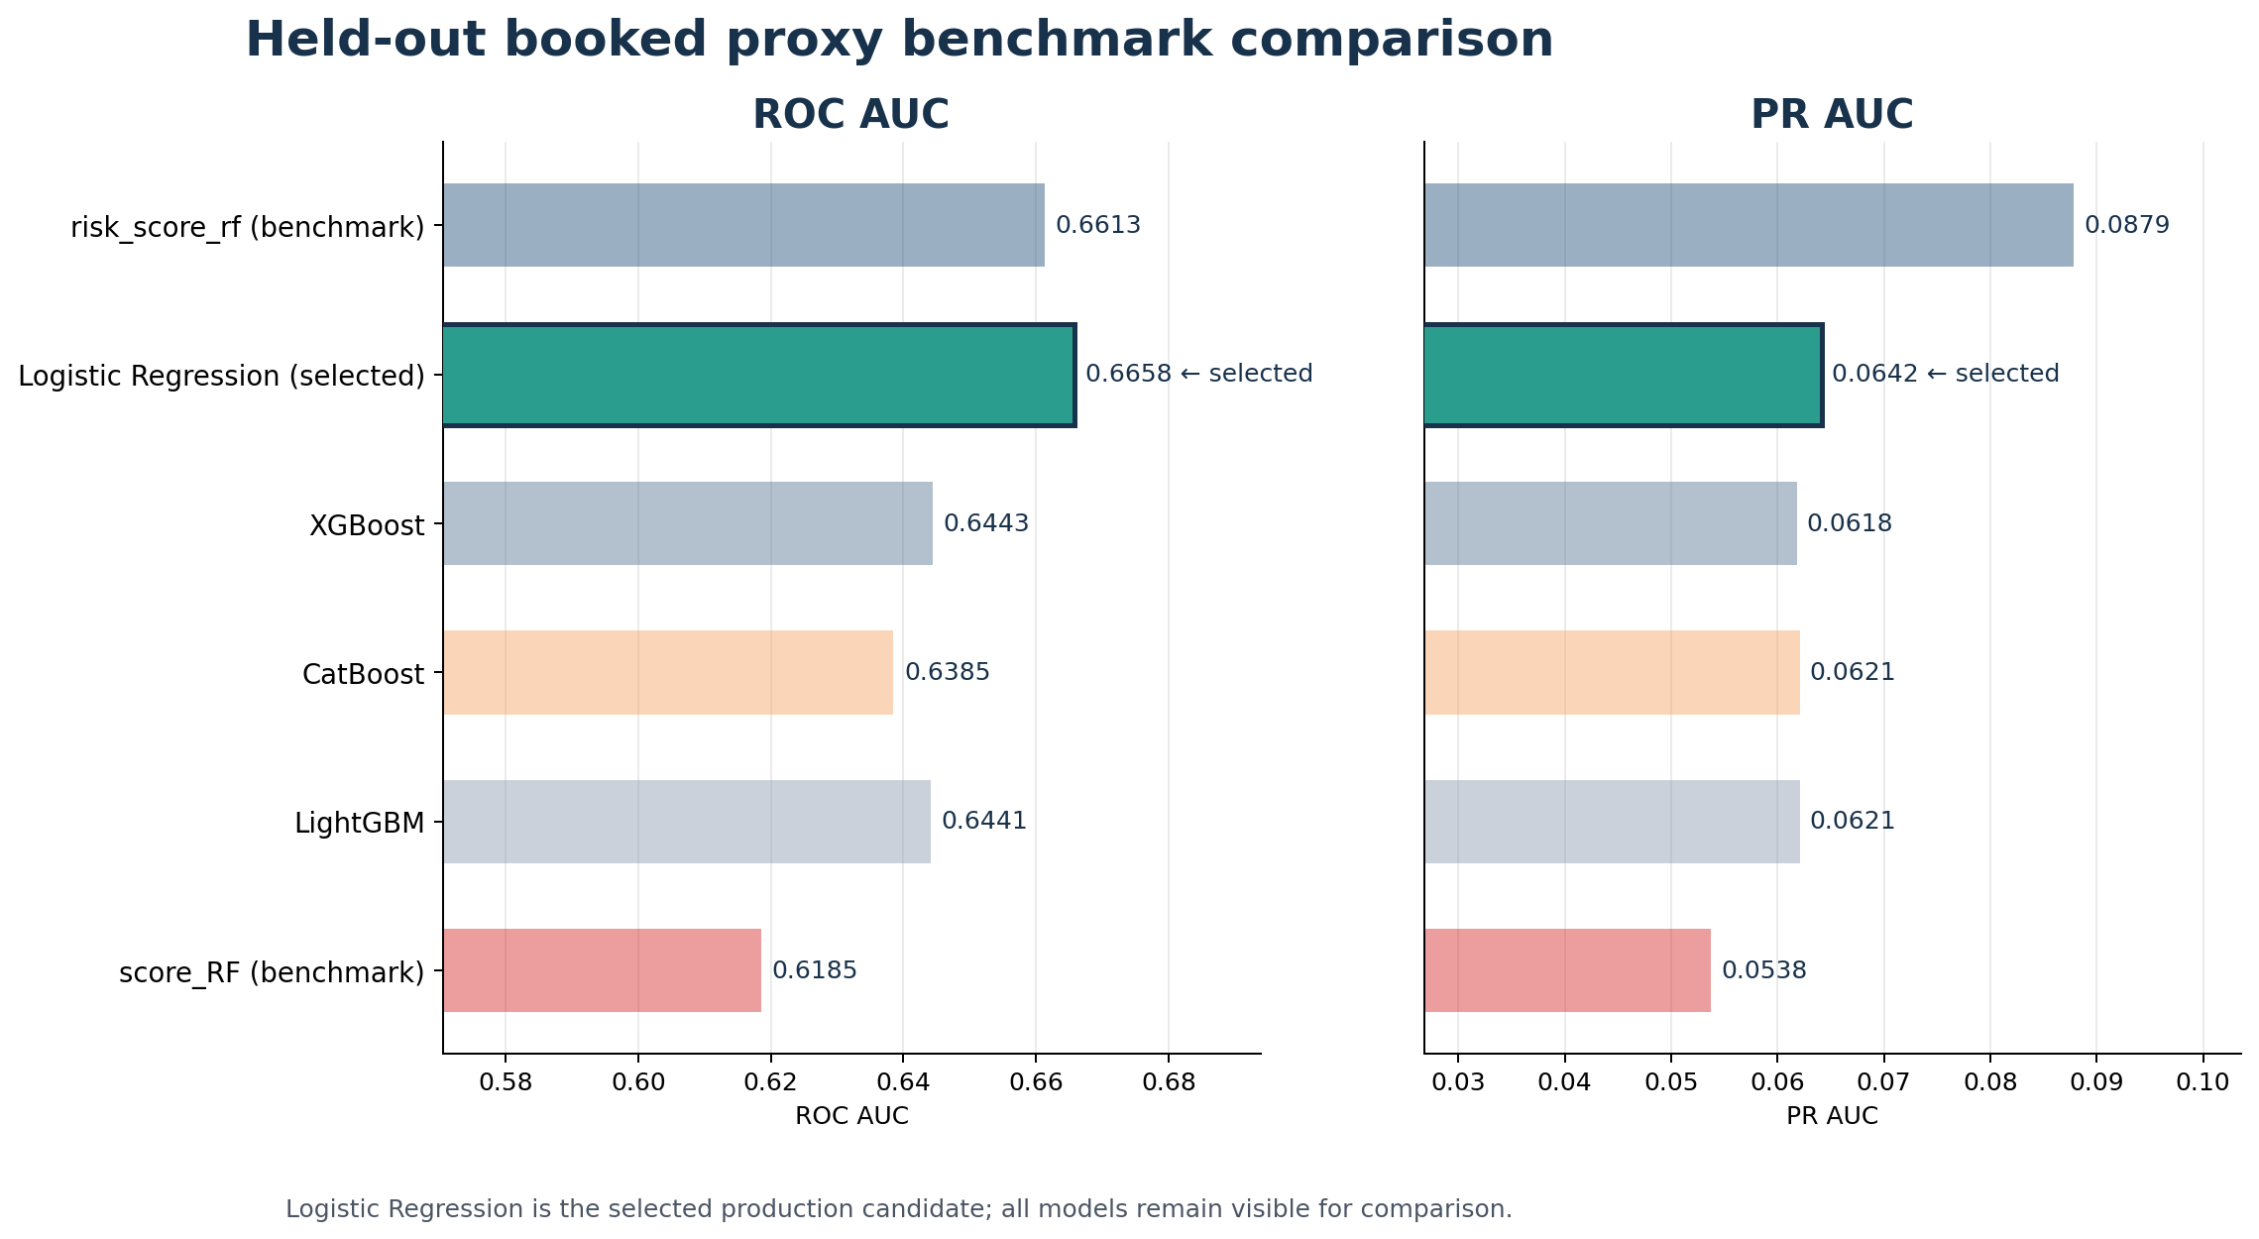

Logistic Regression and the post-hoc ensemble (55% LR + 45% LightGBM) lead on ROC AUC, while risk_score_rf retains the highest PR AUC. The tree models cluster below Logistic Regression on both metrics despite having far more expressive architectures, which is a direct consequence of their overfitting to the training data.

4.2 Model Selection Scorecard
Model | Disc. | Calib. | Stab. | Gen. | Lift | Overall | Rec.
Logistic Regression | 100.0 | 100.0 | 0.0 | 72.1 | 100.0 | 75.8 | Yes
LightGBM | 14.2 | 64.6 | 100.0 | 0.0 | 69.0 | 45.0
XGBoost | 0.0 | 51.4 | 50.2 | 0.0 | 69.3 | 28.2
CatBoost | 11.9 | 0.0 | 67.1 | 0.0 | 61.0 | 26.7

Logistic Regression achieves the highest weighted score (75.8/100) by combining the best discrimination, the best benchmark lift, and the cleanest generalization profile. Tree models score well on calibration (isotonic calibration helps their Brier scores) and stability, but are heavily penalized on generalization due to their extreme train-test gaps.

4.3 Overfitting Analysis
The overfitting report compares each model's metrics on the training data versus the held-out test. A train-test delta above 0.03 on AUC or PR AUC triggers a flag. This analysis explains why tree models, despite having access to more expressive hypothesis spaces, underperform the linear model on held-out data.
Model | Train AUC | Test AUC | Delta | Train PR | Test PR | PR Delta | Flag
Logistic Regression | 0.7010 | 0.6658 | +0.0351 | 0.0720 | 0.0642 | +0.0078 | YES
LightGBM | 0.9766 | 0.6441 | +0.3325 | 0.5841 | 0.0621 | +0.5219 | YES
XGBoost | 0.9061 | 0.6443 | +0.2618 | 0.2679 | 0.0618 | +0.2062 | YES
CatBoost | 0.8919 | 0.6385 | +0.2534 | 0.2510 | 0.0621 | +0.1889 | YES

Logistic Regression's AUC delta (+0.035) is borderline, reflecting modest memorization that does not substantially harm generalization. In contrast, LightGBM (+0.333), XGBoost (+0.262), and CatBoost (+0.253) achieve near-perfect training performance but lose most of this advantage on unseen data. This pattern is typical of tree ensembles on low-event-rate credit data where a small number of default cases can be perfectly separated by complex splits that do not generalize.

4.4 Bootstrap Confidence Intervals
Stratified bootstrap confidence intervals (1,000 iterations, stratified by class) provide uncertainty bounds. Point estimates are the observed test-set statistics, not bootstrap medians.
Model | ROC AUC [95% CI] | PR AUC [95% CI]
Logistic Regression | 0.6658 [0.6455, 0.6853] | 0.0642 [0.0589, 0.0709]
LightGBM | 0.6441 [0.6225, 0.6633] | 0.0621 [0.0563, 0.0712]
XGBoost | 0.6443 [0.6241, 0.6654] | 0.0618 [0.0560, 0.0704]
CatBoost | 0.6385 [0.6162, 0.6603] | 0.0621 [0.0561, 0.0711]
risk_score_rf (benchmark) | 0.6613 [0.6356, 0.6843] | 0.0879 [0.0766, 0.1034]
score_RF (benchmark) | 0.6185 [0.5979, 0.6395] | 0.0538 [0.0495, 0.0604]

4.5 Rolling Out-of-Time Validation
Rolling OOT validation trains fresh models on expanding time windows and evaluates on forward holdout periods. This simulates the model's behaviour as the calendar advances and is a stronger stability test than the single held-out evaluation.
Model | Folds | Mean AUC | Std | Mean PR | Std
risk_score_rf (benchmark) | 4 | 0.6587 | (0.0109) | 0.0841 | (0.0093)
LightGBM | 4 | 0.6315 | (0.0274) | 0.0631 | (0.0114)
CatBoost | 4 | 0.6258 | (0.0218) | 0.0615 | (0.0063)
XGBoost | 4 | 0.6345 | (0.0273) | 0.0606 | (0.0096)
Logistic Regression | 4 | 0.6354 | (0.0238) | 0.0581 | (0.0046)
score_RF (benchmark) | 4 | 0.6264 | (0.0165) | 0.0544 | (0.0051)

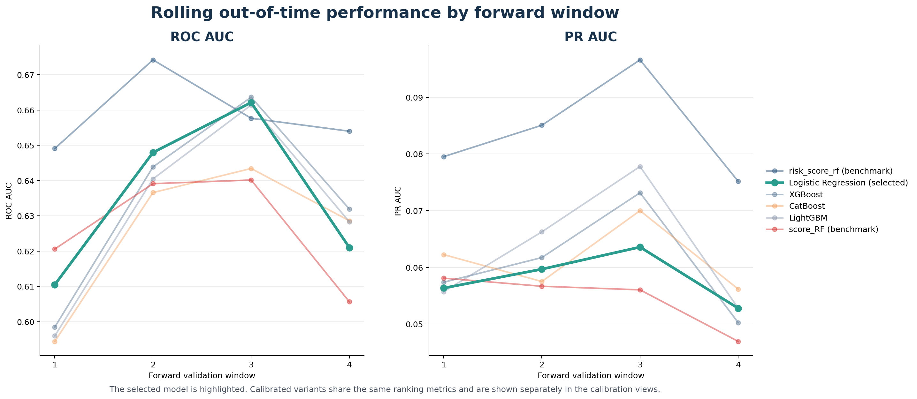

4.6 Concept Drift Detection
Concept drift is assessed by fitting a linear trend to PR AUC across rolling OOT folds. A declining trend exceeding 0.02 first-to-last triggers a drift flag, indicating that the score-to-outcome relationship may be degrading over time.
Model | First PR | Last PR | Slope/Fold | Drift
Logistic Regression | 0.0563 | 0.0528 | -0.0007 | NO
LightGBM | 0.0557 | 0.0528 | +0.0003 | NO
XGBoost | 0.0574 | 0.0502 | -0.0010 | NO
CatBoost | 0.0622 | 0.0562 | -0.0006 | NO

No models show concept drift in the current evaluation period. PR AUC fluctuations are within normal sampling variance across all four forward windows.

5. Operational Analysis

5.1 Decile Lift Table
The lift table for Logistic Regression shows how defaults concentrate in the highest-risk score deciles. This is the most operationally relevant view for setting rejection thresholds.
Decile | Accounts | Defaults | Default Rate | Lift | Cum. Lift | Capture
1 | 1,610 | 124 | 7.7% | 2.03x | 2.03x | 20.3%
2 | 1,610 | 109 | 6.8% | 1.78x | 1.91x | 38.1%
3 | 1,610 | 76 | 4.7% | 1.24x | 1.69x | 50.6%
4 | 1,610 | 78 | 4.8% | 1.28x | 1.58x | 63.3%
5 | 1,610 | 63 | 3.9% | 1.03x | 1.47x | 73.6%
6 | 1,610 | 57 | 3.5% | 0.93x | 1.38x | 83.0%
7 | 1,610 | 40 | 2.5% | 0.66x | 1.28x | 89.5%
8 | 1,610 | 23 | 1.4% | 0.38x | 1.17x | 93.3%
9 | 1,610 | 26 | 1.6% | 0.43x | 1.08x | 97.5%
10 | 1,619 | 15 | 0.9% | 0.24x | 1.00x | 100.0%

The riskiest decile has a 7.7% default rate versus 0.9% in the safest decile -- an 8:1 concentration ratio. The top two deciles capture 38.1% of all defaults.
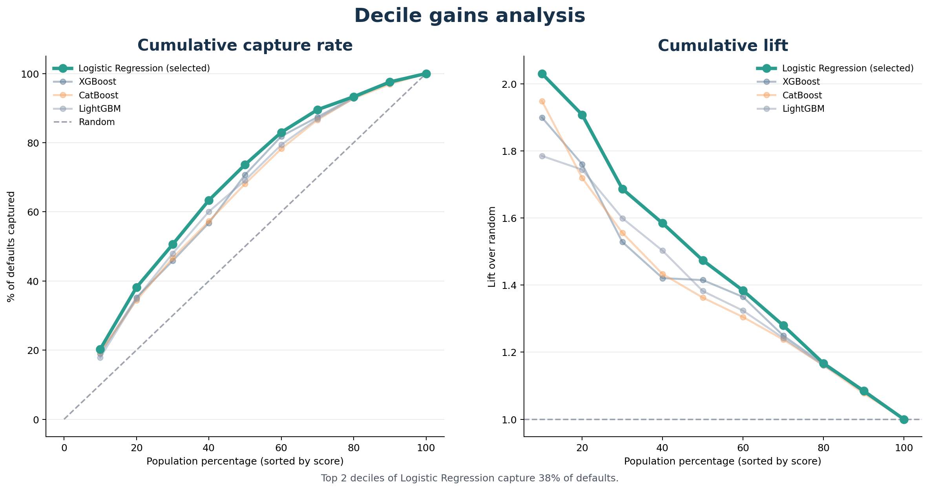

5.2 Rejection Threshold Analysis
The table below shows how many defaults are captured at various rejection thresholds. For example, rejecting the top 10% riskiest applicants captures a certain percentage of defaults while maintaining a 90% approval rate.
Reject % | Rejected | Precision | Recall | Capture Rate
5% | 807 | 8.2% | 10.8% | 10.8%
10% | 1,612 | 7.7% | 20.3% | 20.3%
15% | 2,418 | 7.6% | 30.0% | 30.0%
20% | 3,223 | 7.2% | 38.1% | 38.1%
25% | 4,029 | 6.9% | 45.2% | 45.2%
30% | 4,834 | 6.4% | 50.6% | 50.6%

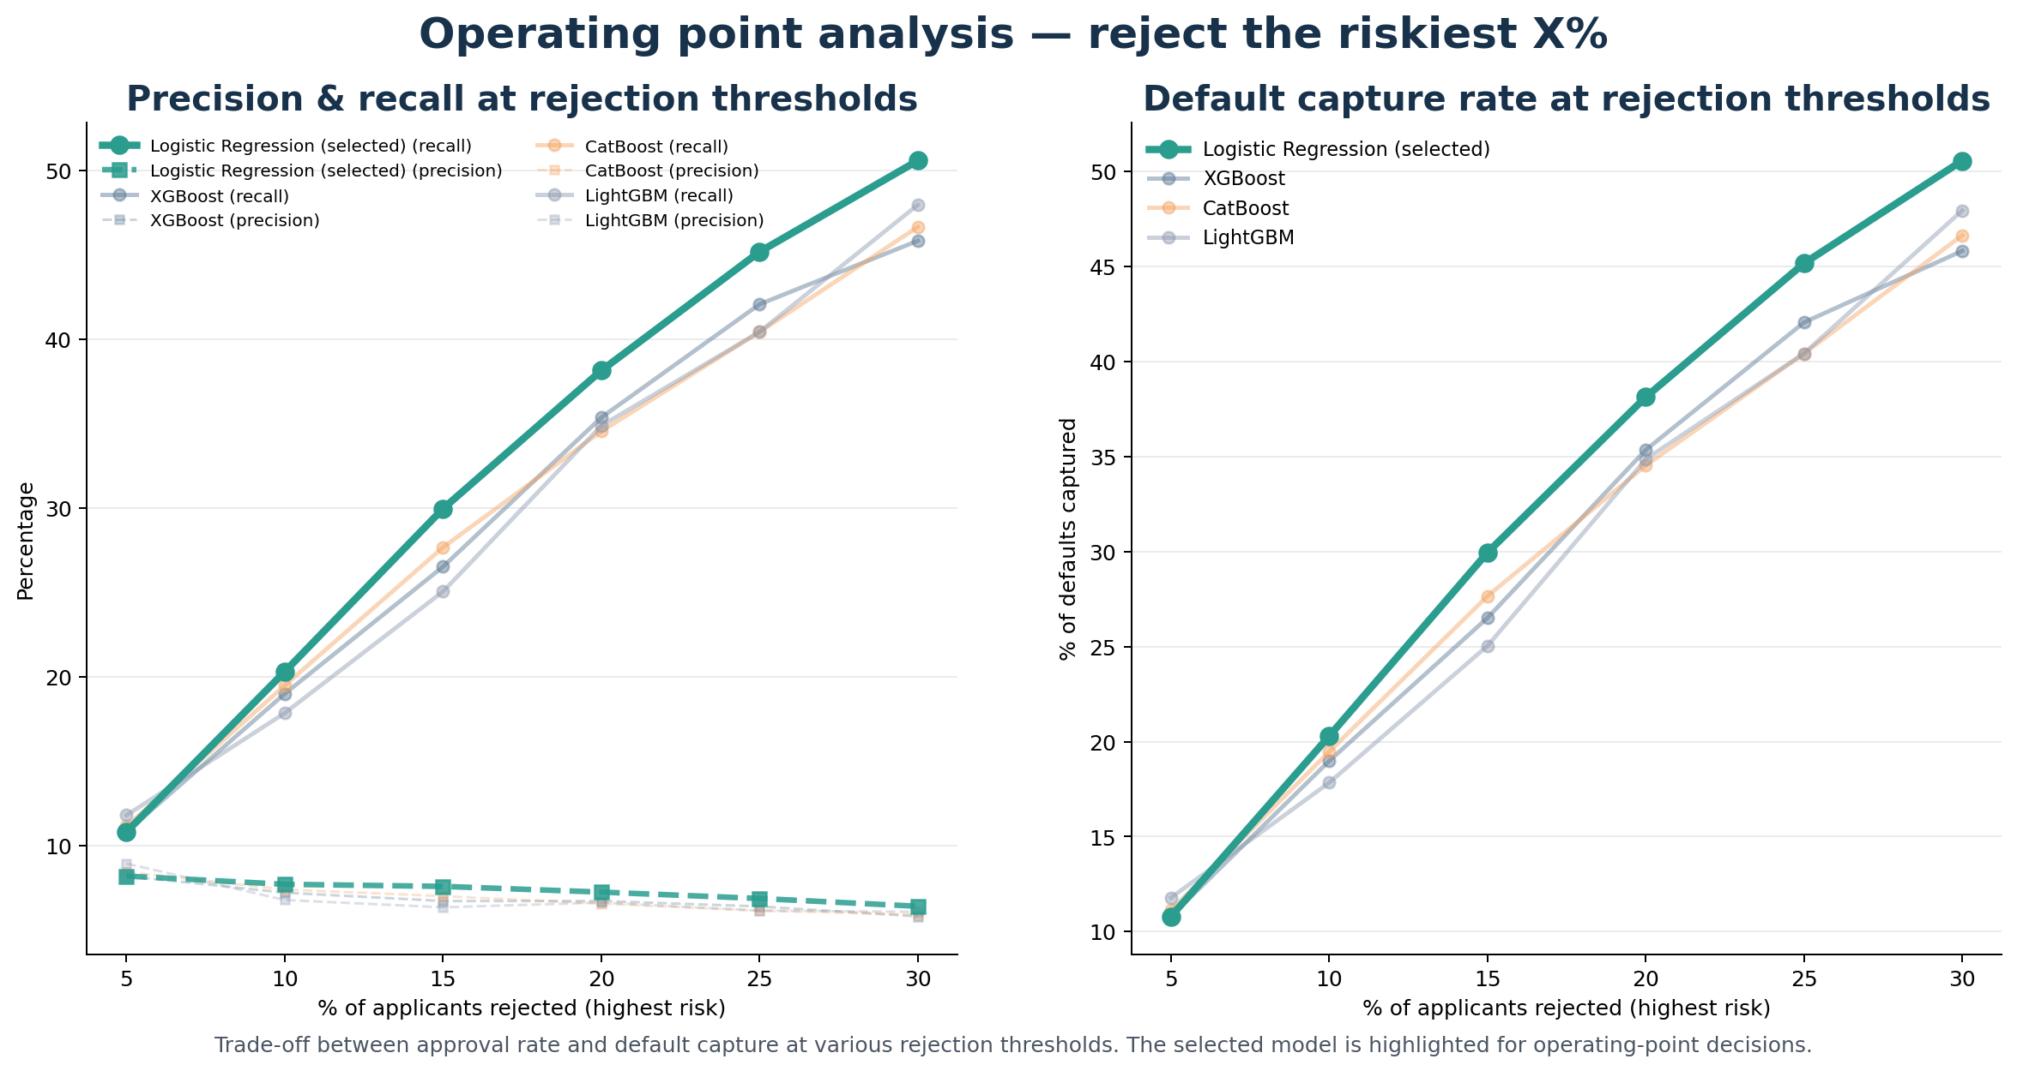

6. Calibration and Score Stability

6.1 Score Distribution Stability (PSI)
The Population Stability Index measures whether the model's score distribution has shifted between the training and test populations. PSI < 0.10 indicates stable distributions; 0.10-0.25 indicates moderate drift; > 0.25 indicates significant drift.
Model | PSI | Interpretation
Logistic Regression | 0.0036 | Stable
LightGBM | 0.0126 | Stable
XGBoost | 0.0069 | Stable
CatBoost | 0.0102 | Stable

All PSI values are far below 0.10, confirming that the score distributions are highly stable between development and test. This is expected given the short time span and stable lending environment across the evaluation period.
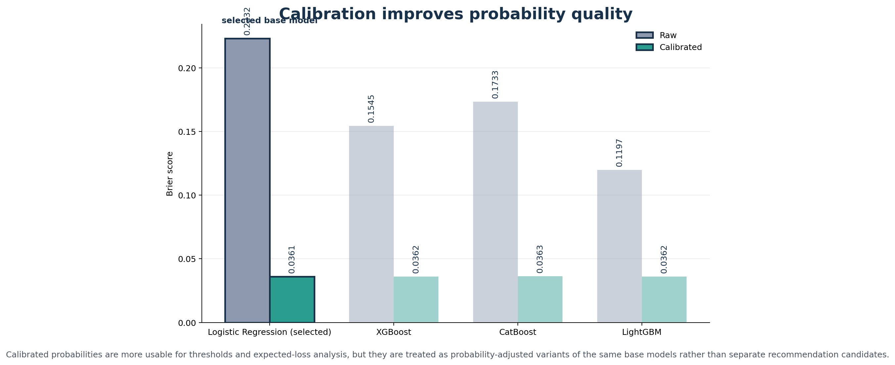

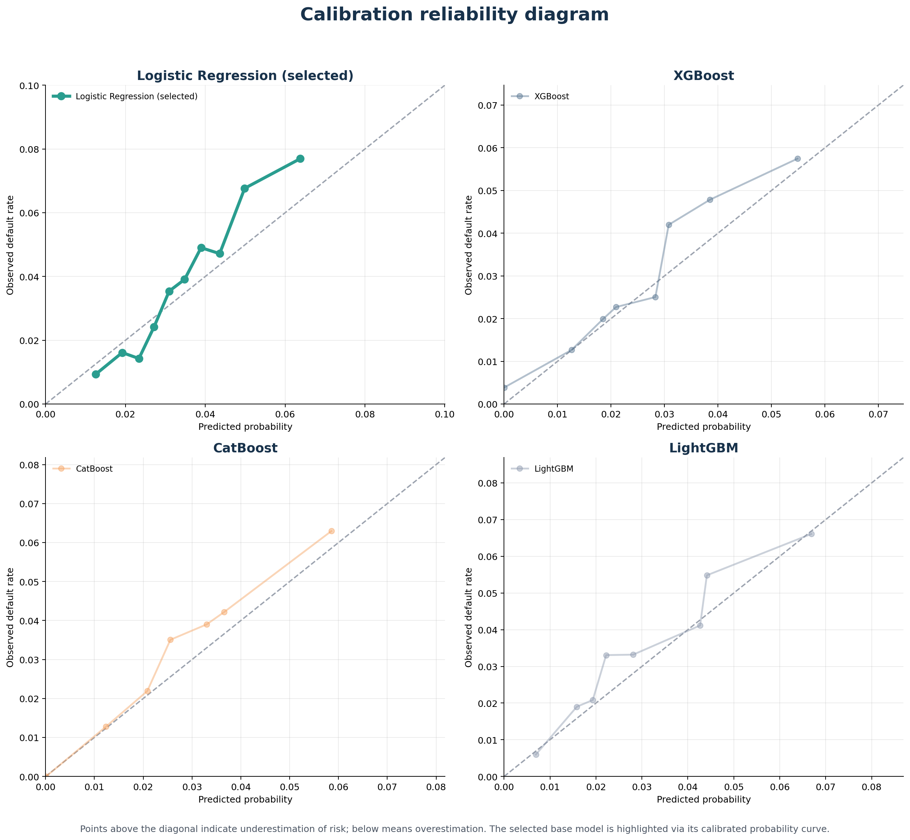

7. Population Bias and Fairness

7.1 Selection Bias
Selection bias arises because the model is trained only on booked (accepted) accounts but will be applied to all applicants. Two diagnostics measure the extent of this bias:
- Score distribution divergence (KS test): measures how differently the model scores booked vs non-booked applicants. A large KS statistic is expected (the existing decision already separated them), but an extremely high value might indicate the model is merely recapitulating the old decision boundary rather than learning new risk signal.
- Correlation with existing benchmark: the Pearson and Spearman correlation between model PD and the original risk_score_rf. HIGH correlation (> 0.90) would suggest the model adds little new information beyond the existing score.
Model | Pearson r | Spearman rho | Flag
Logistic Regression | +0.1273 | +0.0807 | LOW
LightGBM | +0.1329 | +0.1358 | LOW
XGBoost | +0.1639 | +0.1560 | LOW
CatBoost | +0.0850 | +0.0924 | LOW

All models show LOW correlation with the existing risk_score_rf (Pearson 0.09-0.16), confirming that the new models capture genuinely different risk dimensions rather than simply replicating the existing decisioning mechanism.

7.2 Adverse Impact by Age
Adverse impact analysis evaluates whether the model disproportionately rejects applicants in specific age bands. At a 10% rejection threshold, the adverse impact ratio (AIR) compares each band's approval rate to the best band. AIR below 0.80 triggers the conventional four-fifths rule threshold for disparate impact.
Age Band | N | Obs. Default | Mean PD | Approval | AIR | Flag
18-25 | 338 | 7.4% | 59.2% | 74.0% | 0.78 | FAIL
25-35 | 2,890 | 4.9% | 52.7% | 82.2% | 0.86 | PASS
35-45 | 4,545 | 3.9% | 45.5% | 89.9% | 0.94 | PASS
45-55 | 4,907 | 3.4% | 41.8% | 92.8% | 0.97 | PASS
55-65 | 2,348 | 2.9% | 39.9% | 93.6% | 0.98 | PASS
65-100 | 1,081 | 2.9% | 36.6% | 95.4% | 1.00 | PASS

The 18-25 age band is flagged (AIR = 0.78), reflecting a genuinely higher observed default rate (7.4% vs 2.9% for ages 65+). The model correctly identifies this elevated risk, but the resulting differential treatment requires regulatory review to determine whether age-based risk differentiation is permissible in the applicable jurisdiction. If mitigation is required, options include capping the age contribution in the model or applying post-hoc threshold adjustments for younger applicants.

8. Feature Assessment

8.1 Information Value
Information Value (IV) measures univariate predictive power on the development-fit sample. IV < 0.02 is considered useless; 0.02-0.10 weak; 0.10-0.30 medium; 0.30-0.50 strong; > 0.50 suspicious (potential leakage).
Feature | IV | Strength
AGE_T1_DIV_MAX_CREDIT_TJ_AV | 0.2238 | Medium
FREQ_BIN_MAX_CREDIT_TJ_AV_x_FAMILY_SITUATION | 0.2052 | Medium
BIN_MAX_CREDIT_TJ_AV_x_ESTCLI2 | 0.2046 | Medium
BIN_MAX_CREDIT_TJ_AV_x_ESTCLI1 | 0.2034 | Medium
FREQ_HOUSE_TYPE_x_FAMILY_SITUATION | 0.1898 | Medium
INCOME_T1_DIV_MAX_CREDIT_TJ_AV | 0.1783 | Medium
FREQ_BIN_MAX_CREDIT_TJ_AV_x_HOUSE_TYPE | 0.1742 | Medium
LEFT_TO_LIVE_DIV_MAX_CREDIT_TJ_AV | 0.1619 | Medium
FREQ_BIN_TOTAL_AMT_x_HOUSE_TYPE | 0.1585 | Medium
FREQ_BIN_INSTALLMENT_AMT_x_HOUSE_TYPE | 0.1583 | Medium

No feature exceeds IV 0.30, which rules out data leakage. The top features are bureau-capacity ratios (AGE/MAX_CREDIT, INCOME/MAX_CREDIT), binned numerical x categorical interactions, and frequency-encoded categorical surrogates. This pattern indicates that risk differentiation comes primarily from the relationship between borrower capacity and credit utilization rather than from any single demographic or product attribute.
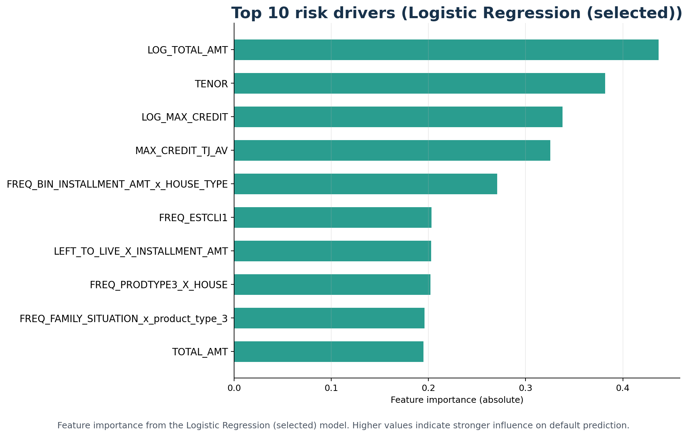

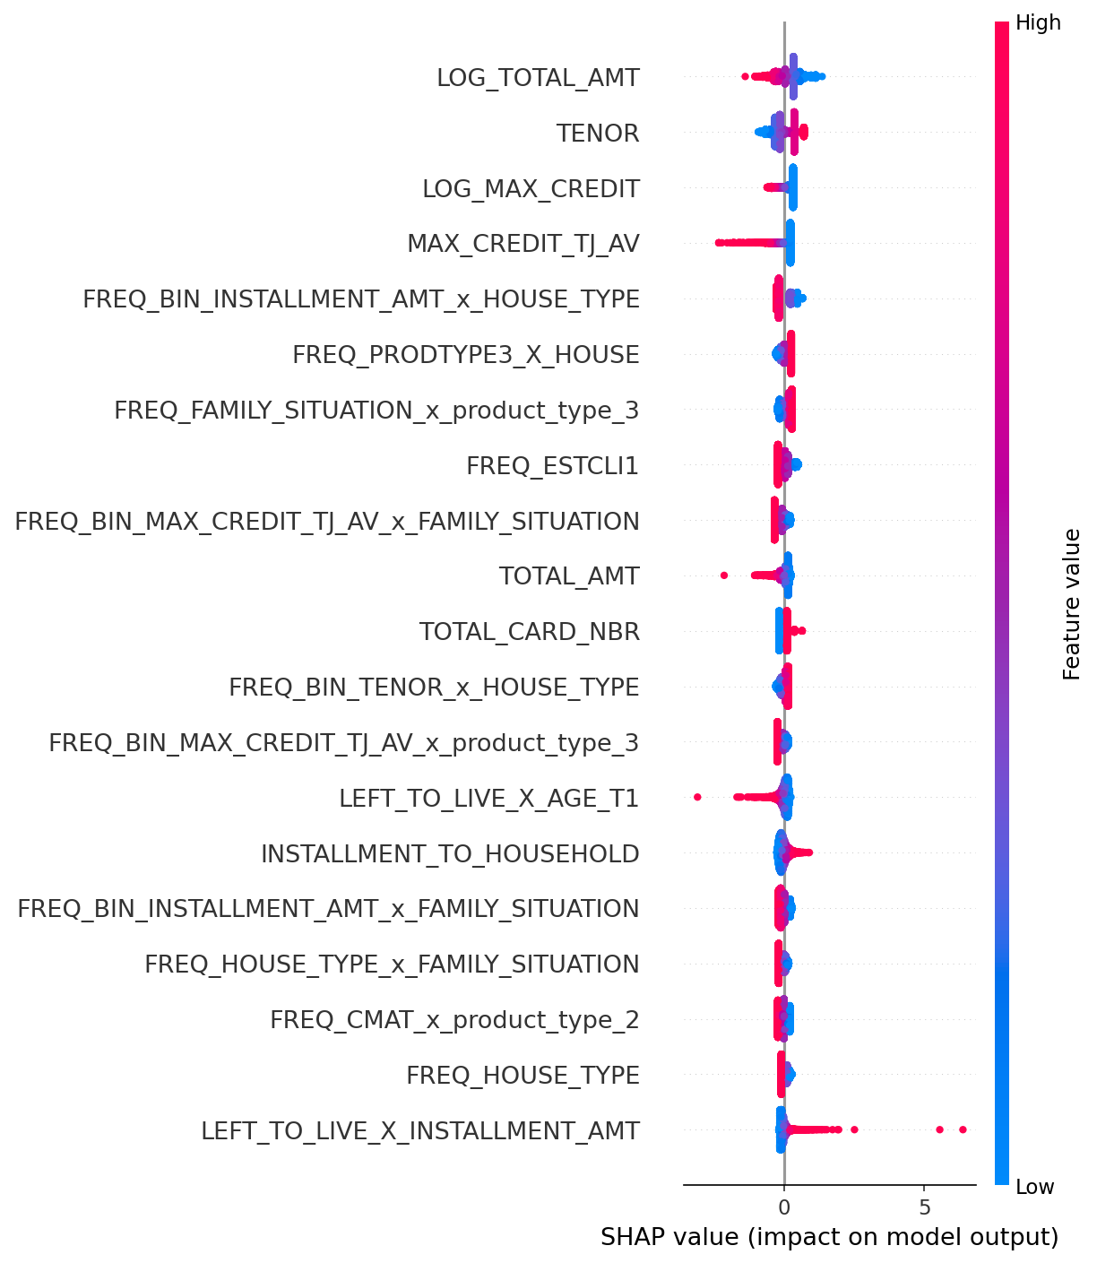

9. Post-Hoc Ensemble
A post-hoc ensemble blends Logistic Regression (55%) and LightGBM (45%), with weights optimized via grid search on calibration holdout PR AUC. On the held-out test, the ensemble achieves ROC AUC 0.6661 and PR AUC 0.0656, marginally improving on the standalone Logistic Regression (ROC AUC 0.6658, PR AUC 0.0642).
The ensemble provides a slight discrimination improvement by combining LR's stable generalization with LightGBM's different error profile. However, the added operational complexity of maintaining two models should be weighed against the marginal performance gain.

10. Limitations and Caveats
Booked-proxy evaluation. All metrics are computed on the accepted population only. Rejected and canceled applicants have no observed default outcome, so the model's performance on the full applicant population is unknown. The booked-proxy metrics are an optimistic estimate of true applicant-stage performance because the existing decisioning has already filtered out the highest-risk applicants.
Tree model overfitting. Despite tightened complexity bounds (shallow depth, high minimum leaf sizes, coarse bins), all tree models exhibit severe overfitting. This limits their contribution to the production recommendation. Further regularization or larger training samples may help.
Age-based adverse impact. The 18-25 age band fails the 80% AIR threshold. While this reflects genuinely higher default risk in this segment, it may require mitigation depending on regulatory requirements.
Benchmark ceiling. risk_score_rf retains a meaningful PR AUC advantage, particularly in concentrating defaults in the highest-risk segment. Closing this gap is the primary modeling opportunity.
Single temporal test window. The held-out evaluation covers July 2024 to January 2025. While rolling OOT provides additional evidence, a longer forward evaluation period would strengthen confidence in production stability.
Calibration sensitivity. Calibrated probabilities depend on the holdout sample size and default rate. Changes in the portfolio mix or economic environment may require recalibration.

Appendix: Stakeholder Charts

Executive Summary
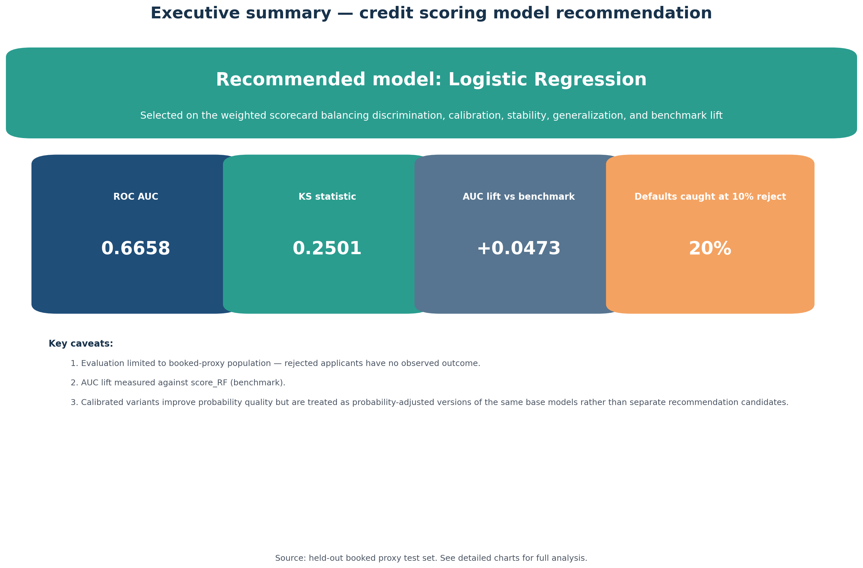

Key Performance Indicators
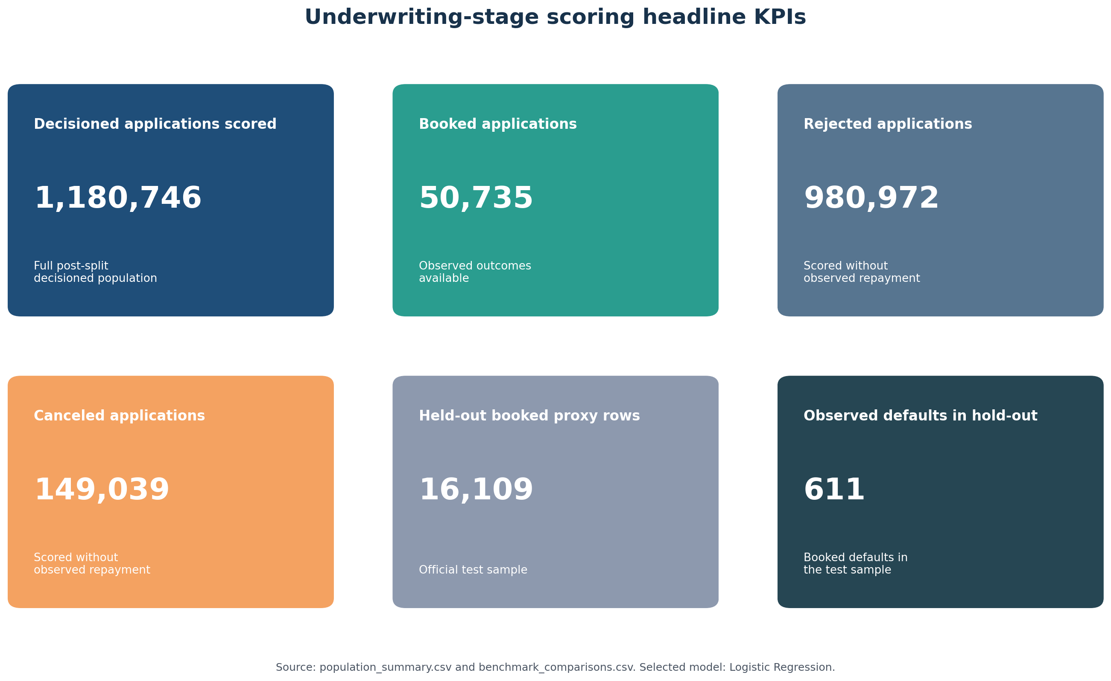

Population Coverage
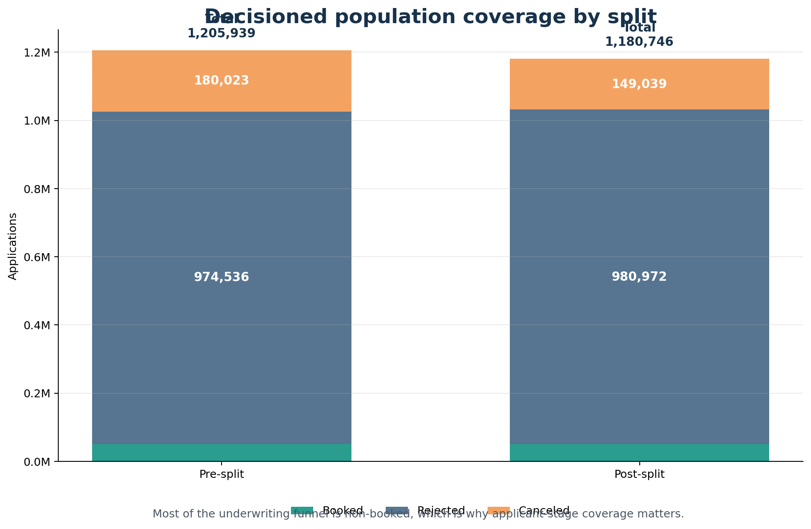

ROC and Precision-Recall Curves
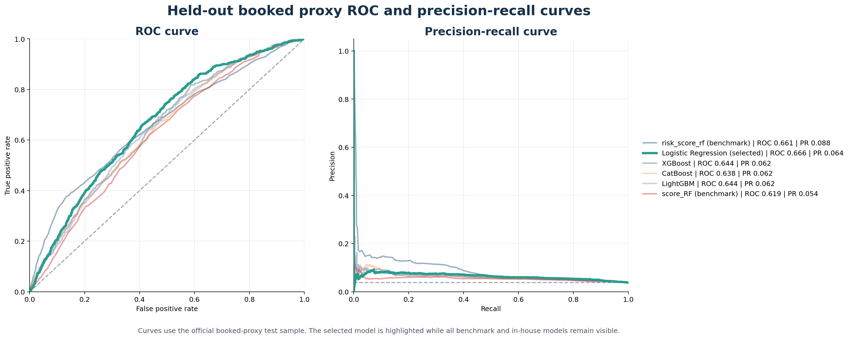

AUC Lift vs Benchmarks
