Selection Bias Analysis: Score Discriminance Under Range Restriction

Executive Summary
This analysis investigates whether the low observed Gini of score_rf and risk_score_rf can be attributed to selection bias (range restriction from the acceptance policy). Six complementary analyses were run at the reporting-supersegment level ("known", "others") and total.
Key findings:
- Risk Score RF shows genuine selection bias attenuation of 14-19%. The Thorndike-corrected Gini is 0.41-0.53 vs observed 0.35-0.45.
- Score RF in "known" (Gini = 0.23) is not primarily explained by selection bias. The variance ratio is 0.92 (mild restriction) and the Thorndike correction recovers only 7.6%. The low Gini reflects genuinely weak discriminance on this population.
- Score RF in "others" shows no attenuation (u > 1) — the booked population is actually more dispersed than demand, because selection in this group is driven by non-score factors (only 2.4% acceptance rate, nearly all rejection is policy-based, not score-based).
- The Combined logistic score (score_rf + risk_score_rf) consistently outperforms both individual scores (Gini 0.37-0.64) and is more robust to selection effects.

Methodology

Analysis 1: Distribution Truncation
When the acceptance policy selects applicants based on their score, the booked population has a narrower score distribution than the full demand. The variance ratio quantifies this:
u = SD(score | booked) / SD(score | demand)
A value u < 1 indicates truncation (range restriction). A two-sample Kolmogorov-Smirnov test confirms distributional shift.

Analysis 2: Thorndike Case 2 Correction
Given a known variance ratio u, Thorndike's (1949) formula estimates the Gini that would be observed on the unrestricted population:
- Convert observed Gini to AUC, then to point-biserial correlation r via the normal-ogive model:
d' = sqrt(2) * Phi^{-1}(AUC), then r = d' / sqrt(1 + d'^2).
- Apply Thorndike Case 2:
r_corrected = r_observed / (u * sqrt(1 + r^2 * (1/u^2 - 1)))
- Convert back to AUC and Gini.
Assumption: bivariate normality and direct selection on the predictor. Credit scores violate normality, so the correction is approximate (likely an upper bound).

Analysis 3: Simulated Range Restriction
Starting from the full booked population, progressively remove the riskiest percentiles (bottom 5%, 10%, ..., 50% by score) and recompute Gini at each step. This demonstrates empirically how Gini degrades with truncation — without requiring any distributional assumptions.

Analysis 4: Temporal Acceptance Rate vs Gini
Pair the rolling 3-month Gini (already computed in run_score_metrics.py) with a rolling 3-month acceptance rate on the same windows. If acceptance rate varies over time and Gini co-moves, this provides a natural experiment controlling for population composition.

Analysis 5: Rejection Profile by Score Decile
Compute booked vs rejected counts by score decile across the full demand population. Confirms whether rejection concentrates in the risky tail (as expected under score-based selection).

Analysis 6: Cross-Group Acceptance Rate vs Gini
Scatter supersegments + total on (acceptance_rate, Gini). A positive slope would suggest selection bias: groups with higher acceptance rates (less truncation) show higher Gini. This analysis is supplementary only — with 3 data points and confounded population differences, statistical power is very low.

Results

1. Distribution Truncation
Group | Score | Acceptance Rate | u ratio | SD demand | SD booked | KS stat | KS p-value
------- | ------- | :-: | :-: | :-: | :-: | :-: | :-:
known | Score RF | 15.4% | 0.921 | 28.64 | 26.39 | 0.200 | 0.0
known | Risk Score RF | 15.4% | 0.845 | 26.71 | 22.57 | 0.199 | 0.0
others | Score RF | 2.4% | 1.262 | 22.52 | 28.41 | 0.514 | 0.0
others | Risk Score RF | 2.4% | 0.834 | 28.94 | 24.13 | 0.374 | 0.0
total | Score RF | 7.1% | 0.988 | 27.16 | 26.84 | 0.416 | 0.0
total | Risk Score RF | 7.1% | 0.792 | 28.98 | 22.94 | 0.328 | 0.0

Interpretation:
- Risk Score RF is consistently truncated across all groups (u = 0.79-0.85). The KS test is highly significant everywhere. Selection acts on this score.
- Score RF in "known": mild truncation (u = 0.92). Selection exists but is moderate.
- Score RF in "others": u = 1.26 > 1.0. The booked population has higher variance than demand. This anomaly means selection in the "others" group is not primarily score-based — at 2.4% acceptance, nearly all applicants are rejected by policy rules regardless of score.
- Score RF in total: u = 0.99, essentially no truncation at the aggregate level.

"Known" — the booked KDE (green) is slightly narrower than demand, especially for Risk Score RF:
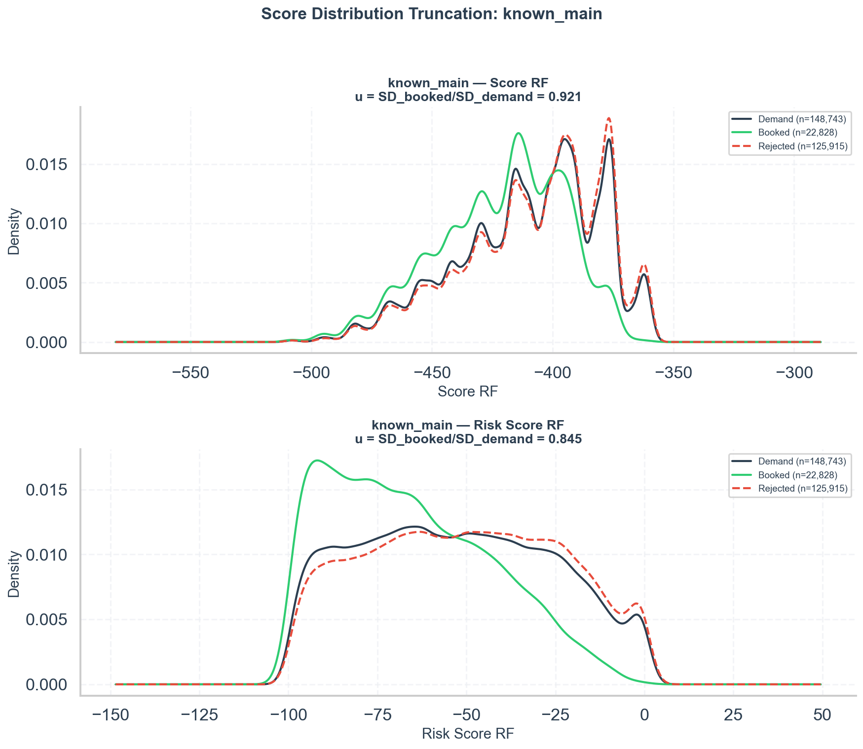

"Others" — Score RF booked (green) is actually wider than demand; Risk Score RF shows clear truncation:
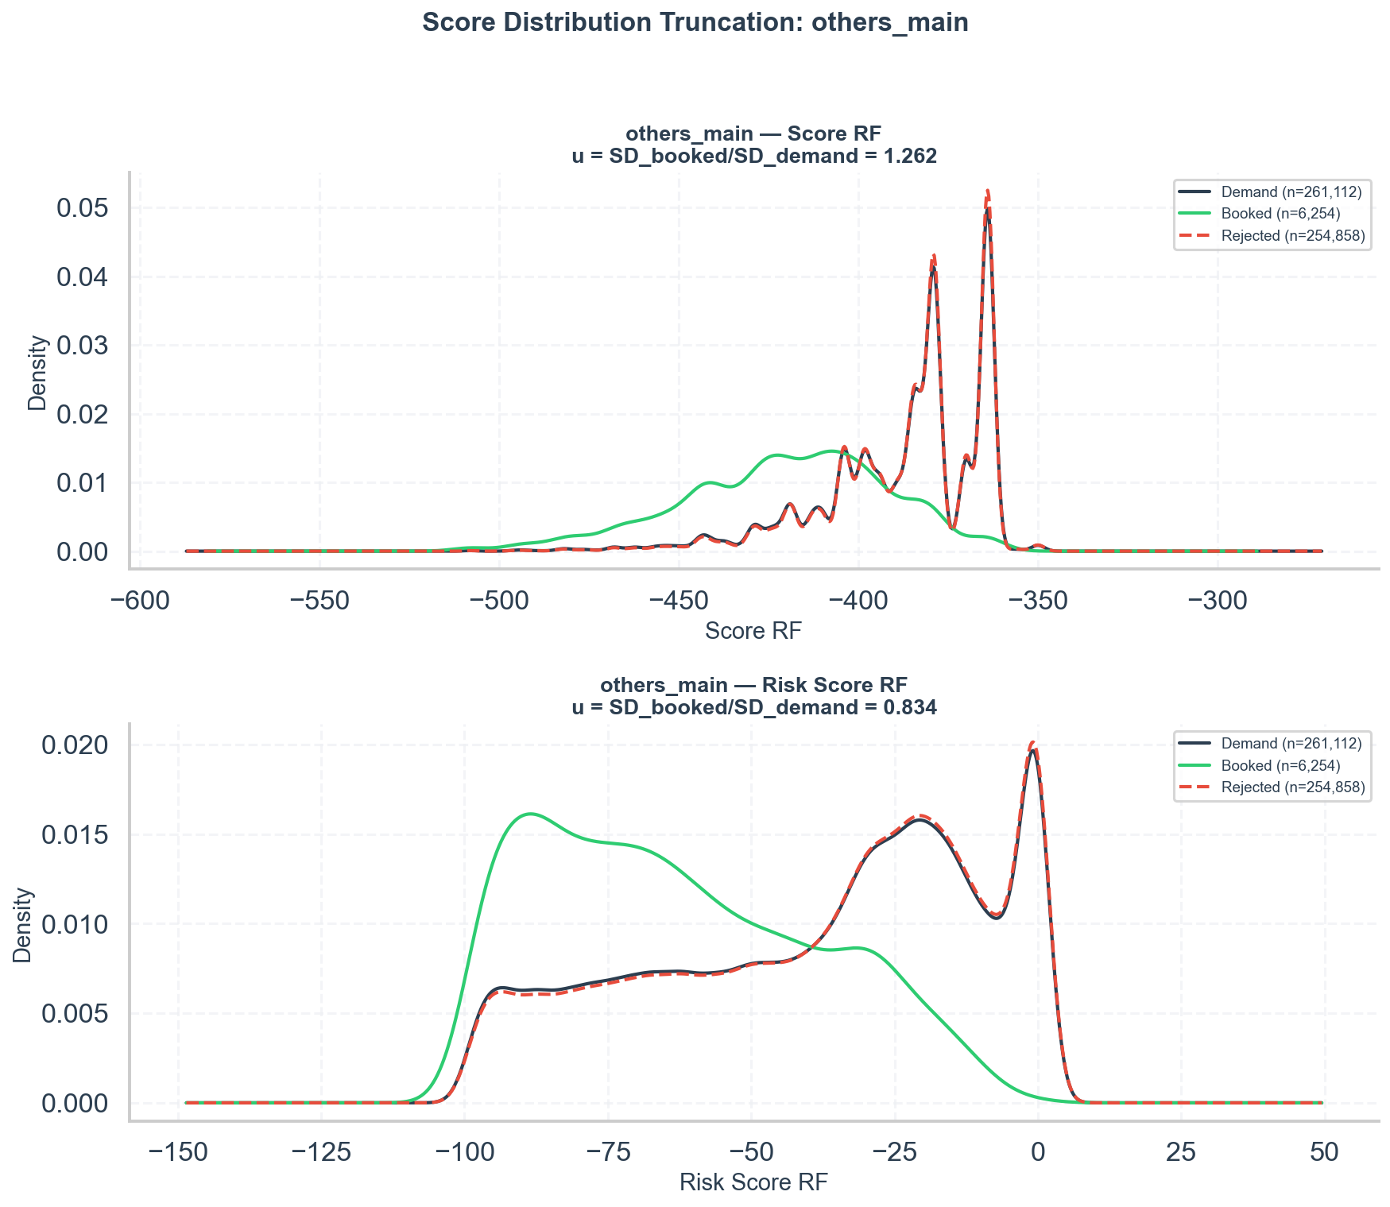

Total:
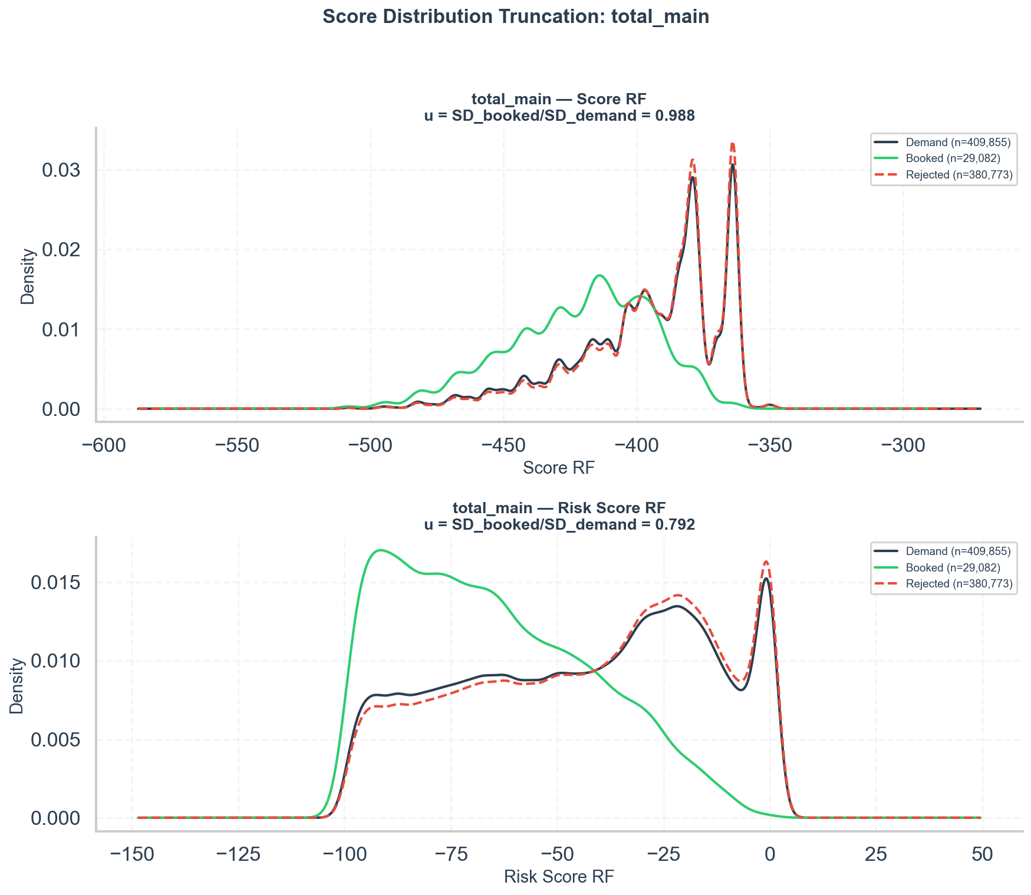

2. Thorndike Case 2 Correction
Group | Score | Observed Gini | u ratio | Corrected Gini | Attenuation
------- | ------- | :-: | :-: | :-: | :-:
known | Score RF | 0.227 | 0.921 | 0.246 | 7.6%
known | Risk Score RF | 0.349 | 0.845 | 0.407 | 14.4%
others | Score RF | 0.432 | 1.262 | 0.432 | 0.0%
others | Risk Score RF | 0.450 | 0.834 | 0.526 | 14.5%
total | Score RF | 0.287 | 0.988 | 0.290 | 1.1%
total | Risk Score RF | 0.380 | 0.792 | 0.469 | 19.0%

Interpretation:
- Risk Score RF attenuation is substantial: 14-19% across groups. The "true" (unrestricted) Gini is estimated at 0.41-0.53, roughly 5-9 Gini points higher than observed. This is meaningful and consistent with the truncation evidence.
- Score RF correction is minimal except in "known" (7.6%). The low Gini of 0.23 in "known" would only improve to 0.25 — still well below Risk Score RF. Selection bias explains at most 2 Gini points of the gap; the remaining 10+ points reflect genuine weakness.
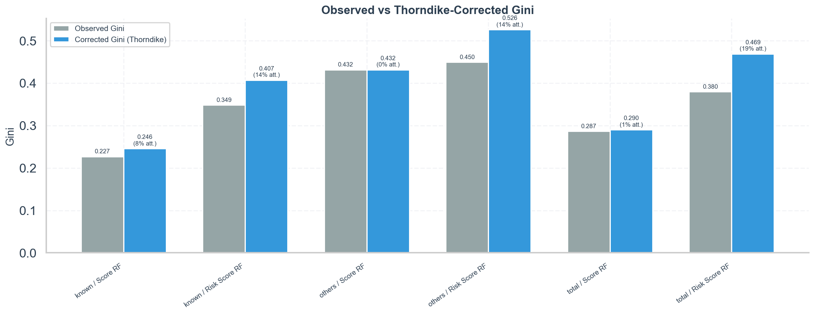

3. Simulated Range Restriction
Group | Score | Gini at 100% | Gini at 50% | Drop
------- | ------- | :-: | :-: | :-:
known | Score RF | 0.227 | 0.144 | 36.5%
known | Risk Score RF | 0.349 | 0.305 | 12.5%
others | Score RF | 0.432 | 0.220 | 49.0%
others | Risk Score RF | 0.450 | 0.458 | -1.9%
total | Score RF | 0.287 | 0.172 | 40.1%
total | Risk Score RF | 0.380 | 0.354 | 6.9%

Interpretation:
This reveals a fundamental difference between the two scores:
- Score RF is highly sensitive to truncation (36-49% Gini loss when 50% of the riskiest booked are removed). Its discriminance relies heavily on the tails — without the risky end, it cannot separate good from bad.
- Risk Score RF is robust to truncation (only 7-13% loss, and actually gains Gini in "others"). It maintains discriminance even within the narrower safe population. This is a more useful property for a production score.
The implication: Score RF would benefit most from being evaluated on the full demand, but even with full range, its underlying discrimination mechanism is weaker than Risk Score RF's.
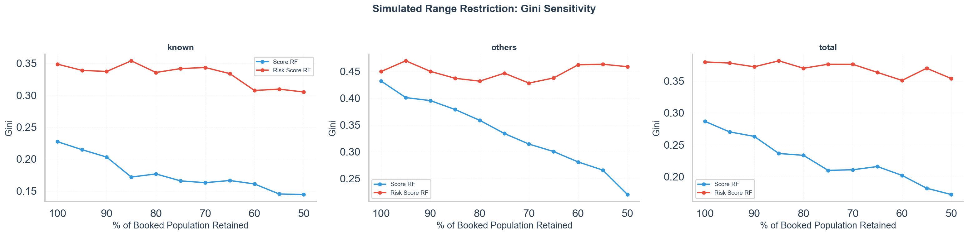

4. Temporal Acceptance Rate vs Gini
Group | Acceptance Rate Range | Score RF Gini Range | Risk Score RF Gini Range
------- | :-: | :-: | :-:
known | 14.9% - 15.9% | 0.12 - 0.30 | 0.32 - 0.40
others | 1.7% - 3.3% | 0.24 - 0.47 | 0.25 - 0.58
total | 6.2% - 8.2% | 0.21 - 0.33 | 0.31 - 0.46

Interpretation:
- "Known": acceptance rate barely varies (15.0-15.9%), yet Score RF Gini fluctuates widely (0.12-0.30). This variation cannot be explained by selection bias changes — it reflects either sampling noise or genuine score instability.
- "Others": acceptance rate nearly doubles (1.7% → 3.3%), but sample sizes are very small (16-70 bads per 3-month window), making Gini estimates extremely noisy. No reliable trend can be extracted.
- "Total": acceptance rate increases from 6.2% to 8.2%. Risk Score RF Gini also increases (0.34 → 0.46), but this is the opposite of what selection bias predicts (higher acceptance = less truncation → higher Gini should happen only if bias was depressing it). More likely, this reflects a changing population mix as "others" grows.
Conclusion: The temporal analysis is inconclusive for proving selection bias due to (a) insufficient variation in acceptance rates for "known" and (b) too-small samples for "others".
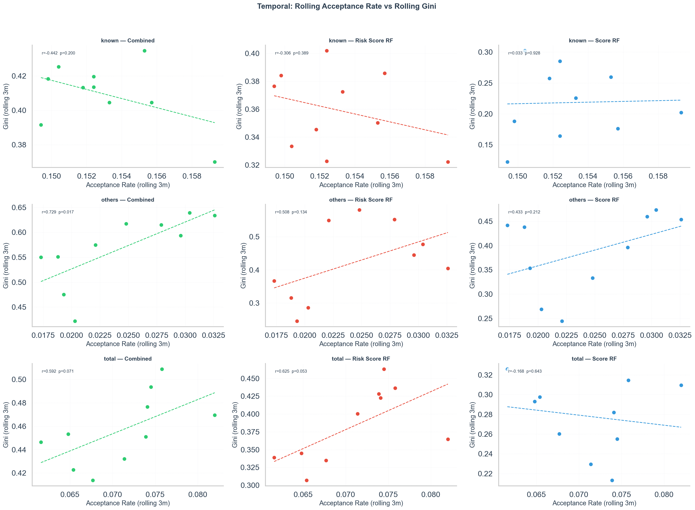

5. Rejection Profiles
"Known" group — Score RF:
Decile (1=safest) | Booked | Rejected | Rejection Rate
:-: | :-: | :-: | :-:
1 | 3,471 | 11,634 | 77.0%
5 | 3,037 | 12,496 | 80.5%
10 | 95 | 7,652 | 98.8%

Rejection increases from 77% to 99% across deciles — a clear gradient confirming score-based selection, but even the safest decile has 77% rejection, meaning most rejection is not score-driven.
"Others" group — Score RF:
Decile (1=safest) | Booked | Rejected | Rejection Rate
:-: | :-: | :-: | :-:
1 | 3,163 | 25,252 | 88.9%
5 | 130 | 12,962 | 99.0%
9 | 2 | 1,897 | 99.9%

Rejection is 89-100% across all deciles. Even the safest applicants have 89% rejection. This confirms that "others" rejection is overwhelmingly non-score-based — policy rules, not the score, drive the extreme rejection rates.

"Known" — clear gradient from 77% to 99% rejection, but high baseline rejection even in the safest decile:
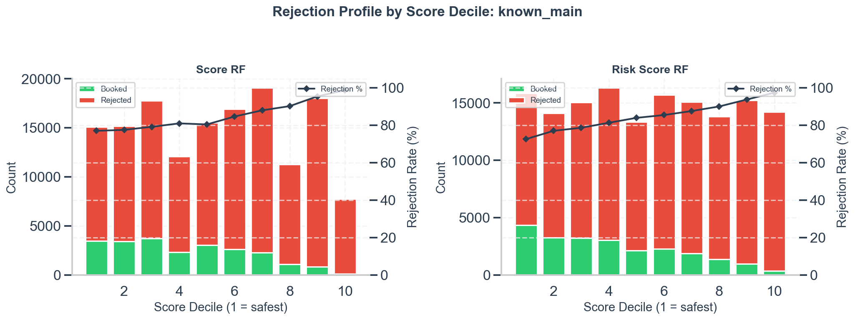

"Others" — near-total rejection across all deciles, confirming non-score-based selection:
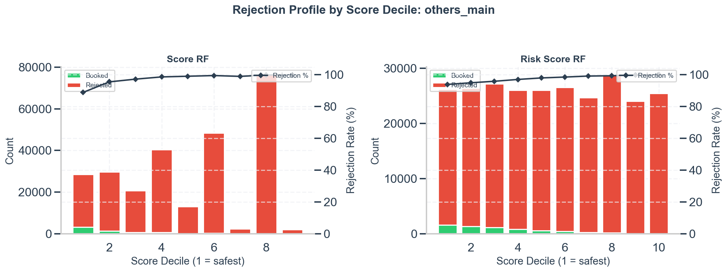

Total:
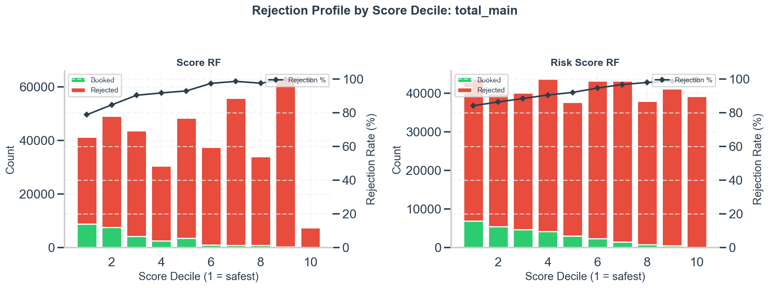

6. Cross-Group Scatter
Group | Accept Rate | Score RF Gini | Risk Score RF Gini
------- | :-: | :-: | :-:
known | 15.4% | 0.227 | 0.349
total | 7.1% | 0.287 | 0.380
others | 2.4% | 0.432 | 0.450

The pattern is inverted: lower acceptance rate → higher Gini. This is the opposite of the selection bias prediction. The reason is population confounding: the "others" group (new segments: fintonic, open banking, consolidation) has fundamentally different risk characteristics, not just different acceptance rates.
This analysis should not be used as evidence for or against selection bias given 3 data points and heavy confounding.
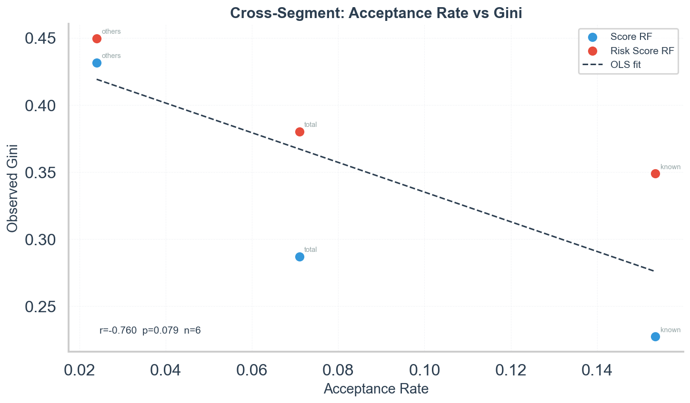

7. Booked-vs-Rejected Discriminance (Selection Gini)
This analysis uses status_name (booked=1, rejected=0) as the target on the full demand population. It measures how well each score predicts who gets accepted — without requiring early_bad. If a score has high selection Gini but low outcome Gini, that is the classic selection-bias signature.
Group | Score | Selection Gini | Outcome Gini | Gap
------- | ------- | :-: | :-: | :-:
known | Score RF | 0.290 | 0.227 | +0.063
known | Risk Score RF | 0.327 | 0.349 | -0.022
others | Score RF | 0.674 | 0.432 | +0.242
others | Risk Score RF | 0.488 | 0.450 | +0.038
total | Score RF | 0.563 | 0.287 | +0.276
total | Risk Score RF | 0.456 | 0.380 | +0.076

Interpretation:
- Score RF has much higher selection Gini than outcome Gini in "others" (+0.242) and "total" (+0.276). It is very good at predicting acceptance but much weaker at predicting default within the accepted population. This is a strong signal of selection bias — the score's apparent power is consumed by the selection mechanism.
- Risk Score RF shows the opposite in "known": outcome Gini (0.349) actually exceeds selection Gini (0.327). This means Risk Score RF discriminates default risk even beyond what the selection policy captures — genuine predictive power, not an artifact of selection.
- The extreme gap for Score RF in "others" (0.674 vs 0.432) confirms that Score RF drives acceptance decisions heavily in this group, leaving less residual discriminance for the outcome.
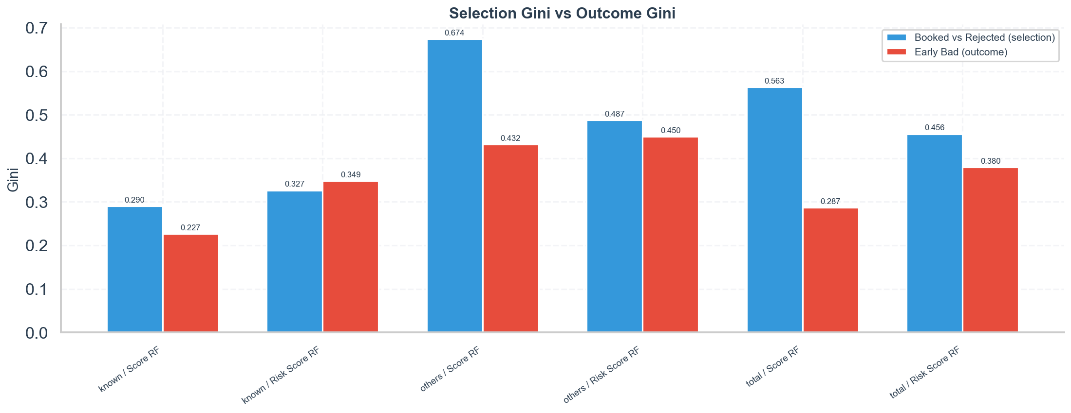

8. Score-Rejection-Only Truncation
This recomputes the variance ratio filtering demand to only booked + reject_reason == "09-score", excluding non-score rejections ("08-other"). This isolates the score-based selection channel.
Group | Score | u (all demand) | u (score-reject only) | Score-only Accept Rate
------- | ------- | :-: | :-: | :-:
known | Score RF | 0.921 | 0.981 | 41.9%
known | Risk Score RF | 0.845 | 0.882 | 41.9%
others | Score RF | 1.262 | 1.501 | 4.9%
others | Risk Score RF | 0.834 | 0.906 | 4.9%
total | Score RF | 0.988 | 1.157 | 15.9%
total | Risk Score RF | 0.792 | 0.862 | 15.9%

Interpretation:
- When isolating to score-based rejections only, the acceptance rate jumps dramatically: from 15.4% to 41.9% for "known", from 2.4% to 4.9% for "others", from 7.1% to 15.9% for total. This confirms that the vast majority of rejections are non-score-based.
- The u_ratio moves closer to 1.0 in all cases (less truncation). For "known" Score RF: 0.921 → 0.981 (nearly no truncation). For Risk Score RF: 0.845 → 0.882 (still some truncation, but less severe).
- Score RF in "others" becomes even more anomalous (u = 1.50), confirming that score-based selection is not truncating Score RF in this group.
This means the effective score-based selection is much milder than raw acceptance rates suggest. The Thorndike correction based on raw u_ratios may actually overestimate the selection bias effect.
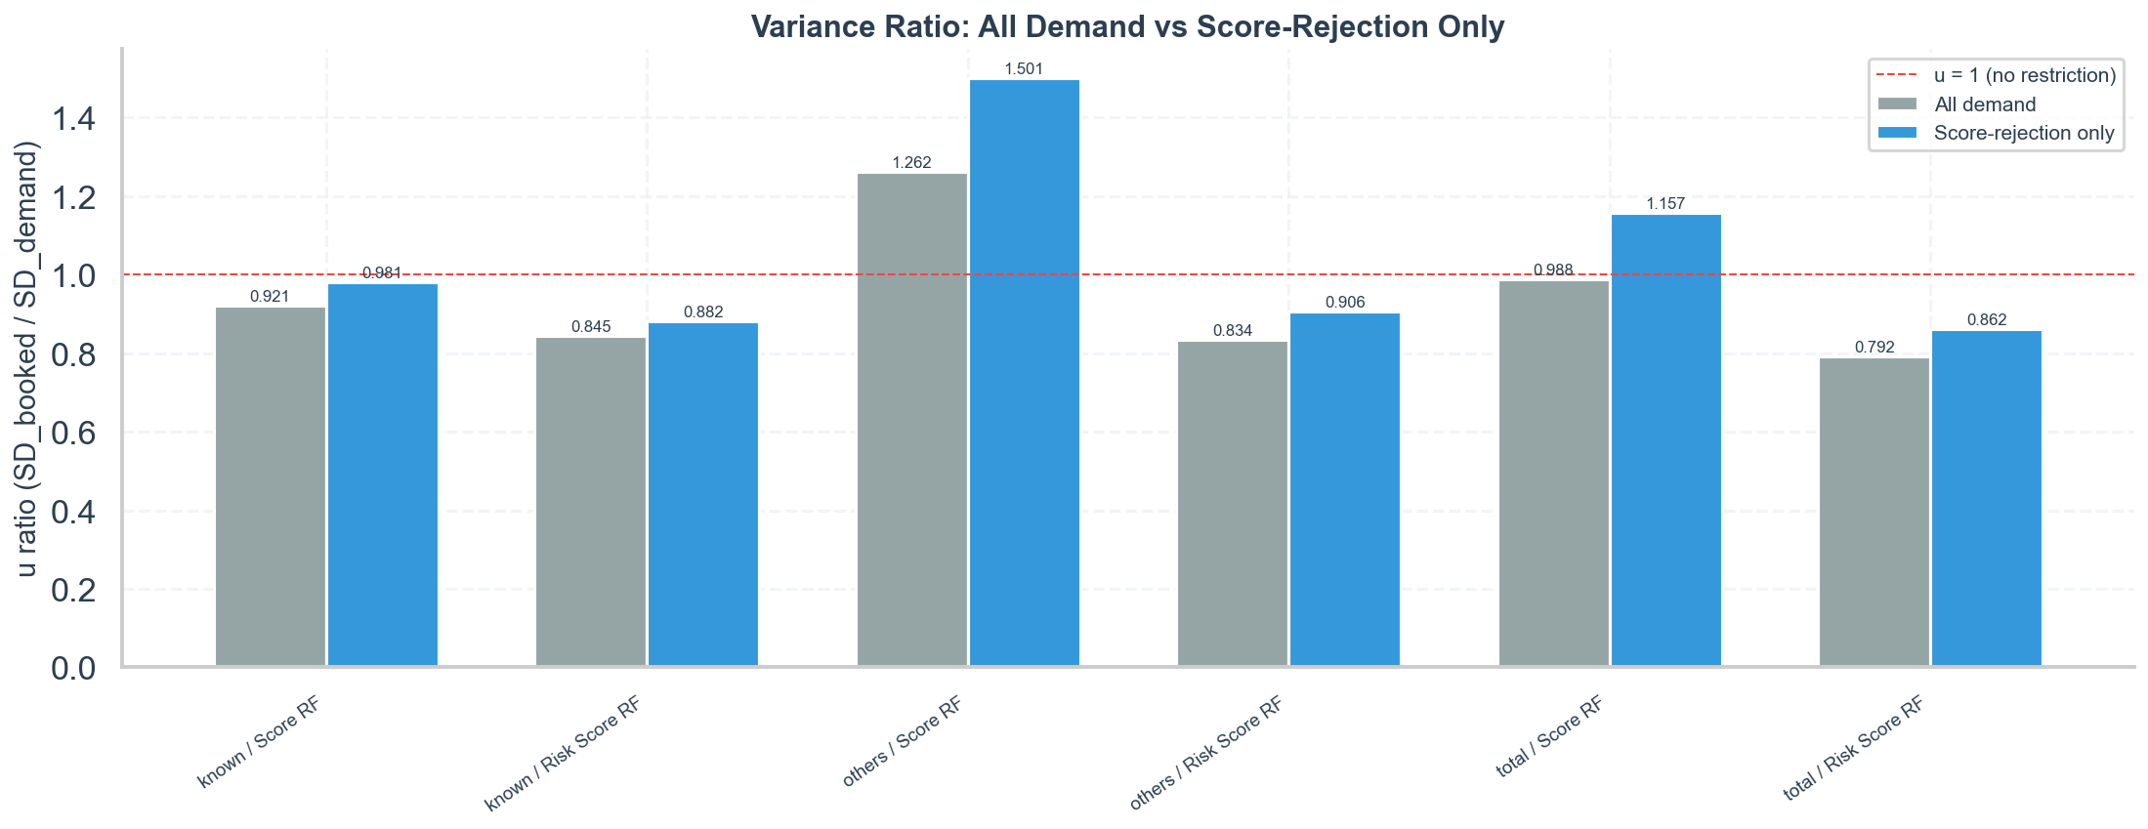

9. Bad Rate by Score Decile (Within Booked)
This shows the early_bad rate by score decile within the booked population. A flat curve means the score has no rank-ordering power even on the observed range. A steep gradient means it discriminates effectively.
"Known" — Score RF:
Decile (1=safest) | Bad Rate
:-: | :-:
1 | 0.75%
5 | 1.44%
10 | 3.08%

"Known" — Risk Score RF:
Decile (1=safest) | Bad Rate
:-: | :-:
1 | 0.74%
5 | 1.35%
10 | 6.00%

Interpretation:
- Score RF shows a ~4x gradient from decile 1 (0.75%) to decile 10 (3.08%). There IS some rank-ordering, but the gradient is modest — consistent with a Gini of 0.23.
- Risk Score RF shows a ~8x gradient from 0.74% to 6.00%. The last decile has a dramatically higher bad rate. This steep gradient explains its higher Gini (0.35) and confirms genuine discriminance.
- In "others", Risk Score RF reaches 8.45% in decile 10 vs 0.90% in decile 1 (~9.4x gradient), and Score RF reaches 7.56% vs 0.61% (~12.4x). Both scores have strong gradients in "others".
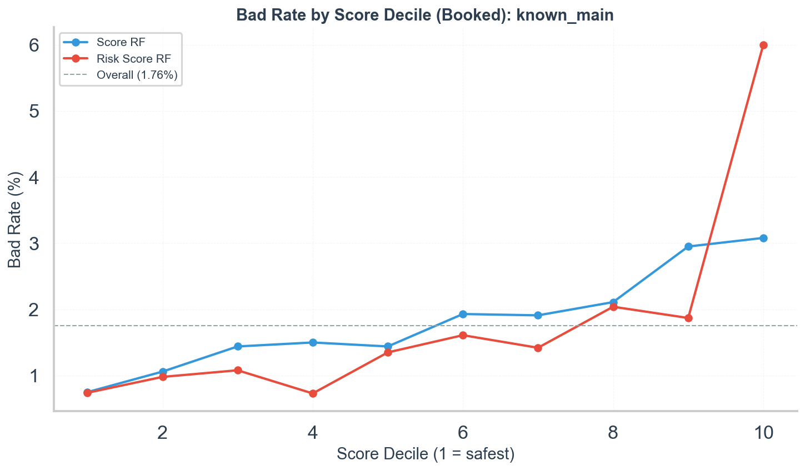
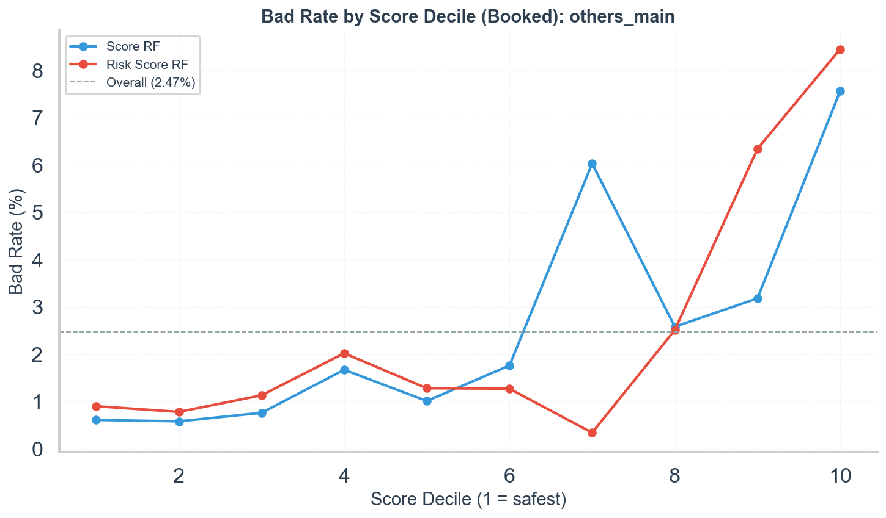
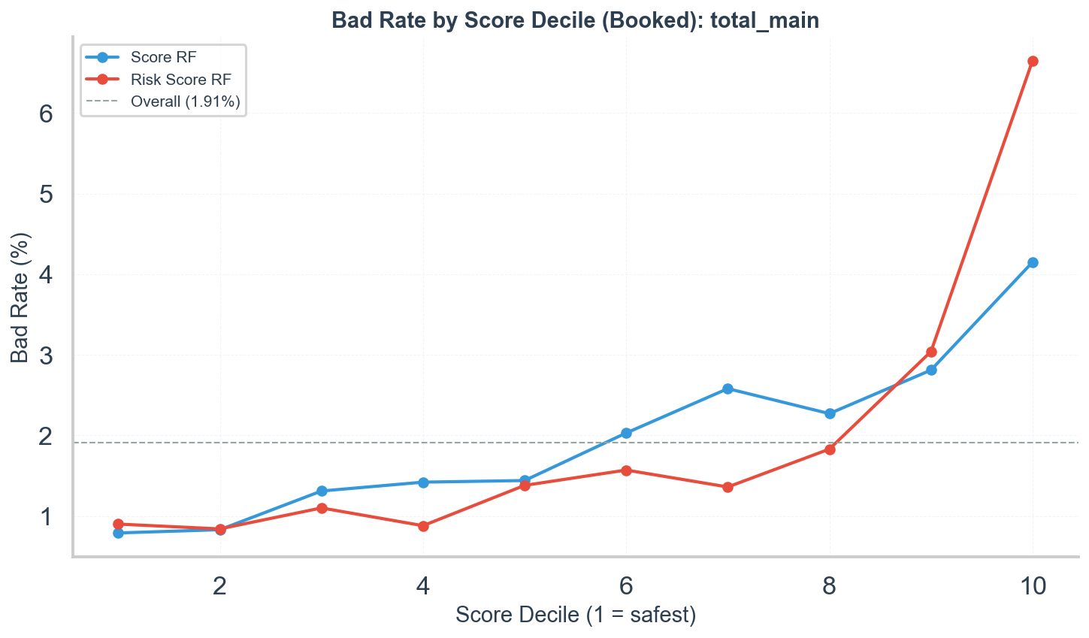

10. Score-to-Score Correlation
Pearson and Spearman correlation between score_rf and risk_score_rf on the full demand population:
Group | Pearson r | Spearman r | n
------- | :-: | :-: | :-:
known | 0.248 | 0.249 | 148,743
others | 0.270 | 0.256 | 261,112
total | 0.324 | 0.328 | 409,855

Interpretation:
- The two scores are only weakly correlated (r = 0.25-0.32). This means selection on one score does NOT automatically truncate the other. Each score's selection bias is largely independent.
- This explains why Score RF can have u > 1 in "others" while Risk Score RF has u < 1: they capture different dimensions and the acceptance policy weights them differently.
- The weak correlation also explains why the Combined logistic score outperforms both: it captures complementary information.

11. Reject Inference Gini (Full-Population Estimate)
Impute outcomes for rejected applicants using per-decile bad rates from booked, uplifted by 1.5x, then compute Gini on the combined population (50 bootstrap replicates for CI):
Group | Score | Observed Gini | Thorndike Gini | RI Gini (mean) | RI 95% CI
------- | ------- | :-: | :-: | :-: | :-:
known | Score RF | 0.227 | 0.246 | 0.281 | [0.269, 0.292]
known | Risk Score RF | 0.349 | 0.407 | 0.453 | [0.443, 0.463]
others | Score RF | 0.432 | 0.432 | 0.332 | [0.326, 0.340]
others | Risk Score RF | 0.450 | 0.526 | 0.718 | [0.714, 0.721]
total | Score RF | 0.287 | 0.290 | 0.412 | [0.404, 0.418]
total | Risk Score RF | 0.380 | 0.469 | 0.603 | [0.597, 0.607]

Interpretation:
- Risk Score RF RI Gini is substantially higher than observed: 0.453 vs 0.349 ("known"), 0.718 vs 0.450 ("others"), 0.603 vs 0.380 (total). This confirms that Risk Score RF's full-population discriminance is much stronger than observed on the booked population. The RI estimate is even higher than the Thorndike correction in most cases.
- Score RF RI Gini is mixed: higher than observed in "known" (0.281 vs 0.227) and total (0.412 vs 0.287), but lower in "others" (0.332 vs 0.432). The drop in "others" reflects that when rejected applicants are added back, the score has a weaker gradient on the full population.
- These are upper-bound estimates (circular: the score informs both selection and imputation). The CIs are tight, indicating stable estimation.
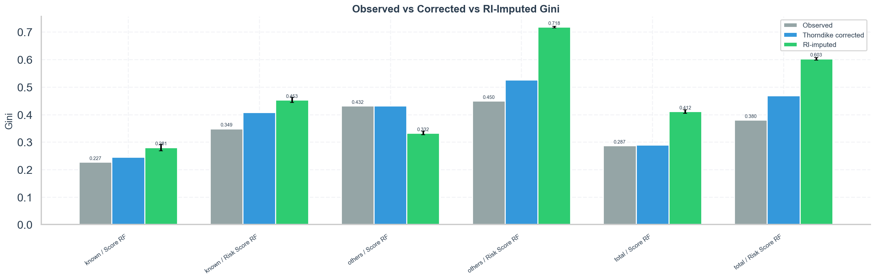

12. Score Distribution Stability (Monthly PSI)
PSI of each score's distribution across monthly vintages within the booked population (first 3 months as baseline). Thresholds: < 0.1 = stable, 0.1-0.25 = moderate shift, > 0.25 = significant shift.
"Known":
Score | PSI Range | Max PSI | Interpretation
------- | :-: | :-: | ---
Score RF | 0.005 - 0.027 | 0.027 | Stable (all < 0.1)
Risk Score RF | 0.004 - 0.069 | 0.069 | Stable, slight uptick in Jun-Jul 2025

"Others":
Score | PSI Range | Max PSI | Interpretation
------- | :-: | :-: | ---
Score RF | 0.030 - 0.182 | 0.182 | Moderate shift from Mar 2025
Risk Score RF | 0.002 - 0.105 | 0.105 | Moderate shift in Apr 2025

"Total":
Score | PSI Range | Max PSI | Interpretation
------- | :-: | :-: | ---
Score RF | 0.006 - 0.019 | 0.019 | Stable
Risk Score RF | 0.003 - 0.039 | 0.039 | Stable

Interpretation:
- In "known" and total, both scores are stable (all PSI < 0.1). Gini fluctuations are not explained by score distribution drift.
- In "others", Score RF shows moderate distribution shift (PSI = 0.13-0.18 from March 2025 onwards). This could reflect changing applicant mix as the "others" segments grow. Risk Score RF also shifts moderately in April. This means some of the Gini volatility in "others" may be driven by population composition changes, not just selection bias or sampling noise.
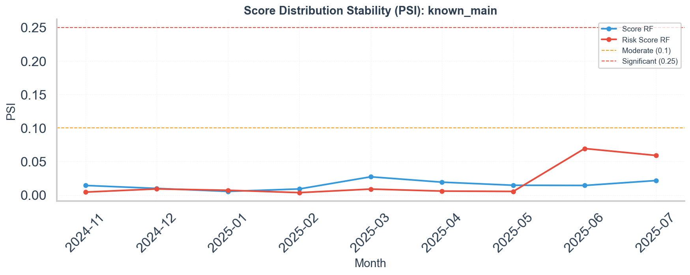
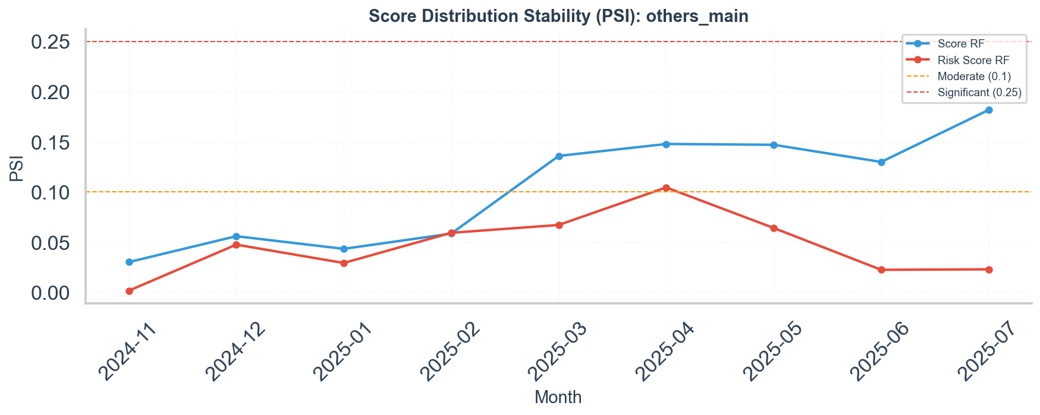
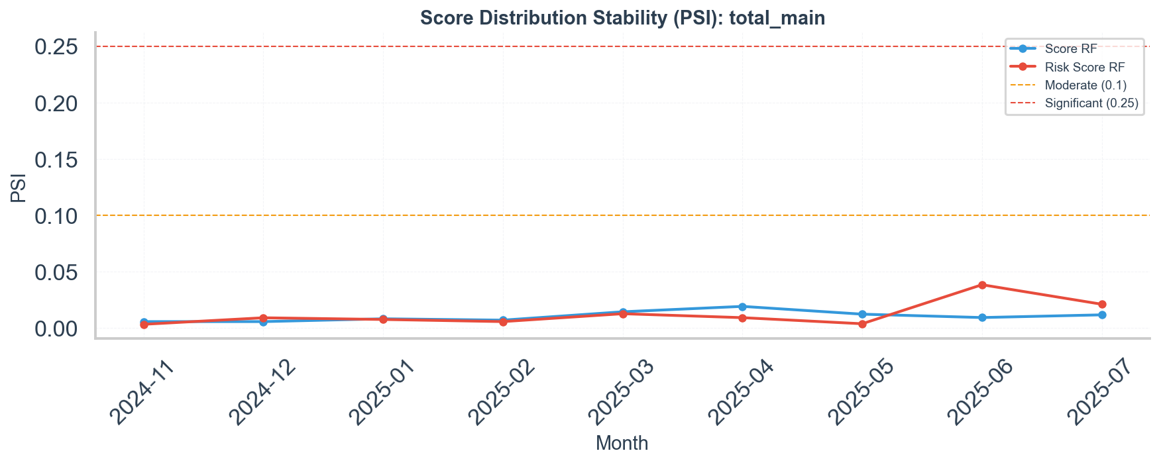

Conclusions

What selection bias explains
- Risk Score RF loses 14-19% of its discriminance due to range restriction. The Thorndike-corrected Gini is 0.41-0.53, and the RI-imputed Gini is even higher (0.45-0.72) across groups. Both methods agree: the true unrestricted Gini is substantially above observed. This is the clearest finding.
- Risk Score RF is truncated consistently (u = 0.79-0.85), and this holds even after isolating to score-based rejections (u = 0.86-0.91). The acceptance policy genuinely acts on this score.
- Score RF has very high selection Gini (0.56-0.67) but much lower outcome Gini (0.23-0.43), which is the classic selection-bias signature. Its discriminance is largely "consumed" by the acceptance decision.

What selection bias does NOT explain
- Score RF's low Gini in "known" (0.23) — all corrections are modest: Thorndike gives 0.25, RI gives 0.28, score-rejection-only u = 0.98 (essentially no truncation). The bad-rate gradient (0.75% → 3.08%) is present but weak (~4x). The low discriminance is genuine.
- The gap between Score RF and Risk Score RF — even after all corrections, Risk Score RF outperforms Score RF in "known" (RI Gini: 0.45 vs 0.28). Risk Score RF has a ~8x bad-rate gradient (0.74% → 6.00%) vs Score RF's ~4x. This is intrinsic discriminance, not an artifact.
- Temporal Gini fluctuations — Score RF Gini varies widely in "known" (0.12-0.30) while PSI stays below 0.03 and acceptance rate barely moves. This instability is not driven by population shift or selection changes.
- The scores are weakly correlated (r = 0.25-0.32), meaning selection on one does not strongly truncate the other. Score RF's issues are its own.

The role of non-score rejection
When isolating to score-based rejections only, the acceptance rate jumps from 15.4% to 41.9% ("known") and from 2.4% to 4.9% ("others"). The u_ratio moves closer to 1.0 in all cases. This confirms that most rejection is policy-driven, not score-driven, and the effective score-based truncation is much milder than raw acceptance rates suggest.
In "others", Score RF has u > 1.0 even after filtering (u = 1.50), meaning the score simply does not drive selection in this group.

Score stability
Both scores are stable in "known" and total (PSI < 0.07). In "others", Score RF shows moderate distribution shift (PSI up to 0.18) from March 2025, coinciding with segment growth. This suggests some Gini volatility in "others" reflects changing population composition rather than selection bias.

Recommendations
- Risk Score RF's observed Gini should be interpreted with a +20-60% correction when comparing to benchmarks. The RI-imputed Gini (0.45-0.72) provides a practical upper bound.
- Score RF's low discriminance in "known" is a genuine finding. Its bad-rate gradient is weak, and the booked-vs-rejected analysis reveals that its power is concentrated in the acceptance decision, not default prediction. This suggests the score's features may need retraining for outcome prediction.
- The Combined logistic score (Gini 0.37-0.64) should be preferred for monitoring. The weak inter-score correlation (r ~ 0.25) confirms they capture complementary information.
- Monitor PSI monthly in the "others" group. The moderate distribution shift (PSI 0.13-0.18) may signal population drift that affects model performance.

Caveats and Limitations
- Thorndike Case 2 assumes bivariate normality and direct selection on the predictor. Credit scores have non-normal distributions. The correction is approximate and likely an upper bound on the true unrestricted Gini.
- RI Gini is circular: the score informs both the selection mechanism and the outcome imputation. The estimates should be treated as upper bounds, not precise corrections.
- `early_bad` is only observed for booked loans. There is no way to compute the "true" unrestricted Gini directly. All evidence is indirect — the convergence of multiple methods (Thorndike, RI, booked-vs-rejected, simulated restriction) strengthens the conclusions.
- Cross-group scatter has only 3 data points and is heavily confounded by population differences. It should be treated as illustrative, not evidential.
- Temporal analysis is limited by very stable acceptance rates in "known" and very small sample sizes in "others". A longer observation window or period with policy changes would strengthen this analysis.
- The "others" group includes heterogeneous segments (fintonic, open banking, consolidation products) whose aggregation may mask within-group patterns. The moderate PSI shift suggests this heterogeneity is increasing over time.

