Alexandria University  Faculty of Engineering  Computer and Systems Engineering Department  CS 401 – Graduation Project | 

Graduation Project
General-Purpose Computer and Game Console
MIPS-I Instruction Set Architecture

Student:

- Mostafa Abd El-Aziz (65)

Supervisor:

- Prof. Dr. Layla Abo Hadid

Introduction:

This document contains a summary for MIPS-I instruction set, as well as pointers to related parts in “MIPS IV Instruction Set.”

There are several versions of MIPS, as MIPS-I ISA was extended three times. The newer MIPS instruction sets are backward compatible with MIPS-I instruction set, as seen in the figure below.

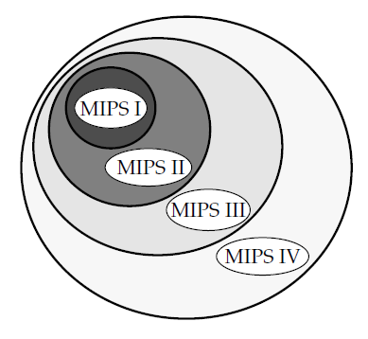

MIPS Architecture Extensions
Instruction Set:

Instructions are divided into several groups:

- Load and Store
- ALU
- Jump and Branch
- Miscellaneous
- Coprocessor

Following is a listing for instructions with references to pages in “MIPS IV Instruction Set” that describe the instructions.

Load and Store Instructions
Mnemonic | Description | Page
LB | Load Byte | A-80
LBU | Load Byte Unsigned | A-81
SB | Store Byte | A-123
LH | Load Halfword | A-91
LHU | Load Halfword Unsigned | A-92
SH | Store Halfword | A-139
LW | Load Word | A-98
SW | Store Word | A-152
LWL | Load Word Left | A-101
LWR | Load Word Right | A-104
SWL | Store Word Left | A-155
SWR | Store Word Right | A-158
ALU Instructions
Mnemonic | Description | Page
ADDI | Add Immediate Word | A-29
ADDIU | Add Immediate Unsigned Word | A-30
SLTI | Set on Less Than Immediate | A-143
SLTIU | Set on Less Than Immediate Unsigned | A-144
ANDI | And Immediate | A-33
ORI | Or Immediate | A-119
XORI | Exclusive OR Immediate | A-179
LUI | Load Upper Immediate | A-97
ADD | Add Word | A-28
ADDU | Add Unsigned Word | A-31
SUB | Subtract Word | A-150
SUBU | Subtract Unsigned Word | A-151
SLT | Set on Less Than | A-142
SLTU | Set on Less Than Unsigned | A-145
AND | And | A-32
OR | Or | A-118
XOR | Exclusive Or | A-178
NOR | Nor | A-117
SLL | Shift Word Left Logical | A-140
SRL | Shift Word Right Logical | A-148
SRA | Shift Word Right Arithmetic | A-146
SLLV | Shift Word Left Logical Variable | A-141
SRLV | Shift Word Right Logical Variable | A-149
SRAV | Shift Word Right Arithmetic Variable | A-147
MULT | Multiply Word | A-115
MULTU | Multiply Unsigned Word | A-116
DIV | Divide Word | A-60
DIVU | Divide Unsigned Word | A-62
MFHI | Move From HI | A-109
MTHI | Move To HI | A-113
MFLO | Move From LO | A-110
MTLO | Move To LO | A-114
Jump and Branch Instructions
Mnemonic | Description | Page
J | Jump | A-76
JAL | Jump and Link | A-77
JR | Jump Register | A-79
JALR | Jump and Link Register | A-78
BEQ | Branch on Equal | A-34
BNE | Branch on Not Equal | A-50
BLEZ | Branch on Less Than or Equal To Zero | A-43
BGTZ | Branch on Greater Than Zero | A-41
BLTZ | Branch on Less Than Zero | A-45
BGEZ | Branch on Greater Than or Equal To Zero | A-36
BLTZAL | Branch on Less Than Zero and Link | A-46
BGEZAL | Branch on Greater Than or Equal To Zero and Link | A-37
Miscellaneous Instructions
Mnemonic | Description | Page
SYSCALL | System Call | A-165
BREAK | Breakpoint | A-52

Instruction Encoding:

Page A-177 summarizes CPU instruction encoding for MIPS-I instruction set. Instructions are grouped in three classes based on their opcode.

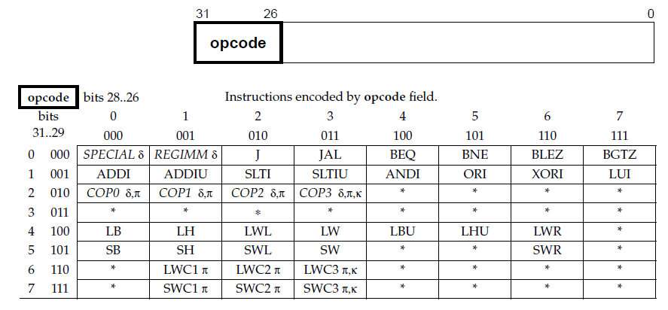

Class A Instructions

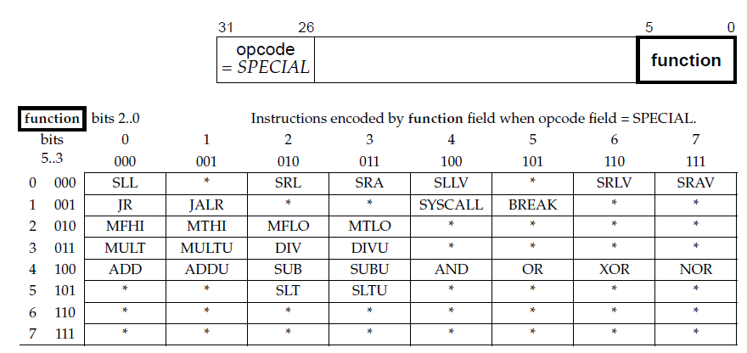

Class B Instructions

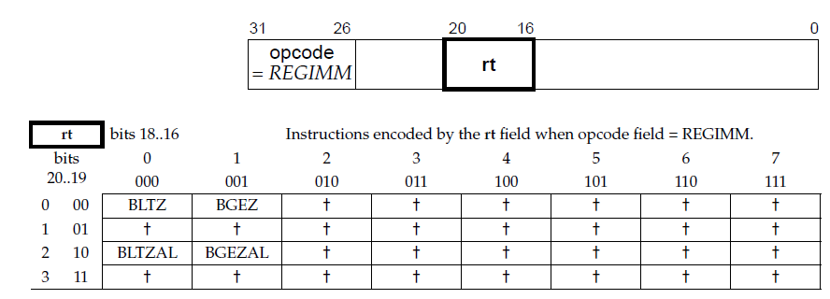

Class C Instructions

