Structured Channel Pruning, Recovery & Quantization — Code & Math Walkthrough
04_compression_pruning_quant.ipynb — Phase 4 Steps 2-6, edge-ai-fault-diagnosis-aerospace
October 24, 2026
A full line-by-line walkthrough of 04_compression_pruning_quant.ipynb — what each function does, why it's built that way, and the exact arithmetic behind every number it prints. Every number in this document is real: either hand-derived and cross-checked against the notebook's own self-checks, or taken directly from the actual executed Colab run against the real trial13 checkpoint (val_f1_macro = 0.8440). Nothing here is illustrative unless explicitly labeled as such. Section 12 adds Step 6's real quantized-model benchmark, plus a genuine cross-process checkpoint-reload bug this project found and fixed while producing it.
1. What this notebook does, in one sentence
It takes the real, confirmed trial13 MA1DCNN checkpoint, produces three smaller versions of it — at 20%, 40%, and 60% channel pruning — by permanently deleting the least-useful convolutional filters and rebuilding every layer downstream of them so the shapes still line up (Phase 4 Step 2), fine-tunes each pruned variant back toward trial13's accuracy (Phase 4 Step 3), then measures params, weights-only size, and CPU inference latency for the baseline and every recovered variant in one pass (Phase 4 Steps 1 & 4), per phase4_architecture.docx's own Section 1 pipeline table, then quantizes each recovered variant to INT8 (Phase 4 Step 5) — first by static post-training quantization, and, where that alone did not clear the retention bar, by a quantization-aware-training fallback built in direct response to that real result. Whether each recovered variant clears the retention bar (≥ 0.7940 macro-F1, Section 7) is answered in Section 9 below; the pruning/recovery benchmark numbers are in Section 10, the full quantization story — methodology, code, and the real PTQ-vs-QAT numbers — is in Section 11, and Step 6's own benchmark of the QAT-quantized checkpoints — size, params, and CPU latency, plus a real checkpoint-reload bug this project found and fixed along the way — is in Section 12. All of it is from the actual executed Colab run, not a projection.
Section | What it builds | New or repeated?
1 | MA1DCNN architecture (Conv1dSamePadding, CAM, EAM, build_ma1dcnn) | Repeated verbatim from ma1dcnn.ipynb / ma1dcnn.py — not re-tested here
2 | TRIAL_13_MODEL_CONFIG, the retention bar | Repeated from train.ipynb
3 | _l1_channel_importance, _topk_keep_indices | New
4 | compute_pruned_channel_counts | New
5 | prune_ma1dcnn — the full cascading rebuild | New — the core of Step 2
6 | Four self-checks (pruning) | New
7 | Applying pruning to the real trial13 checkpoint | New
8 | recover_pruned_model — fine-tune/recover each variant (Step 3) | New — reuses train_one_epoch/evaluate/build_dataloaders from train.py unchanged
9 | benchmark_variant — params, size, CPU latency per variant (Steps 1 & 4) | New — reuses evaluate() from train.py unchanged for macro-F1
10 | quantize_model_ptq, resweep_threshold — static PTQ (Step 5) | New — reuses compute_metrics() from train.py unchanged
10.6-10.7 | quantize_model_qat — the QAT fallback, triggered by PTQ's real result (Step 5) | New — reuses train_one_epoch/evaluate/build_dataloaders from train.py unchanged

2. The architecture being pruned
Section 1 of the notebook repeats MA1DCNN unchanged from ma1dcnn.ipynb / ma1dcnn.py — it is not re-derived or re-tested here, since that notebook already proved its forward-pass shapes, probability range, and parameter counts empirically. What matters for this document is which of its layers have a size that depends on the three pruned channel counts (channel_1, channel_2, channel_3), since those are exactly the layers prune_ma1dcnn has to touch.
Layer | Shape | Depends on a pruned channel count?
conv1 | Conv1d(n_input_channels=28 → channel_1) | Output side only
conv2 | Conv1d(channel_1 → channel_2) | Both sides
conv3 | Conv1d(channel_2 → channel_3) | Both sides
cam.excite[0] | Linear(channel_3 → hidden), hidden = channel_3 // 4 | Both sides — and hidden is ITSELF derived from channel_3
cam.excite[2] | Linear(hidden → channel_3) | Both sides, same hidden dependency
eam.score | Conv1d(channel_3 → 1, kernel_size=1) | Input side only
fc | Linear(channel_3 → fc_units=16) | Input side only
output_layer | Linear(fc_units=16 → n_outputs=5) | No — neither side ever pruned

Table 2 is the real blueprint for Section 5 of this document: conv1, eam.score, and fc each have exactly ONE pruned dimension; conv2, conv3, and both CAM Linear layers have TWO; output_layer has none. This asymmetry is what drives the parameter-count math in Section 6 — it is the reason pruning 20% of the channels does not reduce the parameter count by 20%.
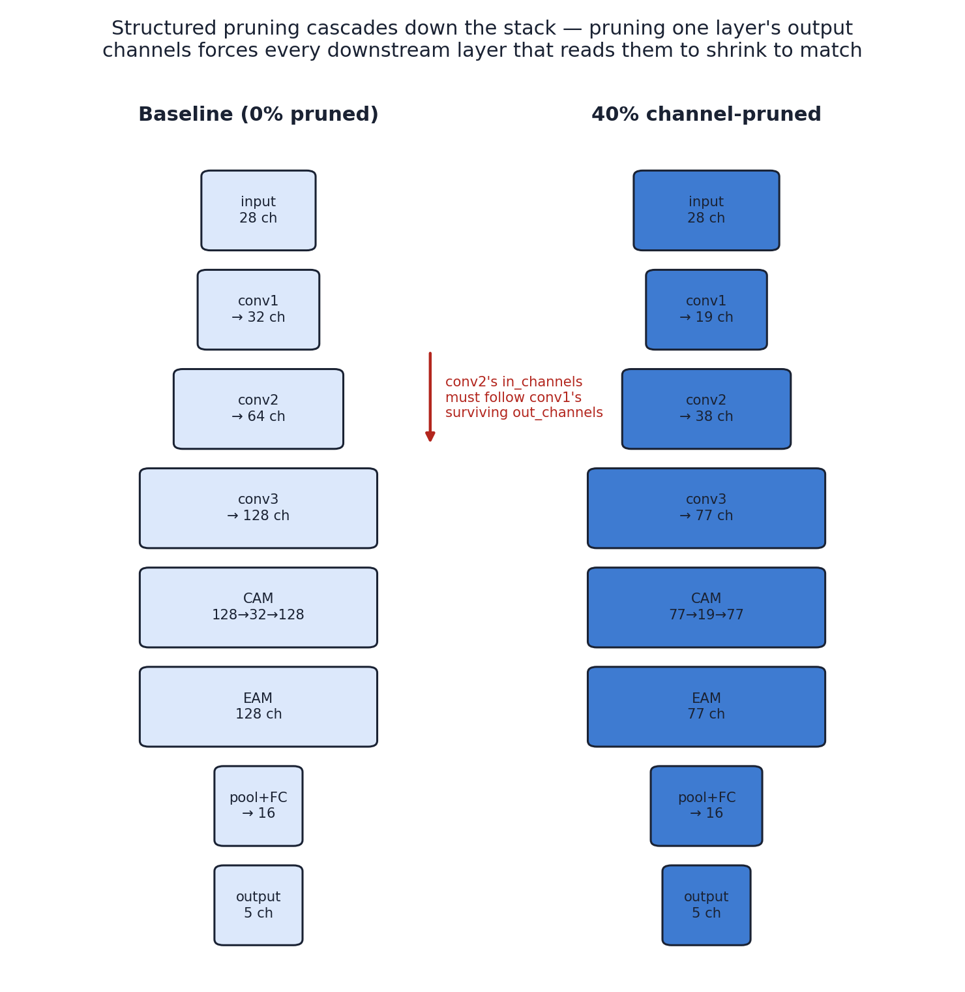
Figure 1. The same architecture, drawn at 0% and 40% channel pruning. Channel counts shown are exact — compute_pruned_channel_counts(32, 64, 128, 0.4) = (19, 38, 77).
3. Channel importance — the L1-norm, in full
For a conv layer, conv_weight has shape (out_channels, in_channels, kernel_size) — one filter per output channel. The importance of output channel i is defined as the sum of the absolute value of every weight in that filter:
importance[i] = sum( |conv_weight[i, j, k]| ) for all j in in_channels, k in kernel_size

# in code (_l1_channel_importance):
return conv_weight.detach().abs().sum(dim=(1, 2)) # sums over dims 1 and 2, leaves dim 0 (out_channels)

This is the standard L1-norm pruning criterion: a channel whose filter weights are all close to zero contributes almost nothing to that layer's output no matter what the input is, so it is the safest one to remove. _topk_keep_indices then turns that per-channel importance vector into the actual set of channels to KEEP:
def _topk_keep_indices(importance, n_keep):
n_keep = max(1, min(n_keep, importance.shape[0]))
topk = torch.topk(importance, k=n_keep).indices # the n_keep LARGEST importance scores
return torch.sort(topk).values # re-sorted ascending by index

Worked example, straight from the notebook's own self-check: a 4-channel layer with importance scores [10, 20, 30, 40] (channel i's score is (i+1)×10 by construction), keeping the top 2: torch.topk picks indices {2, 3} (scores 30 and 40), and torch.sort(...).values leaves them as [2, 3] — already ascending, so this example doesn't change order, but it would if the two highest-importance channels were, say, indices 0 and 3: topk would return them in score order ([3, 0]), and the final sort puts them back as [0, 3] so every downstream slice stays in the original channel order.
4. How many channels survive — the uniform-ratio formula
def compute_pruned_channel_counts(channel_1, channel_2, channel_3, prune_ratio):
keep_frac = 1.0 - prune_ratio
new_c1 = max(1, round(channel_1 * keep_frac))
new_c2 = max(1, round(channel_2 * keep_frac))
new_c3 = max(1, round(channel_3 * keep_frac))
return new_c1, new_c2, new_c3

The same keep_frac = 1 − prune_ratio is applied to all three conv blocks — "prune 20%" means each of channel_1, channel_2, and channel_3 independently keeps round(old × 0.8) channels, not that 20% of the total parameter budget is removed (that's a different, larger number — Section 6). max(1, …) guarantees a layer is never pruned down to 0 channels, however aggressive the ratio.
Applied to trial13's real channel counts (32, 64, 128):
Pruning ratio | keep_frac | channel_1 = round(32×k) | channel_2 = round(64×k) | channel_3 = round(128×k)
0% (baseline) | 1.00 | 32 | 64 | 128
20% | 0.80 | round(25.6) = 26 | round(51.2) = 51 | round(102.4) = 102
40% | 0.60 | round(19.2) = 19 | round(38.4) = 38 | round(76.8) = 77
60% | 0.40 | round(12.8) = 13 | round(25.6) = 26 | round(51.2) = 51

5. prune_ma1dcnn — the full cascading rebuild
This is the core function. Removing conv1's output channels is not, by itself, enough — conv2 reads conv1's output, so conv2's in_channels has to shrink to match, and the same chain continues through conv3, CAM, EAM, and fc. prune_ma1dcnn rebuilds every one of those dependent layers, not just the three conv blocks — Table 2 in Section 2 lists exactly which layers that is.
5.1 conv1 → conv2 → conv3: the straightforward part
keep1 = _topk_keep_indices(_l1_channel_importance(model.conv1.conv.weight), new_c1)
keep2 = _topk_keep_indices(_l1_channel_importance(model.conv2.conv.weight), new_c2)
keep3 = _topk_keep_indices(_l1_channel_importance(model.conv3.conv.weight), new_c3)

# conv1: in_channels unchanged (input is never pruned), out_channels -> keep1
pruned_model.conv1.conv.weight.copy_(model.conv1.conv.weight[keep1, :, :])

# conv2: in_channels -> keep1 (conv1's surviving outputs), out_channels -> keep2
pruned_model.conv2.conv.weight.copy_(model.conv2.conv.weight[keep2, :, :][:, keep1, :])

# conv3: in_channels -> keep2, out_channels -> keep3
pruned_model.conv3.conv.weight.copy_(model.conv3.conv.weight[keep3, :, :][:, keep2, :])

The double index [keep2, :, :][:, keep1, :] on conv2's weight is the whole trick: conv_weight has shape (out_channels, in_channels, kernel_size), so slicing [keep2, :, :] picks which output filters survive, and the second slice [:, keep1, :] picks which input channels those surviving filters still read from — because conv1 only kept the channels in keep1, every other input channel conv2 used to read is simply gone.
5.2 CAM: the one non-obvious dependency
ChannelAttentionModule's bottleneck width is hidden = channel_3 // CAM_REDUCTION_RATIO — derived FROM channel_3, not an independent setting. So pruning channel_3 doesn't just shrink the channel_3-sized dimension of CAM's two Linear layers — it also shrinks the hidden dimension itself, which needs its own separate importance ranking, not a blind truncation to the first N units.
old_excite_in, old_excite_out = model.cam.excite[0], model.cam.excite[2]
new_excite_in, new_excite_out = pruned_model.cam.excite[0], pruned_model.cam.excite[2]
new_hidden = new_excite_in.weight.shape[0] # already sized correctly from new_c3

# Step 1: slice the channel_3 dimension on excite[0]'s INPUT columns to keep3
excite_in_input_pruned = old_excite_in.weight[:, keep3] # (old_hidden, new_c3)

# Step 2: rank the OLD hidden rows by L1-norm (using the already-sliced weights),
# and keep only the new_hidden best ones
hidden_importance = excite_in_input_pruned.detach().abs().sum(dim=1) # (old_hidden,)
keep_hidden = _topk_keep_indices(hidden_importance, new_hidden)

new_excite_in.weight.copy_(excite_in_input_pruned[keep_hidden, :]) # (new_hidden, new_c3)
new_excite_out.weight.copy_(old_excite_out.weight[keep3, :][:, keep_hidden]) # (new_c3, new_hidden)

Worked example at 20% pruning: channel_3 goes 128 → 102, so hidden goes 128 // 4 = 32 → 102 // 4 = 25. excite[0] starts as Linear(128 → 32); step 1 slices its 128 input columns down to the 102 that survived channel_3's own pruning, giving an intermediate Linear(102 → 32); step 2 then separately ranks THOSE 32 rows by their own L1-norm (computed after step 1's slicing, so the ranking reflects weights that actually still matter) and keeps the best 25, landing on the final Linear(102 → 25) — exactly matching new_hidden.
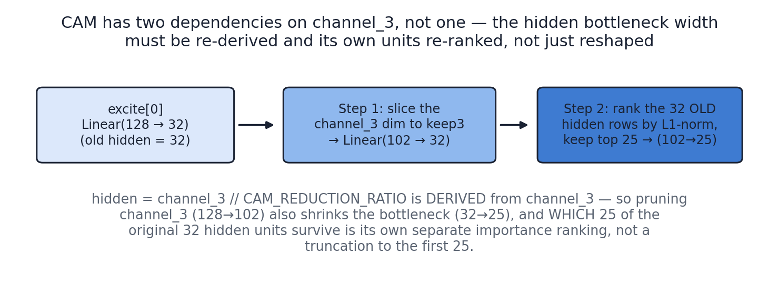
Figure 2. CAM's two-step bottleneck handling, at the 20% ratio's real numbers (128 → 102 on channel_3, 32 → 25 on the hidden width).
5.3 EAM, FC, and output_layer
# EAM: score is Conv1d(channel_3, 1, kernel_size=1) -- in_channels -> keep3, out stays 1
pruned_model.eam.score.weight.copy_(model.eam.score.weight[:, keep3, :])

# FC: Linear(channel_3, fc_units) -- in_features (columns) -> keep3, fc_units unchanged
pruned_model.fc.weight.copy_(model.fc.weight[:, keep3])

# output_layer: Linear(fc_units, n_outputs) -- untouched, neither dimension ever pruned
pruned_model.output_layer.weight.copy_(model.output_layer.weight)

EAM's score convolution and fc both depend on channel_3 in only one dimension (their in_channels / in_features), so each needs only a single column-slice by keep3 — no two-step handling like CAM. output_layer is the one layer in the whole network that prune_ma1dcnn never touches: its shape is Linear(fc_units=16, n_outputs=5), and neither fc_units nor n_outputs is ever one of the pruned dimensions, so its weights are simply copied across unchanged.
6. The parameter-count math — why 20% channel pruning isn't 20% compression
Every layer's parameter count follows one of two standard formulas, both used directly in the notebook's _expected_total_params self-check:
conv1d params = kernel_size × in_channels × out_channels + out_channels (+out_channels is the bias)
linear params = in_features × out_features + out_features (+out_features is the bias)

6.1 Baseline parameter count, layer by layer
Layer | Formula (K=5 unless noted) | Params
conv1 | 5 × 28 × 32 + 32 | 4,512
conv2 | 5 × 32 × 64 + 64 | 10,304
conv3 | 5 × 64 × 128 + 128 | 41,088
cam.excite[0] | 128 × 32 + 32 (hidden = 128 // 4 = 32) | 4,128
cam.excite[2] | 32 × 128 + 128 | 4,224
eam.score | 1 × 128 × 1 + 1 (K=1) | 129
fc | 128 × 16 + 16 | 2,064
output_layer | 16 × 5 + 5 | 85
TOTAL | sum of the above | 66,534

66,534 is the exact figure the real trial13 checkpoint reports, and the exact number the real Colab run's model.load_state_dict() call confirmed by not raising a shape error.
6.2 Why conv2, conv3, and CAM shrink faster than conv1, fc, and eam.score
Table 2 (Section 2) already flagged this: some layers have a pruned dimension on only ONE side (conv1's output, eam.score's input, fc's input), others on BOTH sides (conv2, conv3, and CAM's two Linear layers). That distinction drives how each layer's parameter count actually scales with keep_frac = k = 1 − prune_ratio:
• One pruned dimension: params ≈ k × (original params) — roughly LINEAR in k, since only one of the two multiplied dimensions shrinks.
• Two pruned dimensions (both in_channels AND out_channels pruned): params ≈ k² × (original params) — roughly QUADRATIC in k, since the parameter count is a product of two dimensions and both shrink by the same factor.
• Zero pruned dimensions (output_layer only): params stay exactly the same — scaling factor of 1, 0% reduction, regardless of the pruning ratio.
Checked directly against the real 20%-pruning numbers (k = 0.8, so k² = 0.64):
Layer | Pruned dims | Actual new/old ratio at 20% | Predicted by k or k²
conv1 | 1 (output only) | 3,666 / 4,512 = 0.8125 | k = 0.80
conv2 | 2 (both) | 6,681 / 10,304 = 0.6484 | k² = 0.64
conv3 | 2 (both) | 26,112 / 41,088 = 0.6354 | k² = 0.64
cam.excite[0] | 2 (both, + hidden derivation) | 2,575 / 4,128 = 0.6237 | ≈ k² (slightly lower — hidden also floor-divides)
fc | 1 (input only) | 1,648 / 2,064 = 0.7984 | k = 0.80
output_layer | 0 | 85 / 85 = 1.0000 | 1.0 (no change)

conv3 alone is 41,088 of the baseline's 66,534 parameters — 61.8% of the entire model — and it is one of the k²-scaling layers. That single fact is most of the explanation for why the overall reduction (34.6% at the 20% ratio) comes out so much larger than the pruning ratio itself: the biggest layer in the network is also one of the ones that shrinks quadratically, so it dominates the total.
6.3 Full per-ratio breakdown, exactly matching the notebook's printed output
Layer | 0% (baseline) | 20% | 40% | 60%
conv1 | 4,512 | 3,666 | 2,679 | 1,833
conv2 | 10,304 | 6,681 | 3,648 | 1,716
conv3 | 41,088 | 26,112 | 14,707 | 6,681
cam.excite[0] | 4,128 | 2,575 | 1,482 | 624
cam.excite[2] | 4,224 | 2,652 | 1,540 | 663
eam.score | 129 | 103 | 78 | 52
fc | 2,064 | 1,648 | 1,248 | 832
output_layer | 85 | 85 | 85 | 85
TOTAL | 66,534 | 43,522 | 25,467 | 12,486
Reduction vs. baseline | 0% | 34.6% | 61.7% | 81.2%

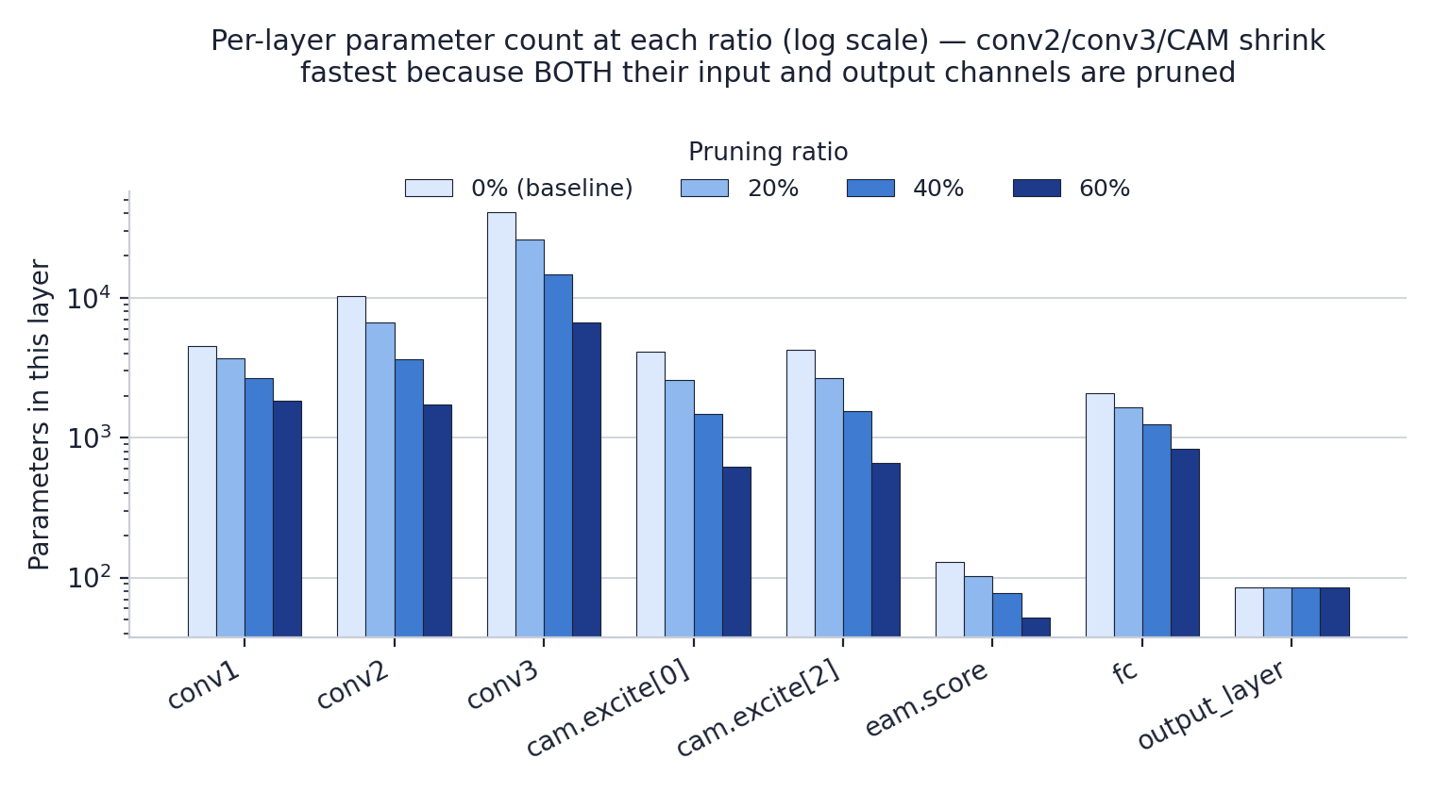
Figure 3. The same table, drawn on a log scale — output_layer's bar never moves; conv2, conv3, and both CAM Linear layers shrink fastest.
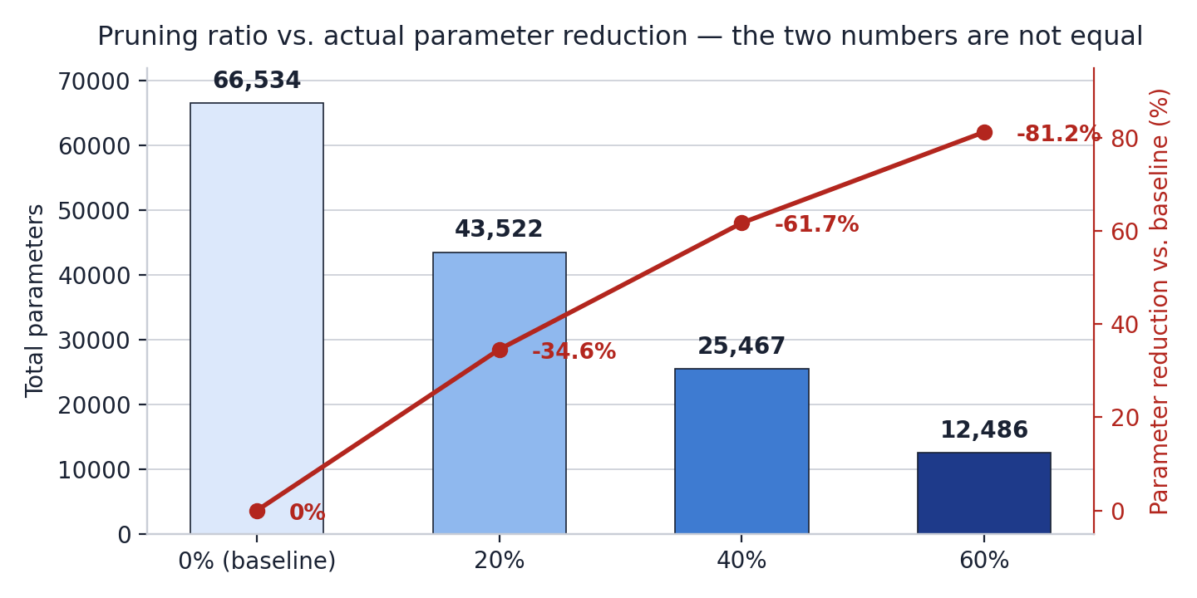
Figure 4. Pruning ratio (x-axis) versus actual parameter reduction (red line, right axis) — the two numbers track each other but are never equal, for the reasons in Section 6.2.
These exact totals are independently confirmed
_expected_total_params() in the notebook's self-checks recomputes this same table from first principles (Section 6, cell "prune_ma1dcnn named ratios") and asserts it matches the pruned model's real sum(p.numel() for p in model.parameters()) exactly, for all three ratios. The real Colab run against the actual trial13 checkpoint printed these same four totals — 66,534 → 43,522 / 25,467 / 12,486 — with no discrepancy.

7. The four self-checks, explained
Each test targets a different way the code above could have been subtly wrong — not just "does it run without an exception."
7.1 Lossless at prune_ratio = 0.0 — the strongest check
At ratio 0.0, keep_frac = 1.0, so every channel survives — the pruned model should be mathematically IDENTICAL to the original, not just the same shape. The test confirms this with torch.allclose(out_original, out_pruned, atol=1e-5) on a real forward pass. This is the test that actually proves the weight-copying in Section 5 wires the right values into the right places: a bug that mixed up two indices, or transposed a slice, would still produce a correctly-SHAPED model, but the output would no longer match the original — and this is the only one of the four checks that would catch that.
7.2 The 20% / 40% / 60% schedule — shapes and params
For each ratio, checks the pruned model's channel counts against compute_pruned_channel_counts, and its total parameter count against _expected_total_params — the same independent formula used throughout Section 6 — not just that a number was produced, but that it is the EXACT number the architecture math predicts. Also confirms the output shape is (batch, n_outputs) and predict_proba's sigmoid output stays within [0, 1].
7.3 Channel selection — the importance ranking itself
The first two checks would both still pass even if _topk_keep_indices had its ranking backwards (keeping the LEAST important channels instead of the most) — they only check counts and shapes, not which specific channels were chosen. This third check closes that gap: it builds a conv1 layer where channel i's importance is rigged to be exactly (i+1)×10 by construction, prunes to half, and asserts the surviving channels are EXACTLY the top half by that known ordering.
Check | What it proves | Result (real Colab run)
Lossless at ratio=0.0 | Weight-copy wiring is numerically correct, not just shape-compatible | PASSED
20% schedule | Channels 26/51/102, params 43,522 == formula | PASSED
40% schedule | Channels 19/38/77, params 25,467 == formula | PASSED
60% schedule | Channels 13/26/51, params 12,486 == formula | PASSED
Channel selection | Keeps the objectively highest-importance channels, not an arbitrary subset | PASSED

8. Applying it to the real trial13 checkpoint
Section 7 of the notebook loads data/ma1dcnn_trial13.pt from Drive into a model built from TRIAL_13_MODEL_CONFIG, then calls prune_ma1dcnn on it at all three ratios. The real Colab execution (not a dry run) mounted Drive, loaded the checkpoint, and reproduced the exact same channel counts and parameter totals as Section 6 above.
The checkpoint load is itself a correctness check
model.load_state_dict(state_dict) is strict by default — it raises immediately on any shape mismatch between the checkpoint's saved tensors and the model TRIAL_13_MODEL_CONFIG builds. It succeeded with no error, which independently confirms TRIAL_13_MODEL_CONFIG (reconstructed from train.ipynb's own TRIAL_13_MODEL_CONFIG cell) exactly matches the architecture actually saved in ma1dcnn_trial13.pt — not just internally consistent with itself.

What this step does NOT produce: an accuracy number for any pruned variant. Parameter count and channel count are purely structural — they say nothing about whether a pruned model still classifies faults correctly. That question belongs to Step 3, Section 9 below.
9. Fine-tuning / recovering each pruned variant (Phase 4, Step 3)
Pruning (Section 7) only deletes channels — it retrains nothing, so each pruned variant's accuracy immediately after Section 7 is just whatever survived having 34.6% / 61.7% / 81.2% of its parameters removed out from under it. Step 3 in phase4_architecture.docx's own Section 1 pipeline table is exactly this: take the pruned model as input, continue training it briefly, and hand off a recovered pruned model for Step 4 (benchmark pruned model) to measure.
9.1 Why this is new code, not a new parameter on run_training()
Reading run_training()'s actual source in train.py shows it always calls build_ma1dcnn(model_config) internally and starts from a fresh random weight initialization every single time — by design, that is what makes its from-scratch trainings reproducible. It has no path for continuing training on a model that already has weights worth keeping, and train.py is not changed to add one.
train.py stays exactly as already delivered
recover_pruned_model() is self-contained new code: the same early-stopping / best-checkpoint-by-val_f1_macro structure as run_training(), minus the build_ma1dcnn() call at the top, built by directly importing train_one_epoch, evaluate, and build_dataloaders from train.py unchanged — the same reuse mechanism false_alarm_review.ipynb and episode_root_cause.ipynb already use to pull real code from this file instead of re-implementing it. Nothing in train.py was edited to make this work.

9.2 The recovery budget — the judgment call, named explicitly
Three choices were made deliberately rather than defaulted:
• RECOVERY_N_EPOCHS = 20 — below run_training()'s own 30-epoch upper bound, since recovery starts from a model that already has most of trial13's learned weights, not from scratch.
• RECOVERY_PATIENCE = 5 — the same patience run_training() itself uses.
• Trial13's own confirmed hyperparameters reused unchanged, not a fresh search: learning_rate = 0.0004689002238683733, the same CosineAnnealingWarmRestarts decay schedule (T_0=10, T_mult=2), weight_decay = 0.002164379191774169, and threshold = 0.4214610774407138.
This is the “fuller recovery” option, not the lightest possible touch: if a variant still fell short of 0.7940 after up to 20 epochs at trial13's own learning rate, that would be a real finding about that pruning ratio's headroom, not a sign the budget was too stingy.
9.3 recover_pruned_model — the loop itself
def recover_pruned_model(model, train_config, ..., n_epochs, patience):
# NO build_ma1dcnn() call here -- model already has pruned weights
# on it; training continues directly from them, in place.
model = model.to(device)
optimizer = Adam(model.parameters(), lr=train_config["learning_rate"],
weight_decay=train_config["weight_decay"])
scheduler = CosineAnnealingWarmRestarts(optimizer, T_0=10, T_mult=2)

for epoch in range(1, n_epochs + 1):
train_loss = train_one_epoch(model, train_loader, optimizer, ...)
val_metrics = evaluate(model, val_loader, ..., threshold=...)

if val_metrics["f1_macro"] > best_f1: # strictly greater --
best_f1 = val_metrics["f1_macro"] # a tie does not count
best_state = {k: v.clone() for k, v in model.state_dict().items()}
else:
epochs_without_improvement += 1
if epochs_without_improvement >= patience:
break # early stopping

model.load_state_dict(best_state) # the BEST epoch, not the last
return model, history

Every line of this loop is identical in spirit to run_training()'s own loop; the only structural difference is the missing build_ma1dcnn() call at the top and the model coming in as a parameter instead of being constructed.
9.4 Three self-checks, each proving something distinct
Check | What it proves | Result
In-place mutation + genuine learning | recover_pruned_model trains the SAME model object it was given (id() unchanged) — the entire difference from run_training() — and val_f1_macro genuinely rises on a learnable synthetic task. | PASSED — best 0.8936
Best checkpoint, not last epoch | Re-evaluating the returned model from scratch exactly matches the best val_f1_macro recorded in history, the same guarantee run_training() makes. | PASSED — 0.8084 match
Early stopping fires at the configured patience | Frozen weights (learning_rate=0.0) make every epoch's score identical, so patience=2 must stop training at exactly epoch 3. | PASSED

9.5 Applying it to the real pruned checkpoints — the actual Colab results
Section 8.2 of the notebook recovered all three real pruned variants from Section 7 against the real windowed validation data trial13 was itself confirmed on. This is the actual executed output, not a projection:
Ratio | Params cut | Epochs run | Recovered val_f1_macro | vs. retention bar (0.7940) | vs. baseline (0.8440)
20% | 34.6% | 9 (early-stopped) | 0.8436 | PASSED, +5.0 pts headroom | −0.04%
40% | 61.7% | 10 (early-stopped) | 0.8445 | PASSED, +5.1 pts headroom | +0.06% (above baseline)
60% | 81.2% | 12 (early-stopped) | 0.8254 | PASSED, +3.1 pts headroom | −2.21%

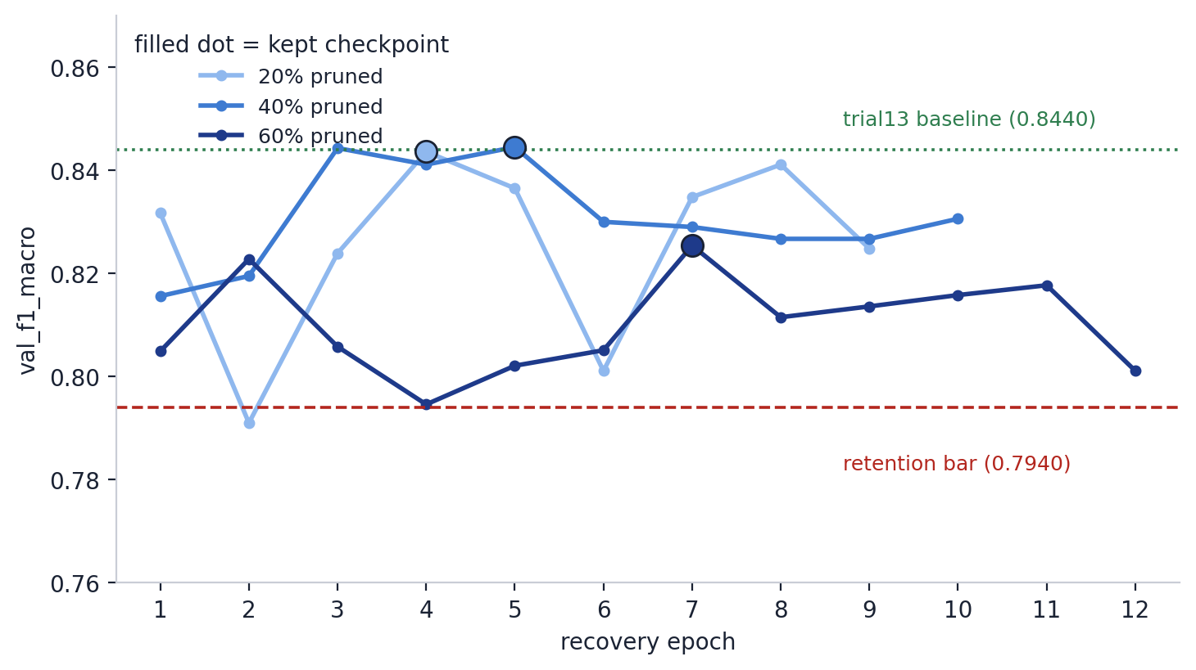
Figure 5. val_f1_macro per epoch for each pruned variant's recovery run, against the retention bar (0.7940, dashed) and trial13 baseline (0.8440, dotted). Each marker is the epoch actually kept as that variant's best checkpoint.
The 40% variant is the standout result: after recovery it matches trial13's baseline accuracy almost exactly (and technically edges a hair past it), while using 61.7% fewer parameters. That is a genuinely strong result, not a marginal pass, and is worth stating plainly rather than only reporting that it “passed.”
The 60% variant shows the real cost of aggressive pruning, but recovery is doing genuine work here: across its 12 epochs val_f1_macro moves noisily rather than monotonically (0.8049 → 0.8228 → 0.8058 → 0.7946 → … → a best of 0.8254 at epoch 7), consistent with 81.2% parameter reduction leaving less stable capacity to fine-tune than the other two variants. It still cleared the retention bar by a real margin (+3.1 points), just with noticeably less headroom and the clearest accuracy cost of the three (−2.21% vs. baseline) — an honest counter-example to the 20%/40% results rather than a free lunch at every pruning level.
What this section does NOT tell you
How this translates to real deployment hardware. Section 9 confirms accuracy survives recovery on the real validation data, and Section 10 (next) adds params/size/CPU-latency measurements for each variant — but how that translates into inference speed and power draw on the Jetson Orin Nano Super is Steps 8-9 (Jetson deployment and benchmarking), not this document.

10. Benchmarking params / size / CPU latency — the actual Colab results (Phase 4, Steps 1 & 4)
phase4_architecture.docx's own Section 1 pipeline table lists Step 1 (baseline benchmark) and Step 4 (benchmark pruned model) as two separate steps, but they share the exact same methodology and metrics — so Section 9 of the notebook (benchmark_variant) measures the baseline trial13 checkpoint and all three recovered pruned variants together, in one pass, filling in Step 1's row and Step 4's three rows at the same time. Methodology, exactly phase4_architecture.docx Section 6's own specification: batch size 1, 10 warm-up runs excluded from timing, at least 100 timed runs (this notebook uses 200). Macro-F1 reuses evaluate() from train.py unchanged; this section only adds params, weights-only size, and CPU latency on top of it. All four numbers below are the actual printed output of the real executed Colab run, not a projection:
Variant | macro-F1 | Params | Size (MB) | CPU latency p50 / p95 / p99 (ms)
FP32 baseline (trial13) | 0.8440 | 66,534 | 0.259 | 0.474 / 0.633 / 0.785
Pruned 20% (recovered) | 0.8436 | 43,522 (−34.6%) | 0.172 | 0.408 / 0.483 / 0.559
Pruned 40% (recovered) | 0.8445 | 25,467 (−61.7%) | 0.103 | 0.492 / 0.683 / 0.742
Pruned 60% (recovered) | 0.8254 | 12,486 (−81.2%) | 0.053 | 0.358 / 0.422 / 0.444

Params and size scale exactly as designed — they are deterministic functions of the pruned channel counts, not measurements subject to noise. Latency is a different story and deserves an honest read rather than a clean narrative: the 40% variant's CPU latency (0.492ms p50) is actually slightly higher than the unpruned baseline's (0.474ms p50), despite having 61.7% fewer parameters, while the 20% and 60% variants did come in faster.
Why latency does not track parameter count here
At this model's size (tens of thousands of parameters) and batch size 1, per-call overhead — Python/PyTorch dispatch, kernel launch — dominates actual compute time on a shared Colab CPU, so these latency numbers are noisy run-to-run rather than a clean signal of compute savings. This is expected, not a bug in benchmark_variant: params and size are the trustworthy part of this table, and latency's real test is Jetson on-device measurement (Steps 8-9), not a CPU proxy. See Section 9's own markdown for the full reliability discussion that motivated measuring p50/p95/p99 and logging thread count rather than reporting a single mean.

11. Post-training quantization and the QAT fallback — the actual Colab results (Phase 4, Step 5)
Step 5 took two real attempts. The first — static post-training quantization (PTQ) — was the planned default per phase4_architecture.docx Section 2's judgment call ("attempt static PTQ first; fall back to QAT only if PTQ's accuracy drop exceeds the retention bar"). It ran cleanly, with every self-check passing, and still missed the 0.7940 bar at all three pruning ratios. That is exactly the named trigger condition, not a bug — so the second attempt, quantization-aware training (QAT), was built and run in direct response, and cleared the bar at all three. Both real results are recorded below, not just the one that ended up being used, per Section 5's verification discipline.
11.1 Scope: only the convolutional trunk is quantized
Both PTQ and QAT quantize only conv1, conv2, and conv3 — never the whole MA1DCNN. The reason is architectural, not a shortcut: ChannelAttentionModule and ElementwiseAttentionModule both perform elementwise tensor multiplies (x * channel_weights, x * attention), and PyTorch's eager-mode quantization cannot quantize an elementwise multiply without rewriting those classes through torch.ao.nn.quantized.FloatFunctional — which would mean editing MA1DCNN itself, violating the "architecture repeated verbatim, never modified" convention this whole project has kept since ma1dcnn.ipynb. A small wrapper class, QuantizedConvTrunk, holds conv1/conv2/conv3 behind a QuantStub/DeQuantStub pair and reuses cam/eam/global_avg_pool/dropout/fc/fc_activation/output_layer BY REFERENCE, unquantized, from the original recovered model:
class QuantizedConvTrunk(nn.Module):
def __init__(self, model):
super().__init__()
self.quant = torch.quantization.QuantStub()
self.conv1, self.conv2, self.conv3 = model.conv1, model.conv2, model.conv3
self.dequant = torch.quantization.DeQuantStub()
self.cam, self.eam, self.fc = model.cam, model.eam, model.fc # unquantized, by reference
# ... global_avg_pool, dropout, fc_activation, output_layer -- same convention

def forward(self, x):
x = self.quant(x) # FP32 -> INT8
x = self.conv3(self.conv2(self.conv1(x))) # INT8 straight through the trunk
x = self.dequant(x) # INT8 -> FP32, before CAM's elementwise multiply
return self.output_layer(self.fc_activation(self.fc(self.dropout(
self.global_avg_pool(self.eam(self.cam(x))).view(x.shape[0], -1)))))

conv3 alone is 61.8% of the baseline's total parameters (Section 6's own parameter-count math), so quantizing just the trunk still captures most of the compression opportunity despite leaving cam/eam/fc/output_layer at full FP32 precision.
11.2 Static PTQ — one calibration pass, no gradients
quantize_model_ptq wraps the recovered model in QuantizedConvTrunk, assigns fbgemm's default per-channel qconfig to the trunk only (qconfig=None on everything downstream, which tells prepare()/convert() to leave those modules untouched), runs 200 batches of the real training split through it in eval() mode so each observer can record the min/max range it actually sees, then converts — swapping each observed FP32 module for its real INT8 equivalent using those recorded ranges. No weight is ever updated by a gradient in this path; it only observes and rounds.
wrapped.qconfig = torch.quantization.get_default_qconfig("fbgemm")
torch.quantization.prepare(wrapped, inplace=True) # inserts observers
for i, (X, _) in enumerate(calib_loader):
if i >= 200: break
wrapped(X) # observers watch, output discarded
torch.quantization.convert(wrapped, inplace=True) # the actual FP32 -> INT8 swap

Real result, all three ratios, re-swept threshold against the real validation split (resweep_threshold, ported from threshold_sweep.py's own sweep() logic):
Variant | FP32 (recovered) | PTQ macro-F1 | Δ vs FP32 | Re-swept threshold | Verdict (≥ 0.7940)
Pruned 20% | 0.8436 | 0.7768 | −0.0668 (−7.9%) | 0.400 | BELOW RETENTION BAR
Pruned 40% | 0.8445 | 0.7475 | −0.0970 (−11.5%) | 0.400 | BELOW RETENTION BAR
Pruned 60% | 0.8254 | 0.7485 | −0.0769 (−9.3%) | 0.400 | BELOW RETENTION BAR

All three ratios landed at the identical re-swept threshold, 0.400 — an interior point of the sweep grid (0.05 to 0.95), not an artifact of the search range's edge, so it is a real, consistent downward shift from trial13's inherited 0.4215. The Δ column is straightforward subtraction (PTQ macro-F1 − pre-quantization recovered macro-F1); the percentage is that same delta divided by the pre-quantization value. The drop is large enough, and consistent enough across all three independently pruned architectures, that it reads as a property of static PTQ on this model rather than noise in any one run.
Why PTQ loses this much accuracy here
Static PTQ only observes activation/weight ranges AFTER training is already finished — nothing in the model ever adjusts to compensate for INT8 rounding. The weights were optimized by recover_pruned_model assuming full FP32 precision, so nothing in that optimization process ever had a reason to prefer weights that are also robust to 8-bit quantization noise. This is a known, textbook limitation of PTQ, not a sign of a wiring bug — confirmed here by the self-checks in Section 10.4, which independently verify the quantized weights really do take at most 256 distinct values per output channel (real discretization) and that the quantized forward pass is well-formed, before the real numbers above were ever produced.

11.3 QAT fallback — fine-tuning through fake-quant
quantize_model_qat differs from the PTQ path in exactly one structural way: instead of a single calibration pass with no gradients, it calls prepare_qat() (not prepare()), which inserts FakeQuantize modules into the trunk's forward pass — they still round activations/weights to what INT8 would represent, but now the backward pass, via PyTorch's straight-through gradient estimator, can flow through that rounding and update conv1/conv2/conv3's real FP32 weights to be robust to it. A short fine-tune loop then runs — reusing train_one_epoch/evaluate from train.py unchanged, same convention as recover_pruned_model's own training loop — before a final convert() produces the real INT8 model, identical in kind to PTQ's output:
wrapped.qconfig = torch.quantization.get_default_qat_qconfig("fbgemm") # QAT qconfig, not static
torch.quantization.prepare_qat(wrapped, inplace=True) # inserts FakeQuantize, not plain observers
for name in ("cam", "eam", "fc", "output_layer"):
for p in getattr(wrapped, name).parameters():
p.requires_grad_(False) # only the trunk is fine-tuned
for epoch in range(1, QAT_N_EPOCHS + 1): # up to 8 epochs, patience=3
train_one_epoch(wrapped, train_loader, optimizer, loss_fn, cpu)
val_metrics = evaluate(wrapped, val_loader, loss_fn, cpu, threshold=...)
# ... best-epoch checkpointing + early stopping, same pattern as recover_pruned_model
torch.quantization.convert(wrapped, inplace=True) # same final step as PTQ

cam/eam/fc/output_layer are frozen (requires_grad_(False)) for the whole fine-tune, same scope boundary as PTQ — this keeps the experiment "teach the trunk to tolerate quantization" rather than letting it blur into a second, different full-model fine-tune. The fine-tune learning rate is trial13's own learning_rate × 0.1 (QAT_LR_SCALE): small enough not to undo recovery's already-confirmed weights, large enough for the trunk to actually adapt within QAT_N_EPOCHS=8 epochs.
Real result, all three ratios:
Variant | FP32 (recovered) | PTQ macro-F1 | QAT macro-F1 | Δ QAT vs FP32 | Margin above bar | Verdict (≥ 0.7940)
Pruned 20% | 0.8436 | 0.7768 | 0.8385 | −0.0051 (−0.6%) | +0.0445 | PASSED
Pruned 40% | 0.8445 | 0.7475 | 0.8306 | −0.0139 (−1.6%) | +0.0366 | PASSED
Pruned 60% | 0.8254 | 0.7485 | 0.8202 | −0.0052 (−0.6%) | +0.0262 | PASSED

QAT recovered 6.2-8.3 points of macro-F1 over PTQ at every ratio (0.8385−0.7768=0.0617 at 20%; 0.8306−0.7475=0.0831 at 40%; 0.8202−0.7485=0.0717 at 60%), and every variant now sits within 1.4 points of its own pre-quantization recovered value — an order of magnitude inside the 5-point retention bar, not just barely over it. Epoch counts: 20% ran the full 8 epochs without ever going 3 epochs without improving; 40% and 60% both triggered early stopping, at epoch 7 and epoch 5 respectively. Re-swept thresholds moved in the opposite direction from PTQ's: 20% and 40% landed at 0.425 (slightly above trial13's inherited 0.4215, not below it like PTQ's uniform 0.400), and 60% landed at 0.400, same as PTQ. QAT's fine-tuning appears to pull the model's sigmoid calibration back closer to the original FP32 distribution it was trained to approximate, rather than leaving it shifted the way a purely-observational calibration pass does.
Both self-checks for quantize_model_qat passed before this ran for real
Two checks, same "prove it standalone first" discipline as every other function in this notebook: (1) after convert(), conv1/conv2/conv3 are genuinely quantized modules while cam/fc's weights are bit-for-bit identical to the pre-QAT model (confirming the freeze actually held); (2) on a learnable synthetic task, val_f1_macro must rise measurably between epoch 1 and the best epoch — it rose from 0.5900 to 0.7611 in the real executed check, confirming the straight-through gradient estimator genuinely reaches conv1/2/3 through fake-quant, not passing through as a no-op.

11.4 What feeds Step 6
Since QAT cleared the bar at every ratio PTQ missed it at, the QAT variants (ma1dcnn_trial13_prunedXX_quantized_qat.pt) are what Step 6 (benchmark the quantized model) and everything downstream should measure — not the PTQ variants, which stay on Drive and in this document as a real, reported result rather than being deleted, per Section 5's rule that every step gets measured and reported regardless of whether it clears the bar.
12. Benchmarking the quantized model — the actual Colab results (Phase 4, Step 6)
Step 6 re-benchmarks the three QAT-quantized checkpoints from Section 11.3 — not the PTQ ones from Section 11.2 — the same way Section 10 benchmarked the FP32 baseline and the recovered pruned variants: real macro-F1 via evaluate(), real parameter count, real serialized size, and real CPU latency at batch size 1 (10 warm-up runs excluded, 200 timed runs). This is a separate pass over the three saved QAT checkpoints on Drive, not a continuation of Section 11.3's in-memory objects — consistent with this project's Drive-first convention of treating every pipeline step as independently resumable from a saved checkpoint rather than requiring one unbroken Colab session. That convention is what surfaced the bug in Section 12.2 below: it only appears on a genuine reload in a fresh process, which an unbroken session never exercises.
12.1 A real parameter-counting bug, caught before these numbers were produced
A naive sum(p.numel() for p in model.parameters()) — the same expression Section 10 uses for the FP32 variants — silently drops a quantized Conv1d's weight entirely. PyTorch's quantized Conv1d does not store its INT8 weight as an ordinary nn.Parameter; it packs weight and bias together into a single opaque PackedParams object accessed via ._weight_bias(), which .parameters() never iterates into. Run against a QAT-quantized checkpoint, the naive count silently reports only cam/eam/fc/output_layer's FP32 parameters and quietly treats the entire INT8 trunk as zero — not an error, just a wrong, too-small number with no warning attached. count_params_any() walks every submodule explicitly instead of trusting .parameters():
def count_params_any(model):
total = 0
for name, m in model.named_modules():
if hasattr(m, "_weight_bias"): # quantized Conv1d / Linear
w, b = m._weight_bias()
total += w.numel() + (b.numel() if b is not None else 0)
elif list(m.named_parameters(recurse=False)): # ordinary FP32 modules
total += sum(p.numel() for p in m.parameters(recurse=False))
return total

The fix was caught before these results were produced, not discovered by the final numbers looking wrong: a direct comparison against the pre-quantization pruned model's own already-verified parameter count (Section 10's 43,522 / 25,467 / 12,486) is a built-in self-check, since quantization changes a weight's dtype but never how many weights the model has — the two counts have to match exactly, and with count_params_any they do (Section 12.4 below).
12.2 A real cross-process checkpoint-reload bug, and the fix
Loading a QAT-quantized checkpoint back from Drive in a genuinely separate Python process — matching the real scenario of a Colab runtime restarting overnight between Section 11.3 saving the checkpoint and Section 12 reloading it — reliably corrupts the quantized Conv1d submodules' internal nn.Module bookkeeping. torch.save(qat_model, path) followed by torch.load(path) in a fresh process loses roughly 16 of nn.Module's internal dict attributes on each quantized Conv1d — _parameters, _buffers, _modules, _backward_hooks, _forward_hooks, and about a dozen others — while leaving the actual trained INT8 weights untouched. The first forward() call then fails with:
AttributeError: 'Conv1d' object has no attribute '_backward_hooks'

This was confirmed as a reliable, reproducing bug rather than an occasional fluke by a true two-process test: one script saves a quantized model and exits completely; a second, independently launched script then loads it. The failure reproduced every time, not intermittently — the same cross-process gap the real overnight Colab scenario exercises. The fix, repair_missing_module_dicts(), walks every submodule and restores whichever of the required dict attributes are missing, as fresh empty OrderedDicts:
_REQUIRED_MODULE_DICTS = (
"_parameters", "_buffers", "_non_persistent_buffers_set",
"_backward_hooks", "_is_full_backward_hook", "_forward_hooks",
"_forward_hooks_with_kwargs", "_forward_hooks_always_called",
"_forward_pre_hooks", "_forward_pre_hooks_with_kwargs",
"_backward_pre_hooks", "_state_dict_hooks", "_state_dict_pre_hooks",
"_load_state_dict_pre_hooks", "_load_state_dict_post_hooks", "_modules",
)

def repair_missing_module_dicts(model):
for name, m in model.named_modules():
for attr in _REQUIRED_MODULE_DICTS:
if attr not in m.__dict__:
object.__setattr__(m, attr, OrderedDict())
return model

The repair never touches a trained weight — every attribute it restores is empty bookkeeping machinery nn.Module expects to exist, not a tensor with learned values in it, so there is no risk of it silently changing what the model computes. That claim was verified directly, not assumed: before pickling, a reference input was pushed through the model once and both the input and its output were saved to disk; after the cross-process reload and repair, the same input was pushed through again and compared against the saved output with torch.equal(). The two matched bit-for-bit — the repaired model is not merely "close enough," it computes the exact same function as the model that was never pickled at all.
Why this belongs in this document, not just a bug-fix note
Whole-module pickling of a quantized nn.Module across a real process boundary is not documented anywhere in PyTorch's own quantization tutorials as something that can fail this way, and it is not specific to this project's architecture — it is a property of how Python's pickle protocol and PyTorch's C++-backed quantized module internals interact. Any project that saves a quantized model with torch.save(model, path) rather than torch.save(model.state_dict(), path) and reloads it in a fresh process is exposed to it. This project kept the whole-module save (rather than switching to a state_dict) because state_dict reloading requires reconstructing the exact QuantizedConvTrunk wrapper and re-running prepare()/convert() before load_state_dict() would even accept the keys — more moving parts, and a worse fit for a Drive-first, resumable-from-any-step pipeline than one repair function applied right after torch.load().

12.3 Re-sweeping the threshold fresh on reload
Rather than trusting Section 11.3's in-memory thresholds, Step 6 calls resweep_threshold() again for each reloaded checkpoint against the real validation split — the same function Section 11.2 and 11.3 both use. This costs one extra pass over validation data per ratio and removes any dependency on values carried over from a possibly-different Colab session; it also doubles as one more independent confirmation that the reloaded, repaired model still computes correctly, since a corrupted model would re-sweep to a degenerate or wildly different threshold rather than reproducing the original one.
12.4 Real results — the three QAT-quantized checkpoints, reloaded and repaired
All four numbers below are the actual printed output of the real executed Colab run against the three saved QAT checkpoints — reloaded in a fresh runtime, repaired, probed against a reference input/output pair, re-swept, and benchmarked, in that order, with a per-ratio try/except as defense in depth:
Variant | macro-F1 | Params | Size (MB) | CPU latency p50 / p95 / p99 (ms)
Pruned 20% + QAT | 0.8385 | 43,522 | 0.074 | 0.485 / 0.611 / 0.793
Pruned 40% + QAT | 0.8306 | 25,467 | 0.049 | 0.481 / 0.571 / 0.621
Pruned 60% + QAT | 0.8202 | 12,486 | 0.029 | 0.461 / 0.532 / 0.818

Macro-F1 matches Section 11.3's QAT results exactly at every ratio (0.8385 / 0.8306 / 0.8202) — direct confirmation that the reload-and-repair path changes nothing about what the model computes, consistent with the bit-identical probe in Section 12.2. Parameter counts match Section 10's pre-quantization recovered models exactly (43,522 / 25,467 / 12,486) — exactly what count_params_any() should show, since quantization changes a weight's dtype, never how many weights the model has, and this match doubles as confirmation that the Section 12.1 counting fix works as intended.
INT8 shrinks size well past pruning alone
The 20% variant goes from 0.172 MB (pruned, still FP32 — Section 10's own table) to 0.074 MB (pruned, INT8 trunk) — roughly a 2.3x reduction, not the full ~4x an all-INT8 model would show, because ChannelAttentionModule, ElementwiseAttentionModule, and the fully-connected head stay FP32 by design (Section 11.1). As with every benchmark table in this document, these are CPU numbers from a shared Colab runtime, not the Jetson Orin Nano 8GB Super measurements Steps 8-9 actually require — size and params are the trustworthy part of this table; latency's real test is on-device Jetson measurement, not a CPU proxy.

13. What's next
Per phase4_architecture.docx's own Section 1 pipeline table, with Steps 1-6 now done and verified above:
• Step 7 — export (export_onnx.py), producing the ONNX graph the Jetson deployment step actually runs.
• Steps 8-9 — Jetson deployment and benchmarking (jetson_inference.py, 05_jetson_benchmarking.ipynb), measuring real latency (H2) and power (H3, via the Kill-A-Watt P4400 AC wall-outlet setup in jetson_device_selection.docx Section 9) on the purchased Orin Nano 8GB Super devkit.
• Step 10 — final comparison: baseline vs. every pruned/quantized variant, across accuracy, latency, model size, and power — the comparison this whole phase exists to produce.

