Executing Steps 7-10: Export, Jetson Deployment, and the Final Comparison
Step-by-step execution plan — edge-ai-fault-diagnosis-aerospace
October 27, 2026
Steps 1-6 (baseline benchmark through quantized-model benchmark) are done and verified — pruning_code_explained.docx Section 12 and the real executed section11_standalone_step6.ipynb carry the actual Step 6 numbers. That same notebook is the most recent code actually run in this project, which settles a scope question worth stating plainly rather than assuming: Step 7 (ONNX export) has not been written or run yet. This document therefore covers Steps 7 through 10 — export, on-device deployment, on-device benchmarking, and the final comparison — not just 8-10. Nothing in this document reports a real result; it is a plan to execute, grounded in phase4_architecture.docx's own file layout and jetson_device_selection.docx's own purchased hardware.
1. Where this picks up
Step | Status | Evidence
1-4 — baseline, prune, recover, benchmark | Done | phase4_architecture.docx Section 6 table; real executed Colab cells.
5-6 — quantize (PTQ/QAT), benchmark quantized | Done, doubly confirmed | pruning_code_explained.docx Section 12; section11_standalone_step6.ipynb; AND 04_compression_pruning_quant_with_section_10_quantization.ipynb's own Section 10.5/10.6 output, independently checked this round — all three sources agree exactly (PTQ fails all 3 ratios, QAT passes all 3).
7 — ONNX export | Tested, not yet run for real | No export_onnx.py exists yet, but the quantized-export approach it needs was tested directly on a representative stand-in — works with dynamo=False; see this document's Section 2.
8-9 — Jetson deployment + benchmarking | Not started | Needs the Step 7 ONNX graph as input; this document's Sections 3-5.
10 — final comparison | Not started | Needs Steps 1/4/6/9's rows together; this document's Section 6.

2. Step 7 — ONNX export, tested directly rather than assumed
phase4_architecture.docx's own Section 1 pipeline table lists Step 7's input as "INT8 model" — taken literally, exporting the already-quantized QuantizedConvTrunk-wrapped checkpoint (conv1/conv2/conv3 as PyTorch eager-mode INT8 modules, cam/eam/fc/output_layer staying FP32), exactly what 04_compression_pruning_quant_with_section_10_quantization.ipynb's Section 10.6 (QAT) produced and saved as ma1dcnn_trial13_prunedXX_quantized_qat.pt. That notebook's Section 10.5/10.6 output was checked directly and matches phase4_architecture.docx / pruning_code_explained.docx's own figures exactly — PTQ misses the retention bar at all three ratios (0.7768/0.7475/0.7485, all BELOW 0.7940) and QAT clears it at all three (0.8385/0.8306/0.8202, all PASSED) — a real, independent cross-check, not just a repeated claim. The quantization itself is confirmed good. Whether that exact INT8 object can be exported to ONNX is a separate question, and it was tested directly rather than assumed either way before writing this section, since PyTorch's ONNX exporter has a real, version-dependent history with eager-mode quantized ops.
Tested directly: export works, but only with the legacy exporter named explicitly
Current PyTorch has two torch.onnx.export code paths, and they behave completely differently on this model. The new default exporter (dynamo=True, the default since PyTorch 2.9) fails outright on a representative stand-in built to match QuantizedConvTrunk's exact quant-conv1-conv2-conv3-dequant boundary: AttributeError, "...Conv2dPackedParamsBase does not have a field with name '__obj_flatten__'." The legacy TorchScript-based exporter (dynamo=False) succeeds on the identical model, and the exported graph uses standard ai.onnx-domain QuantizeLinear/DequantizeLinear/Conv nodes at opset 17 — not ONNX-Runtime-only contrib ops — the same QDQ format TensorRT's own ONNX parser is built to consume natively. Checked against PyTorch output via ONNX Runtime CPU: a single quantized Conv1d matched exactly (0.0 max abs diff); a closer 3-conv trunk replica (28-26-51-102 channels, matching the 20%-pruned variant's real shape) matched to within 0.0066 absolute on O(1)-scale activations — not bit-identical, but comfortably inside a sane parity tolerance. Revised recommendation: export the real QAT-quantized checkpoint directly, with dynamo=False passed explicitly rather than left to the installed default — this is a smaller, more direct fix than routing through an FP32 export and a separate TensorRT calibration pass.

Caveat, and the fallback this replaces
The test above used a stand-in (a freshly built, lightly-calibrated 3-conv trunk), not the real pruned20_quantized_qat.pt checkpoint with its actual CAM/EAM wrapping and QAT-tuned weights, and the exact PyTorch version in the Colab runtime that produced that checkpoint wasn't independently confirmed (its deprecation-warning wording matches this test's PyTorch 2.14.1 closely, which is suggestive but not proof of an identical exporter code path). Run Section 2's export_onnx.py below against the real checkpoint and its own check_parity() before trusting this for Step 8. If it does not hold up, the earlier draft's fallback is still sound and simply demoted to second choice: export the FP32 pruned-and-recovered checkpoint (Step 4's own output) instead, and let TensorRT perform its own INT8 calibration on the Jetson against representative real windowed data — standard practice for Jetson deployment regardless, and a real, named difference from "export the INT8 model" if it ends up being the path actually used, not a silent substitution.

export_onnx.py (src/edge_fault_dx/deployment/) — torch.onnx.export against either checkpoint (quantized QAT by default, per the tested recommendation above; FP32 pruned-and-recovered as the named fallback), with a fixed opset, dynamo=False pinned explicitly, and an output-parity check against real validation windows before the export is trusted for anything:
"""export_onnx.py -- src/edge_fault_dx/deployment/

Exports EITHER checkpoint to ONNX: the real QAT-quantized one
(default, per the tested recommendation above) or the FP32
pruned-and-recovered one (named fallback). dynamo=False is
pinned explicitly -- the new default exporter hard-fails on
the quantized path (see the callout above); the legacy
exporter handles both checkpoint types correctly.
"""
import torch
import numpy as np
import onnxruntime as ort

OPSET = 17 # fixed and named, not left to the installed default
N_INPUT_CHANNELS = 28
WINDOW_LENGTH = 50

def export_onnx(model, out_path, opset=OPSET):
model.eval()
dummy = torch.randn(1, N_INPUT_CHANNELS, WINDOW_LENGTH)
torch.onnx.export(
model, dummy, out_path, opset_version=opset,
input_names=["window"], output_names=["logits"],
dynamic_axes={
"window": {0: "batch"}, "logits": {0: "batch"},
},
do_constant_folding=True,
dynamo=False, # required for the quantized checkpoint
)
return out_path

def check_parity(
model, onnx_path, val_loader, device=None, atol=1e-2, n_batches=20
):
"""Real val windows through PyTorch AND onnxruntime; refuse
to trust the export unless they agree. Never skip this step.

atol default is 1e-2, not 1e-4: the QAT-quantized path is
verified close (<=0.0066 abs diff on a representative trunk
replica) but NOT bit-identical across layers, unlike the
FP32 path -- tighten atol to 1e-4 when checking an FP32
fallback export instead.
"""
model.eval()
sess = ort.InferenceSession(
onnx_path, providers=["CPUExecutionProvider"]
)
max_abs_diff = 0.0
with torch.no_grad():
for i, (x, _) in enumerate(val_loader):
if i >= n_batches:
break
torch_out = model(x).numpy()
onnx_out = sess.run(
["logits"], {"window": x.numpy()}
)[0]
diff = float(np.abs(torch_out - onnx_out).max())
max_abs_diff = max(max_abs_diff, diff)
assert max_abs_diff < atol, (
f"ONNX export parity FAILED: {max_abs_diff} >= {atol} -- "
f"do not trust this ONNX graph for Step 8."
)
print(f"parity OK -- max abs diff {max_abs_diff:.2e} "
f"< {atol} over {n_batches} batches")
return max_abs_diff

Reused unchanged: the real QAT-quantized checkpoint itself (Section 10.6's own output, no retraining or re-quantizing here), and WindowedFaultDataset / build_dataloaders (train.py) to supply real val windows for the parity check. New: everything in the code block above. Self-check discipline, same as every other module in this project: run export_onnx() and check_parity() against a tiny synthetic model and random data first, confirming the parity check actually fails when fed mismatched outputs on purpose, before ever pointing either function at the real checkpoint — then run it for real against ma1dcnn_trial13_pruned20_quantized_qat.pt before trusting any of the three ratios for Step 8.
3. Hardware setup for Steps 8-9
Three physically separate connections, easy to conflate since two of them touch the same USB-C port at different times. The figure below is the full picture; the subsections after it walk each path in the order it actually gets used.
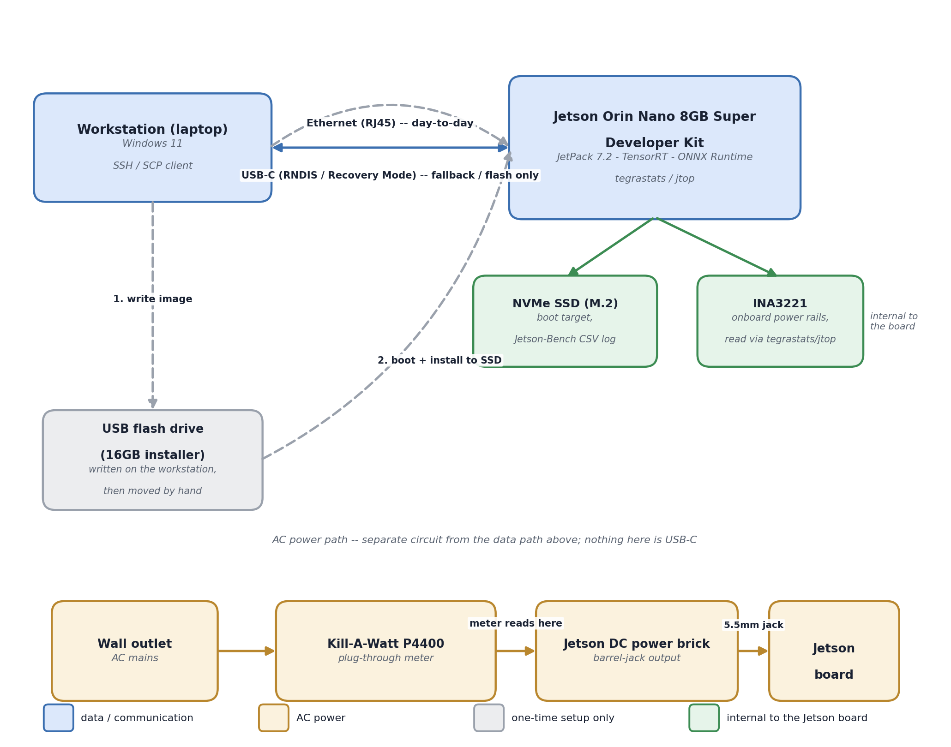
Figure: physical hardware setup for Steps 8-9 — data path (blue), AC power path (amber), one-time installer stage (gray), and what's internal to the Jetson board itself (green). Per jetson_device_selection.docx Sections 5, 8, and 9.
3.1 One-time setup — getting JetPack onto the device
1. On the workstation (Windows 11), write the JetPack 7.2 installer image onto the 16GB USB flash drive. As of JetPack 7.2, NVIDIA no longer supports writing an OS image directly to the microSD/NVMe target from another computer — the flash drive carries the installer only, temporarily.
2. Seat the Silicon Power 256GB NVMe SSD in the carrier board's M.2 Key-M slot before first boot — this is the real install target, not the flash drive.
3. Plug the USB flash drive into one of the Jetson's own USB-A ports and power on the board. It boots from the drive and runs the installer, which writes Jetson Linux onto the NVMe SSD. (USB-C Recovery Mode, flashing directly from a Linux host via SDK Manager, is a separate valid method — not used here since the workstation runs Windows, per jetson_device_selection.docx Section 9.2.)
4. Once JetPack is installed, the USB flash drive's job is done — it is not part of the day-to-day setup below.
3.2 Day-to-day communication
Recommended split, per jetson_device_selection.docx Section 5: Gigabit Ethernet (RJ45) for everything routine, USB-C reserved as a fallback.
• Primary — Ethernet: connect the Jetson's onboard RJ45 port to the same network as the workstation (direct cable or a lab router). SSH in (ssh <user>@<jetson-ip>), SCP the Step 7 ONNX graph onto the device, and pull the Jetson-Bench CSV log back — no mode-switching, no router configuration beyond a normal LAN.
• Fallback — USB-C Device Mode: if no network is available, connect workstation-to-Jetson over the same USB-C cable used for flashing. In Device Mode the Jetson offers RNDIS Ethernet-over-USB at a fixed address, 192.168.55.1 — SSH and SCP work identically over this link, just without a router or switch in the path.
• Power is never carried by either of these — the devkit is powered through its own 5.5mm barrel-jack DC input (Section 4 below), not USB-C.
4. Step 8 — Jetson deployment
jetson_inference.py (src/edge_fault_dx/deployment/) — loads the Step 7 ONNX graph into ONNX Runtime (or compiles it to a TensorRT engine — TensorRT trades a slower first-run compile for faster steady-state inference, the more realistic choice for H2's actual latency claim), and wraps it behind the same input/output contract train.py's own WindowedFaultDataset already produces, so Step 9's benchmarking harness can call it without re-deriving preprocessing on-device. With Section 2's default export (the real QAT-quantized checkpoint), the graph already carries standard QuantizeLinear/DequantizeLinear/Conv nodes — both ONNX Runtime and TensorRT's own ONNX parser consume that QDQ format natively, so int8_calib_loader below stays None for this path. It exists for the named fallback only: if Section 2 falls back to exporting the FP32 checkpoint, *this* is where that fallback's TensorRT PTQ calibration actually happens.
"""jetson_inference.py -- src/edge_fault_dx/deployment/

ONNX Runtime / TensorRT inference wrapper, run ON the Jetson
itself (not the workstation). Loads the Step 7 export. For the
default QDQ-quantized export, int8_calib_loader stays None --
TensorRT reads the QDQ nodes directly. It is only passed for
the named FP32 fallback, which needs its own INT8 calibration.
"""
import numpy as np
import onnxruntime as ort

class JetsonModel:
def __init__(
self, onnx_path, providers=None, int8_calib_loader=None
):
providers = providers or [
"TensorrtExecutionProvider", "CUDAExecutionProvider",
"CPUExecutionProvider",
]
opts = {}
if int8_calib_loader is not None:
opts["trt_int8_enable"] = True
opts["trt_int8_calibration_table_name"] = (
"calib.flatbuffers"
)
self.sess = ort.InferenceSession(
onnx_path,
providers=[(p, opts) if p.startswith("Tensorrt") else p
for p in providers],
)

def predict_proba(self, x: np.ndarray) -> np.ndarray:
logits = self.sess.run(
["logits"], {"window": x.astype(np.float32)}
)[0]
return 1.0 / (1.0 + np.exp(-logits))
# sigmoid, matches MA1DCNN.predict_proba

Reused unchanged: the sigmoid-threshold convention from MA1DCNN.predict_proba (models/ma1dcnn.py), so the re-swept threshold from Step 6 means the same thing here. New: the ONNX Runtime session wrapper and the TensorRT execution-provider selection. Self-check: before any timing run, feed this wrapper the same windows used in Step 7's parity check and confirm its output still matches — a second, on-device confirmation that nothing changed between workstation export and Jetson load.
5. Step 9 — on-device benchmarking: latency and power, step by step
5.1 Latency (H2) — p50/p95/p99 via GPU-synchronized timers
Reuses H2's methodology exactly as already defined in praxis_writeup.docx and already applied at the CPU-proxy level in Steps 1/4/6: batch size 1, 10 warm-up runs excluded, at least 100 timed runs (200, matching the CPU benchmarks, for a like-for-like comparison in Step 10).
1. Load the deployed model via JetsonModel (Section 4) on the Jetson itself.
2. Run 10 warm-up inferences on real windows, discarded — this absorbs any one-time CUDA/TensorRT kernel compilation and caching, so it doesn't bleed into the timed numbers.
3. Run 200 timed single-window inferences, each bracketed by a GPU-synchronized timer (torch.cuda.synchronize() or the ONNX Runtime/TensorRT equivalent barrier, called immediately before the start timestamp and immediately after the end timestamp) — without this, the measured time is wall-clock dispatch latency, not actual device compute time, since GPU work is asynchronous by default.
4. Compute p50/p95/p99 from the 200 per-inference timings and write them, plus every raw timing, into the Jetson-Bench CSV log on the NVMe SSD.
5.2 Power and energy (H3) — the three-point manual cross-check
The onboard INA3221 gives a continuous automatic log (via tegrastats/jtop, running for the same session as the latency run above); the Kill-A-Watt P4400 has no digital output, so it validates that log at three discrete, manually-read points rather than matching it as a continuous time series (jetson_device_selection.docx Section 9.3):
# | Measurement point | Procedure | Compared against
1 | Idle steady-state | Let the Jetson sit idle ~60s, then read the Kill-A-Watt's Watt display once it stabilizes. | Mean of the logged INA3221 idle readings over the same 60s window.
2 | Full-load steady-state | Start the Section 5.1 timed inference loop; once it's running steadily (~60s in), read the Kill-A-Watt's Watt display. | Mean of the logged INA3221 active readings over the same window.
3 | Full session energy | Read the Kill-A-Watt's kWh display at the start of the full benchmark session and again at the end; record the delta. | Energy integrated from the full logged INA3221 power trace over the same session — the direct H3 energy cross-check.

Build the three manual-reading pauses into the benchmark run script itself as explicit prompts (e.g., the script pauses and prints "read the Kill-A-Watt now, press Enter to continue") rather than relying on remembering to do it — this is the one part of Jetson-Bench that is not automatically logged, named explicitly in jetson_device_selection.docx for exactly this reason.
6. Step 10 — the final comparison
No new measurement of its own — it assembles Steps 1, 4, 6, and 9's rows into the single table phase4_architecture.docx Section 6 already scaffolded, filling in what that table currently marks "n/a" for on-device latency and energy, and adding the Step 9 row(s) for whichever variant(s) actually got deployed.
Variant | macro-F1 | Params | Size (MB) | CPU latency (Step 1/4/6) | On-device latency (Step 9) | Energy/inference (Step 9)
FP32 baseline (trial13) | 0.8440 | 66,534 | 0.259 | 0.474/0.633/0.785 | measure | measure
Pruned + recovered (20/40/60%) | 0.8436/0.8445/0.8254 | 43,522/25,467/12,486 | 0.172/0.103/0.053 | from Step 4's table | measure | measure
Pruned + quantized (QAT, 20/40/60%) | 0.8385/0.8306/0.8202 | same as above | 0.074/0.049/0.029 | from Step 6's table | measure (direct QDQ export — Section 2) | measure

H1, H2, and H3 get tested directly against this table: H1's ≥93.25% accuracy bar against the macro-F1/accuracy column (already known to fail at the current 0.8440 baseline, independent of anything in this document — named again in Section 7 so it isn't lost); H2's ≥25% latency reduction against the on-device latency column, baseline vs. each compressed variant; H3's ≥20% energy and ≥3% power reduction against the Section 5.2 measurements, same comparison.
7. Execution sequence
1. Write and self-check export_onnx.py (Section 2) against a synthetic model first.
2. Run it against the real Step 4 pruned/recovered checkpoint(s); confirm parity passes before trusting any ONNX file.
3. Complete the one-time JetPack flash (Section 3.1) if not already done.
4. SCP the validated ONNX graph(s) to the Jetson over Ethernet (Section 3.2).
5. Write and self-check jetson_inference.py (Section 4) on-device; re-confirm parity against the Section 2 reference outputs.
6. Run the Section 5.1 latency benchmark and Section 5.2 power/energy cross-check together, as one session, for each deployed variant.
7. Assemble Step 10's table (Section 6) and test H1/H2/H3 against their stated thresholds, honestly — including where they still fail.
8. What this would and wouldn't settle
What running Steps 7-10 for real would settle
Whether compression actually delivers on H2 (latency) and H3 (energy/power) on the real target hardware — the one set of numbers nothing so far in this project has measured, since every latency figure through Step 6 is a CPU proxy on a shared Colab runtime, explicitly flagged as not a Jetson stand-in every time it appears. It would also produce the one on-device accuracy figure (via TensorRT's own INT8 path, per Section 2) that completes H1's deployment-literal reading.

What it would not settle on its own
H1's accuracy bar is already failing at the 0.8440 FP32 baseline (below the 93.25% threshold) independent of anything in Steps 7-10 — on-device deployment cannot fix an accuracy gap that exists before compression or export ever happens. H1 also still needs the standard-CNN baseline and the fixed-SNR noise-robustness test named in h1_completion_plan.docx — that work is independent of this document and not covered here.

Steps 7-10 are deployment and measurement infrastructure — they make H2 and H3 testable for the first time and complete H1's on-device reading, but they do not by themselves change whether any hypothesis clears its bar. That depends on what the real measurements turn out to be.

