Irving Gan

Assignment 2 Pacman - Pseudocode

Decomposition

Break down or decompose the problem.

- Building the arcade game pacman. In this game, the user moves the pacman around the maze and eats the kibble while avoiding 4 ghouls.
- There are 2 character which are the pacman and the ghouls. The pacman eats the kibble and avoiding the ghouls. The ghouls moves around and try to eats the pacman. You win the game when the pacman finished eating the kibbles. You lose the game when the ghouls eats the pacman.
- The pacman and ghouls will move around the maze, the pacman will eat the kibble, the ghouls will eat pacman. If the pacman finish eating the kibble, you win, if ghouls eats the pacman then you lose.
- Pause, ghoul chase pacman, powerups
- Not make the pacman and ghouls go over the wall, make the pacman die if the ghouls touches pacman, make the pacman eat the kibble instead of stepping over it.

Form Design

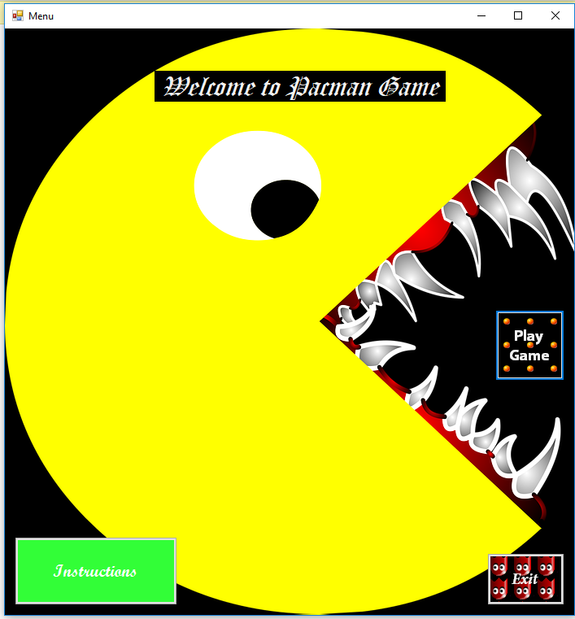
Menu page

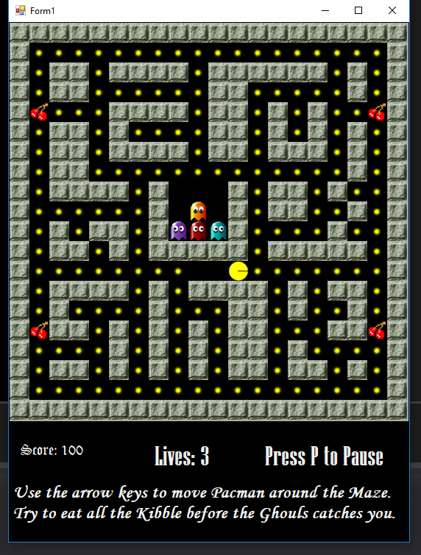

When the game starts

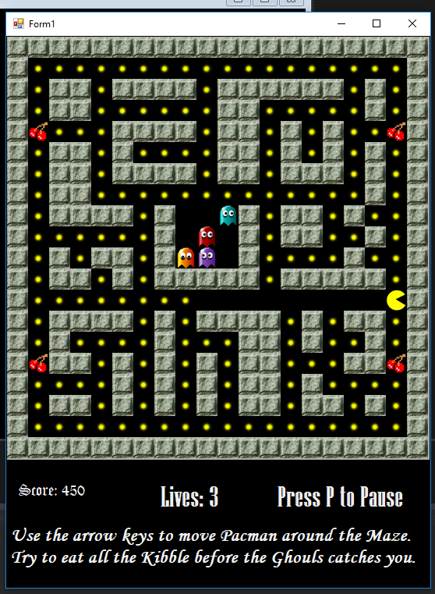
When game is playing

- The user will move the pacman by pressing the arrow key. The events needed is to move pacman according to the direction the user pressed using the keyboard.

Abstraction

Identify the characteristics that distinguish one character from another:

- 5 class. Form class, character class with a descendants of pacman and ghouls, maze class, direction and blocks enum class and controller class.
- The form class is to build the maze, create a timer. The character class is to create the pacman and the ghouls and also do some collision detection with the wall and between the pacman and the ghouls and the kibble. The controller class controls the start of the game, the score, the lives, the kibble count and other more. The direction class holds the value for up down left right.

Encapsulation
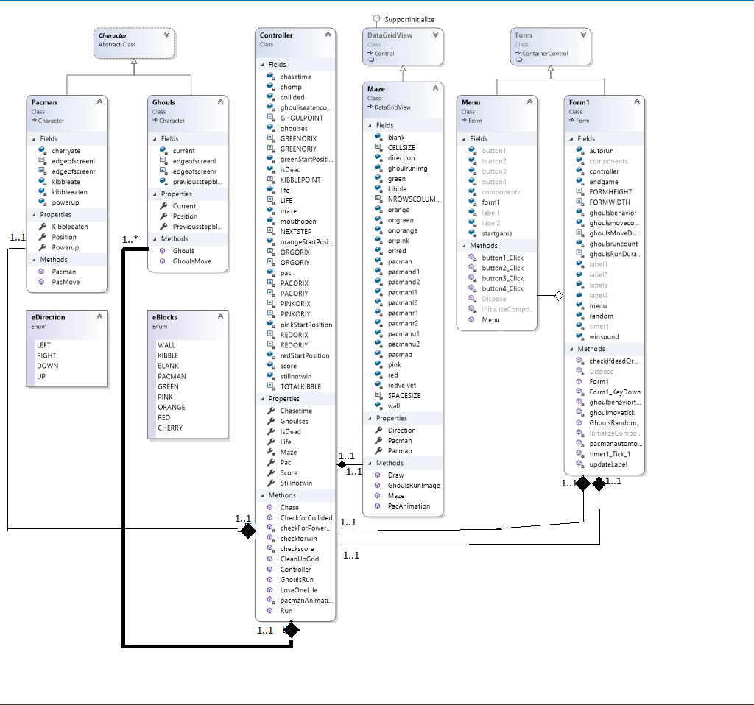

Iterative Refinement

For each method:
- Character class
  - Character class just holds the fields for the child class
- Ghouls class,
  - Ghoulsmove method is to move the ghoul around.
- Pacman class,
  - Pacmove method is to move the ghoul around.
- Controller class,
  - Chase method is to make the ghouls chase pacman
  - Checkforcollided is to check that whether ghouls touches pacman
  - Checkscore is to for the number of kibble that pacman has eaten and turn it into score
  - Run method is to run the whole program. Run method has most of the other method inside of it.
  - LoseOneLife is to move pacman and the ghouls back to the original position when pacman is eaten by the ghouls
  - CleanUpGrid is to reset the block type value of the ghouls so that the spawn area of the ghouls will not have new kibble popping out
  - checkForPowerUP checks for whether or not pacman has eaten the cherry or not
  - checkforwin checks for whether the pacman has eaten all the kibble or not
  - Chase method makes the ghouls chase pacman
  - GhoulsRun method is used when pacman eats the cherry and the ghouls will run away from pacman
  - pacmanAnimation method is used to just animate the pacman mouth
- Form class
  - checkifdeadOrwin checks for whether the pacman has eaten all of the kibble of when the ghoul touches the pacman
  - ghoulmovetimer is to move the ghoul
  - ghoulrandommovement is to make the ghouls move in random direction when not in chase mode
  - timer1 moves the pacman, run the controller, update the label, check when to move the ghoul, check when to make the ghoul chase pacman and check for whether the user wins or lose
  - Updatescore updates the label on the form with the current score
  - GhoulsRandomMovement method is use to move the ghouls randomly
  - checkifdeadOrwin check whether the user lose or win
  - updateLabel updates the label with the score
  - pacmanautomove method is use to make pacman move automatically without having to keep pressing the arrow keys
  - ghoulbehaviortick method is to change the ghouls behaviour
- Maze class
  - Draw is drawing the whole maze
  - pacAnimation is to put the different images for pacman so it will animate itself
  - GhoulsRunImage is used to swap the ghoul image between runtime image or normal image depending on when the pacman eats the cherry
- Menu class
  - Menu class just holds some buttons
  - One button is to run the game
  - One button is to exit the game
  - One button is to show the instructions

Identify extra functionality that will improve your solution.
- Sound
- Bonus points(when pacman eats ghouls)
- Pause button
- Multiple forms
- Menus
- Multiple lives
- Instructions
- Power Up
- Portal (make the pacman/ghouls move go to the other side of themaze)
- Ghouls chase pacman

